### MLL406 Taxation

**Jordan Edwards\_214136151**

Contents

[**Topic 1: Introduction to Taxation Law** 6](#_Toc526958683)

[Types of Taxes Imposed in Australia 6](#_Toc526958684)

[Constitutional Basis for Taxation in Australia 6](#_Toc526958685)

[The 4 qualities to which a tax should aspire: 7](#_Toc526958690)

[Incidence of Tax 8](#_Toc526958691)

[Vertical fiscal imbalance 9](#_Toc526958692)

[Overview of Tax Legislation 10](#_Toc526958693)

[General Structure of Tax Acts 10](#_Toc526958694)

[Statutory Interpretation 10](#_Toc526958695)

[Residency of taxpayer and source of income 10](#_Toc526958696)

[TOPIC 2 CHECKLIST – ASSESSABLE INCOME 11](#_Toc526958697)

[Ordinary Income (OI) s 6-5 11](#_Toc526958698)

[Statutory Income (SI) s 6-10 15](#_Toc526958699)

[Exempt Income: s 6-20 15](#_Toc526958700)

[Topic 2: Assessable income – Ordinary Income 16](#_Toc526958701)

[The income tax equation 16](#_Toc526958702)

[Prerequisites and characteristics of ordinary income 17](#_Toc526958703)

[What is and is not income? 19](#_Toc526958704)

[Compensation Payments 19](#_Toc526958705)

[Mutual receipts are not income 20](#_Toc526958706)

[Constructive receipts 20](#_Toc526958707)

[Illegality 20](#_Toc526958708)

[Income from personal services 20](#_Toc526958709)

[Gifts 21](#_Toc526958710)

[Prizes & gambling 23](#_Toc526958711)

[Capital receipt or personal exertion? 24](#_Toc526958712)

[Restrictive Covenants 24](#_Toc526958713)

[Revision questions 25](#_Toc526958714)

[Topic 2: Ordinary Income – Property 27](#_Toc526958715)

[Interest 28](#_Toc526958716)

[Dividends 28](#_Toc526958717)

[Annuities 29](#_Toc526958718)

[Royalties 29](#_Toc526958719)

[Topic 2: Ordinary Income –Business 29](#_Toc526958720)

[Step 1: Carrying on a business: 30](#_Toc526958721)

[Indicators of a business activity 30](#_Toc526958722)

[Hobby or Business – Gambling, Sportspeople, Investment Activities & Land Sales 31](#_Toc526958723)

[Commencement of a business 33](#_Toc526958724)

[Step 2: Normal proceeds of a business Nature of the business 33](#_Toc526958725)

[Step 2: Normal proceeds of a business Nexus of receipt with business 34](#_Toc526958726)

[Step 2: Normal proceeds of a business Non-cash business benefits & Extraordinary and isolated transactions 34](#_Toc526958727)

[Extraordinary transactions in summary 38](#_Toc526958728)

[Revision questions 39](#_Toc526958729)

[Topic 2: Ordinary Income - Business Compensation, Statutory Income and Exempt Income 42](#_Toc526958730)

[Compensation for lost income or capital? 42](#_Toc526958731)

[Compensation for the loss of capital 42](#_Toc526958732)

[Compensation for business losses 43](#_Toc526958733)

[Compensation for breach of contract 44](#_Toc526958734)

[Compensation for loss of a business asset 44](#_Toc526958735)

[Compensation by way of insurance 45](#_Toc526958736)

[Composite claims 45](#_Toc526958737)

[Reimbursement of previously deducted expenses 45](#_Toc526958738)

[Revision question 46](#_Toc526958739)

[II. STATUTORY INCOME (Individual) 46](#_Toc526958740)

[Statutory income (Business) 48](#_Toc526958741)

[Exempt Income 49](#_Toc526958742)

[Consequences of an amount being exempt income 50](#_Toc526958743)

[Revision questions 50](#_Toc526958744)

[TOPIC 3 CHECKLIST - DEDUCTIONS 51](#_Toc526958745)

[General Deductions s 8-1 51](#_Toc526958746)

[Specific Deductions: s 8-5 54](#_Toc526958747)

[TOPIC 3 – DEDUCTIONS 56](#_Toc526958748)

[Overview 57](#_Toc526958749)

[Deductions (general and specific) and trading stock 57](#_Toc526958750)

[**General Deductions** 57](#_Toc526958751)

[Nexus with Income 58](#_Toc526958752)

[Judicial tests 58](#_Toc526958753)

[Nexus sufficiently direct or too remote 60](#_Toc526958754)

[Sufficient temporal nexus 60](#_Toc526958755)

[‘Necessarily incurred’ 61](#_Toc526958756)

[What are losses or outgoings 62](#_Toc526958757)

[Apportionment 63](#_Toc526958758)

[Tax minimization situations - Purpose 64](#_Toc526958759)

[S 8-1 (2): The Negative Limbs 66](#_Toc526958760)

[Negative Limb 1: Capital or of a Capital nature 66](#_Toc526958761)

[Negative Limb 2: Private or Domestic Expenses 68](#_Toc526958764)

[Denied deductions 68](#_Toc526958765)

[Travel expenses 69](#_Toc526958766)

[Self-Education expenses 70](#_Toc526958769)

[Clothing & dry cleaning expenses 71](#_Toc526958770)

[Home Office expense 71](#_Toc526958771)

[Interest expenses & gearing 72](#_Toc526958772)

[Substantiation of deductions 72](#_Toc526958773)

[Negative Limb 3: Losses or Outgoings relating to Exempt Income 73](#_Toc526958774)

[Negative Limb 4: Specific Provisions altering the General Principles 73](#_Toc526958775)

[Legislative Exclusions 73](#_Toc526958776)

[Other provisions 73](#_Toc526958778)

[Revision questions 73](#_Toc526958779)

[**Specific Deductions** (s 8-5) 76](#_Toc526958780)

[1. S 25-5: Tax related expenses 76](#_Toc526958781)

[2. S 25-10: Repairs 77](#_Toc526958782)

[3. S 25-35: Bad debts 80](#_Toc526958783)

[4. S 25-55: Payments to associations (memberships and union fees) 81](#_Toc526958784)

[5. Gifts – Div 30 81](#_Toc526958785)

[6. S 25-100: Travel between workplaces 81](#_Toc526958786)

[7. Prior year tax losses – Div 36 82](#_Toc526958787)

[8. S 25-25: Borrowing Expenses 83](#_Toc526958788)

[9. Capital expenditure allowances (depreciation) – Div 40 84](#_Toc526958789)

[10. Capital works deductions – Div 43 (Special building write off) 88](#_Toc526958790)

[11. Black Hole Expenses – Subdivision 40-1 89](#_Toc526958791)

[12. No Double Deductions 8-10 90](#_Toc526958792)

[Other specific deduction provisions 90](#_Toc526958793)

[Revision questions 90](#_Toc526958794)

[TOPIC 3.4 CHECKLIST: Deductions - TRADING STOCK 91](#_Toc526958795)

[What is trading stock? 91](#_Toc526958796)

[TOPIC 4.5: TRADING STOCK 92](#_Toc526958797)

[‘Trading stock’ to be taken into account – Background 93](#_Toc526958798)

[Trading stock defined 94](#_Toc526958799)

[Revision questions 95](#_Toc526958800)

[Year-end adjustments 95](#_Toc526958801)

[When is trading stock ‘on hand?’ 96](#_Toc526958802)

[Revision question 97](#_Toc526958803)

[Transactions involving trading stock, not in in the ordinary course of business or not ‘at arm’s length’ 98](#_Toc526958804)

[Special rules 98](#_Toc526958805)

[Small business entity concession 99](#_Toc526958806)

[Interaction with other income tax rules 99](#_Toc526958807)

[TOPIC 3 CHECKLIST – CAPITAL GAINS TAX (CGT) 99](#_Toc526958808)

[STEP 1: IS THERE A GAIN OR LOSS? 99](#_Toc526958809)

[Is there a CGT Event? 100](#_Toc526958810)

[STEP 2: CALCULATING CAPITAL GAIN 101](#_Toc526958811)

[TOPIC 4: CAPITAL GAINS TAX (CGT) 103](#_Toc526958812)

[Steps for CGT 103](#_Toc526958813)

[Overview 103](#_Toc526958814)

[CGT Provisions 103](#_Toc526958815)

[STEP 1: Is there a capital gain/loss? 103](#_Toc526958816)

[i. Has a CGT event happened? 104](#_Toc526958817)

[ii. CGT ‘asset’? 105](#_Toc526958818)

[Timing – Disposal & Acquisition 108](#_Toc526958819)

[iii. Exceptions and exemptions 108](#_Toc526958820)

[Subdiv 118-B: Main Residence Exemption 109](#_Toc526958821)

[Iii Roll-over relief 110](#_Toc526958822)

[STEP 2: Calculating Capital Gain 110](#_Toc526958823)

[Six modifications to capital proceeds: 110](#_Toc526958824)

[Cost base 111](#_Toc526958825)

[STEP 3: Calculate Net capital gain/loss for FY 114](#_Toc526958826)

[Revision questions 115](#_Toc526958827)

[4. Other CGT Events 118](#_Toc526958828)

[CGT Events 118](#_Toc526958829)

[S 104-10(1): Review of CGT Event A1 – Disposal of a CGT Asset 118](#_Toc526958830)

[S 104-35: D1 CGT Event – Creation of Contractual Rights 119](#_Toc526958831)

[S 104-20: CGT Event C1 – Loss or Destruction of a CGT Asset 119](#_Toc526958832)

[S 104-25: CGT Event C2 – Cancellation, Surrender or Similar Endings 120](#_Toc526958833)

[S 104-110: CGT Event F1 – Lease Grant or Renewal 121](#_Toc526958834)

[S 104-155: CGT Event H2 122](#_Toc526958835)

[3. Exceptions and exemptions 122](#_Toc526958836)

[Main residence exemption 122](#_Toc526958837)

[CG effects from a death 124](#_Toc526958838)

[Small business CGT Concessions (Div. 152) 124](#_Toc526958839)

[Record Keeping 126](#_Toc526958840)

[Revision questions 126](#_Toc526958841)

[Topic 5 Checklist: Who pays tax and how? Individuals, Companies, Trusts and partners 128](#_Toc526958842)

[Taxation of company distributions ‘dividends’ 129](#_Toc526958843)

[Trusts 129](#_Toc526958844)

[Partnership 130](#_Toc526958845)

[Topic 5.1: The Taxation of Individuals 131](#_Toc526958846)

[Topic 5.2: Taxation of Companies and Shareholders 132](#_Toc526958847)

[Taxation of dividends 132](#_Toc526958848)

[Division 7A 133](#_Toc526958849)

[Deemed dividends for liquidator distributions 134](#_Toc526958850)

[Imputation system 134](#_Toc526958851)

[Company losses 137](#_Toc526958852)

[Topic 5.3: Taxation of Trusts 137](#_Toc526958853)

[Types of trusts 137](#_Toc526958854)

[Taxation of trust income 139](#_Toc526958855)

[1. Net Income or loss of the trust? 139](#_Toc526958856)

[2. Presently entitled? 140](#_Toc526958857)

[3. Legal disability? 140](#_Toc526958858)

[CGT events for trusts 141](#_Toc526958859)

[Revision questions 141](#_Toc526958860)

[Topic 5.4: Taxation of Partners and Partnerships 142](#_Toc526958861)

[Collection of tax 144](#_Toc526958862)

[TOPIC 6.1 CHECKLIST –GST 146](#_Toc526958863)

[Step 1: define GST (s7-1): 146](#_Toc526958864)

[Step 2: For a taxable supply to exist s 9-5 states that it requires five elements: 146](#_Toc526958865)

[Step 3: is it a type of supply that doesn’t get GST taxed? 146](#_Toc526958866)

[Step 4: Is it an input taxed supply? 146](#_Toc526958867)

[Step 5: Apply input tax credits 147](#_Toc526958868)

[TOPIC 6.1: GOODS AND SERVICES TAX 147](#_Toc526958869)

[Underlying principles 148](#_Toc526958870)

[Requirements to register for GST 149](#_Toc526958871)

[Taxable supplies (s 9-5 -GST Act) 149](#_Toc526958872)

[Credible acquisitions (s 11-5 – GST Act) 152](#_Toc526958873)

[Special rules 153](#_Toc526958874)

[Administration 153](#_Toc526958875)

[Revision question 155](#_Toc526958876)

[Thi Nguyen owns and operates a small beauty salon in the inner eastern suburbs of Melbourne. The business employs three employees and is registered for GST. The business is operated from rented premises. For the tax period 30 June 2016, the following transactions were reported in the journals of the business: 155](#_Toc526958877)

[TOPIC 6.2 CHECKLIST –FBT 157](#_Toc526958878)

[Step 1: Determine whether a benefit has been provided to an employee or associate 157](#_Toc526958879)

[Step 2: Determine the category of fringe benefit 158](#_Toc526958880)

[Step 3: Apply any reductions in taxable value 158](#_Toc526958881)

[Step 4: State the type of fringe benefit 159](#_Toc526958882)

[Step 5: Calculate the TV of the benefits and the FBT liability 159](#_Toc526958883)

[Topic 6.2: Fringe Benefits Tax (FBT) 159](#_Toc526958884)

[Step 1: Determine whether a benefit has been provided to an employee or associate 160](#_Toc526958885)

[Step 2: Determine the category of fringe benefit 162](#_Toc526958886)

[Car fringe benefit 162](#_Toc526958887)

[Debt waiver fringe benefit 163](#_Toc526958888)

[Loan fringe benefit 163](#_Toc526958889)

[Expense payments fringe benefit 163](#_Toc526958890)

[Meal entertainment fringe benefit 164](#_Toc526958891)

[Property fringe benefit 164](#_Toc526958892)

[Residual fringe benefits 164](#_Toc526958893)

[Exempt fringe benefits 165](#_Toc526958894)

[Step 3: Apply any reductions in taxable value 165](#_Toc526958895)

[Step 4: Type of fringe benefit 166](#_Toc526958896)

[Step 5: Calculate the taxable value of the benefits and calculate the FBT liability 166](#_Toc526958897)

[Interaction with other taxes 167](#_Toc526958898)

[Revision questions 168](#_Toc526958899)

[TOPIC 7 CHECKLIST – TAXATION ADMINSTRATION & AVOIDANCE 170](#_Toc526958900)

[Tax avoidance 170](#_Toc526958901)

[TOPIC 7 – TAXATION ADMINISTRATION & AVOIDANCE 172](#_Toc526958902)

[Annual returns 172](#_Toc526958903)

[Self-Assessment 172](#_Toc526958904)

[Commissioner making an assessment 172](#_Toc526958905)

[Amending Assessment 172](#_Toc526958906)

[Commissioner power to obtain information 172](#_Toc526958907)

[Tax Audits 173](#_Toc526958908)

[Substantiation of expenses 173](#_Toc526958909)

[Commissioner’s Information Gathering Powers 173](#_Toc526958910)

[Disputes with the Tax Office 173](#_Toc526958911)

[Interest and penalties 173](#_Toc526958912)

[Collection of tax from third parties 174](#_Toc526958913)

[General anti-tax avoidance 174](#_Toc526958914)

[Specific anti-avoidance provisions 176](#_Toc526958915)

[Objections, review and appeals 177](#_Toc526958916)

[Commissioner’s access powers 178](#_Toc526958917)

[Written Assignment Question 178](#_Toc526958918)

[Trimester 2: 2017 Examination 184](#_Toc526958919)

[2016 T2 Exam – Q2 189](#_Toc526958920)

# Topic 1: Introduction to Taxation Law

* An overview of the taxation process and the tax mix
* Policy considerations in the taxation system

**What is tax?**

* Generally defined as a “compulsory exaction of money by a public authority for public purposes, enforceable by law, and is not a payment for services rendered.”
* See, *Matthews v Chicory Marketing Board* (1938) 60 CLR 263

## Types of Taxes Imposed in Australia

* **Personal Income Taxes**
* Imposed by Cth and the most significant source of revenue for this level of government. It is progressively imposed in Australia.
* **Corporate Taxes**
* Taxes are paid on profits. Unlike personal income taxes which use a progressive scale, corporate taxes in Australia are calculated at a flat rate. Tax is paid on corporate income at the corporate level before it is distributed to individual shareholders as dividends. A tax credit (called a franking credit) is provided to individuals who receive dividends to reflect the tax already paid at the corporate level (a process known as dividend imputation).
* **Goods and Services Tax (GST)**
* The GST is an indirect tax, introduced on 1 July 2000. It applies a 10% tax on the consumption of most goods and services (some are exempt). It is an indirect type of tax because the burden of tax falls on the final consumer but is paid by the supplier. GST is levied on the supply of goods and services throughout the production or distribution chain. A credit is also given for GST paid at each stage of the supply chain, so that the full cost of the tax eventually falls on the final consumer.
* **Property Taxes**
* Local governments are typically funded largely by property taxes (council rates) on residential, industrial and commercial properties.
* The state governments also levy taxes on the transfer of property title (stamp duties).
* **Excise taxes**
* Both the federal and state governments impose excise taxes on inelastic goods such as cigarettes, petrol, and alcohol.
* **Payroll taxes**
* State governments impose payroll taxes at varied rates.
* **Inheritance tax**
* There is absolutely no inheritance tax in Australia, although inherited assets may have Capital Gains Tax implications for beneficiaries.
* **Superannuation Taxes**
* Superannuation is taxed at three points: contributions to funds, on investment income and on benefits received.
* **Fringe Benefit Tax**
* A fringe benefit is a benefit, other than a salary or wage, derived from employment. Before the introduction of FBT in 1986, most fringe benefits weren’t taxed. FBT applies to non-cash remuneration benefits paid or given by an employer and received by or benefiting an employee (or associate of an employee).

## Constitutional Basis for Taxation in Australia

* The constitutional basis of taxation in Australia is based on a group of powers in the Australian Constitution: sections 51(ii), section 90, section 114, section 53, section 55, and section 96.

### S 51(ii) *–* Tax power

* Section 51(ii) allows the Commonwealth to enact laws implementing:

*Taxation, but so not as to discriminate between States or parts of States.*

* The non-discrimination limitation repeats the more general prohibition found in Section 99 that the Commonwealth cannot discriminate between States in laws on trade, commerce, or revenue.
* The broad power in s51(ii) to impose 'taxation' must be read subject to the start of s51 which grants the powers 'subject to this constitution'. S51(ii) must be considered in combination with s90.

### S 90 – Impose duties of customs and of excise

* Section 90 gives the Commonwealth the exclusive, as opposed to concurrent with the States, power to impose 'duties of customs and of excise'.
* Any state taxing law on this power will be unconstitutional.
* The definition of 'customs and excise' has therefore been an important, and litigated, constitutional issue.
* Generally, a customs duty is a tax imposed on goods entering a jurisdiction.
* An excise is a type of sales tax on goods, and the HCA has interpreted this power extremely broadly so as to limit state taxing power.
* The major purpose of section 90 was that important objectives of federation were achieved: uniform trade relations with other countries; and free trade between the states
* However, in application and interpretation section 90 has led to a revenue imbalance.
* That is, section 90 limits the States ability to raise money even though they have considerable funding obligations (e.g. education and schools)

### SS 114, 53 & 55

* Section 114 provides that the Commonwealth cannot tax State property, nor States tax Commonwealth property.
* Sections 53 and Sections 55 (tax provisions may only be in tax Acts) prescribe procedural limitations on tax legislation.

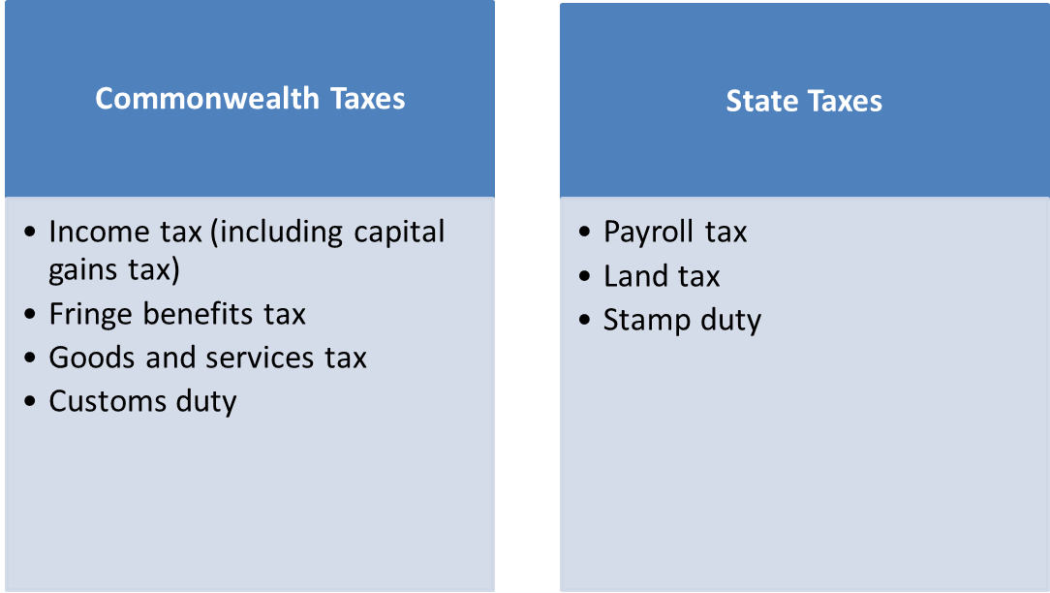

## Purpose and Effects

* The funds received through taxation are used for many purposes. These include enforcement of law and public order, protection of property, economic infrastructure (roads, legal tender, enforcement of contracts, etc.), public works, social engineering, and the operation of government itself.
* Most modern governments including that in Australia also use taxes to fund welfare and public services. These services can include education systems, health care systems, pensions for the elderly, unemployment benefits, and public transportation. Energy, water and waste management systems are also common public utilities.

## The 4 qualities to which a tax should aspire:

1. **Fairness**

* A taxation system should be fair and equitable amongst its citizens. If it is perceived not to be fair this may lead to distrust and tax avoidance.
* For fairness, we **look to Vertical equity and Horizontal equity**.
* ***Horizontal equity*:** This means that those people that are in a similar position should be treated equally. It also means that all business entities should be taxed in a similar manner.
* ***Vertical equity:*** This requires persons that are in different financial positions be treated differently. That is, a higher income recipient pays more tax than a lower income recipient.

1. **Simplicity**

* The simplicity of a tax, and **an overall taxation system, is determined by:**
* the ease in which a taxpayer may comply with the Act; and
* the authorities’ ability to administer the Act and collect tax.
* Australia’s Tax Act have problems in respect to size and complexity
* **Size**
* The ITAA36 and ITAA 1997 rank amongst the largest examples of taxation legislation in the world.
* The first real step in reducing the size of the ITAA36 and ITAA 1997 was effected by the enactment of Tax Laws Amendment (Repeal of Inoperative Provisions) Act 2006 (Cth).
* This was in response to the Board of Taxation’s identification of over 2100 pages of inoperative tax provisions, and so many were repealed. We look at complexity of the Acts later in this lecture
* **Complexity**
* This occurs when provisions in the Act and their meaning are obscure.
* Unfortunately, the ITAA’s have also failed in this respect.
* The capital gains provisions have further been criticized by the judiciary for their obscurity: *FCT v Cooling* (1990) 90 ATC at 4488 per Hill J**:**
* [The capital gains provisions] are drafted with such obscurity that even those used to interpreting the utterances of the Delphic oracle might falter in seeking to elicit a sensible meaning from its terms.

1. **Certainty**

* **Certainty of incidence**
* Pertains to the ability of taxation authorities to predict who will actually bear the tax burden.
* It is submitted that, particularly where a taxation system is used for social engineering, introducing a new tax may have unintended effects, such as discouraging a form of trading or encouraging tax avoidance.
* These unintended changes may dramatically alter the intended incidence of tax amongst the community. Changes may also be positive – the Carbon Tax may promote increased use of alternate energy (solar power etc.)
* **Certainty of liability**
* Is adjudged by how easily taxpayers may determine their liability and how accurate that determination will be.
* Ie: Under the self-assessment regime of our Income Tax Acts, ITAA36 and ITAA97, the easier it is for taxpayers to calculate exactly what they are liable for – makes for certainty of liability. Unfortunately, given that there are over 125 different taxes this is not really apparent in Australia.
* It is apparent that this form of certainty is closely connected with the goal of simplicity.
* **Evasion ratio**
* Evasion ratio is closely connected with certainty of incidence.
* This ratio looks at the extent of tax avoidance and tax evasion and the authorities’ ability to combat these problems so that the incidence of tax will lie where it was intended.
* **Fiscal marksmanship**
* Relates to the certainty by which the authorities may predict the amount of tax that will be collected in a particular year. It depends on the number of taxpayers and of course the mix of tax payers. Remembering that companies pay tax at a fixed rate of 30%, whilst individual taxpayers follow a progressive scheme

1. **Efficiency**

* Generally, to be efficient, a taxation system must be
* Administratively efficient; and
* Neutral
* **Administratively efficient**
* Taxes should not skew resource allocation across the economy
* Costs of administering and complying with the Tax Acts should also be minimized
* **Neutrality**
* Neutrality requires that a taxation system should not influence individual and business decision making in the market place.
* But we have seen in practice that this is not the case. Companies are taxed at different tax rates than individuals, and GST is applied differently to different goods and services for example.
* In addition, Governments often ignore the goal of neutrality and use taxation systems to promote extraneous social, economic and political objectives. Governments intentionally encourage, and discourage, types of activities by altering their tax treatment

## Incidence of Tax

* Incidence of tax may be regressive, proportional or progressive
* ***Regressive***
* A tax is regressive if it exacts a lesser proportion of tax the greater the income derived.
* Under a regressive tax as a taxpayer earns more income that additional income is taxed at a lower rate than initial income receipts.
* A regressive tax places a proportionate higher tax burden on low income earners than on high income earners.
* ***Proportional***
* A proportional tax exacts the same proportion of tax on each dollar of income. Hence, a 15% flat tax on all income will be said to be proportional.
* In Australia, companies are taxed at a proportional rate. The current rate of tax for companies is 30 cents in the dollar.
* As everybody pays the same amount of tax regardless of their income and financial position, flat taxes impose a greater burden on low income earners
* ***Progressive***
* **In contrast to a regressive tax**, a tax is progressive if it exacts a greater proportion of tax on income as it increases.
* Under a progressive tax system, theoretically, a greater tax burden is placed on high income earners.
* The Australian taxation system’s treatment of personal income is progressive.

## Vertical fiscal imbalance

Vertical fiscal imbalance means that the revenue-raising abilities of the governments do not coincide with their spending responsibilities.

As Section 51 and other provisions of the constitution (such as s52 and s90) prescribe only limited legislative powers to the Commonwealth, Australian states have considerable obligations (like funding of schools, hospitals etc).

The Cth collects money through taxes and distributes to the States through “tied grants” (power to distribute in s96 Constitution).

States like this and protects them from dealing with the politics associated with imposing taxation directly. Leave it to the Commonwealth.

**Levies and charges**

* Australian tax system is also a collection mechanism for other amounts payable by Australian tax residents. Examples:
  + Medicare levy
  + Medicare levy surcharge
  + Repayment of higher education debts (Higher Education Loan Program, known as HELP).

**Assessable Income and Allowable Deductions**

In summary, we will be concerned with the following relationships as they relate to income tax:

**Tax payable** = (Taxable income X Tax rate) – Tax offsets

-and-

**Taxable income** = Assessable income – Allowable deductions

The following steps describe the basic procedure for determining the income tax due on taxable income as set out in the ITAA 97:

* Section 4-1: Who must pay tax? **Taxpayer**
* Section 4-10: Tax is paid each year ending 30 June. **Tax Period**
* Tax is based on taxable income (multiplied by applicable rate or rates) less tax offsets. **Tax Base and Tax Rate**
* Section 4-15: Taxable income is calculated by determining assessable income less deductions. **Tax Base**
* Section 6-1: Assessable income is classified into *ordinary income* (s 6-5) and *statutory income* (s 6-10). It does not include *amounts that are neither ordinary or statutory income* (s 6-15) nor *exempt income* (s 6-20) or NANE income (s 6-23).
* Division 8: Deductions are classified into *general deductions* (s 8 1) and *specific deductions* (s 8-5).In addition some expenses are excluded from deductibility altogether.

## Overview of Tax Legislation

* In this unit we will be covering the major provisions of the ITAAs, The GST Act and the FBT Act with only some minor reference to the other acts.
* *Income Tax Assessment Act 1936* (ITAA 36)
* *Income Tax Assessment Act 1997* (ITAA 97)
* *A New Tax System (Goods and Services Tax) Act 1999*—This Act deals with the GST.
* *Fringe Benefits Tax Assessment Act 1986* and other related acts.
* *Taxation Administration Act 1953* (TAA 1953) – covers taxation objections and appeals.
* *Income Tax Regulations*—These prescribe how certain parts of the principal Act are to be implemented.
* *Rating Acts (Income Tax Rates Act 1986)*—They impose the actual tax on taxable income as determined by the ITAA (amended as required to reflect change).
* *Crimes (Taxation Offences) Act* *1980*.

## General Structure of Tax Acts

* ITAA 97, Divs 2, 3 and 4 provide an overview of the structure of the new Act and explain the core purpose of the Act as the determination of taxable income
* **The following steps describe the basic procedure for determining the income tax due on taxable income as set out in the ITAA 97:**
* **Section 4-1**: Who must pay tax?
* **Section 4-10**: Tax is paid each year ending 30 June.
* Tax is based on taxable income less tax offsets.
* **Section 4-15**: Taxable income is calculated from assessable income and deductions.
* **Section 6-1**: Assessable income is classified into *ordinary income* (s 6-5) and *statutory income* (s 6-10). It does not include *amounts that are neither ordinary or statutory income* (s 6-15) nor *exempt income* (s 6-20).
* **Division 8**: Deductions are classified into *general deductions* (s 8 1) and *specific deductions* (s 8-5). In addition, some expenses are excluded from deducibility altogether.

## Statutory Interpretation

* **Definitions**
* **Section 995-1(1), ITAA 97 is a general definition provision that should be used if you require a definition of any word used in the Act** (in the ITAA 97 all defined words are identified with and ‘\*’, see s 6-1).
* Because the **TLIP is still in progress some of the definitions contained in s 995-1(1) simply refer back to ITAA 36, s 6(1) which is the general definition section for the old Act.**
* **And/Or**
* When reading definitions or other legislation that requires a number of steps and alternative actions, it **is imperative that you clearly understand whether the requirements of the section are all included (i.e. *and*) or whether only one is required (i.e. *or*).**
* **Less confusion is likely with the ITAA 97 and the ‘and/or’ is stated at the end of each paragraph** so that the reader is always aware of the relationship with other requirements of the section.

## Residency of taxpayer and source of income

* **Residency**
* Residents and non-residents are subject to different rates of tax – residents have a tax-free threshold and start to pay tax at 19%, non-residents have no tax-free threshold and start to pay tax at 32.5%
* Sections 6-5(2) & (3) and 6-10(4) and (5) distinguish between the assessable income of a resident and a non-resident. A resident of Australia is taxable on income from all sources whereas a non-resident is only taxed on income from Australian sources.
* **Section 995-1 defines an Australian resident** as having the same meaning as that given in ITAA 36 s 6(1). Section 6(1)(a) defines a **resident** to mean:

a person, other than a company, who resides in Australia and includes a person:

1. whose domicile is in Australia, unless the Commissioner is satisfied that the person’s permanent place of abode is outside Australia;
2. who has actually been in Australia, continuously or intermittently, during more than one-half of the year of income, unless the Commissioner is satisfied that the person’s usual place of abode is outside Australia and that the person does not intend to take up residence in Australia …

A company which is incorporated in Australia, or which, not being incorporated in Australia, carries on business in Australia, and has either its central management and control in Australia, or its voting power controlled by shareholders who are residents of Australia.

* **Source of income**
* Sections 6-5 and 6-10 provides that a resident taxpayer must pay tax on income from all sources, whilst a non-resident need only pay Australian tax on income with an Australian source. This makes it important to be able to identify the source of a non-resident’s income.

**4 tests of residence to apply to an individual taxpayer:**

* + “resides” according to ordinary concepts test- reference to factors derived from Court decisions
  + Domicile test
  + 183 day test
  + Superannuation test (only applies to Commonwealth public servants)

**3 tests to apply to companies:**

* + Incorporation test
  + Central management and control test
  + Controlling shareholders test

# TOPIC 2 CHECKLIST – ASSESSABLE INCOME

* S 4 -15:Taxable income = Assessable income – Deductions
* Income Tax = (Taxable income x Tax rate) – offsets
* Categories in which income can be derived from:
* Personal services
* Property
* Business
* **Assessable income includes ordinary income, or ‘income according to ordinary concepts:** s 6-5
* What would a reasonable person define as ‘income’: *Scott v C of T (NSW)*
* Objective test: *Hayes v FC of T* (1956)

## Ordinary Income (OI) s 6-5

1. **Are the two prerequisites apparent?**

**Sample Answer:** \_\_\_\_\_\_\_\_\_\_\_\_\_ made a gain that is cash/cash convertible (*FCT v Cooke and Sherden* (1980)), and it was a real gain (*Hochstrasser v Mayes* [1960]); thus \_\_\_\_\_\_\_\_\_ has satisfied the prerequisites of OI

* **Receipts that are not cash or cash convertible are not OI**
* Free accommodation that cannot be sublet by TP = not OI: *Tennant v Smith*
* If it can be transferred, but not sold = not OI: *Payne* (frequent flyer points)
* Income is regular and ‘flows’: *Eisner v Macomber* (1920)
* Tree is capital and the income that flows from that asset is income
* **Business:** If a receipt goes to the fundamental business structure, as opposed to the process: **per Dixon J** *Sun Newspapers*
* **Constructive receipts:** Will be OI where TP is entitled to the receipt, but has arranged for another party to receive on their behalf: *Federal Coke Co P/L v FCT***;** s 6-5(4)
* Illegality used to not effect assessable income: *Lindsay v IR Comms; TR 93/25*
* **Mutual receipts not OI where TP contributes financially to their club:** *Aust Music Traders*

1. **When does ordinary income apply?**

**Personal Services**

* **As long as the remuneration shows a nexus to the labour of the taxpayer, it does not matter whether the remuneration is for past, present or future services:** *Hochstrasser v Mayes* [1960] AC 376
* **Doesn’t it matter that it is paid by a third party**, rather than the recipient of the services: *Kelly v FCT* (1985) 16 ATR 478
* **Consider the cases below and conclude whether OI**

**Identify the work or service that is being performed**

* It is essential to establish a nexus between the income received and the work performed: *Moorhouse v Dooland* [1955]

**Gift:**

* One off payments with no nexus to personal services is a gift; thus a windfall gain that is not assessed as OI: *FCT v Harris*
* **Characteristics of personal gift from** *Scott***upheld in** *Hayes***, no single factor is determinative, all assist in making a conclusion:**
* Whether the gift was unexpected: *Scott*
* Whether it was a one off lump sum (*Harris*), or whether payments were regular and relied upon: *Dixon****,*** *Scott*
* Motives of the donor: *Scott*
* Prior Remuneration: *Scott****,*** *Hayes*
* Whether it is a personal or professional relationship with the donor: *Scott****,*** *Hayes*
* Character of receipt in hands of donee: *Scott*
* Nature of the employment of the donee: *Scott*
* Whether the payment is a reward for past or present services: *Scott*
* Whether donor also made gifts to others, depending on context: *Laidler*
* **Employer ‘Thank you’ card with voucher attached = OI** as ‘thank you’ card established nexus with employment: *Laidler v Perry*
* **OI where reward primarily for services rendered by TP:** *Brown v FCT*

**Prizes & Gambling**

* Gambling winnings are a **windfall gain unless the gambler is in the business of gambling:** *Babka v FCT* (1989)
* **Ask:** Is TP a casual punter, or a bookmaker?
* **Prizes for business activity OI** (provided TP is carrying on a business and scope of business (below))
* **More skill contributed than chance = OI:** *Kelly v FCT***Sport prize OI**
* Can still be OI if prize donated by an unrelated third party: *Kelly*
* Large sum of money won throughout year not OI, systematic business-like approach to gambling required: *Evans*
* **Consider (***Case 37***):**
* Degree of professionalism
* Reward for services or personal qualities
* Paid before or after service
* Related to contract

**Capital receipt/Restrictive Covenants**

* Where income is treat as capital, as opposed to OI
* **Test:** Consider are they giving up a capital right (eg restrictive covenant) or is the money replacing income: *Hepples*
* Lump sum to **not play for any other football club** is capital: *Woite*
* **Restriction on disclosing employer trade secrets** for lump sum capital: *Hepples*
* **Earnings from sharing story** with journalists is **OI as it is ongoing and no capital right is given up:** *Brent* HC
* **Compensation for** **removal of previous rights** in position of employment is **capital (so long as** compensation **does not relate to income):** *Bennett*
* Payment for **giving up a status** that had rights incidental to that status is **capital**: *Jarrold v Boustead***–** amateur football to professional football

**Property**

* Interest
* Dividends
* Rent and lease income
* Royalties
* Annuities

**Interest**

* ‘A payment which becomes due because the creditor has not has his money at the due date’: *Riches v Westminster**Bank Ltd*
* Pre-judgement interest is capital if it is considered as compensation for a personal injury, not for lost income: *Whitaker*
* Post-judgement interest exempt from OI: ss 51-57
* **If it is compensation for lost of wages/income/salary:** OI
* If it is compensation **for loss of capital right (losing sight/business):** Capital

**Dividends:** s 44 ITAA 36

* **Not OI**
* **Sample Answer:** Dividends are considered as statutory income pursuant to s 44 ITAA 36.

**Annuities**

* An **annuity is a stream of payments that occur at regular intervals and may be for a fixed length of time** (or life) of individual
* **Full amount of the regular annuity payment is regarded as ordinary income:** *Egerton v. Warburton v. FCT* (1934) 51 CLR 568
* Return of capital from an annuity is tax free: s 27H ITAA 36

**Royalties**

* Payment for the rights over property, royalties is significant if the payment is made for a particular quantity: *McCauley****;*** *Stanton*
* **To be assess as SI, unless the royalty can be considered as OI:** s 15-20
* Royalties that are product of exploiting IP will be OI
* If royalty relates to physical resources – capital royalty
* Royalty apparent where payment is for the usage: **HC** *McCauley*
* **Taking any amount and paying based on what was taken = royalty as the payment is based on the usage, OI:** *McCauley*
* Eg $1000 per 1 ton of timber
* **Taking an amount for a predetermined sum that does not seem to directly reflect the usage:** *Stanton***see** s 15-20 **as will be SI**
* Eg $1000 for access to all timber

**Carrying on a Business**

* The main issues relevant to business activities and the definition of income in ordinary concepts are:

1. Are they carrying on a business: *Ferguson*
2. Is amount within the scope of business (**Narrow approach =** *Merv Brown***, broad approach =** *GP International*)

* **If not,** may still be business income if an **isolated** (*Whitfords*) **or extraordinary** (*Myer*) **transaction**
* **‘any profession, trade, employment, vocation or calling, but does not include occupation as an employee’** s. 995-1ITAA 97
* Non cash/cash convertible receipts from businesses are to be valued: s 21A ITAA 36

**Is a business being carried on?**

* *Ferguson* **court considerations**:
* Purpose profit making (important but not essential): *FCT v Murry*
* Repetition and regularity is a consideration but it was also noted that a business could involve a single transaction (businesses have to start with a single transaction): *FCT v Shields; Evans*
* System, organisation and a business-like approach
* Is transaction isolated? Or transaction isolated with intention to be ongoing (but didn’t): *Fairway Estates*
* Has business been terminated?
* Having other sources of income does not preclude operation of a business: *Stone v FCT*
* Size and scale of activities
* Appointment of sponsors or managers for “sport hobbies”: *Spriggs; Riddell; Stone*

**Are the proceeds within the scope of business?**

Must look at:

* Receipts received in the ordinary course of the business: *Merv Brown*
* Receipts incidental to the ordinary course of the business: *Memorex Pty Ltd v. FCT* (1987)
* Receipts from extraordinary transactions: *Myer*
* Gains that directly relate to the business activity will be income: *Californian Copper Syndicate v Harris* (1904)

**Broad approach** (*GP International*):**Money received as a result of work required to be carried out for tender**.

* **OI from Business included both the construction of the factory** as well as the manufacturing of the pipes
* Property sales OI where selling property is a part of the continuous and systematic part of the business: *St Hubert’s Island*
* Profits made illegally taxable: *Partridge v Mallandaine*

**Isolated and Extraordinary transactions**

* A mere realisation of a capital receipt is not OI (done whatever is necessary to sell/trade, nothing further): *Scottish Australian Mining Co Ltd v. FCT* (1950)
* Not every receipt received by a business will be income: *FCT v Spedley Securites Ltd 88 ATC 4126*

**Isolated Transaction:** *Whitfords Beach*

* Repetition is an important indicia of a business but an **isolated transaction may still constitute the carrying on of a business:***FCT v Whitfords Beach Pty Ltd* (1982

Consider the following common law principles:

* If extensive development in the subdivision was apparent: ***Whitfords*** (went **‘above and beyond’** with making roads, railways etc.)
* If only necessary work required is completed = capital: *Statham*
* Higher degree of personal involvement OI, as opposed to hiring an agent: *Stevenson*
* No intention to profit or business-like methodology = capital: *Casimaty*

**Extraordinary Transaction:** *Myer Emporium*

**First strand**

1. Commercial transaction (always assume this)
2. Intention to profit: *Westfield*

* Intention to profit must exist at the time of purchase: *Westfield*
* Need not be the sole intention to profit, so long as it was a significant intention: *Cooling*
* Original intention to profit must mirror the profit arising from the transaction: *McCurry*

1. Profit made by intended means (did they receive profit in the way they originally intended): *Westfield*

* Discharge of future debt by a lesser amount immediately does not constitute a profit, but merely an accounting difference: *Orica* HC

**Second strand**

1. Exchange of an income stream for a lump sum will amount to OI

* Surrendering the right to interest for a lump sum: *Myer*
* Assigning the right to royalties for lump sum OI: *Henry Jones (IXL)*

**Compensation**

* Compensation takes the character of what it replaces: *C of T (NSW) v Meeks*
* **If compensation an** **undissected lump sum**: the court will treat it as capital notwithstanding how small the portion of capital being compensated for is: *McLaurin*
* The compensation that **can be dissected as replacing income will be assessed as OI**
* If it **cannot be dissected, total will be treated as capital** (CGT – Topic 3)

**For business:** Ascertain whether the compensation is for structure or process of the business: Dixon J in *Sun Newspapers*

* Substantial damage to business from defamation = capital: *Sydney Refractive*
* Cancellation of agreements will depend on the significance of the cancellation to the business: *California Oil Products; Heavy Minerals*

## Statutory Income (SI) s 6-10

* Statutory income is an amount that is specifically made assessable by the Act: s 6-10
* **If an amount is assessable under OI and SI:** s 6-25(2)states that unless the Act states otherwise, **the statutory provision should be applied over the rules relating to ordinary income**

**Allowances or other things provided in respect of employment:** s 15-2

* Allowances and other things provided in respect of employment or personal services not subject to s 6-5 will fall under s 15-2
* **s 6-5 must be considered before s 15-2:** s 15-2(d)

**Sample Answer:** As the income does not satisfy the prerequisites of cash/cash convertibility in s 6-5 (*Cooke v Sherden*), it may be SI under s 15-2 so long as the income relates to employment or services rendered by you

* S 15-2 will apply **so long as an employment nexus can be established:** *Smith*
* If reward for loyalty as opposed to employment not SI:*Payne***–** frequent flyer points awarded for flying with Qantas, not working for KPMG
* Reimbursement of legal fees generally not OI: *Rowe*
* **Allowance represents a business benefit?** See ss 21 and 21A ITAA 36

**Other SI**

* CGT (Topic 3)
* Trading Stock (Topic 4)
* **S 15-10: Bounties and subsidies**
* **Contrary Intention:** Does not apply if OI: **s 15-190(b)**
* **S 15-15: Profit making undertaking**
* **Contrary Intention:** Does not apply if OI: **s 15-15(2)(a)**
* **S 25A ITAA 36**: **Sale of an asset acquired for the purpose of resale**
* Pre CGT asset only (purchase before 20 Sep 1985)
* **S 15-20 ITAA 36: Royalties**
* **Contrary Intention:** Does not apply if OI. OI Royalty is based on usage: *McCauley*
* **Div 20: Recovery of previously deductible amounts**
* an amount that is received by way of insurance or indemnity that has or will be deductible and
* an amount is received that is deductible (in the current year) or was deductible under a provision as listed in **s 20-30 (Topic 4)**.
* **Not OI** *FCT v Rowe* (1997) HC**:** the court found that there was no assumption that the recovery of deductible expenses would be ordinary income
* **S 44 ITAA 36: Dividends**
* **Sample Answer:** Dividends are considered as statutory income pursuant to s 44 ITAA 36
* **No contrary intention with OI**, it simply falls under s 44 ITAA ’36 Act first
* **Ss 21 and 21A ITAA 36: Non-cash business benefits**
* **Differs from 15-2 as 15-2 relates to PS, where ss 21 and 21A relate to business**
* **No cash/cash convertibility requirement:** *Cooke & Sherden*
* The receipt must also exhibit the attributes of income before it will be assessable and then s 21 and 21A

## Exempt Income: s 6-20

This will be obvious if it arises

* S 6-1 ITAA 97: **exempt income is not assessable income**
* s 6-20:exempt income will not contribute towards assessable income where the income is exempt by the Act or another Commonwealth law
* S 11-5 contains the tax exempt entities
* Charity, education or science: **s 50-5**
* Hospital: **s 50-30**
* Trade unions: **s 50-15**
* Societies
* S 11-15 **contains the types of payments that are exempt**
* HECS: s 51-10
* Child care/disability payments
* Charities
* **Consequence of being ‘exempt income’= amount is tax free and not deductible:** **s 8-1(2)**

# Topic 2: Assessable income – Ordinary Income

## The income tax equation

**Taxable income** = Assessable income – Allowable deductions

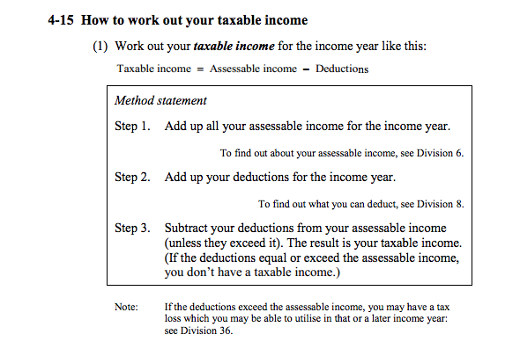

S 6-5 - Income according to ordinary concepts (ordinary income)

             (1)  Your [***assessable income***](http://www8.austlii.edu.au/cgi-bin/viewdoc/au/legis/cth/consol_act/itaa1997240/s995.1.html#assessable_income)includes income according to ordinary concepts, which is called [***ordinary***](http://www8.austlii.edu.au/cgi-bin/viewdoc/au/legis/cth/consol_act/itaa1997240/s995.1.html#ordinary_income)[***income***](http://www8.austlii.edu.au/cgi-bin/viewdoc/au/legis/cth/consol_act/itaa1997240/s995.1.html#ordinary_income).

Note: Some of the provisions about [assessable income](http://www8.austlii.edu.au/cgi-bin/viewdoc/au/legis/cth/consol_act/itaa1997240/s995.1.html#assessable_income) listed in section 10-5 may affect the treatment of [ordinary income](http://www8.austlii.edu.au/cgi-bin/viewdoc/au/legis/cth/consol_act/itaa1997240/s995.1.html#ordinary_income).

             (2)  If you are an [Australian resident](http://www8.austlii.edu.au/cgi-bin/viewdoc/au/legis/cth/consol_act/itaa1997240/s995.1.html#australian_resident), your [assessable income](http://www8.austlii.edu.au/cgi-bin/viewdoc/au/legis/cth/consol_act/itaa1997240/s995.1.html#assessable_income) includes the [ordinary income](http://www8.austlii.edu.au/cgi-bin/viewdoc/au/legis/cth/consol_act/itaa1997240/s995.1.html#ordinary_income) you [derived](http://www8.austlii.edu.au/cgi-bin/viewdoc/au/legis/cth/consol_act/itaa1997240/s995.1.html#derive) directly or [indirectly](http://www8.austlii.edu.au/cgi-bin/viewdoc/au/legis/cth/consol_act/itaa1997240/s995.1.html#indirectly) from all sources, whether in or out of [Australia](http://www8.austlii.edu.au/cgi-bin/viewdoc/au/legis/cth/consol_act/itaa1997240/s30.15.html#australia), during the [income year](http://www8.austlii.edu.au/cgi-bin/viewdoc/au/legis/cth/consol_act/itaa1997240/s995.1.html#income_year).

             (3)  If you are a [foreign resident](http://www8.austlii.edu.au/cgi-bin/viewdoc/au/legis/cth/consol_act/itaa1997240/s995.1.html#foreign_resident), your [assessable income](http://www8.austlii.edu.au/cgi-bin/viewdoc/au/legis/cth/consol_act/itaa1997240/s995.1.html#assessable_income) includes:

                     (a)  the [ordinary income](http://www8.austlii.edu.au/cgi-bin/viewdoc/au/legis/cth/consol_act/itaa1997240/s995.1.html#ordinary_income) you [derived](http://www8.austlii.edu.au/cgi-bin/viewdoc/au/legis/cth/consol_act/itaa1997240/s995.1.html#derive) directly or [indirectly](http://www8.austlii.edu.au/cgi-bin/viewdoc/au/legis/cth/consol_act/itaa1997240/s995.1.html#indirectly) from all [Australian sources](http://www8.austlii.edu.au/cgi-bin/viewdoc/au/legis/cth/consol_act/itaa1997240/s995.1.html#australian_source) during the [income year](http://www8.austlii.edu.au/cgi-bin/viewdoc/au/legis/cth/consol_act/itaa1997240/s995.1.html#income_year); and

                     (b)  other [ordinary income](http://www8.austlii.edu.au/cgi-bin/viewdoc/au/legis/cth/consol_act/itaa1997240/s995.1.html#ordinary_income) that a provision includes in your [assessable income](http://www8.austlii.edu.au/cgi-bin/viewdoc/au/legis/cth/consol_act/itaa1997240/s995.1.html#assessable_income) for the [income year](http://www8.austlii.edu.au/cgi-bin/viewdoc/au/legis/cth/consol_act/itaa1997240/s995.1.html#income_year) on some basis other than having an [Australian source](http://www8.austlii.edu.au/cgi-bin/viewdoc/au/legis/cth/consol_act/itaa1997240/s995.1.html#australian_source).

             (4)  In working out whether you have [***derived***](http://www8.austlii.edu.au/cgi-bin/viewdoc/au/legis/cth/consol_act/itaa1997240/s995.1.html#derive)an [amount](http://www8.austlii.edu.au/cgi-bin/viewdoc/au/legis/cth/consol_act/itaa1997240/s995.1.html#amount) of [ordinary income](http://www8.austlii.edu.au/cgi-bin/viewdoc/au/legis/cth/consol_act/itaa1997240/s995.1.html#ordinary_income), and (if so) when you [***derived***](http://www8.austlii.edu.au/cgi-bin/viewdoc/au/legis/cth/consol_act/itaa1997240/s995.1.html#derive)it, you are taken to have received the [amount](http://www8.austlii.edu.au/cgi-bin/viewdoc/au/legis/cth/consol_act/itaa1997240/s995.1.html#amount) as soon as it is applied or dealt with in any way on your behalf or as you direct.

* Constructive receipt rule^

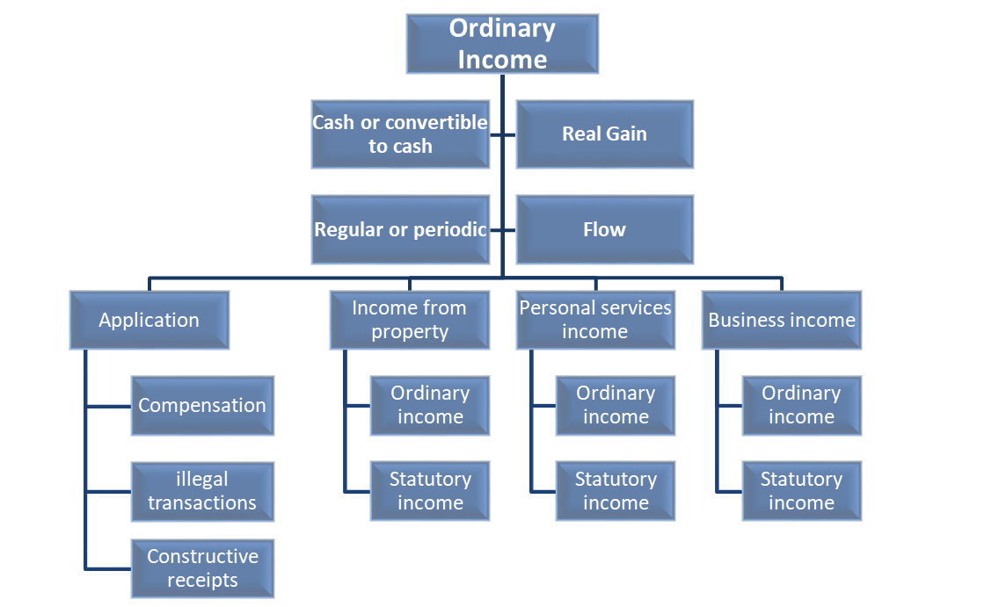

Interpretation of OI: s 6-5 ITAA 97

## Prerequisites and characteristics of ordinary income

* **Two prerequisites must be satisfied for OI**

1. That the gain must either be **cash or cash convertible (you can sell it):** *FCT v Cooke and Sherden* (1980)
2. That there must be a **real gain:** *Hochstrasser v Mayes* [1960]

* **In exam use this sentence:** \_\_\_\_\_\_\_\_\_\_\_\_\_ made a gain that is cash/cash convertible, and it was a real gain; thus \_\_\_\_\_\_\_\_\_ has satisfied the prerequisites of OI
* **Receipts that are not cash or convertible to cash are not ordinary income (remember this is a prerequisite)**
* The ordinary meaning of income contains a notion of gain that is money or convertible to money. The implication is that if some goods or services are received that cannot be converted to cash then there is no benefit to the taxpayer and therefore no ordinary income.
* **Eg** The **gain is** **not cash convertible where it is limited to your use and it cannot be used by third parties**
* **What the courts have said about ordinary income, some prerequisites: STEP 1**
* That the gain must either be **cash or cash convertible**: *Federal Coke Co. Pty Ltd v. FCT* (1977) 7 ATR 515; *Cooke & Sherden (1980)* and
* That there must be a **real gain**: *Hochstrasser v. Mayes* [1960] AC 376. This prerequisite is mostly applied to employment situations
* This principle is discussed in *FCT v Cooke and Sherden* (1980) 10 ATR 696; 80 ATC 4140) where it was held that amounts **that cannot be converted to cash are not income in ordinary concepts, and s 21 of the Act could not give a money value where the non-monetary consideration could not be converted into cash or the right transferred to a third party**.

**Prerequisite 1: Is it cash or cash convertible?**

Note: Parliament has introduced other provisions which bring some non-cash convertible amounts into assessable income, eg s 15-2 and s 21A (look at later). Application of FBT does not depend on cash convertibility.

CASE FOR CASH CONVERTIBILITY not cash convertible where it is limited to your use and it cannot be used by third parties:

|  |
| --- |
| *FCT v Cooke and Sherden* (1980) 10 ATR 696; 80 ATC 4140)  *🡪 Receipt of non-cash-convertible holiday (not OI)*   * TPs sold drinks door to door. * The TPs received a free holiday from the soft drink manufacturer as a result of them selling a certain number of drinks. * The holidays were **non transferrable** * **Could not be sold**. * **NOT OI**   Note FFC followed the principle in the English case of *Tennant v Smith* (1892) that because holidays not cash convertible could not be ordinary income |

|  |
| --- |
| *Tennant v Smith* [1892]   * The TP was an agent for a bank and lived in free accommodation supplied by the bank. The TP was not allowed to sublet the accommodation. * Neither cash nor cash convertible. Not OI. |

If gain is transferable, but can’t be sold = NOT cash convertible. Look to what gain is being received - frequent flyer points direct reward:

|  |
| --- |
| *Payne* (1996)  *🡪 FF points and free flights as a result were not OI (non cash benefit)*   * **Facts:** Janet Payne travelled regularly as a result of her employment with a large accounting firm. * Flights paid for by e’er as they related to business. She was offered to join FF program on one of these trips and she signed up and paid the fee. * She accumulated a lot of points over next few years, most resulting from business travel (minor part was private 3%). * **FC held** that the free flights earned were not OI. * The reason was that the tickets were not money or money worth and they could only be used by the program member or his or her nominee. * They could not be sold in any way or converted to money so they were not cash or cash convertible. |

**Prerequisite 2: Is it a real gain?**

Receipts that are not a real gain are not ordinary income

HL Reimbursement is NOT a real gain, this is merely compensation for a loss:

|  |
| --- |
| *Hochstrasser v Mayes* [1960] AC 376   * *Reimbursement for work-related loss when moving not assessable, not a real gain* * **Facts:** Reimbursement for work-related loss when moving not assessable, not a real gain * TP employer required him to move cities * TP sold his house in city he was leaving and received less than he had paid for it. The employer reimbursed him for the loss. * **Held:** House of Lords held NOT assessable * It was **not a real gain because he had just been reimbursed for work related expense**. * Receipt has to make taxpayer better off |

* What if it was not work related? Receipt then would have been a real gain
* **If employer gave TP extra to the price of the house, this would be a real gain; thus OI**

**Some characteristics of Ordinary Income**

* A gain that is **regular/periodic** is more likely to be ordinary income than a **lump sum:** *FCT v Harris*; and
* If something “**flows**” it is more likely to be ordinary income. Courts have used analogies with fruits and trees to illustrate this concept: *Eisner v Macomber* (1920) 252 US 189.
  + For instance, the sale of a business is the sale of the “tree”, so the gain is likely to be capital and not ordinary income. In contrast, everyday sales income or revenue from the business are the “fruits” that flow from the business tree and so are likely to constitute ordinary income.
* Income must have a **connection** with an earnings source/activity, other egs, income from providing services, income from owning property and letting others use it
* **OI comes into the recipient**
  + The amount must be characterized as ordinary income in the hands of the person who derived it
  + The character of the receipt is determined by reference to the person/entity who derived it. It is not determined by the character of the expenditure that produced the item

|  |
| --- |
| *Federal Coke Co Pty Ltd v FC of T* 77 ATC 4255   * **Facts:** Bellambi Coal Co Ltd coal produced (produced coke, fuel). This was done through its subsidiary companies, Fed Coke was one of these subsids producing the coal/coke. * Bellambi entered into many contracts for the supply of this material. * As result of downturn one Co that Bellambi contracted with, Le Nickel, could not pay full contract price. * 🡪 contract was varied and agreement reached to pay Bellambi $1m compo. * Bellambi received tax advice that the compo would be AI, so they arranged for the payment by Le Nickel to be made to FC instead * Commr assessed FC for the amount as income * **FFC Held:** not assessable income * 🡪 said that receipt not compensation because Le Nickel did not have any contractual obligations with FC that would have made them owe compensation * 🡪Lack of dealings between FC and LN meant could not be OI from dealings as business. * Therefore amount not assessable under section 6-5. * Had Commissioner assessed Bellambi not FC then amount could have been assessable in Bellambi’s hands, through the concept of constructive receipt (that they constructively received compo payment and redirected it to FC). * Constructive receipt concept found in s 6-5(4) * Taxpayer can be assessed on amounts have not actually received * s 6-5(4) includes amounts in a TPs AI that are deemed to have been derived ‘as soon as it is applied or dealt with in any way on TPs behalf or as TP directs’. |

## What is and is not income?

Income is:

* Real Gain
* Money or monies worth
* Generally Regular (but not conclusive)
* Reward for services (personal exertion)
* Return from capital and labour (business)
* Return from investment (property)

What is not ordinary income:

* Capital receipts
* Personal Gifts
* Chance winnings
* Income from recreational activities
* Non-cash receipts

## Compensation Payments

* First state: Whether compensation constitutes assessable income will depend on the nature of the compensation: *C of T (NSW) v. Meeks* (1915) 19 CLR 568. That is, compensation takes on the same character as what it replaces.
* Payments for the loss or sterilization of capital assets are generally capital in nature: *Glenboig Union Fireclay Co Ltd v IRC* (1922); *Burmah Steamship Co v IRC* (1930)
* Difficulties arise where the compensation is for unliquidated damages and the capital and revenue components cannot be identified. In such a situation the Australian courts will not attempt to apportion the amount into revenue and capital components: *McLaurin v FCT* (1961) 104 CLR 381, 8 ATR 180, 12 ATD 273.
* In essence, the Australian courts will treat the whole compensation as a capital payment as long as it contains some portion of capital, no matter how small that portion may be.

## Mutual receipts are not income

* A basic concept of income is that it must “come in” which means that it must be derived from some outside source. Although it may seem obvious, therefore there will not be any ordinary income if the taxpayer is dealing with themselves.
* Similar to this is the notion that an organisation cannot derive income from itself. For example – think of a club that is carried on by its members for its members. If the members contribute financially to the club for an event and there is a surplus, this surplus will be given back to the members through the fund and is not income.
* See RACV Club v FCT (1973) – income from providing breakdown services etc, is not assessable as provided only to members

## Constructive receipts - The amount must be characterized as ordinary income in the hands of the person who derived it

* The **character of the receipt is determined by reference to the person/entity who derived it.** It is not determined by the character of the expenditure that produced the item**:** *GP International Pipecoaters v FC of T* (1990) 170 CLR 124, 136;*Federal Coke Co Pty Ltd v FC of T* 77 ATC 4255**.**
* In *Federal Coke* the issue of a constructive receipt was also raised. **For example, if the taxpayer directs her employer to pay part of her salary to her husband, this amount is still ordinary income of the employee as a constructive receipts**.

## Illegality

* The fact that a receipt is from an illegal activity, does not mean it is not assessable. It is assessable provided it would have been assessed if the activity was legal. For example, assessed on proceeds of drug dealing (we also come back to this when consider deductions and *La Rosa*).
* **Legislation has changed, illegal material no longer deductible**
* Getting money from illegal transactions still constitutes ordinary income, illegality does not affect assessable income: *Lindsay v IR Comms**and TR 93/25*

## Income from personal services

* An amount will be "ordinary" personal exertion income if it is a product or incident of the employment of the person or a reward for services rendered by the person.
* An amount is ordinary income, and therefore may be included as assessable income under s 6-5(1) ITAA97, if there is a sufficient **nexus** between the amount and an earning activity.
* Amounts earned directly or indirectly by virtue of personal exertion will constitute ordinary income (commonly referred to as income from personal services): *Moorhouse v Dooland* [1955] 1 All ER 93
* In characterising an amount, the court will not confine itself to the form of the supporting documentation, but rather will look at the **whole of the circumstances surrounding the receipt**.
* As long as the remuneration shows a nexus to the labour of the taxpayer, it does not matter whether the remuneration is for past, present or future services: *Hochstrasser v Mayes* [1960] AC 376;
* Nor **does it matter that it is paid by a third party**, rather than the recipient of the services: *Kelly v FCT* (1985) 16 ATR 478

**Nexus with services**

Establishing that there is a nexus between amount received, and the work or services performed, is essential! You need to establish this to determine that the receipt is ordinary income (s 6-5)

**Steps to assist with personal services vs gift/capital/prize**

1. **Note the prerequisites**
2. **Identify the work or the service that is being performed**.
3. **Discuss whether the payment**/goods etc **was given as a result of those services** being performed.
4. Use **cases to support your argument**

* You can also query whether the receipt arose out of any other circumstances:

|  |
| --- |
| *FCT v Harris (can also use re gifts)*   * Mr Harris was a retired bank employee * Received one off payment $450 from bank as a ‘pension top up’ to reduce effects inflation * Majority of FFC held that not a product of past, current employment and not OI – not related to length or quality of past service, and no current employment * Also stated was once off, which was not determinative but a consideration * NB may be assessed 27H statutory income (cover this later) |

* We then can consider some specific categories within personal services income which assist us:
* A: Gift v OI 🡪 **A GIFT IS NOT OI**
* B: Prize v OI 🡪 **A PRIZE IS NOT OI**

## Gifts

Gifts are voluntary payments made to a TP

* In contrast to earned income, **receipts received as a gift are not earned and are therefore not income in ordinary concepts** but are a windfall gain (not earned): *Scott v. FCT* (1966) 117 CLR 514
* The distinction to be made between earned income and gifts relies on characterising the receipt as either a reward for services (income) or a receipt resulting from the personal qualities of the recipient (gift).
* Payments made by **parents to their children** (provided they are not for work performed) are gifts and therefore not assessable as ordinary income.
* In contrast, a Christmas bonus paid to employees is income in ordinary concepts (*Laidler v Perry* (1965) 2 All ER 121), as are “top-up” payments received that are regarded by the taxpayer as income: *FCT v Dixon* (1952) 5 AITR 443; 10 ATD 82.
* **Look to *Scott* and *Hayes* to determine gift.**

These are cases about “voluntary payments” (similar in nature to a gift) and whether there is a nexus with the provision of services – if so OI.

**Factors to consider re gift v Payment for personal service (OI)** - NOTE: no factor is determinative, all assist in making conclusion

* Expectation of the gift: *Scott v FCT* (1966)
* Lump sum or regular payments: *FCT v Blake* (1984)
* Motive of the donor: *Scott v FCT* (1966)
  + But, nature of receipt in hands of recipient is more impt: Scott v FCT (1966) Connection earning activity?
* Whether the recipient has been fully remunerated for services provided: *Scott v FCT* (1966)*; Hayes v FCT* (1966)
* Personal relationship: *Scott v FCT* (1966)*; Hayes v FCT* (1966).

|  |
| --- |
| Laidler v Perry  *🡪Xmas bonus was OI where nexus created between gift and the employment*   * Christmas bonus in the form of a voucher was paid to all past and present employees, the voucher could be redeemed for goods * Paid to all staff regardless of pay rate and attached to voucher was letter of thanks for services * **Held** to be income as it arose out of employment, and did not arise out of anything else (like a personal relationship). * Note likely covered by FBT– voucher treated as a FB |

|  |
| --- |
| FCT v Dixon   * *Top up payments if enlisted for WWII were OI* * **Facts:** Employer offered e’ee top-up payments to employees they enlisted in WWII. The payment was the difference between their former salary and their military salary. They would have to cease working for him when join military * Held to be OI. Why? * **Majority Held**: OI as it was **regular, expected, depended upon** by the TP * Other judge said because compensation for lost salary and therefore OI * Dixon’s case is relevant because it shows an amount can be OI where there is no earnings source/activity provided it is regular, expected and relied upon by the taxpayer   + Other examples – cases re Govt payments – Keily (pension) and Anstis (youth training allowance) |

|  |
| --- |
| Scott v FCT   * *Characteristics of a personal gift – Held was a gift* * **Facts:** £10,000 paid by a client (Mrs Freestone) to Mr Scott (solicitor) was not OI because it was a personal gift. * Scott was solicitor for many years, friends with husband and family, business associates. In this matter related to estate when husband passed. * Scott played important role in administering estate and sale of properties, had restrictions lifted, increased value of site. * **Bill of costs prepared by Scott for the work done in relation to estate and this was paid**. * **HOWEVER, before paid, Mrs F told Scott she wanted to give him a gift (one of many) from the estate (sale of property**).   **Held: Not OI.** Why was it not OI? – Indicia of a gift   * Character of receipt is assessed in hands of TP * Must be product of activity or services to be OI. In that sense, if it is a product of friendship etc will not be OI as no nexus * Prior personal relationship before payment * Full remuneration for services * Unexpected * Donor also made other gifts at same time * Motive of donor not determinative but consideration * **Don’t pick one indicia, discuss as many as possible** and give weight to each indicia where necessary |

|  |
| --- |
| *Hayes v FCT HC Case*   * *Characteristics of gift – Held was a gift* * Two friends working together directing Pty Ltd Co. * Hayes was supervising and gen accountant for Mr Richardson business (meat and small goods). * Mr R business taken over by a Co of which Mr H was director, secretary and s/h. Mr R eventually gained control of the entity * Mr H eventually sold his shares to Mr R but remained a director and secretary. * **Co became very successful and was listed as public co. Mr R was allotted a significant amount of shares and he transferred 12,000 of these to Mr H**   **HC said that it was a gift and not OI**  Consider?   * Nature of relationship (personal) - **Much emphasis place on the preexisting nature of relationship** (personal). Personal relationship, and not solely work based * Reward for services or employment? (no, he was fully paid for his services already) * Fully paid for his services already * Held NOT OI |

|  |
| --- |
| *Brown v FCT*   * *OI where reward was primarily for the services that were provide by TP* * **Facts:** TP received free from property developer beachfront apartment with all costs paid for * Total value about $1m * **TP played an important role in success of major property development** 🡪 he introduced purchaser to developer amongst other things (was quite involved) * Helped with marketing the sale of properties * Helped with developers relationships with purchasers * TP **argued that it was a gift and given out of friendship and not OI** * Commonwealth said that was received as result of the services provided and there was a nexus, and it should be assessed as OI.   **Held**   * Full Federal Court agreed with Commonwealth that it was OI * **Benefit provided** to TP was **primarily a reward for the services he provided** * **Nexus established because the reward would only be forthcoming if deal was finalized** * There was no prior remuneration |

**Things to consider re gift v PS income. NOTE: no factor is determinative, all assist in making conclusion**

* Whether expected (Scott)
* Lump sum v recurring (Dixon, Scott, Harris)
* Motive of donor (Scott)
* Prior remuneration (Scott, Hayes)
* Personal or other relationship (Scott, Hayes)

## Prizes & gambling

* The winnings of gamblers will be a windfall gain unless the gambler is in the business of gambling: *Babka v. FCT* (1989**)** 89 ATC 4963. *Prince v FCT* (1959) 12 ATD 45.
* **Example:** It follows that the **winnings of a bookmaker are income, and that the winnings of a casual punter will be a windfall gain.**
* For prizes to be OI they **generally need to be earned as a result of a business activity**, or the level of skill required outweighs the element of chance or luck.
* **Prize for business activity = OI**
* Need to satisfy business indicia (carrying on a business & scope of the business)
* **Skill > chance in personal services = OI:** *Kelly v FCT*

|  |
| --- |
| *Babka*   * *Can also apply in business category as well as personal services – Not OI where there was more chance than skill and not business apparent* * **Facts:** On retiring (age 51) TP commenced spending large amounts on gambling * Mainly horse racing but also some other activities * He had no employees, no office – bet at home * **Comm said he was in the business of gambling because had no other income and that he also kept detailed records and was organised with betting system\** * **Held:** Not in business of gambling – just because devoted large amount of time and were organised does not make it income from business * **Winnings of a casual participant in a television game show are not usually OI as ‘chance and luck’ generally greater than skill: *Case 37*** |

|  |
| --- |
| *Kelly v FCT*   * *Professional sportsperson prize - Held OI* as it is directly related to employment as a footballer and awarded because of skills and ability – Can be paid by unrelated 3rd party * **Facts:** TP played football at high level WA competition * Paid fixed amount for each match played * There was upcoming award for ‘best and fairest’ (Sandover medal) like the Brownlow * Prior to award being announced a local TV station said they would pay $20k to winner of the award * TP won the award and received the $20k * **Held:** Court held that was OI: * Directly related to his employment as footballer * Even though unexpected and once off * **Did not matter that paid by an unrelated third party** * He was only eligible because he was member of club and he was awarded prize because of his skills and ability * IfKelly **played as a hobby** this case may have had a different outcome * If there is a contract, it strengthens the argument that the prize is characterised as OI as it relates to their skill to receive the prize |

**Some things to consider re professional sportspeople? We come back to this in business category.**

* Degree of professionalism
* Reward for services or personal qualities
* Paid before or after service
* Related to contract?

## Capital receipt or personal exertion?

* **Capital receipts are NOT OI**
* Distinction is generally concerned with whether amount is reward for services (OI) or payment for giving up a capital right (C).
* Don’t just look at the terms of the agreement – consider the surrounding circumstances.
* Use cases to support argument
* **A gift is not subject to CGT**
* For capital assess whether the capital is for lost income (OI), or for giving up a capital right such as a ROT agreement (CGT)
* CGT classification last resort

## Restrictive Covenants

* Agreements made by taxpayers entering into restrictive covenants have also been problematic for the courts.
* **Generally, if the restrictive covenant operates outside the employment period of the taxpayer, any amounts received are treated as capital, as compensation for the loss of the right/or restricting the right to work. *Higgs v Olivier* [1952], Ch 311, *FCT v Woite* (1982) 82 ATC 4578.**

|  |
| --- |
| *FCT v Woite*   * *Restrictive covenant on entering into a contract NOT OI but capital – Held NOT OI* * TP was footballer who played for SA team. * He received $10,000 from North Melb club *to not* play football with any other Victorian club other than NM. * The contract did not require Woite to play for NM, unless he decided to move to the Vic league but he never did   **SCSA held NOT OI**   * Payment from NM was not a payment for services but a capital payment. * He gave up capital right to work for any other club in Vic other than NM * Position if he then followed through and signed up to play with NM? Maybe OI because related to future services |

|  |
| --- |
| *Hepples*   * *Restrictive covenant was capital – Held NOT OI* * **Facts:** TP was paid $40,000 on retirement for agreeing not to disclose secrets of his employer * **Held:** Receipt was clearly NOT a substitute for income, and was a capital payment for entering into the restrictive covenant * The **RC was not separate to any employment contract Hepples had** |

.

|  |
| --- |
| *Brent v FCT*   * *Service or capital rights?* – if the service is ongoing, more likely to be OI – services of telling story of crime to journalist consistently * **Facts:** Mrs Brent was wife of infamous criminal and arrested in Melb where they lived together * After arrest was approached by Daily Telegraph 🡪 agreement 🡪 required her to be available to tell her story to staff etc. for publication * TP argued payments she received from newspaper were capital amounts – giving up “property rights” in her story * **Held:** HC said earnings were OI * It was payment of services – not for giving up valuable rights – she sold service of giving her story and did not give up any capital rights – no “property” (eg, IP) in her story of any kind |

|  |
| --- |
| *Bennett v FCT*   * *Relinquishing employment rights* * **Facts:** TP employed as managing director of company he effectively controlled * His original contract terminated * He was reappointed with same remuneration but relinquished certain rights he previously had * One of these rights was absolute control of Co. * To compensate, Co. agreed to pay him 3 payments over 2 years. * **HELD:** Not OI was capital * Why? * Was for removal of rights under contract * Applied the **compensation principle** * Tax treatment of compensation depends on what payment replaces * Because payments not replacing loss of income (if so would be OI), but were replacing right to control company (asset), they were capital. * Position may have been different if TP took a pay cut when reappointed – payment may have been treated as replacing lost income. |

|  |
| --- |
| *Jarrold v Boustead*   * *Capital if agreeing to a status prevents rights once carried with the previous status (amateur footballer to professional footballer) – Held NOT OI* * **Facts:** Amateur rugby player paid 3000 pounds as a sign-on fee to join a professional rugby club and give up his status as an amateur player. * At this time (1963) there was a chance that he could become international player at amateur level, so there were advantages to remaining amateur. * Payment an inducement to give up right to play amateur rugby. * **Held:** Receipt was capital * It was giving up the right to play amateur rugby * Was NOT a payment for future services |

***Sign-on Fees can be OI***

* Fee paid by an employer to induce sportspeople or employees to enter into a services contract, e.g. contract of employment.
* Giving up right to work elsewhere.

In this situation payment less likely to be capital and more like a payment for future services

* Similar situation to Pickford v FCT – payment for giving up entitlements of old job (compensation) and take up new job with new employer
* Held to be OI because it was an incident of TPs employment with new employer

## Revision questions

**1. Bearing in mind the concept of ability to pay and equity between taxpayers,** **which of the following items would you see as income and therefore subject to tax**:

(a) an employer pays for an employee’s child’s private school education - No, the payments are made directly to the school: Is not cash or cash convertible (likely fringe benefits – see later topics)

(b) finding $10 000 buried under a railway bridge – It is cash, a real gain, however it is a lump sum and has no connection with an earning source.

(c) being paid for giving up your right to practice your profession – No, RC, meets prerequisites, it is a lump sum, it does not have a connection with a earning activity/ source, it is a capital gain: *FCT v Woite*

(d) goodwill on the sale of your business - CG

(e) gain realised on the sale of property purchased with the intention to sell it at a profit - CG

(f) gain realised on the sale of your private home – CG (however special provision applies so that a family home doesn’t cop CGT)

(g) gain realised on the sale of property acquired as a long-‐term rental investment - CG

(h) increase in the value of property not yet sold – No effect

(i) gambling winnings – No, windfall

(j) prizes won from a competition involving skill (eg. musical competition) – Yes: *Kelly v FCT*, arguable that it is not if it is a one off.

(k) prizes won by a professional sports person – Yes, *Kelly v FCT*

(l) gifts from a family member – No.

(m) gifts from a business associate – Is it payment for services or a gift?: *Hayes* and *Scott* – see factors above at “Gifts”.

(n) sale of shares in a public company – OI.

2.Consider the following situations and **discuss whether or not they are income in ordinary concepts**:

* A cash prize for being the best student in income tax law received by a student who also receives a Youth Allowance from the government. Cash prize *- Cash and a real gain, but it is a lump sum that does not have a connection with a earning activity.* Youth allowance *– Is cash but no connection to a earning activity, but it is regular and expected, also relied upon: Dixon*
* A gratuity (not being superannuation) received by a widow from her husband’s former employer in recognition of her husband’s services. - *It is akin to a one off payment for services (CG), as the wife has not provided any services to the husband’s former employer. Note if the payment was more than one look at whether they are regular, expected and relied upon (stream of income).*
* An honorarium received by a student for acting as honorary secretary of a small country town football club. *- Unexpected gift for services. It is a voluntary engagement so there is no expectation of payment. Arguably doing it in a personal services. No clear connection with an earning activity here.*
* A bonus received by an employee for a suggestion adopted by the management. *- OI*
* $50,000 received by Matthew from his sister. His sister earns $100,000 a year but directs that half of her salary be paid to Matthew. *- S 6.5 (4) If amounts are paid on someone else’s direction than those amounts are treated as OI.*
* Receipt of a non-‐transferable holiday valued at $3,000 given to an accountant as a work bonus. *- Not OI, but is statutory income (s 15.2 <not sure of section).*
* Compensation of $10,000 paid to an employee who was bullied at work. The $10,000 represented 3 months’ salary/wages. - *Compensation depends on what it is replacing, if it is replacing: Dixon. OI than the compensation itself is treated as OI*

3. Sam and Kim had been friends since their primary school days. Sam and his wife and Kim and her husband would regularly have dinner together. Every year when Sam’s birthday comes around, Kim would always buy him a present, usually worth between $100 and $150.

Sam is an obstetrician at a public hospital. When Kim was giving birth, Sam was the obstetrician on duty to deliver her baby. Her birth was subject to complications, and it was only Sam’s excellent medical skill that saved the baby’s life. A month later, when Sam’s birthday came around, Kim bought him an expensive watch valued at $6,000. She also gave him a card which included the message “Thanks for being a great friend and life saver”. She also gave the two nurses who assisted Sam in delivering her child necklaces worth $1,000 each.

**Ignoring Capital Gains Tax, discuss whether Sam’s receipt of the watch constitutes assessable income**.

*Regular gifts in a personal regard, but not of this amount. The words on the card suggest that the gift is not just solely in a personal regard. There were similar presents to other parties (nurses) which suggest it should be treated as OI. No right answer, could argue either way (remember to cite cases)*. *Context is similar to Scott but this is not payment as well as remuneration.*

4.(Sadiq et al, Principles of Income Tax) Jane and Sally are employed school teachers who have a very wide general knowledge. Both decide to enter a television quiz program called ‘‘Lease of the Decade’’. Under the rules, contestants receive $100 for each appearance, but if questions are answered correctly, they receive substantial cash prizes and other prizes, such as household items and holiday packages. The holiday packages cannot be transferred or redeemed, but the organisers of the program allow them to be converted into alternative venues and accommodation.

Jane and Sally go on the show but Jane is eliminated in the first contest and receives her $100. Sally, however, makes 10 appearances. She wins cash prizes of $50,000, household appliances worth $20,000 and a trip to Europe with her family valued at $30,000.

**Discuss the assessability of these prizes.**

*Jane: Terms of contract payment for services (appearing on the show), at least $100 each appearance, therefore OI. If it was just the once appearance, with no contractual guarantee of payment the case would be different.*

*Sally: $100 same as Jane. Trip to Europe is not cash convertible (CG). Additional cash prizes were not contractually guaranteed, uncertain. Each appearance for extra cash prize was at a chance. Arguably not exploiting a skill?*

**5.** George is a manager at Wollongong Steel Ltd. His employment contract is for 10 years. In the third year George‘s position at the company is made redundant, and his employment terminated. George enters into a restrictive covenant with Wollongong Steel Ltd which provides that:

(a) in return for a payment of $40,000 he agrees not to disclose any trade secrets of his employer to any other person; and

(b) in return for a payment of $200,000 he agrees that he will not work for a competitor for a period of 18 months after his employment with the company ends.

**Are the payments received under the restrictive covenant ordinary income in George’s hands?**

*A: CG: Hepples*.

*B:CG: Higgs & Olivier:* *Contract not to work in an area for payment. Not a rewards for services, an amount received for giving up a right. Effectively giving up a right (which is an asset) for payment.*

6.Neil French and his wife moved to Melbourne after he signed a three year contract to play with Thunder Rugby Club (TFC).

He was given a base salary package of $400,000 a year, half of which he requested be deposited into his wife’s bank account.

The TFC also agreed to pay Neil $100,000 for him agreeing not to undertake any promotional or marketing activities during the life of his contract, other than those approved by TFC.

**Discuss whether the above receipts are likely to be Neil’s “ordinary income” under general concepts.**

Half salary deposited in wife’s bank account: *His salary is clearly OI and assessable under s 6.5 (4)*. *He still has effective control, and he has directed it, the entire sum will be treated as his OI.*

RC: *Term of employment contract. Paying the amount in the course of his services to the club. Should be treated as OI and assessable under s 6.5. It is common for the employer like a football club to regulate marketing activities.*

# Topic 2: Ordinary Income – Property

* Ordinary income from property:
  + Interest
  + Dividends
  + Rent and lease income
  + Royalties
  + Annuities
* Income (being the fruit) flows from capital (being the tree).
* In the context of property…

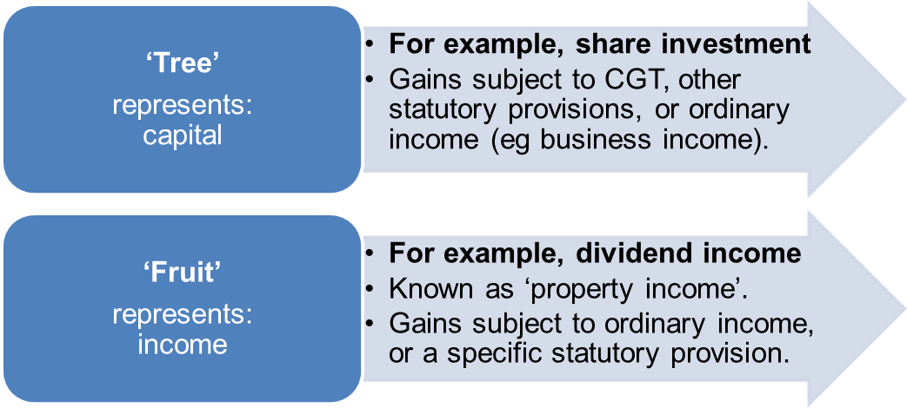

## Interest

* Cost of borrowed funds
* Return on investment
* Note not specifically defined in legislation
* Interest will therefore generally sit as 6-5 OI when received, and we look to it again for the purpose of deductions.

**Interest on compensation**

* *Whitaker v FCT* (1996) – pre-judgment interest - capital
* Post-judgment interest – s 51-57 exempt

|  |
| --- |
| *Whitaker v FCT* (1996)   * *Pre judgment interest is capital and not OI as it is considered compensation for an injury, unless compensation for lost income* * **Facts:** TP awarded compensation of approx $880,000 following surgery which let her blind * Awarded pre judgment interest of $65,000 and about $288k post judgment was unpaid for some time * Commissioner included both as assessable income (OI) * On appeal FFC said that pre-judgment interest was seen as part of compensation for injury and capital in nature * Post-judgment interest was OI as paid for delay in payment of compensation for injury * **Contrary to *Whitaker*, ss 51-57** now changed the position with respect to Post judgment – this was because it wouldn’t be fair to tax someone for the interest of money they were entitled to * **Assess what the compensation is for if it is clear what the compensation is for:** * **If it is compensation for lost of wages/income/salary:** OI * If it is compensation **for loss of capital right (losing sight/business):** Capital * **Note that if the compensation is an undissected lump sum (where it isn’t clear what amount of the compensation is precisely for, it is to be considered as capital: *McCauley*** |

* S 51-57 now changed the position with respect to post-judgment interest - **exempt up to end of Court process (incl any settlement) – but OI from then until date of receipt**

## Dividends

* **Clearly within ordinary income** s.6-5 definition; but also statutory income under s.44 (ITAA36)
* Paid to shareholders from company profits.
* Note specific statutory provision has precedence over ordinary income
* In exam, don’t launch into OI prerequisites etc., **simply state that dividends are SI pursuant to s 44 ITTA36**

## Annuities

* An **annuity is a stream of payments that occur at regular intervals and may be for a fixed length of time** (or life) of individual. An annuity may be purchased.
* May be fixed term or life.
* Under case law **the full amount of the regular annuity payment is regarded as ordinary income: *Egerton v. Warburton v. FCT* (1934) 51 CLR 568**
* **HOWEVER,** This **produced an unfair outcome** as **only part of annuity might be a real gain** (in effect it is return on capital). **Legislation was then enacted (27H ITAA1936) which makes return of annuity capital component tax free**.

## Royalties

* A royalty payment is a payment that is calculated based on the usage of intellectual property or quantity/value of a substance taken: *McCauley v FCT* (1944)
* Flows from intellectual property - payment for rights over property   
  - e.g. copyright - right to publish music
  + *McCauley v FCT* (1944), *Stanton v FCT* (1955)
  + Importance of relationship to quantity
  + Sec 15-20

|  |
| --- |
| *McCauley v FCT* (1944)   * *Royalty is apparent where payment is for the usage - paying to remove timber from land is royalty.* * **Facts:** TP was dairy farmer who owned land with trees on it * TP entered into an agreement where Laver would cut and take down trees from TP land * Laver was to pay TP an amount based on quantity of timber that had been cut and removed * **HC held:** Was royalty as payment related to the amount of timber removed |

|  |
| --- |
| *Stanton v FCT* (1955)   * *Predetermined amount may be capital and not a royalty as license defined by form not substance* * **Facts:** TP was a farmer who granted saw miller the right to come on to his land and remove timber in exchange for a predetermined sum which was paid quarterly * Agreement also stated max amt timber that could be removed and reduced payments if less * **HC held:** Not a royalty but was capital, and the agreement expressed it as a predetermined amount. They defined by form rather than substance. |

* Section 15-20 deems royalties to be assessable as statutory income, but only if royalty is not OI.
* But to be a capital royalty, payment must be calculated on basis of usage.
* So which ones will be OI? Royalties that are a product of exploiting IP will constitute OI, but where relates to physical resources, more likely capital royalty.
* But arguable these are OI.
* Case law on what constitutes a capital royalty unclear. But if the amount is varied, then the amount will be treated as capital.

# Topic 2: Ordinary Income –Business

* Gains arising from carrying on a business constitute ordinary income (s 6-5).
* Gains from non-business activities (e.g., a hobby or pleasure activities) are not assessable income, unless:
  + Another general concept of ordinary income applies (e.g., extraordinary and isolated transactions – look at later); or
  + Specifically made assessable by legislation (i.e., statutory income).
* The main issues relevant to business activities and the definition of income in ordinary concepts are:
* identifying when a business is being carried on
* identifying business income
* Identifying what the scope and ordinary proceeds of a business are.
* **Apply case law to reinforce whether party carrying on a business**
* Inclusive definition – not exhaustive
* Look to cases to determine whether or not a business is being conducted.

1. ARE THEY CARRYING ON BUSINESS: ***Ferguson***
2. IS AMOUNT WITHIN SCOPE OF BUSINESS (**Narrow approach =** ***Merv Brown*, broad approach = *GP International***)

* IF NOT, MAY STILL BE BUSINESS INCOME WHERE IT IS AN ISOLATED (***Whitfords***)/EXTRAORDINARY (***Myer***) TRANSACTION
* It is necessary to determine when a hobby or recreational activity becomes a business:
* Legislative definition of a “business” (s 995-1):
  + “Includes any profession, trade, employment, vocation or calling, but does not include occupation as an employee”.
* Definition adds to general meaning of business – it is still necessary to ascertain the ordinary meaning of the word “business” due to broadness of legislative definition.

## Step 1: Carrying on a business:

## Indicators of a business activity

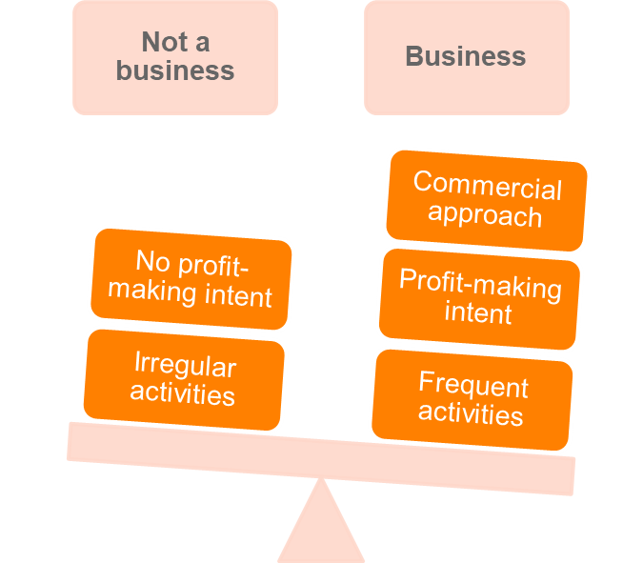

**Common business indicators considered by the courts**

* Whether there is a **profit-making intent**:
  + Not necessary to show actual profit to show intent
  + Lack of profit-making intention doesn’t necessarily preclude there being a business: *Stone v FCT* (2005).
* **Scale of activities**, including the nature and type of capital and level of turnover:
  + Small operation can still constitute a business if there are sufficient other characteristics: *FCT v JR Walker* (1985).
* **Commercial approach** is taken:
  + Whether professional advice is sought before or during activity
  + Exploration of markets
  + Whether the production is more than needed for domestic purposes: *Thomas v FCT* (1972).
* **System and organisation** employed
  + Degree of planning and amount of time invested
  + Record keeping
  + Taxpayer may delegate these duties and still be considered a business: *Ferguson v FCT* (1979).
* **Methods characteristic** of the particular line of business
  + Business practices consistent with industry.
* Sustained and frequent activity
* The type of activity and the type of taxpayer.

|  |
| --- |
| *Ferguson v FCT* (1979)   * *Indicia of a business being carried on* * **Facts:** TP planned rural cattle business * At the start of this, he leased a small number of animals to breed (5 females for 4 years and a bull) * TP said was running a business * Commr said not business as was preparing for future business * **FFC held:** That was a business even though small and preliminary to intended future business   Court considered:   * Purpose profit making (important but not essential) * Repetition and regularity is a consideration but it was also noted that a business could involve a single transaction (businesses have to start with a single transaction) * Organisation and a business-like approach with appropriate record keeping indicates business activity * Having other sources of income does not preclude operation of a business * Size of operation and capital investment are relevant, considered in context of activity * Court concluded activities were more than just minor preparation for future business |

Other decisions illustrating application of indicators: JR Walker (1985); Thomas (1972)

## Hobby or Business – Gambling, Sportspeople, Investment Activities & Land Sales

**Hobby or business - Gambling**

* Professional bookmakers and casino operators carry on a gambling business (scale, commerciality, and profit-intention).
* Individuals who gamble are very unlikely to be considered a business, unless a significant degree of indicators exist, for example:

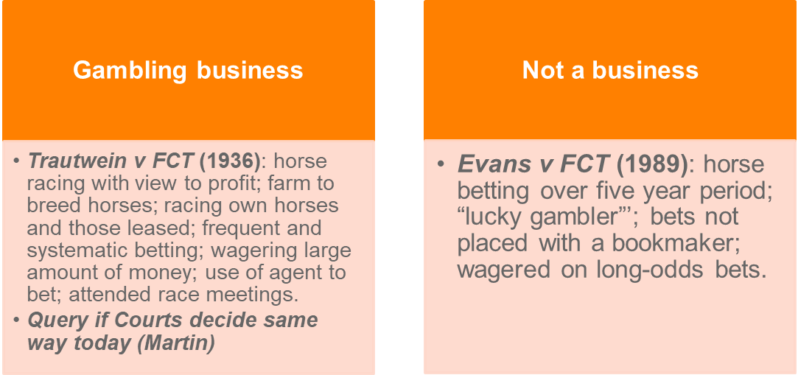

|  |
| --- |
| *Evans v FCT*   * *Large volume of betting/money is not indicative of carrying on a business, there needs to be a systematic approach* * Won about $430k on punting in a year * **Held not to be in business even though made large sum of money** * Large volume betting not sufficient * To be classified as **business likely need systematic record keeping and higher level of organisation** |

**Hobby or Business – Sportspeople**

* Important to determine whether the receipts derived by a professional sportsperson is from a business or personal services:
  + An employee has limited deductions compared to a business.
* Courts have **tended to more likely label professional sportspeople as being in business**:
  + Olympian (also a full-time police officer) derived among other things: prize money, sponsorship and appearance fees. No clear profit motive: *Stone v FCT* (2005).
  + Playing football full-time, sports managers (representatives), ancillary activities such as endorsements and media arrangements: *Spriggs v FCT; Riddell v FCT* (2009).

|  |
| --- |
| Stone v FCT   * HC – Sponsorship deals/managers in sport hobbies may amount to the hobby being characterised as a business = OI * Stone was world class javelin thrower * Also employed FT with the QLD police force * She competed in national and international competitions and was selected for Olympic team * **During FY ended 1999 she earned approx $136,500 from javelin (prize money, grants, appearance fees and sponsorship)** * She also had a manager for a short time * **Issue:** Hobby (no OI), or business (OI)?   **HC held that Stone was COB**   * Although no profit making motive this did not preclude business * Sponsorship deals given weight in coming to this conclusion |

|  |
| --- |
| Spriggs v FCT; Riddell v FCT (2009)   * Professional team sportspeople COB * Both played professional football and arranged for their managers to negotiate new contracts when changing clubs * Following negotiation, managers charged them a fee which they sought to deduct * Would only be deductible if business   **Held**   * **Court distinguished *Maddalena* case** (which said that were employment activities) and confirmed COB * **Were carrying on a business** * The fact that **they had managers – it demonstrated they have approached the sport “hobby” in a business-like manner** |

**Hobby or Business – Investment activities**

A business of investment can exist where there is a sufficient indicators of business

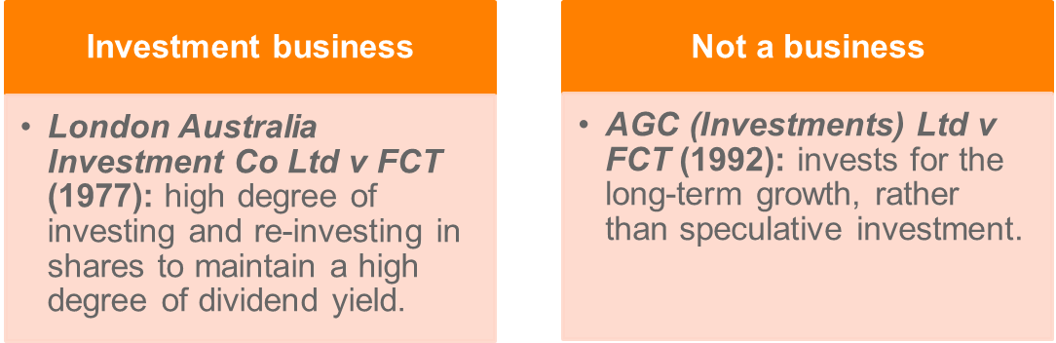

Taxation consequences:

* If a business, the investment (eg, shares) will be treated as trading stock and hence on revenue account.
* If not a business: the investment is on capital account, investment itself is a tree, any income (fruit) from the investment treated as ordinary income (or in case of dividends, statutory income).

**Hobby or Business – Land sales**

Proceeds from sale of land or capital?

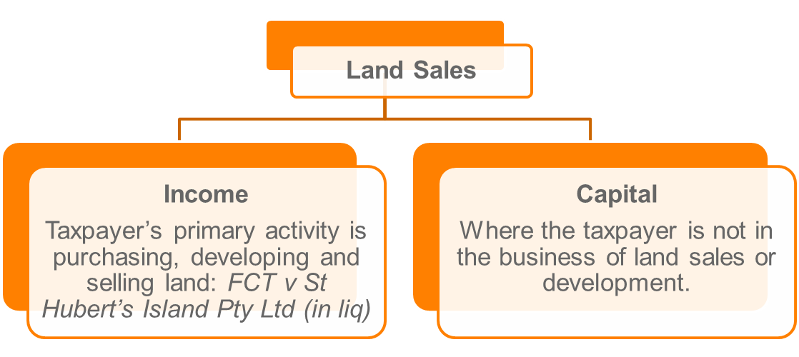

* Note, notwithstanding a *prima facie* capital characterisation, activities of land development could constitute an extraordinary or isolated transaction.

## Commencement of a business

Necessary to identify the time when the business commences:

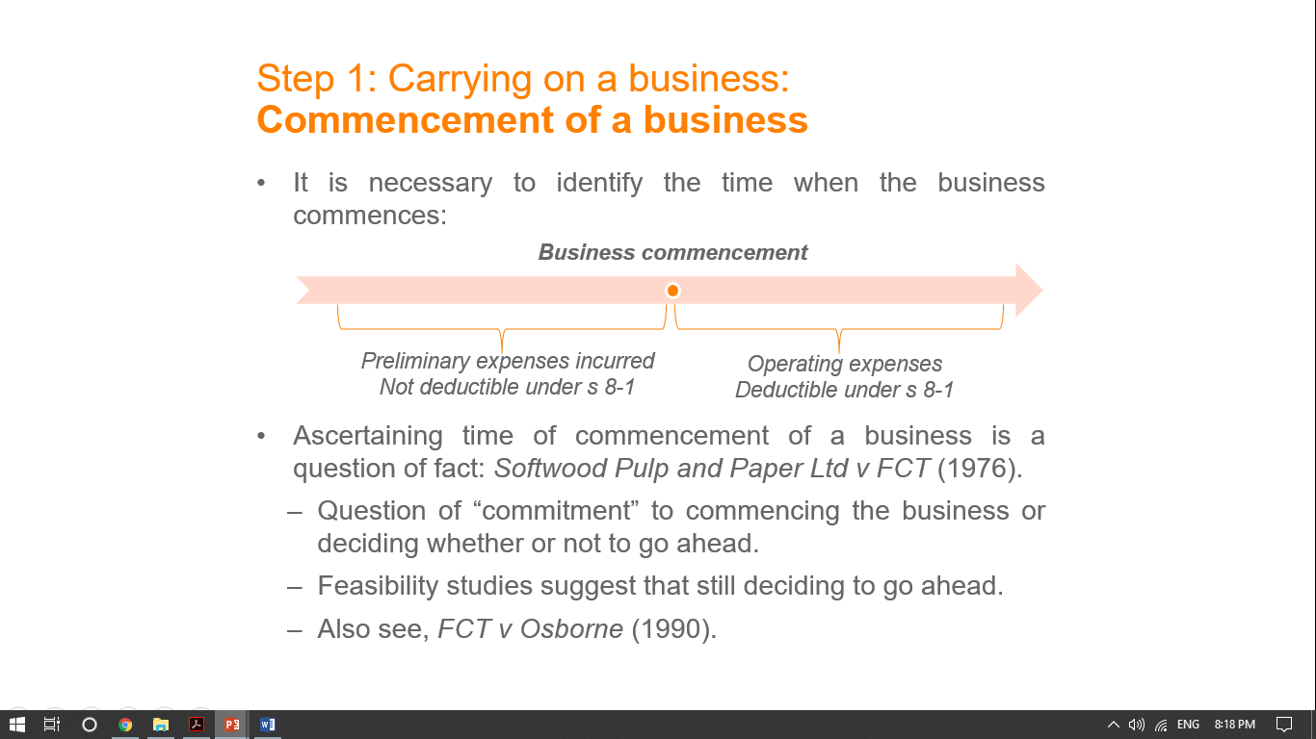

A receipt from the normal proceeds of business

Characterising a receipt as part of the normal proceeds of the business requires:

1. An investigation of the **nature** of the business; and
2. Assessing whether the receipt has a **nexus** with the identified business activity.

## Step 2: Normal proceeds of a business Nature of the business

A receipt from the normal proceeds of business

Characterising a receipt as part of the normal proceeds of the business requires:

1. An investigation of the **nature** of the business; and
2. Assessing whether the receipt has a **nexus** with the identified business activity.

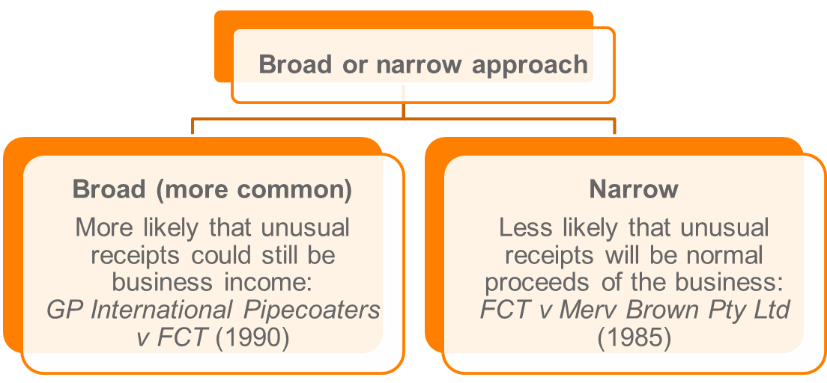

* Broad approach requires a strong nexus between the core business and the unusual activity: *Memorex Pty Ltd v FCT.*

Broad approach:

|  |
| --- |
| *GP International Pipecoaters v FCT* (1990)   * PREFERRED APPROACH OVER *Merv Brown – Broad approach to Nature of the business* * **Facts:** Two companies tendered to coat pipes that were going to be supplied to State Elec Commission of WA for a pipeline * Requirement of tender was that pipes coated in Australia * This meant had to build factory * TP was incorporated by the successful tender Co to construct facility and carry out coat piping * The WA commission paid TP about $5m to cover construction costs of this factory * TP argued that it was capital as not in scope of business * **HC found** that was in the normal scope of the business proceeds and took a broad approach * **Money was received as a result of work which was required to be carried out due to the tender. Therefore, business included both the construction of the factory and manufacture of the pipes** |

## Step 2: Normal proceeds of a business Nexus of receipt with business

A receipt constitutes the normal business proceeds when it is derived as:

1. Part of the ordinary business activity; or
2. An ordinary incident of business.

* In relation to (2), the frequency and magnitude of the activity can be an important consideration:
* Regular sale of ex-leased equipment in a leasing of equipment business: *Memorex Pty Ltd.*
* Infrequent sale of import quotas in a sale of imported clothing and fabric business: *FCT v Merv Brown Pty Ltd*.
  + Sale due to change in Govt policy – resulted in reorg of business

## Step 2: Normal proceeds of a business Non-cash business benefits & Extraordinary and isolated transactions

Remember prerequisites of ordinary income:



* Ordinary income does not include receipts that are not cash or convertible to cash: *FCT v Cooke and Sherden* (1980).
* Section 21A ITAA36 enacted to deem non-cash business benefits as being convertible to cash (at it’s arm’s length value):
  + The gain will be assessable as ordinary income provided it arises from a business and satisfies nexus requirements.

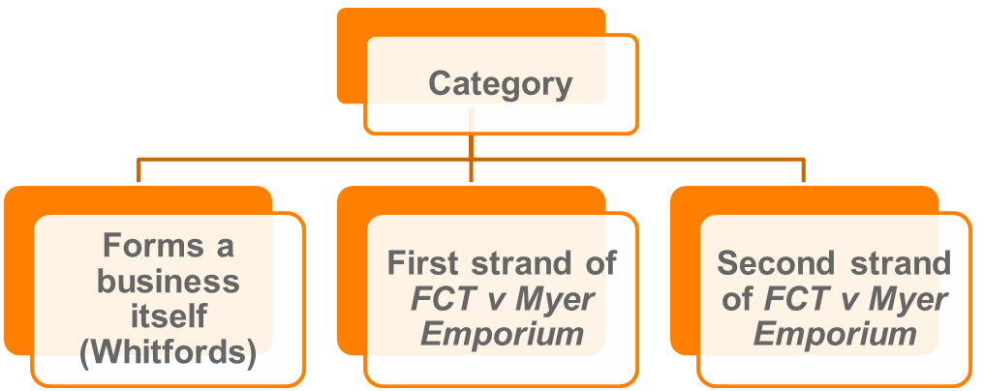

**Isolated transaction with the intention to profit**

* A **mere realisation is a capital receipt** (done whatever is necessary to sell/trade, nothing further)(*Scottish Australian Mining Co Ltd v. FCT* (1950);
* But an **extraordinary transaction with an intention of profit is income in ordinary concepts:** *FCT v. Myer Emporium Ltd* (1987) 163 CLR 199; 18 ATR 693; 87 ATC 4346.
* Repetition is an important indicia of a business but an **isolated transaction may still constitute the carrying on of a business:**FCT v Whitfords Beach Pty Ltd (1982) 150 CLR 355; 12 ATR 692, 82 ATC 4031.
* In determining whether the proceeds of an isolated activity are ordinary income we will see that the courts distinguish between the mere realisation of a capital asset and transactions that are seen as incidental to the taxpayer’s normal business activities.
  + Look at *Myer Emporium* and *Whitfords Beach*

**Extraordinary and isolated transactions**

* Extraordinary transaction of an existing business – *Myer Emporium* (1987)
* Isolated transaction not connected to an existing business – *Whitfords Beach* (1982)

These will be ordinary income **if:**

* Transaction is a business itself
* Fall under the first or second strand of *Myer*

**Isolated transactions in summary**

* Transaction forms a business   
  – *Whitfords Beach* (1982)
* Sufficient indicia of a business – following three cases assist with interpreting *Whitfords*
* *Statham* (1988), *Stevenson* (1991), *Casimaty* (1997)
* How active in development and selling?
* More than a mere realisation: *Scottish Australian Mining* (1950)
* Still business even though once-off
* Net profit is ordinary income – NOT GROSS

**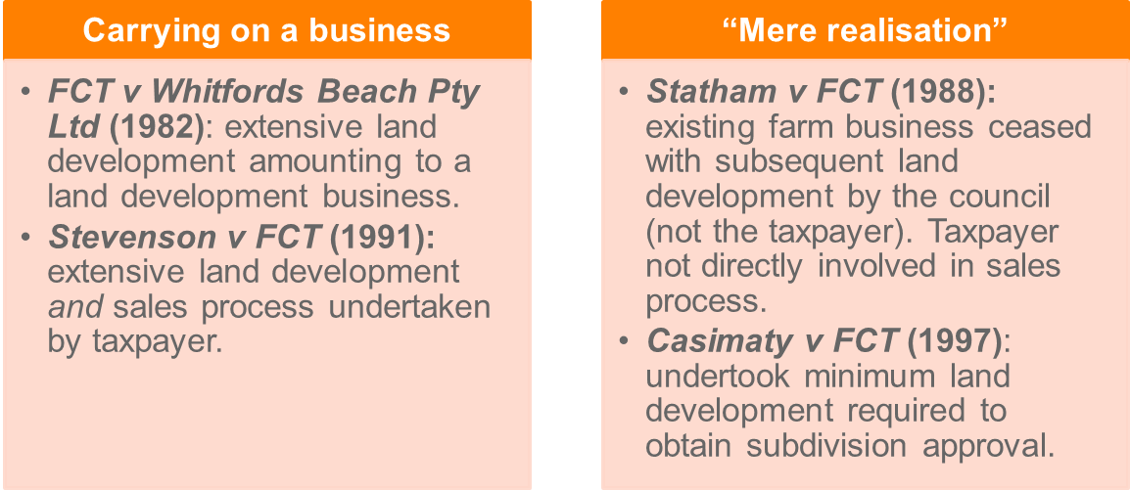**

* Only the profit (not total sales proceeds) is assessable as ordinary income under the principle in *FCT v Whitfords Beach Pty Ltd* (1982).

Profit is calculated as:

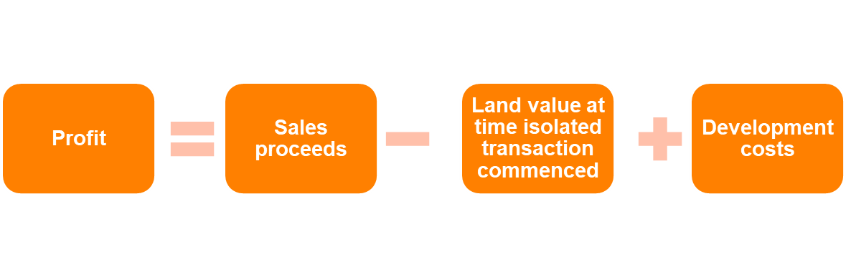

Proceeds from an extraordinary or isolated transaction will be ordinary income if the first *or* second strand of Myer applies.

|  |
| --- |
| *Whitfords Beach* (1982)   * IMPORTANT CASE – *OI for Business where extensive ‘above and beyond’ development of property for transaction* * **Facts:** Whitfords Beach Pty Ltd purchased 1584 ac of land in 1954 to gain access for the shareholders to their beach shacks. * The property became valuable and the shareholders wished to sell it. * The potential purchaser wished to develop and sell the land for housing. * The purchaser did not buy the land but purchased (1967) the shares in Whitford’s Beach Pty Ltd for $1.6 mil (the land had not changed hands). * The articles of the company were changed to allow the development and subdivision of the land. A large subdivision took place in 1970-75 costing $5.7 mil. Purpose of co changed this was an important point. * Constructed roads, installed sewerage and other essential services * View that company changed from holding land for domestic purposes to one which engaged in a commercial venture with an intention to profit. * **Question:** Did it turn from mere realisation of capital asset to a commercial transaction? * **At issue:** Was the profit realised on the sale of the land a mere realisation of a capital asset of Whitford’s Beach Pty Ltd, or was the company now in the business of selling land making the profit on the sale income in ordinary concepts (s 25(1) or 26(a)).   **Held**   * **The *profit* on the sale was income in ordinary concepts. The decision in** *Scottish Australian Mining* **did not extend the meaning of a mere realisation to the situation where a business of land development and sale is undertaken.** * **Importance of the change in ownership and intention of the company**. Used a net approach to determining assessable income. |

|  |
| --- |
| *Statham* (1988)   * UPHELD *Whitfords* - *Mere fact you are subdidving land will not amount to an isolated transaction, only where development is extensive = Capital* * TP trustee of estate for person who acquired 240 acres land for farm in 1970. * Executor of estate had started to develop then died * Subdiv then carried out by council who undertook necessary work * Trustee made gain on capital account not OI. * Consider? Demonstrated that owner who acquires land for purposes unrelated to prop development and engages others to subdividing and sell can have gain assessed as cap and may not result in profit making scheme (causing OI assessment) * You may get assistance from others and it still will not be a business (eg the council to assist with subdividing) |

|  |
| --- |
| *Stevenson* (1991)   * UPHELD *Whitfords* - *Higher degree of personal involvement suggests isolated transaction; thus OI in business = OI* * TP decided to scale back farming activities and sell some of his property (most) * He could not find purchaser and then commenced subdiv himself * Obtained finance and engaged in extensive activities. * Personally dealt council and engineers and advertised sale himself (no agent) * Subdiv into 220 blocks and sold 180   **Held**   * **Was profit OI?** * TP carrying on business of subdividing, developing and selling land. Assessed as OI. * Agreed with Whitfords that magnitude and scale of the development was relevant indicator, so is the degree of personal involvement in carrying out the subdivision. * Personally dealing with council and engineers was an indicative of isolated transaction for purposes of OI * The amount of involvement and time he personally contributed was significant |

|  |
| --- |
| *Casimaty* (1997)   * *Mere realisation (minimum work necessary conducted, no profit motive of business-like methodology) will suggest capital, not OI* * TP given fathers farm to continue primary production activities. * 15 or so years later had not made any money from this and had a lot of debt * He then (over 20 years) slowly disposed of parts of the property (subdiv). * The **work he did was minor, necessary for the subdivision (water connections, entrances and fencing).** * During this time he continued farming activities * He did not personally deal with any of the sales and delegated work to the relevant professionals * Comm said OI * Fed Court said **not OI**. * was a mere realisation of part of the farmer’s property   **Why?**   * **No profit making motive or business-like methodology** * **Slow subdivision**, did minimum necessary * You may insert utilities into subdivisions, it just cannot be ‘above and beyond’ the minimum work necessary |

Consider

* Agent involved v Personal involvement
* Minimum work conducted v Extensive work conducted and extra utilities
* Commercial purpose v purposes of disposal of the land

|  |
| --- |
| *FCT v Myer Emporium* HC   * Established the two strands for characterising OI from extraordinary transactions * TP lent $80 million to one of its subsidiaries at a commercial rate (7 years 12.5%) * A few days after, as always intended, the TP assigned its right to receive interest under the loan from Citicorp (finance co) for approx $45 million * This amount was calculated on outstanding interest payable with discount of 16% per annum * ATO treated this lump sum payment as AI (OI) for YE 30 June 1981. On appeal the SCV and then FCFCA held was capital receipt. The matter then went to Full HC. * **HELD** was income according to ordinary concepts (OI). * There were two alternative reasons for its decision   **First strand:**   * **The amount was profit from a transaction which, even though was outside ordinary course of TP business, was entered into with purpose of making profit.** * **What do we need?**  1. Commercial transaction (always assume this) 2. Intention to profit 3. Profit made by intended means (did they receive profit in the way they originally intended)   **Second strand:**   * **If exchanging income stream for a lump sum, this will still amount to OI** * Sale of the right to income without underlying asset will be ordinary income * TP sold mere right to interest for a lump sum, that lump sum was exchanged for (present value), the future interest it would have received. The interest would have been OI, they simply converted future income into present income * As an alternative basis for its decision, the High Court held in Myer that the $45.37m received by Myer Emporium for the assignment of its right to receive interest payments from Myer Finance was assessable as ordinary income or the basis that where a lender sells a mere right to interest for a lump sum: *"the lump sum is received in exchange for, and ordinarily as the present value of, the future interest which he would have received.”* |

**Important points from *Myer*:**

* The High Court confirmed the narrowing of the "mere realisation' doctrine treating as ordinary income the profit from "isolated transactions as interpreted in *Whitfords Beach*.
* Even ***extraordinary*** transactions – that is those not of a type that the taxpayer engaged in regularly in the course of its business operations can generate assessable income.
* A lump sum takes on the character of the income stream which it replaces.

**Application of the first strand**

* First Strand - application
* *Westfield* (1991): Still possible to have a mere realisation. **Intention to profit must exist at purchase**. Second element not present
* *Cooling* (1990) Transaction was part of business activity with intention to profit. Although once-off it was still income
* *McCurry* (1998) Initial intention not changed by break in use. Purchased three townhouses but then newsagency, then sold townhouses, OI

|  |
| --- |
| *Westfield* (1991)   * Still possible to have a mere realisation where original intention to profit did not occur at time of purchase * **ESSENTIAL TO DISCUSS THIS CASE IF FOLLOWING MYER STRAND 1** * FFC applied Myer * Westfield business was design and construction of shopping centres and leasing and management of them * TP did this on its land (but not often), other people land and JV land. * Purchased some land which was unsuitable for shopping centre but would be ok to develop as shopping centre if they could obtain the adjacent land which they did not own * Why did TP purchase the land? To keep out another developer and hopefully purchase adjacent land and develop * The court accepted they did not purchase with intention to sell the land * Eventually the TP sold the land (at profit) to owner of adjacent land and entered into contracts with purchaser for design and construction of shopping centre. * **Held: Was not OI**. The view of the principle from Myer is that the profit made must actually be made by the intended means when the transaction/profit making scheme was entered into. Here, this was not satisfied. * Again, profit making intention does not have to be the sole one but cannot be insignificant * **Intention to profit at the time of purchase must be followed through. If profit came from a separate intention, the *Myer* first strand is not satisfied. Therefore, it will amount to capital and not OI** * Here Westfield profit from the land resale and it was their intention to make the land a shopping center. * Therefore, profit was not made from their intended means |

|  |
| --- |
| *Cooling* (1990)   * UPHELD *Myer* – the intention to profit need not be the sole intention, but must be a significant intention * Lump sum payment made to partners of law firm to enter into a new lease and relocate premises with AMP * This case followed Myer and said that was commercial transaction, intention to profit, and profit was made by intended means. * Difficult as often lease premium often CGT. * The receipt was a commercial transaction which formed part of the business activities of the firm and a significant motive was an intention to profit. * The profit realised on the sale was capital in nature. * *Myer's* does not make profits from all business transactions income. To be income a profit motive is required that underlies the transaction. In this case the sale of land was not part of the normal business activities of the t/p.   *For Myer to apply a transaction that is outside the normal business of the taxpayer, the* ***transaction must be entered into with the intention to profit, and profit must be made in intended way.*** |

**Application of the Second Strand**

Sale of an income stream without its underlying asset is ordinary income

### 

|  |
| --- |
| Henry Jones (IXL) (1991)   * *Second Myer strand applies where the lump sum payment is a substitute for an income stream* * TP and subsid entered into 10 year agreement with two other (arm’s length) companies under which T and sub granted a licence to the other companies to use labels in return for royalties spread over term of contract. * TP and sub then assigned right to royalties to finance co for $7.6m * Royalties would go to subsidiary and the subsidiary would give the payments to TP * **HELD**OI under second strand myer |

## Extraordinary transactions in summary

* To reiterate - an extraordinary transaction of a business entered into with an intention of profit is ordinary income: *FCT v Myer Emporium Ltd (*1987) 163 CLR 199; 18 ATR 693; 87 ATC 4346.
* First strand of the reasoning in Myer: "extraordinary" transactions

**The Myer Emporium doctrine will apply where:**

1. taxpayer had a profit-making intention or purpose upon entering into the transaction.
2. profit was made in carrying out a business operation or commercial transaction.
3. where the way that the profit was made is consistent with at least one of the intentions that the taxpayer had upon entering into the transaction—*Westfield v. Federal Commissioner of Taxation* (1991) 21 ATR 1399.

Other notes

* Not every receipt received by a business will be income: *FCT v Spedley Securites Ltd 88 ATC 4126*
* Myer reasoning can apply even if there is a dual profit making purpose: *Moona Sands Pty Ltd v FCT 88 ATC 4897*
* Profit making purpose must not be an insignificant one: *FCT v Cooling (1990)*

## Revision questions

1. A chef decides to write a cookbook. He spends two years writing this book and receives two offers from publishing companies as follows:

(a) Company 1: purchase of the copyright of the book for a lump sum of $120,000. The chef would have to give up all claims to copyright and future royalties.

(b) Company 2: pay 10% of the sale price of each book sold provided the chef agrees to assignment copyright in the book to the publisher for 5 years.

**Discuss the effect on assessable income for each of the offers above.**

*A: It is a lump sum, CG (selling the tree – the copyright). It is not a payment based on usage, not OI or a royalty.*

*B: Royalty according to Stanton and McCauley. Based on usage, how much the publisher uses the copyright? Then need to work out if it is OI? It is cash, a real gain: Cash and real gain cases. Does the receipt have the characteristics of OI? The Copyright is a tree, the payment flows from an earning source. The royalty under offer two is OI*

2. (Source ATO Ruling) Jennifer has been painting for several years. She is employed full-time as a public servant but works on her art in her spare time - on average 12 to 15 hours a week outside normal work hours.

Activities prior to the 2012 income year

Jennifer uses a spare room in her home as a painting studio and to store materials. She is a member of a local landscape painting club which regularly arranges painting trips to sites in the area and once a year to the Northern Territory. Her club participation involves attending club meetings once a month and showing her work to gain feedback from the other club members. She engages in her art activity with a great deal of enthusiasm and commitment.

Jennifer does not make any concerted efforts to sell her art works. Such sales as she has made have been to family and friends, and then only at prices that just cover the cost of the materials used. In the 2011 income year, Jennifer sold two of her art works to friends for a total of $760 and she spent $4,800 to create several other works of art. Jennifer does not keep receipts for all of her expenses.

Activities from the 2012 income year

In July 2011, Jennifer began working part-time at her job in the public service so that she could devote more time to her art and make a name for herself as a landscape artist. Jennifer also became a member of two professional arts associations. For the first time, she engaged an agent to assist with the exhibitions she has planned for the 2012 income year and with marketing her work more generally. In consultation with her accountant and her agent, she develops a business plan for the 2012-2014 income year.

Jennifer’s business plan involves renting of a small studio to conduct her painting and store her materials. In the 2012 income year, she exhibited her works at various local galleries as part of group exhibitions and sold a number of paintings for a total of $9,200. She received very good write-ups in art review magazines. She keeps detailed records of her income and expenses. Her art expenses for the 2012 income year were $11,200, comprised of the following:

Type of expense Amount

Materials $2,320

Rent $5,000

Gallery commission (40% of total sales) $3,680

Membership fees in professional arts associations $150

Journal subscription fees $50

In the 2012 income year, Jennifer returned a net loss of $2,000 from her art activity.

In the 2013 income year, she had an 'off-exhibition' year to build up a body of work so that she could participate in exhibitions (local and interstate) she has planned for the following year, which meant that no sales were made. She incurred the same expenses for the 2013 income year as she did in the 2012 income year, and therefore returned a loss from the activity.

In the 2014 income year she incurs expenses of $12,000 but makes $45,000 selling her art.

She is setting up a website of her works for greater exposure. She intends to ultimately resign from her full-time job and spend more time marketing and producing her art if that is sustainable.

**Using case law to substantiate your answer, is Jennifer carrying on a business and if so, when did her business commence and what amounts of assessable income did she receive?**

***Is she carrying on a business? When does an activity turn from a hobby to a business?***

* **Profit-making intent**?
  + Not necessary to show actual profit to show intent
  + Lack of profit-making intention doesn’t necessarily preclude there being a business: *Stone v FCT* (2005) *– Her activities prior to 2012 do not indicate an intention as she is not making conscious efforts to sell her art.*
* **Scale of activities**, including the nature and type of capital and level of turnover:
  + Small operation can still constitute a business if there are sufficient other characteristics: *FCT v JR Walker* (1985). - *Small scale pre 2012, growing in 2012 year.*
  + Can have a full time job and a business: *Ferguson v FCT* (1979).
* **Commercial approach** is taken:
  + Whether professional advice is sought before or during activity *– None taken pre 2012, taken advice from accountant etc. in 2012 year.*
  + Exploration of markets – *Not yet, only sold to friends and family*
  + Whether the production is more than needed for domestic purposes: *Thomas v FCT* (1972) – *Only sold a few to friends, arguably not a commercial approach*.
  + *Prior to 2012 there is no evidence to suggest that she is looking for markets - Social membership is not a market.*
* **System and organisation** employed
  + Degree of planning and amount of time invested – not much time and effort put in yet, post 2012 she has put more time and effort into it.
  + Record keeping – keeps records of expenses – *None pre 2012 but she does in the 2012 year.*
  + Taxpayer may delegate these duties and still be considered a business: *Ferguson v FCT* (1979). *- Delegated stuff post 2012 to accountant and agent.*
* **Methods characteristic** of the particular line of business
  + Business practices consistent with industry *– Art exhibition, professional*

4. (Source Sadiq et al) Nico owns and operates a mobile phone business at Chadstone shopping centre. To promote its product, Telstra provides Nico with two new top of the range mobiles each year. During the current tax year Nico received two phones with a market value of $900. The distribution agreement that Nico has with Telstra states that Nico cannot sell the phones. Nico uses one of the phones and give the other phone to his wife.

**Explain to Nico whether the phones constitute ordinary income in Nico’s hands.**

***Not cash convertible. S 21A applies?***

* *Under ss 21 and 21A(1) ITAA 36 certain non-cash business benefits are deemed to be convertible to cash, thereby statutorily overruling the cash or cash convertible rule from FCT v Cooke & Sherden (1980) 80 ATC 4140.*
* *Therefore no cash convertibility issue under ss 21 and 21A*
* *Sections 21 and 21A simply provide a means of valuing non-cash business benefits and they do not deem the receipt to constitute income.*
* *The receipt must also exhibit the attributes of income before it will be assessable and then s 21 and 21A can be used to value the receipt:*
  + *The receipt is regular (the phones)*
  + *It is connected with an earning activity: his job selling phones.*
  + *Is it incidental to the carrying on of his mobile phone business:*
  + *It is regular and expected: Memorax, so yes.*
  + *S 21A makes both phone’s values treated as assessable income under s 6 – 5.*

5. (Source Sadiq et al) Two years ago Peta purchased a house in Kew. This house had two old tennis courts down the back which were in poor condition. She purchased the property for two reasons:

(a) So that she and her family could live in the house; and

(b) So that she could build three units on the tennis courts and sell them at a profit.

In the current tax year, the tennis club next door offered to buy the old tennis courts, but only if Peta first restored them to good condition. Peta decided to accept the club’s offer instead of going ahead with her plan to build and sell units. Peta spent $100,000 on preparing the tennis courts for sale. This involved a great deal of work. Peta had to resurface the tennis courts and build new fences around them. She then sold the tennis courts in the current tax year to the tennis club for $600,000.

**Discuss whether the receipt of $600,000 is ordinary income under s 6-5.**

***Mere realisation of an asset (CG) v OI (PSI, business, isolated transaction and Myer 1 & 2)***

* *Normal proceeds of a business? She does not have a land developing business or a business for re-surfacing tennis courts, so no, an isolated transaction: Whitfords Beach.*
* *Isolated or extraordinary transaction not connected to an existing business – Whitfords Beach (1982) Will be ordinary income if:*
* *Transaction forms a business itself (Whitfords Beach); or*
* *Falls under the first or second strand of Myer*

*Does the transaction form a business in itself?*

* *She planned to build town houses on the yard. Would this activity form a business in itself?*
* *In Whitfords there was a subdivision and considerable effort put into increasing its amenities, not just putting a fence around a block of land. Extensive development: A lot of capital and planning, which indicates a business.*
* *Re-surfacing a court is not as significant as planning the building of town houses arguably. You can put some value to an asset to make it attractive to a purchaser that is acceptable as being a mere realisation: Casimaty case and California.*
* *Has there been sufficient capital and planning in developing the land (Whitfords beach)? No but if she built town houses than yes arguably.*
* *The gain is not OI under Whitfords beach – distinguish.*

*First strand of Myer?*

*Three elements as they apply to an Isolated Transaction:*

1. *Is it a commercial transaction? Buying the property and selling it is a commercial transaction.*
2. *Profit making intention? Abandoned original intention. Not consistent with what was originally intended, original intention at time of purchase of asset must be followed through: Westfield.*
3. *Was the profit realised in the manner intended? ^No*

*Failed first strand*

*Second strand of Myer?*

* *Does not apply here as she is not selling the rights to OI separate to the asset.*

6. Hal and Burt are famous song-writers. They hold the copyright in a number of popular songs of the 1960s. They licence their copyright in a number of songs to be used in a musical theatre production in Melbourne that is expected to run for 2 years. They will receive significant royalties each year from the licensing arrangement.

They are also in financial difficulties and sell their right to the royalties to Big Bank Ltd for $5m. Big Bank will now receive the royalties. Hal and Burt retain the copyright to the songs.

**Advise Hal and Burt whether the $5m will be ordinary income.**

* *A royalty under ordinary concepts is OI. Then discuss OI characteristics, cash, real gain, flows from the OI.*
* *Licensing their copyright to theatres could be a business for them?* 
  + *The gains from licensing would be the normal proceeds of the song writing business.*
  + *Assigned the right to another bank, this gain would not be the normal proceeds of the business, the facts indicate that they only do it because they are in financial trouble: Leads to an extraordinary activity which brings the situation to Myer’s strands OR if not a business than an isolated activity – Myer strands.*

*Myer 1:*

1. *If it is a business operation, it could be connected to the business (financing transaction), intention when acquiring the license is not clear.*
2. *They entered into the licensing agreement with the theatre for royalties but no initial intention to sell their licenses evident on the facts.*

*Not caught under first strand – no intention to sell the licenses*

*Myer 2:*

* *The right to OI stream (the royalty) is being sold separate to the asset as in Myer: second strand of Myer satisfied, thus will be OI.*

# Topic 2: Ordinary Income - Business Compensation, Statutory Income and Exempt Income

## Compensation for lost income or capital?

* **OI in compensation is a question of whether the compensation takes the character of what it replaces:** *C of T (NSW) v Meeks* (1915)
* **Compensation for business structure = capital**
* **E.g.** the office burns down and you receive a lump sum of insurance = **capital**
* **Replaced income/business processes = Income**
* E.g. Insurance to cover lost wages
* *Sydney Refractive Surgery v FCT* (2008)

## Compensation for the loss of capital

* Takes the character of what it replaces: *C of T (NSW) v Meeks* (1915)
* **Replaces capital = capital**
* E.g. Loss of ability to work, loss reputation, loss of assets
* *Glenboig Union Fireclay Co Ltd v IRC* (1922)(part of land of TP could not be used and was paid compensation for this, held capital as part of TP company was ‘sterilized’).
* *FCT v Woite* (1982)
* *FCT v Sydney Refractive Surgery Centre* (2008)
* *Tinkler v FCT* (1979)

|  |
| --- |
| *Sun Newspapers v FCT* (1938) HC   * *Test for distinguishing outgoings on revenue as opposed to capital* * TP was newspaper publisher * Principle competitor was *World* which was published by Sydney Newspapers. Syd News then proposed to publish another new rival paper at cheaper cost. * An agreement made between Sun and Sydney and Sun could use plant and equipment of Syd News and Syd News could not publish new rival paper. TP made payment to Syd New on entering agreement * In effect, TP shut down *World* and stopped new publication being made * TP tried to claim a deduction for the payment. * Held by majority of HC that was capital expense… * **If an item of expenditure forces someone to cease business, this will amount to structure, not income process; thus capital and not OI** * TP acquired a non-wasting and enduring benefit * Income producing process (OI) v income producing structure (cap) * Payment preserved business structure so capital in nature * **Dixon J – This case sets out the test for distinguishing outgoings on revenue as opposed to capital account.** **There are three matters to be considered:**  1. *the character of the advantage sought*, and in this its lasting qualities may play a part, 2. *the manner in which it is to be used*, relied upon or enjoyed, and in this and under the former head recurrence may play its part, and 3. *the means adopted to obtain it*; that is, by providing a periodical reward or outlay to cover its use or enjoyment for periods, commensurate with the payment or by making a final provision or payment so as to secure future use or enjoyment. |

|  |
| --- |
| Sydney Refractive   * *Where defamation damages business reputation substantially, it will be capital* * **Read this case** * TP had business including laser eye surgery. Made money from patients * He sued for damages relating to defamation and was awarded $844k. * It was **held that this amount was compensation for injury to a capital asset and therefore not income according to ordinary concepts.** * **Impact on business structure** * Question of degree * Did the lose business for short term (a few weeks), or was it long term? **Think of the duration of the damage** * **Significant or insignificant loss of** business |

* Cancellation of agency agreements can depend on significance of the cancellation to the business
* *Californian Oil Products v FCT* (1934)
* *Heavy Minerals v FCT* (1966)
* *Allied Mills Industries Pty Ltd* (1989)

## Compensation for business losses

* Follows the replacement principle where:
  + **Income**: replacement of an amount that would have been ordinary income (ie, from the normal course of business or some isolated and extraordinary transactions).
  + **Capital**: amounts for the loss of capital or capital item.

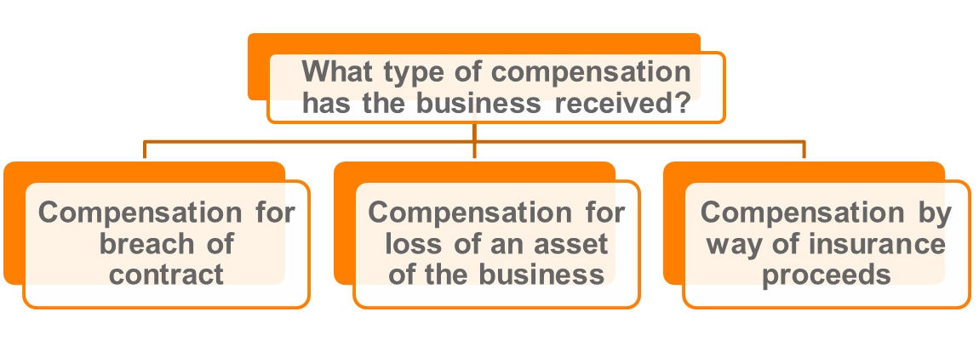

## Compensation for breach of contract

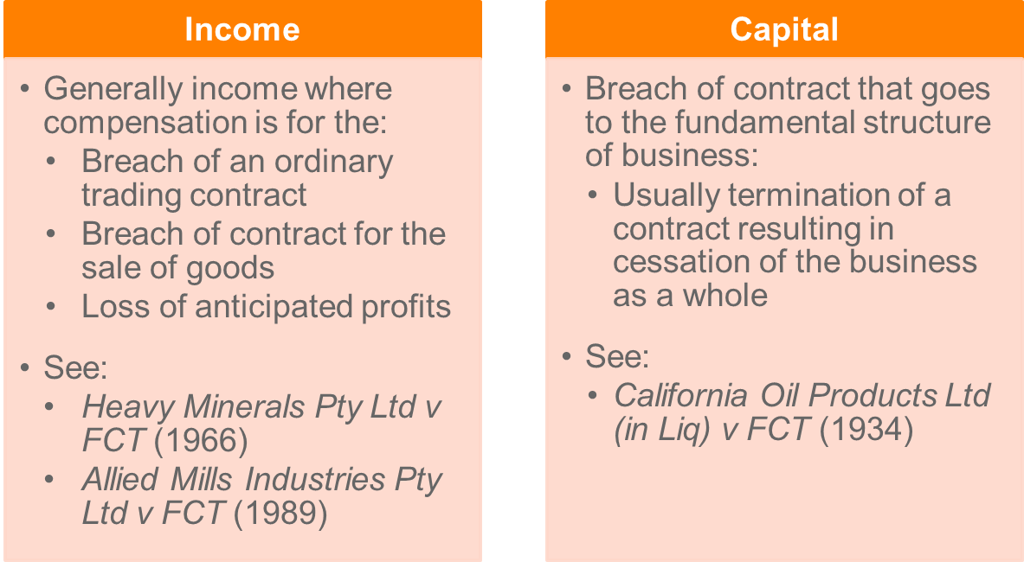

**Income**

* Generally, compensation for lost income **caused by terminating one of a number of business contracts** will generally be income in ordinary concepts: *Heavy Minerals Pty Ltd v. FCT* (1966)

|  |
| --- |
| Heavy Minerals v FCT (1966) HC   * *Compensation for cancellation of contract will be OI where there are numerous contracts and cancellation had not crucial impact* * TP entered into 4 forward selling contracts with American and German suppliers for sale of Rutile. * Subsequent the market collapsed and price of rutile fell * Contracts were then cancelled and compensation was paid by lump sum * Commissioner assessed lump sum and * **HC held** that payments were OI in the hands of the TP - mining operations had been abandoned not because of cancellation of contracts but because of collapse in market and therefore ordinary trading contract = OI * **If there are a number of contracts, more likely to be income** * **Consider:** did the business shut down due to the cancellation of contracts, or was there another reason? |

|  |
| --- |
| *Allied Mills Industries* (1989)   * *Where TP was not parting with a substantial part of the business from contract cancellation = OI* * Again, compensation for breach of ordinary trading contract. * TP had agreement to be sole distributor of biscuits (incl Vita Weat) * Agreement could be terminated on 6 month notice, but TP was to be offered right to manufacture and sell VW for 10 years * Instead of original agreement being followed, parties agreed to terminate distribution agreement for lump sum of approx $372,000 * **FFC held that amount was assessable as OI** * The court held that the TP was not parting with substantial part of business, ceasing to carry on business, or disposing of fixed framework of business |

**Capital**

* In exceptional cases, a **contract may be so fundamental that its cancellation affects the very continuation of the business and therefore impacts upon the value of the taxpayer’s business:***Van Den Bergs Ltd v Clark* (1935). In such a situation compensation paid for the cancellation of the **contract may be capital in nature**.
* Breach of contract that goes to the fundamental structure of the business, resulting in cessation of the business as a whole: *California Oil Products Ltd (in Liq) v FCT* (1934).

## Compensation for loss of a business asset

**Loss of capital assets**

* Characterisation depends on extent of damage to the asset:
  + **Permanently destroyed**/disabled: generally capital in nature (see, *Glenboig Union Fireclay v IR Commissioner* (1922))
  + **Temporarily disabled**: generally income in nature (see, *Ensign Shipping Co Ltd* (1928)).

## Compensation by way of insurance

* Statutory inclusion (s 15-30)
  + Amounts received by way of insurance or indemnity are still assessable if the lost amount would have been included in assessable income and the compensation is not ordinary income.
* Special rules for recovery of losses under insurance policies for **livestock and timber** (s 385-130).
  + Broadly, insurance payout is included in assessable income in equal instalments over five years.

## Composite claims

* Sometimes compensation is not identifiable as a substitute for income or capital.
* Compensation may be paid as an undissected (global) lump sum receipt, comprising compensation for:
  + Loss of income; AND
  + Loss of capital or capital assets.
* Courts are **reluctant to apportion the undissected** sum into income and capital.
  + **Whole sum treated as capital**: *McLaurin v FCT* (1961).
  + Capital gains tax regime may apply

## Reimbursement of previously deducted expenses

**Common law**

* Under **common law**, the assessability of a reimbursement of a previously deducted expense is **determined by reference to ordinary concepts of income**.

|  |
| --- |
| *Allsop v FCT* (1965)   * *Compensation for fees previously deducted = capital* * TP deducted haulage permit fees to Govt – fees held to be unconstitutional and TP sued to recover fees (likely income) and compensation for “interference” with the TPs business (capital) - claim settled and TP received 37,000 pounds * **Held**: Settlement payment was not a reimbursement but a capital amount received in respect of a global settlement of all claims – capital under the principle in McLaurin’s case * They had already deducted the fees paid to the govt, so it was not in relation to income, it was capital. |

|  |
| --- |
| *HR Sinclair & Son Pty Ltd v FCT* (1966)   * *Did* * TP had deducted royalties under protest to the Forests Commission (Vic) – TP convinced Commission royalties incorrectly calculated – TP received a refund –] * **Held**: Refund not OI because a reimbursement of a deductible amount – amount had characteristics of OI as received in course of TPs business. |

**Statutory position**

* Statutory position under Div 20 includes amounts in a taxpayer’s assessable income to **reverse the effect of certain deductions** (provided not otherwise assessable income).
* Two categories of assessable recoupments:
  + Insurance or indemnity;
  + Other recoupments

**Category 1: insurance or indemnity (**s 20-20(2))

* Included in the taxpayer’s assessable income if:
  + An amount is received by insurance or indemnity for the loss or outgoing; and
  + The taxpayer can deduct an amount for the loss or outgoing.

**Category 2: other recoupment (**s 20-20(3))

* Also included in the taxpayer’s assessable income.
* Other recoupments must be of an amount deducted under one of the specific provisions listed in s 20-30, examples:
  + **Bad debts**
  + **Embezzlement or larceny**.
* If you have deducted a debt that has gone bad, and subsequently the amount is recouped, that amount will be included as assessable income.

## Revision question

**Question 1**

Glenn and Lori run a ski resort business comprising a hotel and ski fields. They received many complaints from resort guests describing poor experiences with the ski lifts. One guest had been stuck in a ski lift in a blizzard at the top of the mountain for four hours. The lifts were supplied by ‘Smooth Running Ski Lifts’. After an investigation, ‘Smooth Running’ admitted its ski lifts were defective. Glenn and Lori sued ‘Smooth Running’ for losses suffered and made two claims. First, for lost business income arising from the decrease in hotel bookings in the amount of $150,000. Second, for ongoing lost income from its diminished reputation in the ski industry, as evidenced by negative reviews on travel websites in the amount of $550,000. ‘Smooth Running’ settled the claim for $500,000.

**Required:**

1. Advise Glenn and Lori whether the compensation payment is assessable income. Refer to relevant legislation and case law.

*First claim:*

*Start a compensation question by first asking what it is claimed for? Ask does the compensation result in a temporary or permanent cessation of the business. Is it simply an interruption or has the business ceased?*

* *Here compensation for temporary lost income.*
* *The compensation is treated as a replacement of those profits, treated as OI*

*Second claim:*

* *Compensation for goodwill. Reputation is a part of its profit yielding structure (an asset). Is the damage to goodwill permanent or temporary?* 
  + *Not clear but arguably temporary, as they could get new lifts (could argue either way).*

*Composite claims:*

* *The payment is an* ***un-dissected amount****.*
* *Part of the compensation is arguably of a capital nature and some OI (assuming damage to goodwill is permanent then it is replacing capital not OI) – whole amount treated as capital per McLaurin v FCT* (1961).

## II. STATUTORY INCOME (Individual)

* Statutory income is an amount that is specifically made assessable by the Act (s. 6-10).
* These provisions range from the very specific, e.g. s. 15-5 (accrued leave transfer payments) through to the very general and complex, e.g. Part 3‑1 (capital gains tax) **(Topic 3)**.
* Structuring assessable income into a general (ordinary income) and specific (statutory income) component raises the possibility that an amount may be assessable under more than one provision of the Act.
* Under s 6-25, if an amount is assessable under more than one provision, s 6-25(2) states that unless the Act states otherwise, the statutory provision should be applied over the rules relating to ordinary income.
* However, having given precedent to statutory provisions, many of these statutory provisions only apply if the amount is not ordinary income. For example, ss 15-10, 15-25 and 15-30.

S 6-10 ITTA 97: Other assessable income

   (1)  Your [*assessable income*](http://www7.austlii.edu.au/cgi-bin/viewdoc/au/legis/cth/consol_act/itaa1997240/s995.1.html#assessable_income)also includes some [amounts](http://www7.austlii.edu.au/cgi-bin/viewdoc/au/legis/cth/consol_act/itaa1997240/s995.1.html#amount) that are *not*[ordinary income](http://www7.austlii.edu.au/cgi-bin/viewdoc/au/legis/cth/consol_act/itaa1997240/s995.1.html#ordinary_income).

Note:          These are included by provisions about [assessable income](http://www7.austlii.edu.au/cgi-bin/viewdoc/au/legis/cth/consol_act/itaa1997240/s995.1.html#assessable_income).   
For a summary list of these provisions, see section 10-5.

             (2)  [Amounts](http://www7.austlii.edu.au/cgi-bin/viewdoc/au/legis/cth/consol_act/itaa1997240/s995.1.html#amount) that are *not* [ordinary income](http://www7.austlii.edu.au/cgi-bin/viewdoc/au/legis/cth/consol_act/itaa1997240/s995.1.html#ordinary_income), but are included in your [assessable income](http://www7.austlii.edu.au/cgi-bin/viewdoc/au/legis/cth/consol_act/itaa1997240/s995.1.html#assessable_income) by provisions about [assessable income](http://www7.austlii.edu.au/cgi-bin/viewdoc/au/legis/cth/consol_act/itaa1997240/s995.1.html#assessable_income), are called [*statutory income*](http://www7.austlii.edu.au/cgi-bin/viewdoc/au/legis/cth/consol_act/itaa1997240/s995.1.html#statutory_income).

Note 1:       Although an [amount](http://www7.austlii.edu.au/cgi-bin/viewdoc/au/legis/cth/consol_act/itaa1997240/s995.1.html#amount) is [statutory income](http://www7.austlii.edu.au/cgi-bin/viewdoc/au/legis/cth/consol_act/itaa1997240/s995.1.html#statutory_income) because it has been included in [assessable income](http://www7.austlii.edu.au/cgi-bin/viewdoc/au/legis/cth/consol_act/itaa1997240/s995.1.html#assessable_income) [under](http://www7.austlii.edu.au/cgi-bin/viewdoc/au/legis/cth/consol_act/itaa1997240/s995.1.html#under) a provision of [this Act](http://www7.austlii.edu.au/cgi-bin/viewdoc/au/legis/cth/consol_act/itaa1997240/s995.1.html#this_act), it may be made [exempt income](http://www7.austlii.edu.au/cgi-bin/viewdoc/au/legis/cth/consol_act/itaa1997240/s995.1.html#exempt_income) or [non-assessable](http://www7.austlii.edu.au/cgi-bin/viewdoc/au/legis/cth/consol_act/itaa1997240/s995.1.html#non-assessable_non-exempt_income) [non-exempt income](http://www7.austlii.edu.au/cgi-bin/viewdoc/au/legis/cth/consol_act/itaa1997240/s995.1.html#non-assessable_non-exempt_income) [under](http://www7.austlii.edu.au/cgi-bin/viewdoc/au/legis/cth/consol_act/itaa1997240/s995.1.html#under) another provision: see sections 6-20 and 6-23.

Note 2:       Many provisions in the summary list in section 10-5 contain rules about [ordinary income](http://www7.austlii.edu.au/cgi-bin/viewdoc/au/legis/cth/consol_act/itaa1997240/s995.1.html#ordinary_income). These rules do not change its character as [ordinary income](http://www7.austlii.edu.au/cgi-bin/viewdoc/au/legis/cth/consol_act/itaa1997240/s995.1.html#ordinary_income).

             (3)  If an [amount](http://www7.austlii.edu.au/cgi-bin/viewdoc/au/legis/cth/consol_act/itaa1997240/s995.1.html#amount) would be [statutory income](http://www7.austlii.edu.au/cgi-bin/viewdoc/au/legis/cth/consol_act/itaa1997240/s995.1.html" \l "statutory_income) apart from the fact that you have not received it, it becomes [statutory income](http://www7.austlii.edu.au/cgi-bin/viewdoc/au/legis/cth/consol_act/itaa1997240/s995.1.html#statutory_income) as soon as it is applied or dealt with in any way on your behalf or as you direct.

             (4)  If you are an [**Australian resident**](http://www7.austlii.edu.au/cgi-bin/viewdoc/au/legis/cth/consol_act/itaa1997240/s995.1.html#australian_resident), your [assessable income](http://www7.austlii.edu.au/cgi-bin/viewdoc/au/legis/cth/consol_act/itaa1997240/s995.1.html#assessable_income) includes your [statutory income](http://www7.austlii.edu.au/cgi-bin/viewdoc/au/legis/cth/consol_act/itaa1997240/s995.1.html#statutory_income) from all sources, whether in or out of [Australia](http://www7.austlii.edu.au/cgi-bin/viewdoc/au/legis/cth/consol_act/itaa1997240/s30.15.html#australia).

             (5)  If you are a [**foreign resident**](http://www7.austlii.edu.au/cgi-bin/viewdoc/au/legis/cth/consol_act/itaa1997240/s995.1.html#foreign_resident), your [assessable income](http://www7.austlii.edu.au/cgi-bin/viewdoc/au/legis/cth/consol_act/itaa1997240/s995.1.html#assessable_income) includes:

                     (a)  your [statutory income](http://www7.austlii.edu.au/cgi-bin/viewdoc/au/legis/cth/consol_act/itaa1997240/s995.1.html#statutory_income) from all [Australian sources](http://www7.austlii.edu.au/cgi-bin/viewdoc/au/legis/cth/consol_act/itaa1997240/s995.1.html#australian_source); and

                     (b)  other [statutory income](http://www7.austlii.edu.au/cgi-bin/viewdoc/au/legis/cth/consol_act/itaa1997240/s995.1.html#statutory_income) that a provision includes in your [assessable income](http://www7.austlii.edu.au/cgi-bin/viewdoc/au/legis/cth/consol_act/itaa1997240/s995.1.html#assessable_income) on some basis other than having an [Australian source](http://www7.austlii.edu.au/cgi-bin/viewdoc/au/legis/cth/consol_act/itaa1997240/s995.1.html#australian_source).

* **Discuss 6-5 before 15-2. Flag 15-2 at the end of the question, so long as you establish that it exists**

S 15-2 ITTA: Allowances and other things provided in respect of employment or personal services – (Likely to be on exam)

1. **Your assessable income includes the value to you of all allowances, gratuities, compensation, benefits, bonuses and premiums provided to you in respect of, or for or in relation directly or indirectly to, any employment of or services rendered by you** (including any service as a member of the Defence Force).
2. This is so whether the things were provided in money or in any other form.

* S 15-2 **catches claims that do not satisfy OI. E.g. a non cash convertible holiday:** *Cooke v Sherden*

1. However, the value of the following are not included in your assessable income under this section:
2. a superannuation lump sum or an employment termination payment;
3. an unused annual leave payment or an unused long service leave payment;
4. a dividend or non-share dividend;
5. **an amount that is assessable as ordinary income under section 6-5;**
6. ESS interests to which Subdivision 83A-B or 83A-C (about employee share schemes) applies.

* S 15-2 states that you must consider OI first before determining whether the receipt falls under 15-2

**S 15-2 will not apply – key exclusions:**

* S 23L of the Income Tax Assessment Act 1936 provides that **fringe benefits** are non-assessable non-exempt income.
* S 15-2(3)(d): Does not apply if amount is ordinary income - s 6-5
  + Ask if the amount is OI under section 6-5, if not then consider if section 15-2 brings the amount into assessable income as statutory income.

**Three requirements**

1. **Allowance, gratuity, compensation etc**

* Very broad – cash or non-cash
* Can include gifts – e.g. client gifts
* Does this cover normal wages? Reimbursement?

1. **Provided to you**
2. **In respect of employment or service**

* *Smith v FCT* (1987)**: Nexus easier to meet than s 6-5 (OI)**
* *Payne* (1996)
* *Rowe* (1997): **Reimbursement of legal fees lacked nexus with employment – reimbursement generally not OI**
* What about Salary Sacrifice?

|  |
| --- |
| *Smith v FCT*   * *Nexus in 15-2 easier to meet than 6-5 as SI so long as an employment nexus can be established* * **Facts:** Westpac introduced scheme to encourage its employees to undertake study that it considered related to banking * **Employer would give Employee a certain amount on successful completion of every subject of an approved degree**. At time no tertiary fees so could use for personal purposes * **Smith was one of these employees.** * **Was the amount assessable under predecessor of 15-2?** * **Held:** YES. The Court said that there was sufficient nexus – the scheme existed to increase employee productivity. * Court did not consider OI but said that it is easier for service related gains to be assessable under 15-2 * **Studying at uni being the requirement for the scheme involving their employment would create difficulty in establishing the nexus of OI in 6-5. Therefore, SI in 15-2 has a lower threshold** * **NB *Payne* –** Held that would not be assessable as statutory income, inadequate nexus. Free tickets were reward for flying with Qantas not for services to KPMG |

|  |
| --- |
| *Payne v FCT*   * Recall FF points not OI as benefits received not convertible into cash. * Court also considered s 15-2 – not assessable under this provision either. * **Held:** Not provided to taxpayer ( 2nd requirement not met) * Inadequate nexus between benefit and service provided to KPMG – not a reward to services but a reward for flying with Qantas (3rd requirement not met). |

Other statutory provisions

* **Sec 15-3** – Return to work payments
* **Sec 15-5** – Accrued leave transfer payments
* **Div 82** – Termination of employment - not covered in this unit
* FBT – employer taxed, employee is not assessable on Fringe Benefit **(Topic 6)**

## Statutory income (Business)

* **Sec 15-10 – bounties and subsidies**
* Payment for something relevant to the business or its operations
* Does not apply if ordinary income – s 15-10(b)
* Only applies to businesses
* Eg Capital subsidy
* **Sec 15-15 – Profit-making undertaking**
* Pre CGT asset only 20/9/1985: limited application
* Does not apply if ordinary income – s 15-15(2)(a)
* **Sec 25A ITAA 36 – Sale of an asset acquired for the purpose of resale**
* Pre CGT asset only 20/9/1985: limited application
* **CGT (Topic 3)**
* **Balancing adjustment (Topic 4)**
* **Trading stock (Topic 4)**
* Div 10 ITAA 97 – index to statutory income (not complete)

SS 15-20 ITAA 36: Royalties

* **Has a contrary intention – apply royalties as OI from property in 6-5 first. 6-5 royalty is based on usage:** *McCauley*.
* Royalties are clearly ordinary income from property they are also specifically assessable under s 15-20 and the term “royalty” is also is defined with an extended definition in s 6(1) ITAA 36.
* Generally fall within ordinary income definition

Div 20 – Recovery of previously deductible amounts

* It seems obvious that if an expense for a deduction that has been claimed is recovered or repaid, that the receipt of the recovered amount would be ordinary income. However, in *FCT v Rowe* (1997) 187 CLR 266 the court found that there was no assumption that the recovery of deductible expenses would be ordinary income.
* To some degree Div 20 redresses this situation.
* Subdiv 20-A applies to amounts that are not ordinary income or statutory income under other provisions outside of Suvdiv 20-A
* For SubDiv 20-A to apply there must be a recoupment. An assessable recoupment arises under s 20-20.
* There are two types of assessable recoupments under this section:
* an amount that is received by way of insurance or indemnity that has or will be deductible and
* an amount is received that is deductible (in the current year) or was deductible under a provision as listed in s20-30.

Under s 20-30, the major provisions listed include (Deductions Topic):

* **S8-1** rates, taxes and bad debts;
* **S25-5** tax related expenses
* **S25-35** bad debts
* **S 25-45** embezzlement and larceny by an employee
* **S25-60** election expense
* **S25-75** rates and taxes
* Former **s25-80** upgrading assets to meet GST obligations
* **S25-95** work in progress amount
* **Div 40** capital allowances.

### 

Divs 80–83: Employment Termination Payments (NOT EXAMINABLE)

* The taxation of termination payments is currently governed by Divs 80-83 ITAA 97. Under Divs 80-83, there is a separation of ‘superannuation benefits’ from other termination payments. The latter category of benefits is known as ‘employment termination payments’ (‘ETPs’)

S 44 ITAA 36: Dividends

* Note this is the ’36 Act
* Dividends are quite clearly ordinary income for the purposes of s 6-5. However,   
  s 44(1) specifically makes the dividends received by a resident shareholder assessable income. The taxation of dividends is covered later in the unit.
* No contrary intention with OI, it simply falls under s 44 ITAA ’36 Act first

Ss 21 and 21A ITAA 36: Non-cash business benefits

* **Differs from 15-2 as 15-2 relates to PS,** where ss 21 and 21A relate to business
* **Under ss 21 and 21A(1) ITAA certain non-cash business benefits are deemed to be convertible to cash, thereby statutorily overruling this aspect of** *FCT v Cooke & Sherden* (1980) 80 ATC 4140.
* **Therefore no cash convertibility issue under ss 21 and 21A**
* Sections 21 and 21A simply provide a means of valuing non-cash business benefits and they do not deem the receipt to constitute income.
* **The receipt must also exhibit the attributes of income before it will be assessable and then s 21 and 21A** can be used to value the receipt.

## Exempt Income

S 6-1(3) ITAA 1997 **– exempt income is not assessable income**

S 6-20 - Exempt income

             (1)  An [amount](http://www7.austlii.edu.au/cgi-bin/viewdoc/au/legis/cth/consol_act/itaa1997240/s995.1.html#amount) of [ordinary](http://www7.austlii.edu.au/cgi-bin/viewdoc/au/legis/cth/consol_act/itaa1997240/s995.1.html#ordinary_income) [income](http://www7.austlii.edu.au/cgi-bin/viewdoc/au/legis/cth/consol_act/itaa1997240/s995.1.html#ordinary_income) or [statutory income](http://www7.austlii.edu.au/cgi-bin/viewdoc/au/legis/cth/consol_act/itaa1997240/s995.1.html#statutory_income) is [*exempt income*](http://www7.austlii.edu.au/cgi-bin/viewdoc/au/legis/cth/consol_act/itaa1997240/s995.1.html#exempt_income)if it is made exempt from [income tax](http://www7.austlii.edu.au/cgi-bin/viewdoc/au/legis/cth/consol_act/itaa1997240/s995.1.html#income_tax) by a provision of [this Act](http://www7.austlii.edu.au/cgi-bin/viewdoc/au/legis/cth/consol_act/itaa1997240/s995.1.html#this_act) or another [Commonwealth law](http://www7.austlii.edu.au/cgi-bin/viewdoc/au/legis/cth/consol_act/itaa1997240/s995.1.html#commonwealth_law).

For summary lists of provisions about [exempt income](http://www7.austlii.edu.au/cgi-bin/viewdoc/au/legis/cth/consol_act/itaa1997240/s995.1.html#exempt_income),   
see [sections 11](http://www7.austlii.edu.au/cgi-bin/viewdoc/au/legis/cth/consol_act/itaa1997240/s11.html)-5 and [11](http://www7.austlii.edu.au/cgi-bin/viewdoc/au/legis/cth/consol_act/itaa1997240/s11.html)-15.

             (2)  [Ordinary income](http://www7.austlii.edu.au/cgi-bin/viewdoc/au/legis/cth/consol_act/itaa1997240/s995.1.html#ordinary_income) is also [*exempt income*](http://www7.austlii.edu.au/cgi-bin/viewdoc/au/legis/cth/consol_act/itaa1997240/s995.1.html#exempt_income)to the extent that [this Act](http://www7.austlii.edu.au/cgi-bin/viewdoc/au/legis/cth/consol_act/itaa1997240/s995.1.html#this_act) excludes it (expressly or by implication) from being [assessable income](http://www7.austlii.edu.au/cgi-bin/viewdoc/au/legis/cth/consol_act/itaa1997240/s995.1.html#assessable_income).

             (3)  By contrast, an [amount](http://www7.austlii.edu.au/cgi-bin/viewdoc/au/legis/cth/consol_act/itaa1997240/s995.1.html#amount) of  [statutory income](http://www7.austlii.edu.au/cgi-bin/viewdoc/au/legis/cth/consol_act/itaa1997240/s995.1.html#statutory_income) is [*exempt income*](http://www7.austlii.edu.au/cgi-bin/viewdoc/au/legis/cth/consol_act/itaa1997240/s995.1.html#exempt_income)only if it is made exempt from [income tax](http://www7.austlii.edu.au/cgi-bin/viewdoc/au/legis/cth/consol_act/itaa1997240/s995.1.html#income_tax) by a provision of [this Act](http://www7.austlii.edu.au/cgi-bin/viewdoc/au/legis/cth/consol_act/itaa1997240/s995.1.html#this_act) outside this Division or another [Commonwealth law](http://www7.austlii.edu.au/cgi-bin/viewdoc/au/legis/cth/consol_act/itaa1997240/s995.1.html#commonwealth_law).

             (4)  If an [amount](http://www7.austlii.edu.au/cgi-bin/viewdoc/au/legis/cth/consol_act/itaa1997240/s995.1.html#amount) of [ordinary](http://www7.austlii.edu.au/cgi-bin/viewdoc/au/legis/cth/consol_act/itaa1997240/s995.1.html#ordinary_income) [income](http://www7.austlii.edu.au/cgi-bin/viewdoc/au/legis/cth/consol_act/itaa1997240/s995.1.html#ordinary_income) or [statutory income](http://www7.austlii.edu.au/cgi-bin/viewdoc/au/legis/cth/consol_act/itaa1997240/s995.1.html#statutory_income) is [non-assessable non-exempt income](http://www7.austlii.edu.au/cgi-bin/viewdoc/au/legis/cth/consol_act/itaa1997240/s995.1.html#non-assessable_non-exempt_income), it is not [*exempt income*](http://www7.austlii.edu.au/cgi-bin/viewdoc/au/legis/cth/consol_act/itaa1997240/s995.1.html#exempt_income).

Note:          An [amount](http://www7.austlii.edu.au/cgi-bin/viewdoc/au/legis/cth/consol_act/itaa1997240/s995.1.html#amount) of [non-assessable non-exempt income](http://www7.austlii.edu.au/cgi-bin/viewdoc/au/legis/cth/consol_act/itaa1997240/s995.1.html#non-assessable_non-exempt_income) is not taken into account in working out the [amount](http://www7.austlii.edu.au/cgi-bin/viewdoc/au/legis/cth/consol_act/itaa1997240/s995.1.html#amount) of a [tax loss](http://www7.austlii.edu.au/cgi-bin/viewdoc/au/legis/cth/consol_act/itaa1997240/s995.1.html#tax_loss).

S 11-5**: Lists tax exempt entities**

* E.g. charities, churches, trade unions, socities etc.
* Normally comes up where it is quite obvious

S 11-15 **Lists types of payments that are exempt**

* Exempt income is ordinary or statutory income that is made exempt by a provision of ITAA97, ITAA36 or another Commonwealth law (s 6-20 ITAA97).
* Exempt income is not assessable income (s 6-1(3) ITAA97), but it may have other tax consequences.

## Consequences of an amount being exempt income

* The amount is tax-free
* Outgoings incurred in deriving the exempt income are generally not deductible (s 8-1(2) ITAA97
* Capital gains and losses do not arise on the disposal of an asset which was used only to produce exempt income, or which was owned by a taxpayer whose income is totally exempt (s 118-12 ITAA97)
* Exempt income is counted in reducing prior year tax losses that can be deducted in the current year and in reducing tax losses carried forward in later years
* Exempt income may be taken into account in determining the tax payable on income from certain overseas projects or employment, and
* Where a taxpayer claims a tax offset for a dependant, some exempt income may be included in the calculation of the dependant's separate net income

**Income which is non-assessable non-exempt, no matter whose it is**

E.g. **amounts of GST, FBT**

* NANE income is not counted in reducing prior year tax losses that can be deducted in the current year and in reducing tax losses carried forward in later years.
* NANE income is not exempt income.

## Revision questions

**Question 2**

Deo is the owner of a business that sells computer equipment. One of her suppliers, Bapple, runs a monthly competition. Bapple gives a prize to the business that sells the most laptops for the month in the Melbourne area. For the past 3 years, Deo has won the monthly prize 90% of the time. In February 2018, she is inducted into Bapple’s Hall of Fame and receives a first-class airline ticket to California to attend Bapple’s product launch in September. The airline ticket is non-transferrable.

**Required:**

1. Advise Deo whether the airline ticket is assessable income. Refer to relevant legislation and case law.
2. Would your answer to (a) be different if Deo was an employee of Bapple and won the airline ticket?

*a)*

*It is a real gain, but not cash convertible, so not OI. But under ss 21 and 21A(1) ITAA36* ***non-cash business benefits*** *are deemed to be convertible to cash, thus AI. Here a business benefit is provided by one business to another, thus captured under s 21A.*

*Need to then ask if the business benefit has the characteristics of OI:*

*The holiday is not the normal proceeds of revenue (which is from selling tech products - merely a reward). The receipts are however regular, and arguably incidental to the carrying on of the business.*

*b)*

*PS income: The amount does not meet the prerequisite of OI likewise with* ***ss21 and 21A (only applies to B2B).*** *But s 15 – 2 however brings the value of allowances, gratuities, compensation, benefits, bonuses and premiums provided to you in respect of, or for or in relation directly or indirectly to, any employment of or services rendered by you that do not meet the OI prerequisite of cash convertibility and brings it into statutory income. Deo is getting rewarded here for her services and it is a benefit provided to her. Hence s 15-2 makes the value of the ticket assessable as statutory income.*

# TOPIC 3 CHECKLIST - DEDUCTIONS

* **S 8-1:** General Deductions
* **S 8-5:** Specific Deductions
* **S 8-10:** If two or more provisions of the Act **allow for a deduction in respect of the same amount,** the deduction can only be made under the **provision that is most appropriate**

## General Deductions s 8-1

* Consider Specific Deductions in s 8-5 FIRST
* s 8-1(d)  a provision of this Act prevents you from deducting it

1. **Positive Limb?**

* Is it **incurred in** Gaining Assessable Income?S 8-1(1)(a)
* Is it **necessarily incurred** in Carrying on a Business for the purpose of gaining or producing your assessable income? S 8-1(1)(b)
  + the word business is defined to include ‘any profession, trade, employment, vocation or calling’ but does not include ‘occupation as an employee’ (**S 995-1**) (*Ferguson*)
* **ONLY NEED TO SATISFY EITHER (a) OR (b) [not both]**

1. **Nexus with Income: Incidental and Relevant Test**

* Required connection or ‘nexus’ between a loss or outgoing and the production of assessable income
* Most widely quoted/used and accepted refinement of the statutory language is the *incidental and relevant* test.
* *Lunney* Williams, Kitto and Taylor JJ: the words ‘incidental and relevant’ have been intended as a reference, not necessarily to the purpose for which an item of expenditure has been incurred, but, rather, to the *essential character* of the expenditure itself
* A **very wide application should be given to the expression ‘incurred in gaining or producing the assessable income**’: per Dixon J *Amalgamated Zinc*
* Must relate to income received, **you cannot claim a deduction for spending relating to previous employment:** *Amalgamated Zinc*
* However, preceding/succeeding deduction allowable if business substantially the same: *AGC (Advances) Ltd* HC
* *Herald and Weekly Times v FCT* ***-* Unintentional expenditures d’table**
  + Wanted to claim legal fees as deduction – incur costs in order to actually be able to make income from publishing
  + **HELD:** expenditure was wholly and exclusively laid out for the production of income and was deductible
  + **Expenditure (legal fees)** flows as a necessary or natural consequence from the inclusion of the alleged defamatory matter
  + Payment was consequence of publishing paper, incurred in carrying on business even though not directly producing income

**Nexus with Income: Essential Character Test**

* Loss has to have nature of being a business/personal expense you *need to incur to obtain income*
* **Must be of a work or business nature**
* **This test derives from**:

|  |
| --- |
| *Charles Moore & Co (WA) Pty Ltd v FCT* (1956)   * Employee robbed on way to bank with day’s takings & company claimed loss of robbery as it was en route from work to bank and incurred in gaining or producing AI * **HELD:** to be “in the course of business” – need connection with the operations which more directly gain or produce the assessable income. |

|  |
| --- |
| *Lunney v FCT* (1958) HC –   * Dentist wanted to claim deduction for travel to and from work * Claimed it was “essential” to earning income * **HELD:** ‘at the most … a necessary consequence of living in one place and working in another’ |

* This has been since legislated in **s 25-100 ITAA97** which **allows certain travel as deductible (between workplaces) and refuses other (home to work).**
* In recent cases we see that position may have slightly relaxed (*AGC; Placer Pacific*)

**Nexus with Income: Incurred/Necessarily**

* The courts have considered what is meant by saying that the loss or outgoing is ‘necessarily’ incurred; that it relates to **‘carrying on a business’** and that the **business be ‘for the purpose’ of gaining** or producing assessable **income**

|  |
| --- |
| *FCT v James Flood* HC   * *Expenditure has to actually be incurred* * Included ‘holiday and sick pay’ that was to be paid in the future to employees – tried to take deduction for amount saved for this in his acct * He claimed he has obligation to pay it & should be able to deduct   **HELD:** Hadn’t actually been paid out yet - does not represent an expenditure associated with the production of income… for which a liability had been completely incurred before that date |

.

* Even though leave payments inevitable, TP was not under **present obligation** **to make the payment** until such time as the employees took the leave (***Nilsen Development Laboratories* (HC)**) [now enacted by **s 26-10** now defers deduction for leave until payment is made]
* Outgoing need not be “necessary” but **the operator of business is in the best position to decide that it was ‘appropriate** and adapted’ **or ‘reasonable**’ for the future of the business (***FCT v Snowden & Willson***)

1. **Negative Limbs?**

**HOWEVER**, you cannot [deduct](http://www.austlii.edu.au/au/legis/cth/consol_act/itaa1997240/s995.1.html) a loss or outgoing under this section to the extent that **(only one of these need to apply to exclude a deduction)**:

(a) it is a loss or outgoing of **capital**, or of a capital nature; or

(b)it is a loss or outgoing of **a private or domestic nature**; or

(c)  it is incurred **in relation to gaining or producing your \* exempt income** or your \* non‑assessable non‑exempt income; or

(d) **a provision of this Act prevents you** from deducting it.

1. **The First Negative Limb: Capital or Capital in Nature**

*Sun Newspapers Ltd v FCT* (1939) HC **– Business Entity Test**

* The test is sometimes described as the **structure/process test** in that **Dixon J** sought to draw a distinction between structural expenses, being capital expenses and process expenses, as allowable deductions
  + **Matters to consider from this case: [Business Entity Test]**

1. The **character of the advantage sought**, and in this its lasting qualities may play a part; [*Valambrossa Rubber]*
   * + **EB test**: **long term** (**capital** *Magna Alloys)* vsshort termincome **-** *Snowden & Wilson*)/enduring benefit it is likely to be capital/structure: *Hallstroms*
2. The **manner in which it is to be used**, relied upon or enjoyed and in this and under the former heading recurrence may play a part; [*British Insulated*]
   * + Once & for all test: similar to above, frequently occurring likely to be process
     + Legal expenses not deductible if used to maintain a business’s monopoly: *Broken Hill Theatre*
3. The **means adopted to obtain it**; that is by providing a periodical reward or outlay to cover its use or enjoyment for periods commensurate with the payment or by making a final provision or payment so as to provide for future use or enjoyment.
   * + Lump sum vs recurring: lump sum likely to be capital/structure

|  |
| --- |
| *BP Australia*   * BP paid **lump sum** for petrol stations to only sell BP brand (average agreement **= 5 years**) * **HELD:** Revenue and **deductible** – applied test above and concluded went to process, **not structure** * No long lasting benefit & recurring payments |

* **Note: lump sum every 10-20 years results in capital**: ***Strick v Regent Oil Co***

1. **The Second Negative Limb: Private or Domestic Expenses**

* Losses and outgoings are **NOT** deductible under 8-1 to the extent that they are private or domestic in nature
* It must be a rare case where an outgoing incurred in gaining assessable income is also an outgoing of a private nature (*FCT v Hatchett* (1971))
* Expenditure of a domestic nature **may** **nevertheless** satisfy one or either of the positive limbs (*FCT v Forsyth* (1981) and *Handley v FCT* (1981))
* *FCT v Collings* **– travel between home and office when on call was deductible in this case**. Was ‘in the course of’ and no longer private and domestic
  + **Note**, this **wont apply if just working from home as matter of convenience**

**Self-Education Expenses:** Need to show connection with degree and earning the income (fact that a degree might make someone better at job not enough to make it deductible) (*Hatchett*). Flying lessons could improve performance and improve prospects of promotion (*Studdert*)

* + **S 82A –** first $250 a year excluded

**Clothing:** Can deduct if work environment necessitates it (*Mansfield* and *Edwards*).

**Home Office:** Can only deduct running expenses **NOT** occupancy expenses (*Handley v FCT*). **Occupancy expenses include** interest, council rates, etc. **Running expenses include** electricity, gas, etc.

1. **The Third Negative Limb: Outgoings in relation to exempt income**

Because exempt income is not assessable income (s 6-1(3) ITAA 97**),** expenses incurred to gain such non-assessable income should not be deductible

1. **The Fourth Negative Limb: Specific Provisions Altering the General Principles**

Limits a deduction where a provision of the Act (both ITAA 97 and ITAA 36) prevent a taxpayer from obtaining such a deduction.

1. **Exclusions?**

* **Penalties**: S 26-5
* (1)(a) You cannot deduct an amount payable, by way of penalty, under an Aus. law/foreign law; OR
* (b) An amount ordered by a court to be paid on the conviction of an entity for an offence
* **Leave Payments**: S 26-10
* (1) You cannot deduct a loss or outgoing for long service leave, annual leave, sick leave or other leave; except
* (a) an amount paid in the income year to the individual to whom the leave relates
* **HECS/HELP Debt**: S 26-20
* Denies a deduction for paying your HECS debt

**\*See Notes for other exclusions/provisions\***

1. **Apportionment**

* ‘To the extent’, that is contained in both the positive and negative limbs, has been taken to mean that **mixed expenses should, if necessary, be apportioned**
* If part of an expense does satisfy the requirements but another part does not, a determination must be made as to how much relates to each (*McLaurin v FCT*)
* The charges for management and directors’ fees are entire sums which probably cannot be dissected. But the provision… contemplates apportionment. There must be some fair and reasonable assessment of the extent of the relation of the outlay to assessable income. Not for court to say how much a taxpayer should spend (***Ronpibon***)
* **Dissection** – where for example one invoice contains different amounts that relate to business purposes and private purposes.
* **Apportionment** – done on fair and reasonable grounds where a single outlay serves two or more objects indifferently.
  + ask (1) upon what basis is the disallowable element to be identified? And (2) how is the disallowable element to be apportioned?
* **Purposive basis =** Motive, Subjective and Objective (excessive expenditure may give impression that additional objectives sought: *FCT v Phillips*)

## Specific Deductions: s 8-5

* **S 8-5(1)** You can also *deduct* from your AI an amount that this provision allows you to deduct
* **(2)** Some provisions prevent you from deducting an amount that you could otherwise deduct, or limit the amount you can deduct
* An amount that you can deduct under this Act is called a specific deduction

1. **Tax Related Expenses:** S 25-5

**(1)** You can claim a deduction for expenses you incur in managing your own (income) tax affairs, including:

* preparing and lodging your tax return and activity statements
* travel, to the extent that it is associated with obtaining tax advice - for example, the travel costs of attending a meeting with a recognised tax adviser
* appealing to the AAT or courts in relation to your tax affairs
* obtaining a valuation needed for a deductible gift or donation of property

**Note**: Needs to be done by qualified tax advisor/accountant

* **Refer to notes for expenses relating to preparing/lodging tax return**

1. **Repairs:** S 25-10

(1)You can deduct expenditure you incur for **repairs to premises** (or part of premises) or a **depreciating asset** that you held or used solely for the purpose of producing assessable income.

- Property held or used partly for that purpose

(2) If you **held or used the property only partly for that purpose**, you can deduct so much of the expenditure as is reasonable in the circumstances.

- No deduction for capital expenditure

(3) **You cannot deduct capital expenditure** under this section:

* **Improvement** – changes it’s character; functionally better?
* **Repair of entirety** – what is the subsidiary part and what is the entirety?
* **Initial repair** – defect existed at time of acquiring/purchasing asset
* You **can claim** a deduction for repairs to machinery, tools or premises you use to produce business income as long as the expenses are not capital expenses
  + Generally means to **fix defects,** including **renewing parts, NOT** totally reconstructing – do not have to own item that is repaired
* Repairs **do not include**:
  + **Substantial improvements** to an item/property

*FCT v Western Suburbs Cinema Ltd* (1952)

* **Replacement of entire ceiling** – it did much more than meet a need for restoration
* **“Repair” involves a restoration to a condition without changing it's character** (***W Thomas & Co v FCT***)
* **Note** however that even if **TP not aware repairs necessary at time of purchase, will not be deductible: *W Thomas & Co***
* Apportionment can be made where the item is only part used for the production of AI
* **“Initial repairs” remedy defects which exist at time property acquired** = **capital** expenses (***Law Shipping Co Ltd v Inland Revenue Commissioners***)

1. **Borrowing Expenses:** S 25-25

* Allows a deduction for expenditure incurred in borrowing money where it is used by TP for purposes of producing income
* Must distinguish between the ‘cost’ of borrowing and the ‘cost’ of the money (*Ure v FCT*)
  + **Interest is not deductible under s 25-25, however it should be considered for deductibility under s 8-1**
* Loan application fees
* Lease document expenses (25-20) [for prep, registration and stamping of lease]
* Discharging mortgage (25-30) [given as security for repayment of a loan]

1. **Bad Debts:** S 25-35

* The taxpayer pays tax on the income in the year it is derived. If the debt is not paid, the taxpayer should be entitled to a deduction for the resulting bad debt which has already been taxed at the time the sale was made

**To qualify for the deduction under** s 25-35 ***all* of the following conditions must be satisfied:**

* there must be an existing debt
* the debt must be bad (not merely doubtful) – need to be considered irrecoverable
* the debt must have been written off as bad during the year of income in which the deduction is claimed
* the debt must have been included in the taxpayer’s assessable income for the income year or earlier income year or the debt must be in respect of money lent in the ordinary course of a money lending business

1. **Travel Between Workplaces:** S 25-100

**(1)** An individual **can deduct a transport expense to the extent that it is incurred in your travel between workplaces**

* **See notes for 25-100(2)**
* *FCT v Payne* (2001)
  + **HC found that travel between two unrelated workplaces were not deductible** under 8-1
  + **This provision overrides HC decision** – a **deduction IS allowable where an individual incurs travel expenditure in travelling** **directly** **between two workplaces**, where purpose is to derive AI

1. **Gifts –** ITAA97 Div 30

Div. 30 allows a deduction for gifts or contributions over $2 to certain nominated funds or institutions.

* The Division mainly sets out the organisations that have been approved for tax deductible gifts (**eg Cancer Council**)

1. **Tax Losses –** ITAA97 Div 36

* A tax loss will arise for the year if **deductions exceed total assessable income**
* **Division 36** allows this **tax loss to be carried forward indefinitely to be used as a tax deduction against future taxable income**

1. **Capital Expenditure Allowances (Depreciation) – ITAA97 Div 40**

* Under s 8-1(2)(a) a taxpayer is denied an immediate deduction for an outgoing of capital or of a capital nature. Similarly, under s 25-10(3) capital expenditure is not deductible as a repair
* **HOWEVER**, Taxation allowance for depreciation of wasting assets - depreciation based solely on effective life of the asset
  + Special rules applied to small business taxpayers
* Div. 40 allows the taxpayer a deduction for the write-off of certain depreciable assets used for income-producing purposes
* **Section 40-25** allows the taxpayer to claim a deduction for the decline in value for the income year of depreciable assets that are used for producing assessable income
* May include **plant and machinery**
  + *Yarmouth v France* [1887]*,* ***defined plant as* including whatever apparatus is used by a businessman for carrying on his business**.
  + Sometimes building can be plant - *Woollen Mills Ltd v FC of T,* (1969)
* Depreciation begins when first used or installed ready for use (**S 40-60**)
* Effective life: **s 40-95**

**The key elements of Div 40 are:**

1. the **asset must be a depreciable asset** **[40-30]**
   * Trading Stock; Land; Intangibles (such as IP); building write-off (Div 43)
2. **TP holds the asset** **[40-40]**
   * “Holder” is legal owner (not also economic owner)
3. the **depreciable asset must be used or held ready for use for the production of assessable income during the income year** **[40-25]**
   * Asset must be held; only proportion used for taxable purposes; special rules for motor vehicles
4. the **depreciation deduction is calculated using the asset’s cost and its effective life** **[40-175]**
5. the **taxpayer may choose between the prime cost and diminishing value methods of depreciation** **[40-70 and 40-75]**
6. the **amount of the deduction may be apportioned if the asset is used for non-income earning activities** or is not held for all of the income year.

**Example**: Ben holds a depreciating asset that he uses for private purposes for 30% of his total use in the income year.  If the asset declines by $1,000 for the year, Ben would have to reduce his deduction by $300 (30% of $1,000).

**Small Business Depreciation – ITAA97 Div 328**

* Eligible if:
  + Carry on business; and
  + Average annual turnover < $2 mil
* Deduct in yr of purchase – anything with cost of < $20,000

**No Double Deductions: 8-10**

* If 2 or more provisions of this Act allow you deductions in respect of the same amount (whether for the same income year or different income years), **you can deduct only under the provision that is most appropriate**.

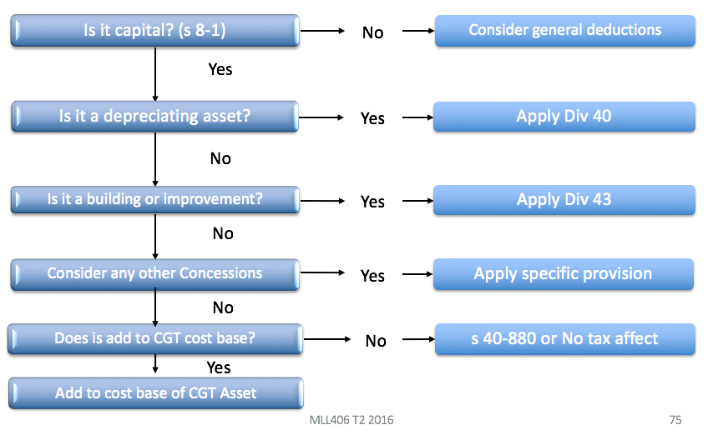

# TOPIC 3 – DEDUCTIONS



## Overview

* Structure of deductions
* Ordinary income
* Statutory income
* Exempt income
* Deductions are made up of:
* General deductions (8-1(1))
* Specific Deductions (8-1(2))
* Exclusions (8-5)

## Deductions (general and specific) and trading stock

* Section 8-1 ITAA 97 provides for **general deductions**.
* Section 8-5 ITAA 97 provides for **specific deductions**.
* Section 8-10 ITAA 97 indicates that if two or more provisions of the Act allow for a **deduction in respect of the same amount**, the deduction can only be made under the provision that is most appropriate.

## General Deductions

S 8-1 ITAA 97: General deductions

General deductions

             (1)  You can [*deduct*](http://www7.austlii.edu.au/cgi-bin/viewdoc/au/legis/cth/consol_act/itaa1997240/s995.1.html#deduct)from your [assessable income](http://www7.austlii.edu.au/cgi-bin/viewdoc/au/legis/cth/consol_act/itaa1997240/s995.1.html#assessable_income) any loss or outgoing to the extent that:

                     (a)  it is incurred in **gaining or producing your**[**assessable income**](http://www7.austlii.edu.au/cgi-bin/viewdoc/au/legis/cth/consol_act/itaa1997240/s995.1.html#assessable_income); or

                     (b)  it is **necessarily incurred in**[**carrying on**](http://www7.austlii.edu.au/cgi-bin/viewdoc/au/legis/cth/consol_act/itaa1997240/s995.1.html#carrying_on)**a** [**business**](http://www7.austlii.edu.au/cgi-bin/viewdoc/au/legis/cth/consol_act/itaa1997240/s995.1.html#business) for the purpose of gaining or producing your [assessable income](http://www7.austlii.edu.au/cgi-bin/viewdoc/au/legis/cth/consol_act/itaa1997240/s995.1.html#assessable_income).

Note:          Division 35 prevents losses from non-commercial [business](http://www7.austlii.edu.au/cgi-bin/viewdoc/au/legis/cth/consol_act/itaa1997240/s995.1.html#business) activities that may contribute to a [tax loss](http://www7.austlii.edu.au/cgi-bin/viewdoc/au/legis/cth/consol_act/itaa1997240/s995.1.html#tax_loss) being offset against other [assessable](http://www7.austlii.edu.au/cgi-bin/viewdoc/au/legis/cth/consol_act/itaa1997240/s995.1.html#assessable_income) [income](http://www7.austlii.edu.au/cgi-bin/viewdoc/au/legis/cth/consol_act/itaa1997240/s995.1.html#assessable_income).

             (2)  However, you cannot [deduct](http://www7.austlii.edu.au/cgi-bin/viewdoc/au/legis/cth/consol_act/itaa1997240/s995.1.html#deduct) a loss or outgoing [under](http://www7.austlii.edu.au/cgi-bin/viewdoc/au/legis/cth/consol_act/itaa1997240/s995.1.html#under) this section to the extent that:

                     (a)  it is a loss or outgoing of **capital**, or of a capital nature; or

                     (b)  it is a loss or outgoing of a **private or domestic nature**; or

                     (c)  it is incurred in relation to gaining or producing your [**exempt income**](http://www7.austlii.edu.au/cgi-bin/viewdoc/au/legis/cth/consol_act/itaa1997240/s995.1.html#exempt_income)**or your** [**non-assessable non-exempt income**](http://www7.austlii.edu.au/cgi-bin/viewdoc/au/legis/cth/consol_act/itaa1997240/s995.1.html#non-assessable_non-exempt_income); or

                     (d)  a **provision of**[**this Act**](http://www7.austlii.edu.au/cgi-bin/viewdoc/au/legis/cth/consol_act/itaa1997240/s995.1.html#this_act)**prevents you** from [deducting](http://www7.austlii.edu.au/cgi-bin/viewdoc/au/legis/cth/consol_act/itaa1997240/s995.1.html#deduct) it.

For a summary list of provisions about [deductions](http://www7.austlii.edu.au/cgi-bin/viewdoc/au/legis/cth/consol_act/itaa1997240/s995.1.html#deduction), see [section 12](http://www7.austlii.edu.au/cgi-bin/viewdoc/au/legis/cth/consol_act/itaa1997240/s12.html)-5.

             (3)  A loss or outgoing that you can [deduct](http://www7.austlii.edu.au/cgi-bin/viewdoc/au/legis/cth/consol_act/itaa1997240/s995.1.html#deduct) [under](http://www7.austlii.edu.au/cgi-bin/viewdoc/au/legis/cth/consol_act/itaa1997240/s995.1.html#under) this section is called a [*general deduction*](http://www7.austlii.edu.au/cgi-bin/viewdoc/au/legis/cth/consol_act/itaa1997240/s995.1.html#general_deduction).

**This means that you need to show one from the positive limb:**

* **1st** - **incurred in gaining** or producing your **assessable income; or**
* **2nd** - it is necessarily **incurred in carrying on a business** **for the purpose of gaining** or producing your **assessable income**

Note that the positive limbs are in the alternative.

**AND none of the four negative limbs to qualify for the deduction because you cannot deduct a loss or outgoing under this section to the extent that:**

1. it is a loss or outgoing of capital, or of a capital nature; or
2. it is a loss or outgoing of a private or domestic nature; or
3. it is incurred in relation to gaining or producing your exempt income or your non‑assessable non‑exempt income; or
4. a provision of this Act prevents you from deducting it

## Nexus with Income

* Nexus can mean a link or a connection especially a causal connection or a relation of interdependence (Butterworth’s Australian Legal Dictionary. 2011).
* Dixon J in *Amalgamated Zinc*: A very wide application should be given to the expression ‘incurred in gaining or producing the assessable income’
* Section 8-1(1)(a) ITAA 97 allows for a deduction “***in the course*** of gaining or producing assessable income”: *Amalgamated Zinc (De Bavay’s) Ltd v FCT* (1935)
* Similarly s 8-1(1)(b) ITAA 97 allows for a deduction to the extent that it is necessarily incurred in the carrying on of a business ‘or the purpose of gaining or producing your assessable income.’
* Required connection or ‘nexus’ between a loss or outgoing and the production of assessable income.
* **Over the years the courts have established a number of tests to determine whether there is sufficient nexus** between the loss or outgoing and the assessable income.
* Incidental and relevant test
* Essential character test

### 

## Judicial tests

See the following nexus tests below:

1. Incidental and relevant test;
2. Essential character test;
3. Occasion of the expenditure test.

**1. Incidental and relevant test**

* The most widely quoted and accepted refinement of the statutory language is the *incidental and relevant* test.
* *Herald and Weekly Times v FCT*
* *Amalgamated Zinc v FCT*
* *W Neveill & Co Ltd v FCT* (1937)
* Note these are under previous provisions relating to deductions.

|  |
| --- |
| *Herald and Weekly Times Ltd v FCT* HC   * *Legal expenditures incidental to producing income is deductible. Unintentional expenditures do not preclude deduction* * **Facts: TP** **published newspaper** and **incurred legal fees in connection with libel (defamation related) claim.** * VSC ultimately disallowed, as was not ‘productive’ expenditure. Was appealed by TP to the HC. * **Held**: by majority that the expenditure was wholly and exclusively laid out for the production of income and was deductible. * **Expenditure flows as a necessary or natural consequence from the inclusion of the alleged defamatory matter in the newspaper and its publication. Cannot be excluded simply because it was an unintended consequence (see Duffy CJ and Dixon J).** * Publication is the common source of income and liability – as **such the necessary connection between the carrying on of the business of the newspaper and the liability which causes the expenditure is complete (see Rich J).** * The use of descriptor ‘incidental’ was taken to mean that the payment was one of the consequences of publishing the paper and was in that sense incurred in carrying on a business even though was not directly productive of income. |

* Then look to *Amalgamated Zinc****,*** which provides expenditure must be relevant as well as incidental.

|  |
| --- |
| Amalgamated Zinc v FCT   * Expenditure must be relevant to the income received – cannot claim deduction for spending relating to previous income production * **Facts:** TP carried on business in Broken Hill. * Mining ceased in 1924. 1929 stocks, plant and machinery sold. * Only income derived was from investments. * However, **company remained liable to compensation payments to workers who contracted tuberculosis**. * For YE 1932 and 1933 **company claimed deduction for these compensation payments against its investment income**. * The Commissioner disallowed the claim on the grounds that the payments were made after TP ceased mining business. * **Held**: Payments were not deductible. * **Latham CJ:** suggested that it would be difficult to see how a loss could ever gain or produce assessable income. He concluded that the section should be read as meaning ‘**losses or outgoings actually incurred *in the course of* gaining or producing … assessable income’** (emphasis added). * On the facts of this case the outgoings had no relation to the assessable income of the years in question. * **Dixon J:** A **very wide application should be given to the expression ‘incurred in gaining or producing the assessable income**’… * In the **present case, the actual expenditure was met in the current year. But it was completely dissociated from the gaining or producing of assessable income of that year.** The payment, in effect, did no more than keep down an **actual charge arising out of a business which had closed**. It is a charge of uncertain duration and of uncertain amount…It was a payment independent of the production of income. * Must be incidental and relevant * Only a few sentences required to explain this, no in-depth explanation is required |

**2. Essential Character Test**

* Does the deduction carry an essential character the relates to the work or business income
* Must be of a work or business nature
* This **test derives from the *Charles Moore & Co (WA) Pty Ltd v FCT* (1956) 95 CLR 344 and the *Lunney v FCT* (1958) 100 CLR 478**, 7 AITR 166, 11 ATD 404 cases.

|  |
| --- |
| *Moore & Co (WA) Pty Ltd v FCT* (1956) 95 CLR 344   * *Loss incurred by way of robbery amounts to a deduction of robbery occurs ‘in the course of business’* * **Fact:** Employee robbed on way to bank with day’s takings. * as the **daily banking of takings by a department store was an ordinary part of its income-producing activities, the loss of the takings by armed robbery en route to the bank was deductible** as a loss incurred in gaining or producing assessable income * **deduction was allowed as it was held to be “in the course of business”.** * speaking of the meaning of the phrase ‘incidental and relevant’ said that the words: * … do not refer to the frequency, expectedness or likelihood of (the loss or outgoing) … but to their nature or character. What matters is their connection with the operations which more directly gain or produce the assessable income. |

|  |
| --- |
| *Lunney v FCT* (1958) 100 CLR 478   * *Travel to and from work is not deductible as essential character of expenditure is personal option of getting to work* * Two appeals heard concurrently. Lunney an employee and Hayley a dentist. * Both claimed a deduction for travel to and from work. * Lunney claimed the travel was “essential” as he could not earn income were he not at work. * **Held: Not deductible - Williams, Kitto and Taylor JJ:** the words ‘incidental and relevant’ have been intended as a reference, not necessarily to the purpose for which an item of expenditure has been incurred, but, rather, to the *essential character* of the expenditure itself… * To say that expenditures on fares is a prerequisite to the earning of a taxpayer’s income is not to say that such expenditure is incurred in or in the course of gaining or producing his income. Whether or not it should be so characterised depends upon considerations which are concerned more with the essential character of the expenditure itself than with the fact that unless it is incurred an employee or a person pursuing a professional practice will not even begin to engage in those activities from which their respective incomes are derived. * The court considered that the travel expenses were ‘at the most … a necessary consequence of living in one place and working in another’. * **McTiernan J** **dissented** stating that was unduly narrow construction of first +ve limb to confine to expenditure made in bare physical and temporal limit of workplace. * **Note:** This has been since **legislated in s25-100 ITAA97 which allows certain travel as deductible (between workplaces)** and **refuses other (home to work)**. |

**3. Occasion of the expenditure test**

* Courts have considered whether the *occasion of the expenditure* arises out of income-producing activities: *FCT v Payne* (2001) and *FCT v Day* (2008):
  + What is meant by being incurred 'in the course of' gaining or producing income is that:
  + To come within the initial part of [s 8-1] it is both sufficient and necessary that the occasion of the loss or outgoing should be found in whatever is productive of actual or expected assessable income.
* Requires an assessment as to what is productive of the taxpayer’s assessable income.
  + Nexus requires a connection between the expenditure and the taxpayer’s operations or activities directed to the production of assessable income.
    - Need to determine what is productive of the taxpayer’s assessable income by considering the scope and nature of the taxpayer’s operations or activities.
* Note: There is no requirement that the expenditure be matched with assessable income in the same income year – **question is – is the activity to which the expenditure relates “productive” of assessable income**

## Nexus sufficiently direct or too remote

* If the nexus between the expense and the production of assessable income is too remote, it is not deductible
* Some cases exist where it is questionable as to whether a nexus can be established, for example:
  1. Expenses involving alleged or actual wrongdoing by the taxpayer;
  2. Expenses to reduce future expenses;
  3. Involuntary losses or outgoings
* **Expenses involving alleged or actual wrongdoing**

Nexus satisfied for expenses arising from alleged or actual wrongdoing incurred by:

* Employees defending **improper conduct charges** which are “**quasi-personal**”: *FCT v Day* (2008).
  + Day incurred expenses defending charges under the public services act, the reason he had to defend the charges at all were cause of his conditions of employment – this deductible under the first limb.
* Business taxpayers in respect of defending claims (e.g. for **libel actions**) arising out of the ordinary course of business: *Herald and Weekly Times v FCT* (1932) and *FCT v Snowden v Willson Pty Ltd* (1958).
  + Articles that are not correct and ruin people’s reputation, the newspapers settle these claims (the occasion of the payments- settlements arise out of the earning activities – Selling newspapers), and it is a **regular and unavoidable incident of publishing**, thus deductible under the first limb.
* **Company directors** incurring costs to defend criminal charges: *Magna Alloys & Research Pty Ltd v FCT* (1980).
  + Costs in defending criminal charges against the directors, deductible as the charges arose because the directors were charged of boosting commissions. The charges reflected a**dversely on the reputation of the directors and thus the company’s**, hence the company incurring the legal expenditure was held to be a sufficient nexus.
* Expenses related to **illegal** business: *FCT v La Rosa* (2003).
  + La Rosa was a drug dealer and sought a deduction for being robbed when he was out selling drugs (carrying on his business) – upheld as a valid deduction. Note s 26-4 now prevents deductions for illegal activities.

1. **Expenses to reduce future expenses**

* Nexus established between an expense that improves the taxpayer’s business overall and reduces future expenses
* Termination payment to end a contract of employment for inefficient staff: *W Nevill and Co Ltd v FCT* (1937) – Terminating a managing director through a termination payment – allowed.
* As long as it improves the taxpayers business overall it has has that nexus.

1. **Involuntary losses or outgoings**

* Nexus established between an involuntary loss where it arises out of the taxpayer’s income-producing activities
* Day’s earnings stolen **while on way to the bank**: *Charles Moore & Co (WA) Pty Ltd v FCT* (1956).

## Sufficient temporal nexus

1. **Expenses related to the production of assessable income in future years**

An expense incurred to gain or produce assessable income in the future may satisfy the nexus requirement

* **Interest associated with the purchase of an asset** which was expected to produce income in the future was deductible (only preliminary expenditure that is allowed- exception): *Steele v DCT* (1999) - **Interest on a loan for land was deductible even though she had not yet commenced a earning activity**, she was **planning on building a motel on the land**.
* However the taxpayer must show that the asset can only be used for an income producing purpose

However, nexus may not be established where:

* The expense is too **preliminary for a business that has** **yet to commence**: *Softwood Pulp and Paper Ltd v FCT* (1976) (e.g. feasibility studies)
* The expense is to put an **employee in a position to gain or produce assessable income**: *Lunney v FCT; Hayley v FCT* (1958)*.*

**Example:**

Jake is an accountant who migrated to Australia three years ago. As part of establishing himself in Australia, he intends to invest in the property market. As Jake is not familiar with the Australian property market, he engaged the assistance of a property broker to assist with finding a suitable investment property. The broker charged an upfront fee of $5,000. Six months later, the broker located a vacant block of land and suggested that Jake develop three townhouses on it.

The cost of the land ($1 million) and estimated development costs ($900,000) exceeded Jake’s budget and he decided to undertake the venture with a business partner. The agreement with the business partner was that Jake would purchase the land and the partner would incur all development costs. The profits from the eventual sale of the townhouses, expected to be in 18 months, would be split equally between Jake and the partner. Jake established a $1 million line of credit facility with his bank and used the money to purchase the land. The interest rate on the facility was 18.5% per annum.

**Explain whether the general deductions nexus under s 8-1 has been satisfied in relation to the brokers fees and bank interest charges.**

*Broker fee is incurred too soon: Softwood Pulp and Paper Ltd v FCT* (1976

*Interest: Deductible under Steele v DCT* (1999)

1. **Expenses related to the production of assessable income in prior years**

Likely to be deductible providing the expense relates to the time when the business was operating (was caused by the prior activity) **Cessation is irrelevant**. For example:

* **Satisfaction of obligations arising from previous business**: *Placer Pacific Management Pty Ltd v FCT* (1995): Subsequent to cessation the TP had expenditure relating to equipment in a factory (expenditure related to obligations incurred when the business was operating – maintaining conveyor belts)
* **Interest expense on a business**: *FCT v Jones* (2002): Mr Jones (original owner of business) died. Mrs Jones closed down the business and sold everything but did not have enough funds from liquidation to pay interest on business loans she was obliged to pay. Only obliged to pay loan because of prior earning activity of the business – thus a sufficient nexus.
  + **Note**: If she was using the loaned money for other activities then it would not be deductible

## ‘Necessarily incurred’

* The **second limb differs from the first limb by requiring that the loss or outgoing be ‘necessarily’ incurred**.
* **‘Incurred’**: the obligation to pay it
* **‘Necessarily’**: the payment was required
* The courts have considered what is meant by saying that the loss or outgoing is ‘necessarily’ incurred; that it relates to ‘carrying on a business’ and that the business be ‘for the purpose’ of gaining or producing assessable income.
* Where the word *necessarily* is concerned, this was not interpreted strictly by the courts.
* **Incurred is about the timing of the deduction. A TP must be definitely committed but obligation need not be indefeasible. Must be an obligation to which TP is completely subjected**.

|  |
| --- |
| *FCT v James Flood* (1953) HC   * *Deduction evident once the obligation is actually paid for – this is what is meant by ‘incurred’ – no deduction for potential expense* * **Facts:** TP (Flood) carried on business as motor-body builder/engineer. * An amount of £1888 was included as ‘holiday and sick pay’ and in this amount was £578 that was accrued through an account ‘provision for holiday pay’ but was never paid. * Deduction for this amount was disallowed as Comm said not incurred. * TP said that after 12 months employees were entitled to holiday pay. If worked less than 12 months then there was no entitlement to this pay. * **Dixon CJ, Webb, Fullagar, Kitto and Taylor JJ Held**: Disallowed claim/deduction. * ‘It is one thing, however, to say that it is not necessary…that an actual disbursement should have taken place. It is another thing to say that in the present case the taxpayer had incurred a loss or outgoing in the year of income in respect of the pay of its men during the annual leave to be taken in the ensuing accounting period by employees whose service had not as yet qualified them for annual leave. * There was not an accrued obligation, whether absolute or defeasible. In short the deduction claimed of £578 does not represent an expenditure associated with the production of income… for which a liability had been completely incurred before that date |

|  |
| --- |
| Nilsen Development Laboratories P/L v FCT (1981) 144 CLR 616   * *Need actual obligation to pay out the expenditure, cannot deduct expected costs* * **Facts:** TP claimed deductions for accrued annual and long service leave entitlements. * Some were satisfied in the sense that employees had accrued the time for entitlement. * Prior to 1974 company raised money for accrued provisions and claimed YE1974, however no leave was in fact taken that year. * **Held:** No loss or outgoing was incurred…Even though the leave payments were inevitable and indefeasible, the TP was not under present obligation to make the payment until such time as the e’ees took the leave or payments in lieu of leave. * Referred to Dixon J in *New Zealand Flax Investments –* ‘incurred…does not include a loss or expenditure which is no more than pending, threatened or expected’ adding that: ‘no matter how certain it is in the year of income that the loss or expenditure will occur in the future’. |

* NB **s 26-10 ITAA97** now defers deduction for leave until payment is made.

|  |
| --- |
| *FCT v Snowden & Willson Pty Ltd* (1958) HC   * *Operator of business has best judgement on whether spending was necessary unless obviously unreasonable* * **Facts: Company paid a director to retire (large one-off sum) and claimed a deduction**. Argument ensued regarding the nature of the payment and whether it was “necessarily incurred” for the business. * **Dixon CJ held:** that it meant ‘dictated by the business ends to which it is directed, those ends forming part of, or being truly incidental to the business’. * **Court held that an outgoing need not be “necessary” but whether the people in the best position to decide that thought it was ‘appropriate and adapted’ or ‘reasonable’ for the future of the business. The court allowed the deduction** **here.** * The result of this case is that when (in particular) applying s8-1(1)(b) and whether a payment is “necessarily incurred” in the course of business – the person running the business is in the best position to decide (within reason). |

* **Don’t go on about whether the business owner could have spent money better elsewhere, refer to this case and state that the business owner is in the best position to decide**. Only go into analysis where it is clearly ridiculous spending

Example:

A famous film actor, Brad, hired an agent, paying her an annual salary of $150,000 per annum. It was noted that at 30 June 2015, Brad owed $15,000 to his agent. He paid this amount on 6 July 2015.

**In what year is the deduction incurred for tax purposes?** *Year ending 30 June 2015 – year obligation was incurred.*

## What are losses or outgoings

* Most obviously amounts claimed under 8-1 will be outgoings, the things that you consider to be business expenses such as interest, rent, wages etc.
* **Examples of loss include:**
* Sale of an item for an amount less than its cost or discharge of a liability for more that its face value.
* Involuntary loss through fire or theft.
* Outgoings may be thought of as voluntary actions on the part of the taxpayer and loss for example is the situation in Charles Moore case (theft of daily takings).

## Apportionment

* The phrase **‘to the extent’,** that is contained in both the positive and negative limbs, has been taken to mean that mixed expenses should, if necessary, be apportioned.
  + E.G. Phone bill, use 60% for business purposes.
* That is, if **part of an expense does satisfy the requirements but another part does not**, a determination must be made as to how much relates to each. This is so regardless of whether the different amounts are easy to calculate or not and is to be contrasted with the treatment of mixed gains under judicial principles of ordinary income: *McLaurin v FCT* (1961) 104 CLR 381, 8 ATR 180, 12 ATD 273.
* Losses and outgoings are allowable deductions ‘to the extent that’ they are incurred in he course of activities directed to the gaining or producing of assessable income. ‘To the extent that’ 🡪 this implies apportionment of a composite expenditure is ok.
* This will allow apportionment of an outlay that in part satisfies and in part fails the +ve parts of s8-1.

|  |
| --- |
| *Ronpibon Tin NL v FCT*   * *Key case describing the methodology of apportionment - you may apportion deductions on reasonable grounds* * **Facts:** Companies carried on business of tin mining in Siam and Malaya. * Income was exempt under former provisions. * Mine was overrun (enemy forces) in 1942. * They also derived income from investments in Australia. * Continued to incur expenses following the loss of the mines – management and director fees, audit and admin fees. * These amounts were previously allowed as deductions (pre-loss of the mine) and when mine overrun and they continued to seek deductions for these amounts (post-loss of the mine), and offset them against investment income. * **Issue:** Can they claim deductions for the investment income even after the mine was overrun? * **Held:** Amounts **related to mining matters were affairs of capital and not deductible** (under first limb of previous provision). * There **was no guarantee that the mines would produce income again**. The % of admin costs that were deductible were remitted to trial judge for determination (ultimately some were remitted). * **Some outgoings related to exempt income – cant claim deduction for production of income that has ceased** * The charges for management and directors’ fees are entire sums which probably cannot be dissected. But the provision… contemplates apportionment. * **There must be some fair and reasonable assessment of the extent of the relation of the outlay to assessable income.** * This should be compared to the income side where in admittedly rare cases, **courts sometimes said that if a lump sum mixed income and non-income items with no objective way to identify the ratio, then no part of the entire sum could be said to be assessable income:** *McLaurin v FCT* (1961) 104 CLR 381, 8 ATR 180, 12 ATD 273. **The same is certainly not true on the deduction side because of the words ‘to the extent that’**. * **Two elements are evident:**  1. **Dissection** – where **for example one invoice contains different amounts that relate to business purposes and private purposes**. This is relatively straightforward.  * **Eg.** Receipt that has business related expenses, as well as an expense for an Xbox One for personal use.  1. **Apportionment** – **done on fair and reasonable grounds** where a single outlay serves two or more objects indifferently.  * **Eg** would be reasonable to deduct $2,000 for a two week holiday that comprised of 1 week for work and 1 week for leisure |

**The legal basis for apportionment**

* When apportionment issue arises, ask (1) upon what basis is the disallowable element to be identified? And (2) how is the disallowable element to be apportioned?
* The answer to the first question is found in legal principles and the second is a question of fact.

Example:

Sulin is an accountant at a large accounting firm. In May, she went to Hong Kong for an accounting conference. She incurred expenses of $2,000 on the plane ticket and $500 on hotel costs. Sulin had chosen to go to the conference because her family is in Hong Kong and she took the opportunity to visit them while she was there. The conference ran for two days and she stayed on for an additional four days at her parents' home.

**Advise Sulin as to the deductibility of the airfare and the hotel costs.**

*S 8-1 “in the course of gaining assessable income’*, *Ronpibon Tin NL v FCT tells us we need to apportion. Here her self-education travel, meal and accommodation expenses are deductible in regards to the two days. Her hotel costs would be deductible in the full as she as she later stays at her family home, but her plane ticket would need to be apportioned as there are two purposes for the travel expense arguably (for example deduct $1,000 – 50%).*

## Tax minimization situations - Purpose

* A taxpayer’s subjective purpose or intention in incurring an expense may be considered where:
  + The taxpayer is in a loss position; and
  + The taxpayer’s purpose in incurring an expense appears to be one of tax minimisation: *Ure v FCT* (1981) and Fletcher v FCT (1991)

Look to the following from *Magna Alloys & Research P/L v FCT* :

1. **Motive** – the reason why taxpayer decided to incur expenditure. However note that taxpayer motive seldom an issue. *Ronpibon Tin*said it is not for the Court or Commissioner to say how much a taxpayer should spend.
2. **Subjective purpose** – the object which the TP intends to achieve.
3. **Objective purpose**- the object which the incurring of the expenditure is apt to achieve.

|  |
| --- |
| *Ure v FCT* |

Example:

Jake is an accountant who migrated to Australia three years ago. As part of establishing himself in Australia, he intends to invest in the property market. As Jake is not familiar with the Australian property market, he engaged the assistance of a property broker to assist with finding a suitable investment property. The broker charged an upfront fee of $5,000. Six months later, the broker located a vacant block of land and suggested that Jake develop three townhouses on it.

The cost of the land ($1 million) and estimated development costs ($900,000) exceeded Jake’s budget and he decided to undertake the venture with a business partner. The agreement with the business partner was that Jake would purchase the land and the partner would incur all development costs. The profits from the eventual sale of the townhouses, expected to be in 18 months, would be split equally between Jake and the partner. Jake established a $1 million line of credit facility with his bank and used the money to purchase the land. The interest rate on the facility was 18.5% per annum.

**Would your response to the deductibility of the bank interest charges change if, instead of buying the block of land himself, Jake on-lent the funds to his sister at an interest rate of 3% and Jake’s sister purchased the block of land in her name?**

*Yes, his reduction will be reduced from the 18.5% interest, to the 3% interest.*

|  |
| --- |
| *FCT v Phillips* (1978) 8 ATR 783   * *Expenditure must be commercial and realistic for apportionment* * **Facts:** TP was partner in accounting firm * As a guard against potential litigation the firm established a service trust (supply the use of equipment, staff, premises and administration services to their main business entity) * Interests in trust held by the partners in proportion to their partnership interests – ultimate beneficiaries were family members. * The **firm then paid a commercial (and realistic) fee to the trust for use of assets and the provision of services.** The partnership claimed a deduction for the service fee. * **Held was deductible** * **Bowen CJ and Deane J**: deduction allowed as **no additional collateral advantage that could be said to be the object of the expenditure**. * **Fisher J**: **services were essential to operation of partnership and charge was commercial and realistic**. Supported the view that it was exclusively for business purposes. * **Decision framed in terms of objective purpose of expenditure. Excessive expenditure may give impression that additional objectives sought**. * If some of the spending was reasonable and some wasn’t, it can be apportioned and the reasonable spending can be deducted |

|  |
| --- |
| Magna Alloys & Research Pty Ltd v FCT (1980) 11 ATR 276   * *Deduction is allowable for self-driven interests if purpose connected to business* * **Facts:** TP employed a number of agents to sell its products on an incentive basis. * As a result of an investigation, certain company directors and agents were charged with criminal offences. * **Legal costs of $285,762 were incurred.** * Sought to deduct the costs. * **Held: FFC allowed the appeal and stated that the fact that defending the personnel was driven by directors’ self-interest did not prevent the expenses being necessarily incurred in carrying on business**. * **Purpose is relevant to describe an element of connection between expenditure and a taxpayer’s undertaking or business** in cases where a taxpayer incurs expenditure…where the occasion of the expenditure… is not manifestly to be found in whatever is productive of assessable income (ATC 4544 and 4548). * It is not essential… that such outgoings be shown to have been incurred with a dominant motive characterised by a lack of self-interest or generosity before they can be said to have been necessarily incurred in carrying on the particular business (ATC 4560). |

|  |
| --- |
| Fletcher v FCT (1991) HC   * **Facts:** TP in partnership with 3 others entered an annuity (allowance) agreement * Arrangement was calculated to return neutral cash flow with high tax deduction and high assess income, esp in last 5 years * Could be terminated in last 5 years * In the relevant year the partnership claimed assess income of $170k and deductions of $360K * FCT contended that interest deduction should be apportioned and disallowed to the extent that it exceeded partnership income * AAT determined whether would run for full term of 15 yr or be terminated in last 5. If full 15 years then assess income would exceed deductions and would be allowable. In the second case, an explanation must be sought for the excess deductions (some $2.7M) over assess income, and to the extent that the explanation lay in substantial tax advantages, the outlays were not incurred in producing assess income. * Commonsense or practical weighing of all the factors to provide for ultimate answer. * Question usually arises where deduct>AI etc * **‘In’ (‘in gaining or producing’; ‘in carrying on a business’)** * This refers to nexus and the connection between expenditure and income or business. * **Purpose** * This appears only in the second positive limb. See s 8-1(1)(b). Purpose of assess income production, not a hobby etc. |

**Carrying on business**

* In regard to the phrase ‘in carrying on a business’ in the second positive limb, the **word business is defined to include ‘any profession, trade, employment, vocation or calling’ but does not include ‘occupation as an employee’ (**Section 995-1). Thus employee deductions must be considered under the first positive limb alone.
* Where other activities are concerned, the **courts have indicated that the important requirement is the *carrying on* of the business**. ***Ferguson* establishes whether a person is carrying on a business**. Expenses incurred prior to the commencement of a business would not satisfy this expression – see previous topic.

## S 8-1 (2): The Negative Limbs

* **IMPROTANT:** For a deduction **you need at least one positive limb and no negative limbs. Remember it can be apportioned if possible.**

(2)  However, you cannot [deduct](http://www7.austlii.edu.au/cgi-bin/viewdoc/au/legis/cth/consol_act/itaa1997240/s995.1.html#deduct) a loss or outgoing [under](http://www7.austlii.edu.au/cgi-bin/viewdoc/au/legis/cth/consol_act/itaa1997240/s995.1.html#under) this section to the extent that:

                     (a)  it is a loss or outgoing of **capital, or of a capital nature**; or

                     (b)  it is a loss or outgoing of a **private or domestic nature**; or

                     (c)  it is incurred in relation to gaining or producing your [**exempt income**](http://www7.austlii.edu.au/cgi-bin/viewdoc/au/legis/cth/consol_act/itaa1997240/s995.1.html#exempt_income) or your [non-assessable non-exempt income](http://www7.austlii.edu.au/cgi-bin/viewdoc/au/legis/cth/consol_act/itaa1997240/s995.1.html#non-assessable_non-exempt_income); or

                     (d)  a provision of [**this Act**](http://www7.austlii.edu.au/cgi-bin/viewdoc/au/legis/cth/consol_act/itaa1997240/s995.1.html#this_act)**prevents** you from [deducting](http://www7.austlii.edu.au/cgi-bin/viewdoc/au/legis/cth/consol_act/itaa1997240/s995.1.html#deduct) it.

## Negative Limb 1: Capital or of a Capital nature

* *Ronpibon Tin NL v FCT*(above) deduction was regarded as capital
* The distinction between capital and revenue expenses is not defined in the legislation. The leading decision on the deduction side is *Sun Newspapers Ltd v FCT* (1939) 61 CLR 337.
* The test is sometimes described as the structure/process test in that Dixon J sought to draw a distinction between structural expenses, being capital expenses and process expenses, as allowable deductions. Example:
* **Structure:** Buying a building for a law firm
* **Remember in Topic 2**: **Where the business as a whole is effected by the expense, it will amount to capital; thus being characterised as ‘structure’**
* **Process:** Paying the lawyers for their work

|  |
| --- |
| *Sun Newspapers and Associated Newspapers Ltd v FCT* HC   * *MUST BE MENTIONED Structure and Process Test – once off, long term spending is likely capital in nature* * **Facts:** Sun Newspapers published journals. Associated Newspapers held nearly all the shares in Sun and entered into an agreement with rival newspaper of £86,500 if agreed not to publish within 300 miles of Sydney for 3 years amongst some other controls. The rival co went out of business as a result. Payment was claimed by Sun/Associated as deduction. * **Held: No part of the outgoing was allowable as capital in nature** * **Dixon J: Three** matters to consider:  1. The **character of the advantage sought**, and in this its lasting qualities may play a part;  * Long term quality is more likely to be capital * Whether the expense has a lasting (capital) or temporary (revenue) benefit  1. The **manner in which it is to be used**, **relied upon or enjoyed** and in this and under the former heading **recurrence may play a part**;  * Requires a consideration of whether the benefit is used one-off (capital) or recurrently (revenue)  1. The **means adopted to obtain it**; that is by providing a periodical reward or outlay to cover its use or enjoyment for periods commensurate with the payment or by making a final provision or payment so as to provide for future use or enjoyment.    * Whether the benefit was obtained through a one-off payment (capital) or recurrent payment (revenue).  * **Process:** Receipts arising in the ordinary operation of a business will be on revenue account. * **Structure (Capital):** Receipts relating to the loss or destruction of the profit making structure will be capital in nature. * **Business Entity Test (is it structure or process?)** is currently the determinative test, but we have some other cases that discuss ‘enduring benefit test’ and ‘once and for all test’ which may assist |

**Some other cases (use these cases with *Sun Newspapers test*)**

|  |
| --- |
| *Broken Hill Theatres*   * *Making a payment to secure a monopoly will likely result in ‘structure’ = capital* * **Dixon CJ** and **court agreed business entity test (*Sun Newspapers*) is the correct test to use (over the EBT)** * TP operated cinema/theatre * Competitor wanted to open cinema nearby * TP spent legal fees opposing this, succeeded. Competitor could re-apply license in 12m * Deductible? * **HELD:** no, **capital** * **Business entity test** 🡪 **being able to maintain monopoly connected with structure** |

|  |
| --- |
| *Snowden & Wilson* and *Magna Alloys*   * *Expenses on goodwill can either go to process or structure – depending on whether the goodwill impact is long term* * **Both related to businesses protecting their reputation (goodwill)** * Snowden & Wilson – legal fees and advertising cost defending before royal commission * Magna – defending employees from criminal charges relating to their work * **Held:** ***Snowden*:** Not capital – resulted in process, ***Magna*:** Capital, expense on legal fees for the bad goodwill caused the whole business to close down = structure * Part of process of running the business, went to process and not structure * Think about whether the goodwill expense is to effectively protect the business as whole (eg. Legal expenses on a huge defamation claim against business is likely to be capital) |

|  |
| --- |
| *BP Australia**Recurring lump sum payment every 5 years is process based – Revenue in nature*  * Petrol stations sold many brands petrol * BP offered them money only to sell BP brand * Paid them lump sum in return for them only selling BP (average agreement was 5 years) * **HELD**: **revenue and deductible (borderline case)** * Applied business entity test concluded went to process not structure. * No long lasting benefit, recurring payments * Note: ***Strick v Regent Oil*** where similar facts but agreement average longer (10-20yrs) and held capital. |

|  |
| --- |
| Strick v Regent Oil Co Ltd (1996)   * *CONTRASTS BP – lump sum payment every 10-20 years resulted in capital in nature* * TP secured exclusive sales through lease premium arrangement. * Retailers leased stations to TP for between 10 -20 years in exchange for lump sum lease premium * TP then sublet back to the retailers a nominal rent on condition sold their oil exclusively. * **HELD CAPITAL** * The fact that was over 20 years was influential – important that they provided substantially longer benefit than in BP case |

|  |
| --- |
| *National Australia Bank Ltd v FCT* (1997)   * *Revenue in nature* * NAB paid the government a lump sum to become an exclusive lender under a government loan scheme * Taxpayer sought to increase customer base and income from loans (not monopoly/structure). Became the exclusive provider of low interest loans to defence force personnel. * **Issue:** Was the lump payment deductible? Or was it a payment for a monopoly (capital)? * **Held:** Deductible,court upheld BP oil decision, **simply a payment to gain access to another group of customers**. * Held that it was not a monopoly structure as the defence force personnel did not have to take the loan, they could get it from somewhere else. It was simply a payment that enabled NAB to gain access to customers, but it was still up to these customers whether to take the product or not. |

|  |
| --- |
| *Colonial Mutual Life Assurance Society Ltd v FCT* (1953)   * *Capital in nature* * Taxpayer acquired a block of land * Payments made to vendor were structured as a “rent charge”, with monthly payments over 50 years. * **Held:** Really instalments of purchase price of asset. TP had the benefit of enduring benefit. |

## Negative Limb 2: Private or Domestic Expenses

* The distinction between private and domestic expenses on the one hand and business or employment related expenses on the other is not defined in the legislation. Losses and outgoings are NOT deductible under 8-1 to the extent that they are private or domestic in nature.
* Losses or outgoings that are incurred in gaining or producing **exempt** or non-assessable non-exempt income are not deductible under s 8-1.
* The first conceptual issue with this negative limb is whether a determination that an expense satisfies one of the positive limbs, necessarily leads to the conclusion that the expense cannot be private or domestic. That is, are they mutually exclusive categories? In *FCT v Hatchett* (1971) 125 CLR 494:
* **Menzies J**: *It must be a* ***rare case where an outgoing incurred in gaining assessable income is also an outgoing of a private nature****. In most cases the categories would seem to be exclusive*.
* In *FCT v Forsyth* (1981) 148 CLR 203 and *Handley v FCT* (1981) 148 CLR 182, the High Court indicated that expenditure of a domestic nature may nevertheless satisfy one or either of the positive limbs.
* E.g. additional food consumed by a professional sportsperson was to put the taxpayer in a position to carry out income-producing activities (private / domestic): *FCT v Cooper* (1991).

## Denied deductions

Examples:

* Certain **penalties** imposed under Australian or foreign laws: s 26-5
* Expenses related to **rebatable benefits** (eg, Austudy): s 26-19
* Repayments of certain **student assistance loans** owing to the Government in respect of studies (eg, higher education): s 26-20
* **Political gifts or donations** made by business taxpayers: s 26-22
* **Relative’s travel expenses**: s 26-30
* Excessive amounts paid to related entities: s 26-35
* **Recreational club** expenses: s 26-45(2)
* **Bribes to foreign public officials** & public officials: ss 26-52 and 26-53
* Expenditure relating to **illegal** activities: s 26-54
* Travel expenses related to earning assessable income **from residential premises**: s 26-31

**Reimbursed expenses**

* Taxpayers are **denied a deduction for expenditure that has been reimbursed**: s 51AH ITAA36
  + Taxpayer is not actually out-of-pocket.

**Entertainment expenses**

* Entertainment expenses are not deductible under s 8-1, unless an exception applies
  + Definition of “entertainment” is broad: includes, “food, drink or recreation”: s 32-10(1).
* Exceptions include:
  + Entertainment provided by way of a fringe benefit: s 32-20
  + Allowance to an employee that is included in the employee’s assessable income: s 32-30
  + Provision of food or drink to an employee under industrial arrangements relating to overtime: s 32-30
  + Promotion and advertising expenses: s 32-45.

**Expenses incurred in gaining employment**

* Expenses incurred in gaining employment are considered too early for the production of assessable income:
  + See, *FCT v Maddalena* (1971).
* However, a distinction is made if the taxpayer is carrying on a business:
  + Professional sports people incurring costs for the negotiation of employment contracts (management fees) deductible: *Spriggs v FCT; Riddell v FCT* (2009).

**Relocation expenses**

* Expenses incurred by a taxpayer in relocating his or her home have been held to be non-deductible:
  + Puts the taxpayer in a position to produce assessable income, rather than incurred in gaining or producing assessable income: *Fullerton v FCT* (1991).

**Childcare expenses**

* Child care expenses are non-deductible
  + Puts the taxpayer in a position to produce assessable income, rather than incurred in gaining or producing assessable income: *Lodge v FCT* (1972)
  + Also likely to be private or domestic in nature: s 8-1(2)(b).

**Travel between home and work**

General rule:

* Expenses for travel between a taxpayer’s ordinary home and regular work location is not deductible: *Lunney v FCT; Hayley v FCT* (1958) and Draft Ruling TR 2017/D6

**Exceptions:**

However, may be considered deductible “work travel” if there are special demands:

* “Fly in-fly out” workers subject to employer’s direction and control during period of travel: *John Holland Group Pty Ltd v FCT* (2015)
* Outside normal work hours where work at home has started prior to undertaking travel: *FCT v Collings* (1976)
* By itinerant workers: *FCT v Wiener* (1978). Multiple unrelated jobs not requiring travel ≠ itinerant worker:   
  *Re Hill v FCT* (2016)
* By taxpayers who are required to carry bulky items to perform employment duties: *FCT v Vogt* (1975) and *Rafferty v FCT* (2017)
* To alternative workplaces on a temporary basis: *FCT v Ballesty* (1977).

## Travel expenses

* **Note** see above for travel between home and work

**Travel between two places of work**

* Under common law, travel between **unrelated** workplaces are not deductible under s 8-1: see *FCT v Payne* (2001)

Statutory position (s 25-100):

* Deduction allowed for travel *directly* between two workplaces where the taxpayer is engaged in income-producing activities
  + Not deductible if a workplace is the taxpayer’s residence.

|  |
| --- |
| *FCT v Collings*   * *Travelling to and from work if you’re ‘on call’ is deductible (contrasts Lunney)* * TP was computer consultant * After hours was sometimes on call. When on call after hours she would deal with queries from home, if couldn’t resolve would travel to office to deal with them. * **HELD**: travel between work and office when on call was deductible in this case * Was ‘in the course of’. Came within 1st +ve limb and none of the negative * NB wont apply if just working from home as matter of convenience |

|  |
| --- |
| *FCT v Payne**Travel not deductible* ***if not*** *‘in the course of’ the same business – pilot travel from airport to farm is not deductible – reflect 25-100(3)*  * **Reflects 25-100(3) – travel expenses not deductible if not ‘in the course of’** * TP pilot for Qantas * Also owned a deer farm where he lived * Wanted to deduct for travel between Syd airport and farm (2 unrelated places) * **HELD:** not deductible * Court emphasized ‘in the course of’… because had two diff IEA was not in the course of. Similar to Lunney, that travel in either case was before production of AI started |

## Self-Education expenses

**Relating to taxpayer’s current career**

Sufficient connection to the production of the taxpayer’s assessable income when:

1. Earning higher income in existing career

|  |
| --- |
| *FCT v Hatchet (1970)*   * *Need to show nexus between the education and earning the income – just because the expense ‘will make you better at your job’ is insufficient* * Teacher who wanted a deduction for both: * Fees for higher certificate that would lead to higher pay scale * Enrolment for subject in arts degree (failed subject) * **Held**: could deduct first not second * Re the second, fact that degree might make someone better at job **not enough** to make it deductible, need to show connection with degree and earning the income |

1. Improving prospects of promotion

|  |
| --- |
| *FCT v Studdert* (1991   * *Deductible where self-education would lead to a promotion and high income* * TP was Qantas flight engineer * Undertook flying lessons and claimed these would lead to a promotion and higher income * **Held**: deductible * Flying lessons could improve performance as a flight engineer and improve prospects of promotion * **Note** **s 82A first $250 a year is excluded** |

1. Requirement to stay up to date: TR 98/9 – e.g. PD for an accountant or lawyer.

**Travel expenses relating to self-education**

* May be deductible when travel relates to income-producing activities.

High Court in *FCT v Finn* (1961) suggested the following factors to determine deductibility:

1. Whether there is **employer support** for travel
2. Clear evidence that the travel was devoted to the collation of information related to income-producing activities; and
3. Resulting from (2), whether there will be an improvement of opportunities for promotion and/or more income.

* Not necessary for all factors to be satisfied. Depends on individual’s circumstances.

**Not related to employment income**

* Self-education expenses potentially deductible where the receipt of income is conditional on the recipient making satisfactory educational progress: See, *FCT v Anstis* (2010)
  + Note, a deduction for expenses related to rebatable benefits specifically denied by s 26-19.

**Non-deductible self-education expenses**

* Payments made under the *Higher Education Support Act 2003* (Cth) (eg, HECS-HELP fees): s 26-20.
* **First $250** of self-education expenses: s 82A ITAA36.
* Apportionment required where self-education expenses are both income-producing and private in nature.

## Clothing & dry cleaning expenses

* **Conventional clothing is not deductible** under s 8-1
  + Considered day-to-day living: not incurred in gaining or producing assessable income and/or private or domestic;
  + Applies even where the clothing is required by the taxpayer’s income producing activities: *Westcott v FCT* (1997). – Black trousers required for working in a restaurant are not deductible.

Exceptions:

* **Abnormal expenditure on conventional clothing**
  + E.g. “additional expenditure” deductible for a significant number of additional outfits required for work : *FCT v Edwards* (1994)
* **Expenditure caused by taxpayer’s work conditions**
  + E.g. flight attendant allowed a deduction for moisturiser and larger shoes due to work environment: *Mansfield v FCT* (1995)*.*

**Occupation-specific clothing, protective clothing and uniforms** are generally deductible: *Morris v FCT* (2002)

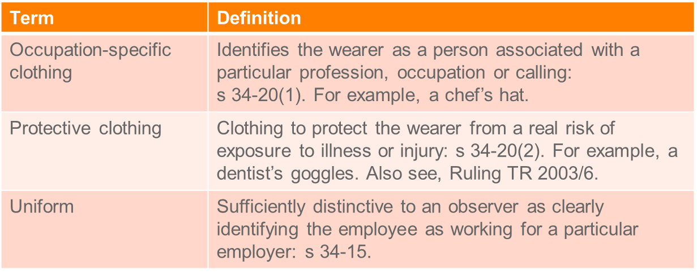

* Clothing items that are expected to last a number of years (e.g. a barrister’s wig) may be capital and subject to depreciation.

|  |
| --- |
| Edwards   * *Deductible where you can apportion work-related clothing with personal clothing* * TP executive secretary at a hotel and then got job as Governor’s wife secretary * Had to spend 3x as much on clothes: had to change a few times a day and go to social functions * AAT held could deduct difference b/w amounts spend on old job v new one * FC approved this decision |

|  |
| --- |
| *Mansfield*   * *If work environment necessitates the clothing – it will be deductible* * Airline hostess, wanted to deduct costs re moisturizer (dry work environment) shoes (swollen feet) and hair products and stockings. * Held: could deduct because work environment necessitated it |

## Home Office expense

* The deductibility of home office expenses depends on:
  + Type of expense: running expenses or occupancy expenses;
  + Whether the taxpayer uses the home office as a ‘genuine home office’ or ‘home office for convenience only.

Deductibility of home office expenses under s 8-1 is as follows

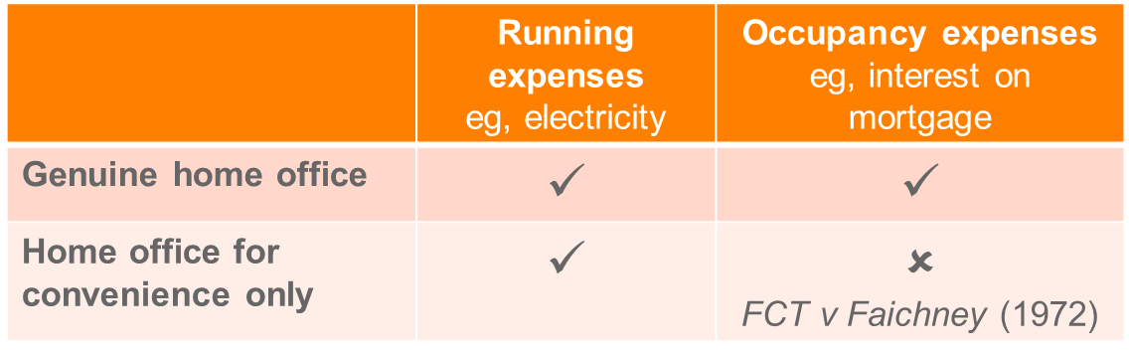

* **Apportionment of expenses:** occupancy expenses e.g., by floor area; running expenses, e.g., by time basis.

|  |
| --- |
| *Handley v FCT*   * *TP was barrister. Also had home office in addition to chambers* * ATO said **could deduct running expenses** (not occupancy expenses) * Also wanted to deduct occupancy expenses but **could not deduct occupancy expenses** (interest, council rates, rent etc) as was using this as a place of convenience |

## Interest expenses & gearing

Deductibility of interest expenses will depend on the taxpayer’s use of borrowed funds: *FCT v Munro* (1926). For example:

**Deductible**

* Interest accruing on borrowed funds **used to** purchase an income-producing asset (eg, business asset, investment / rental property)

**Non-deductible**

* Interest accruing on borrowed funds **used to** purchase the **taxpayer’s residence** that does not produce assessable income.

**Gearing**

* Gearing refers to borrowing money in order to invest (eg purchase of an investment property)
  + - Positive gearing: income > costs of investment
    - Negative gearing: income < costs of investment.
* Deductibility of costs (commonly interest), based on whether s 8-1 satisfied, regardless if the investment is negative geared.
* Generally taxpayer enters into arrangement that involves negative gearing on the basis it will be profitable overall - either because investment becomes positively geared or after-tax capital gain on disposal will cover losses.
* **Exception:** where taxpayer does not intend the investment to be profitable (see Fletcher – taxpayer entered into arrangement for deductions in early part of arrangement, and did not intend to continue arrangement after tax benefit exhausted – when large tax liabilities were expected to arise).
  + In *Fletcher* the deductions were sought after to offset other income. Only stayed in the investment to get the deductions, once the investment became profitable it gave a bigger tax liability.

## Substantiation of deductions

* Taxpayers must be able to substantiate their deduction claims by maintaining and keeping proper documentation.
* Documentation requirements outlined in Div 900.
* Records generally required to be kept for **5 years**: s 900-165.
* Exceptions apply, for example, written evidence is not required:
  + For work expenses of up to $300.
  + For claims arising from expending a travel or overtime meal allowance, provided the claim is within the Commissioner’s reasonable limits: see TD 2017/19 and TR 2004/6.

## Negative Limb 3: Losses or Outgoings relating to Exempt Income

* Because exempt income is not assessable income (section 6-1(3) ITAA 97), expenses incurred to gain such non-assessable income should not be deductible. The third negative limb of section 8-1 ITAA 97 confirms that proposition.
* *Ronpibon Tin NL v FCT*(above) some of the deductions related to exempt income

## Negative Limb 4: Specific Provisions altering the General Principles

* The fourth negative limb, section 8-1 ITAA 97, limits a deduction where a provision of the Act (both ITAA 97 and ITAA 36) prevent a taxpayer from obtaining such a deduction. Some of the more important provisions fall under Division 26.

## Legislative Exclusions

* The fourth negative limb, section 8-1 ITAA 97, limits a deduction where a provision of the Act (both ITAA 97 and ITAA 36) prevent a taxpayer from obtaining such a deduction. Some of the more important provisions fall under Division 26. There are also other provisions that limit deductibility of certain expenses.
* They are as follows

### S 26-5 - Penalties

             (1)  You cannot [deduct](http://www7.austlii.edu.au/cgi-bin/viewdoc/au/legis/cth/consol_act/itaa1997240/s995.1.html#deduct) [under](http://www7.austlii.edu.au/cgi-bin/viewdoc/au/legis/cth/consol_act/itaa1997240/s995.1.html#under) [this Act](http://www7.austlii.edu.au/cgi-bin/viewdoc/au/legis/cth/consol_act/itaa1997240/s995.1.html#this_act):

                     (a)  an [amount](http://www7.austlii.edu.au/cgi-bin/viewdoc/au/legis/cth/consol_act/itaa1997240/s995.1.html#amount) (however described) payable, by way of [penalty](http://www7.austlii.edu.au/cgi-bin/viewdoc/au/legis/cth/consol_act/itaa1997240/s40.1035.html#penalty), [under](http://www7.austlii.edu.au/cgi-bin/viewdoc/au/legis/cth/consol_act/itaa1997240/s995.1.html#under) an [Australian law](http://www7.austlii.edu.au/cgi-bin/viewdoc/au/legis/cth/consol_act/itaa1997240/s995.1.html#australian_law) or a foreign law; or

                     (b)  an [amount](http://www7.austlii.edu.au/cgi-bin/viewdoc/au/legis/cth/consol_act/itaa1997240/s995.1.html#amount) ordered by a court to be paid on the conviction of an [entity](http://www7.austlii.edu.au/cgi-bin/viewdoc/au/legis/cth/consol_act/itaa1997240/s995.1.html#entity) for an offence against an [Australian law](http://www7.austlii.edu.au/cgi-bin/viewdoc/au/legis/cth/consol_act/itaa1997240/s995.1.html#australian_law) or a foreign law.

S 26-10 - Leave payments

             (1)  You cannot [deduct](http://www7.austlii.edu.au/cgi-bin/viewdoc/au/legis/cth/consol_act/itaa1997240/s995.1.html#deduct) [under](http://www7.austlii.edu.au/cgi-bin/viewdoc/au/legis/cth/consol_act/itaa1997240/s995.1.html#under) [this Act](http://www7.austlii.edu.au/cgi-bin/viewdoc/au/legis/cth/consol_act/itaa1997240/s995.1.html#this_act) a loss or outgoing for long service leave, annual leave, sick leave or other leave except:

                     (a)  an [amount](http://www7.austlii.edu.au/cgi-bin/viewdoc/au/legis/cth/consol_act/itaa1997240/s995.1.html#amount) paid in the [income year](http://www7.austlii.edu.au/cgi-bin/viewdoc/au/legis/cth/consol_act/itaa1997240/s995.1.html#income_year) to the [individual](http://www7.austlii.edu.au/cgi-bin/viewdoc/au/legis/cth/consol_act/itaa1997240/s995.1.html#individual) to whom the leave relates (or, if that [individual](http://www7.austlii.edu.au/cgi-bin/viewdoc/au/legis/cth/consol_act/itaa1997240/s995.1.html#individual) has died, to that [individual](http://www7.austlii.edu.au/cgi-bin/viewdoc/au/legis/cth/consol_act/itaa1997240/s995.1.html#individual)'s dependant or [legal personal representative](http://www7.austlii.edu.au/cgi-bin/viewdoc/au/legis/cth/consol_act/itaa1997240/s995.1.html#legal_personal_representative)); or

**HECS/HELP Debt**

* S 26-20 denies a deduction for paying your HECS debt.

**Rebatable Benefits** – eg Youth Allowance s 26-19

## Other provisions

* Division 27 sets out the effect of **GST** on deductions; generally speaking (and in almost all circumstances) GST is disregarded.
* Division 32 - To the extent that you incur a loss or outgoing in respect of providing **entertainment**, you **cannot deduct it under section 8-1**. However, there are exceptions, which are set out in Subdivision 32-B.
* 32-B provides that only deductible if s 8-1 applies see: <http://www.austlii.edu.au/au/legis/cth/consol_act/itaa1997240/s32.30.html>
* Division 34 – **Uniforms**, **s34-10** states that you can deduct a non-compulsory uniform if it is registered under this Act but not otherwise.
* Substantiation: Div 900
* Certain deduction not allowed unless substantiated
* Employment related expenses - subdiv 900-B
* Car expenses - Div 28
* Business travel - subdiv 900-D
* See Topic 8 for more detail

**1936 Act**

* **s 82A** - self education - first $250 excluded
* **s 109** – excessive payments to shareholder, and other Co. associates

## Revision questions

**Question One**

West Bank Ltd is a major Australian financial institution. In the last financial year, the company’s accounts recorded the following transactions:

a) Provision for employee **annual leave** entitlements: $500,000. – *The expense is not incurred until the employee takes the leave or is entitled to it. S 26-10: TP cannot have a deduction until it is paid.*

b) Fines imposed by the banking industry regulator for breaches of the anti-money laundering laws relating to ATMs: $1m – *Arguably an expense necessarily incurred under s 8-1*, however it is a denied deduction under the negative limb: *S 26-5: Cannot deduct penalties.*

c) Travelling expenses for an IT expert who attended a two-day cybersecurity conference in Aspen, Colorado: $20,000. The manager also spent an extra four days skiing and stayed at the Conference hotel. – *Deductible under the positive limb, his knowledge will improve his job and he will be able to share that knowledge with the company. The holiday is arguably a fringe benefit.*

**Citing relevant case law and legislation to support your answer, advise West Bank as to the deductibility of any of the above expenditure for the purposes of s 8-1 of the ITAA 1997.**

**Question Two**

Jake is an accountant who migrated to Australia three years ago. As part of establishing himself in Australia, he intends to invest in the property market. As Jake is not familiar with the Australian property market, he engaged the assistance of a property broker to assist with finding a suitable investment property. The broker charged an upfront fee of $5,000. Six months later, the broker located a vacant block of land and suggested that Jake develop three townhouses on it. The cost of the land ($1 million) and estimated development costs ($900,000) exceeded Jake’s budget and he decided to undertake the venture with a business partner. The agreement with the business partner was that Jake would purchase the land and the partner would incur all development costs. The profits from the eventual sale of the townhouses, expected to be in 18 months, would be split equally between Jake and the partner. Jake established a $1 million line of credit facility with his bank which would enable him to access the required funds as necessary. The interest rate on the facility was 18.5% per annum and Jake provided the title to the land as security for the funds.

a) We have already considered the deductibility of the broker’s fee and the interest in class – **broker’s fee not deductible as incurred too soon,** but the interest is deductible either under Steele’s case or because there is a nexus with a business activity that has commenced - in that case interest is deductible if the borrowed funds are used for an income-producing purpose (Munro).

b) Following from (a), shortly after the land was purchased, Jake’s business partner declared bankruptcy. Jake was unable to find another suitable business partner and subsequently sold the land at auction at a loss of $900,000. With sale proceeds being insufficient to discharge his borrowings, Jake continues to pay interest charges on the remaining $100,000 owed to the bank.

**Advise Jake as to the deductibility of the interest charges incurred after the land was sold?**

*Incurring expenses after the income producing investment has ceased. Deductible if the outgoing is caused by a previous business activity under FCT v Jones* (2002 or *Placier Pacific Management. If Jake had excess money and he used it for something else (like investing in something else or starting a new business), rather than discharging the loan it would not be deductible: FCT v Jones* (2002).

c) Following on from (a), would your response to the deductibility of the bank interest charges change if Jake borrowed the money from the bank and provided the title to his residential home as security for the line of credit facility? Assume that the value of Jake’s residential home exceeds $1 million.

*The use of the borrowed money has not changed: FCT v Munro (1926). He is not using it to purchase his residential home, he is merely using his residential home as security.*

**Question Three**

Brendan is a professional AFL player employed by the Brighton Dolphins, where he is paid a salary of $1.2m per annum. He also receives $1.6m in income from sponsorships provided by a number of different sporting clothing and equipment manufacturers. He also works as a sports commentator on a local TV station and receives $500,000 per annum in salary.

Brendan decides to set up an office in a spare room at his home. The room takes up 10% of the total floor space of Brendan's home. In the income year 2016-17, Brendan pays $30,000 of interest per annum on a bank loan used to purchase his home and he also pays $4,000 per annum for electricity and other running costs of his home.

Brendan lives at Sandringham which is close to the stadium where he trains with the Brighton Dolphins. Every Friday, he travels from his home in Sandringham to the stadium to train with the Dolphins in the morning, and then travels to the TV station in Port Melbourne to prepare for the TV telecast in the evening. After the TV telecast, he travels home from Port Melbourne to Sandringham. He incurs $1,000 in train and bus fares to undertake this trip each Friday.

Brendan decides to open a new fitness centre in the Sandringham area. In April 2017, he pays $500,000 for the right to use the Fitness Burst brand name and business processes for 7 years (with an option to renew). He opens the fitness centre under that name in May 2017.

Brendan is thinking about setting up a store in the fitness centre to sell vitamin supplements to the gym members. He engages a consultant in June 2017 to advise whether his idea is feasible. The consultant charges Brendan $25,000 for the advice, payable upfront.

Brendan hires a media consultant to help him improve his commentating skills when appearing on TV. The media consultant is his wife and he pays her $50,000 for her services. The market rate for media consultants in Melbourne is $40,000.

Brendan’s coach tells him that he needs to eat a high protein diet to attain peak fitness to play AFL football. Brendan goes to the Butcher and spends $500 on the most expensive cuts of beef to put in his freezer. In the past he has purchased sausages.

**Using relevant legislation and case law, explain to Brendan whether the above outgoings are deductible for income tax purposes in the 2016-17 income year.**

***Home office:*** *Deductibility of office expenses (except for running expenses) depend on whether he needs an office in his home? Not needed for playing football or sponsorship. Facts are not clear as to whether he needs it for his television job. He could also be carrying on a business however: Spriggs v FCT and Riddell v FCT. That is he is exploiting his celebratory status. If this is the case he can apportion his costs.*

***Travel expenses:*** *Direct travel between earning activities are arguably deductible under s 25-100. Although travel between home and work is not usually deductible. But if he is running a business under Spriggs and Riddell of exploiting his celebratory status (to get all these earning activities) then his earning activity starts at home and all travel is deductible.*

*Fitness centre expenses:*

* *S 8-1 Positive limb: The $500k -* ***Has the business started yet****? See Softwood Pulp and Paper Ltd v FCT* (1976). *Has the TP committed to the business yet? Assuming the earning activity has started he has incurred start-up costs and they will be deductible. Brought into deductibility under the positive limb.*
* *S 8-1 Negative limb: Revenue or capital in nature? Look at three factors in Sun Newspapers:* 
  + *Character of the benefit sought: whether it is long lasting or short term – The benefits he has attained last 7 years with an option to renew so arguably yes.*
  + *Manner of which the benefit is sought: Can the TP enjoy the benefit on a “once and for all” basis or is the benefit enduring, –*
  + *Means of obtaining the benefit? Lump sum or does the TP have to keep paying to get the benefit? – Lump sum in this instance.*
* *$25K- Would this store be a different business or is he merely changing the profit yielding business? If it is an expense incurred in carrying on his current business then is falls within the positive limbs. Assuming it does fall within the positive limb it might fall under the first negative limb, assuming it’s a new part of the current business this expense could be capital in nature.*

***Self-education:*** *Falls within the first positive limb as it is improving or maintaining his skills as a commentator. Business judgement rule states that it is not for the comm. to tell someone how much they spend on that earning activity.*

*Is it excluded under the* ***4th limb*** *through s 26-35? -: If an amount is paid to a* ***related party****, then the TP only gets a deduction to the extent that it is reasonable. Here s 26-35 will deny a deduction for any amount in excess of the market value of $40k.*

***Food:*** *First limb: Food is a private expenditure and would not likely be deductible: FCT v Cooper*. *Putting someone in the position to earn their assessable income. Assuming it does meet the positive limb, it would be excluded under the negative limb as being private expenditure.*

**Question Four**

**Consider if the following expenses are capital:**

1. The taxpayer is in the business of gas exploration and spends $2mil investigating the viability of commencing a business of laying gas pipe lines. – *Feasibility study? The expense has occurred to soon: Softwood Pulp and Paper Ltd v FCT* (1976).
2. The taxpayer is a large pharmaceutical firm and conducts continuous research on a cure for the common cold. – *Falls under the positive limb as a pharmaceutical company needs to do research about drugs before it manufactures them. Negative limb: Is it capital? Long lasting benefit in the R and D and having a new earning source (new drug)?*
3. A company has spent $50,000 advertising against a government proposal to remove taxation concessions currently enjoyed by the business. – *Positive limb: the occasion of the expense relates to how the business will go about its earning activity, they will have to adapt to a change in the law so arguably yes. Negative limb: Capital? Advertising is*
4. A forestry business spends $20,000 per year controlling weeds in a timber plantation - there will be no income for 15 years. – *Positive limp: arguable that weed killing is necessary to keep the trees alive, does not matter that there is not any income for 15 years, provided the business has started you can deduct expenditure in the year it has been incurred – no income matching. An issue might arise as to whether the business will become profitable or is it a sink hole for deductions for investors?*

## Specific Deductions (s 8-5)

* Section 8-10 ITAA 97 indicates that if two or more provisions of the Act allow for a **deduction in respect of the same amount**, the deduction can only be made under the provision that is most appropriate.

ITAA 97 S 8-5 - Specific deductions

             (1)  You can also [*deduct*](http://www7.austlii.edu.au/cgi-bin/viewdoc/au/legis/cth/consol_act/itaa1997240/s995.1.html#deduct)from your [assessable income](http://www7.austlii.edu.au/cgi-bin/viewdoc/au/legis/cth/consol_act/itaa1997240/s995.1.html#assessable_income) an [amount](http://www7.austlii.edu.au/cgi-bin/viewdoc/au/legis/cth/consol_act/itaa1997240/s995.1.html#amount) that a provision of [this Act](http://www7.austlii.edu.au/cgi-bin/viewdoc/au/legis/cth/consol_act/itaa1997240/s995.1.html#this_act) (outside this Division) allows you to [deduct](http://www7.austlii.edu.au/cgi-bin/viewdoc/au/legis/cth/consol_act/itaa1997240/s995.1.html#deduct).

             (2)  Some provisions of [this Act](http://www7.austlii.edu.au/cgi-bin/viewdoc/au/legis/cth/consol_act/itaa1997240/s995.1.html#this_act) prevent you from [deducting](http://www7.austlii.edu.au/cgi-bin/viewdoc/au/legis/cth/consol_act/itaa1997240/s995.1.html#deduct) an [amount](http://www7.austlii.edu.au/cgi-bin/viewdoc/au/legis/cth/consol_act/itaa1997240/s995.1.html#amount) that you could otherwise [deduct](http://www7.austlii.edu.au/cgi-bin/viewdoc/au/legis/cth/consol_act/itaa1997240/s995.1.html#deduct), or limit the [amount](http://www7.austlii.edu.au/cgi-bin/viewdoc/au/legis/cth/consol_act/itaa1997240/s995.1.html#amount) you can [deduct](http://www7.austlii.edu.au/cgi-bin/viewdoc/au/legis/cth/consol_act/itaa1997240/s995.1.html#deduct).

             (3)  An [amount](http://www7.austlii.edu.au/cgi-bin/viewdoc/au/legis/cth/consol_act/itaa1997240/s995.1.html#amount) that you can [deduct](http://www7.austlii.edu.au/cgi-bin/viewdoc/au/legis/cth/consol_act/itaa1997240/s995.1.html#deduct) [under](http://www7.austlii.edu.au/cgi-bin/viewdoc/au/legis/cth/consol_act/itaa1997240/s995.1.html#under) a provision of [this Act](http://www7.austlii.edu.au/cgi-bin/viewdoc/au/legis/cth/consol_act/itaa1997240/s995.1.html#this_act) (outside this Division) is called a [*specific*](http://www7.austlii.edu.au/cgi-bin/viewdoc/au/legis/cth/consol_act/itaa1997240/s995.1.html#specific_deduction)[*deduction*](http://www7.austlii.edu.au/cgi-bin/viewdoc/au/legis/cth/consol_act/itaa1997240/s995.1.html#specific_deduction).

## 1. S 25-5: Tax related expenses

ITAA97 s 25-5 - Tax-related expenses

             (1)  You can [deduct](http://www7.austlii.edu.au/cgi-bin/viewdoc/au/legis/cth/consol_act/itaa1997240/s995.1.html#deduct) [expenditure](http://www7.austlii.edu.au/cgi-bin/viewdoc/au/legis/cth/consol_act/itaa1997240/s40.548.html#expenditure) you incur to the extent that it is for:

                     (a)  **managing your**[**tax affairs**](http://www7.austlii.edu.au/cgi-bin/viewdoc/au/legis/cth/consol_act/itaa1997240/s995.1.html#tax_affairs); or

                     (b)  complying with an obligation imposed on you by a [Commonwealth law](http://www7.austlii.edu.au/cgi-bin/viewdoc/au/legis/cth/consol_act/itaa1997240/s995.1.html#commonwealth_law), insofar as that obligation relates to the [tax affairs](http://www7.austlii.edu.au/cgi-bin/viewdoc/au/legis/cth/consol_act/itaa1997240/s995.1.html#tax_affairs) of an [entity](http://www7.austlii.edu.au/cgi-bin/viewdoc/au/legis/cth/consol_act/itaa1997240/s995.1.html#entity); or

                     (c)  the [general interest charge](http://www7.austlii.edu.au/cgi-bin/viewdoc/au/legis/cth/consol_act/itaa1997240/s995.1.html#general_interest_charge) or the [shortfall interest charge](http://www7.austlii.edu.au/cgi-bin/viewdoc/au/legis/cth/consol_act/itaa1997240/s995.1.html#shortfall_interest_charge); or

                    (ca)  a [penalty](http://www7.austlii.edu.au/cgi-bin/viewdoc/au/legis/cth/consol_act/itaa1997240/s40.1035.html#penalty) [under](http://www7.austlii.edu.au/cgi-bin/viewdoc/au/legis/cth/consol_act/itaa1997240/s995.1.html#under) Subdivision 162-D of the GST Act; or

                   (cb)  levy [under](http://www7.austlii.edu.au/cgi-bin/viewdoc/au/legis/cth/consol_act/itaa1997240/s995.1.html#under) the [*Major Bank Levy Act 2017*](http://www7.austlii.edu.au/cgi-bin/viewdoc/au/legis/cth/num_act/mbla2017157/); or

                     (d)  obtaining a valuation in accordance with section 30-212 or 31-15.

Note 2:       If you receive an [amount](http://www7.austlii.edu.au/cgi-bin/viewdoc/au/legis/cth/consol_act/itaa1997240/s995.1.html#amount) as [recoupment](http://www7.austlii.edu.au/cgi-bin/viewdoc/au/legis/cth/consol_act/itaa1997240/s995.1.html#recoupment) of the [expenditure](http://www7.austlii.edu.au/cgi-bin/viewdoc/au/legis/cth/consol_act/itaa1997240/s40.548.html#expenditure), the [amount](http://www7.austlii.edu.au/cgi-bin/viewdoc/au/legis/cth/consol_act/itaa1997240/s995.1.html#amount) may be included in your [assessable income](http://www7.austlii.edu.au/cgi-bin/viewdoc/au/legis/cth/consol_act/itaa1997240/s995.1.html#assessable_income): see Subdivision 20-A.

No [deduction](http://www7.austlii.edu.au/cgi-bin/viewdoc/au/legis/cth/consol_act/itaa1997240/s995.1.html#deduction) for certain [expenditure](http://www7.austlii.edu.au/cgi-bin/viewdoc/au/legis/cth/consol_act/itaa1997240/s40.548.html#expenditure)

             (2)  You cannot [deduct](http://www7.austlii.edu.au/cgi-bin/viewdoc/au/legis/cth/consol_act/itaa1997240/s995.1.html#deduct) [under](http://www7.austlii.edu.au/cgi-bin/viewdoc/au/legis/cth/consol_act/itaa1997240/s995.1.html#under) [subsection](http://www7.austlii.edu.au/cgi-bin/viewdoc/au/legis/cth/consol_act/itaa1997240/s26.97.html#subsection) (1):

                     (a)  tax; or

                     (b)  an [amount withheld](http://www7.austlii.edu.au/cgi-bin/viewdoc/au/legis/cth/consol_act/itaa1997240/s995.1.html#amount_withheld) or payable [under](http://www7.austlii.edu.au/cgi-bin/viewdoc/au/legis/cth/consol_act/itaa1997240/s995.1.html#under) [Part](http://www7.austlii.edu.au/cgi-bin/viewdoc/au/legis/cth/consol_act/itaa1997240/s995.1.html#part) 2-5 or [Part](http://www7.austlii.edu.au/cgi-bin/viewdoc/au/legis/cth/consol_act/itaa1997240/s995.1.html#part) 2-10 in Schedule 1 to the [*Taxation Administration Act 1953*](http://www7.austlii.edu.au/cgi-bin/viewdoc/au/legis/cth/consol_act/taa1953269/); or

                     (c)  [expenditure](http://www7.austlii.edu.au/cgi-bin/viewdoc/au/legis/cth/consol_act/itaa1997240/s40.548.html#expenditure) for [borrowing](http://www7.austlii.edu.au/cgi-bin/viewdoc/au/legis/cth/consol_act/itaa1997240/s995.1.html#borrowing) [money](http://www7.austlii.edu.au/cgi-bin/viewdoc/au/legis/cth/consol_act/itaa1997240/s995.1.html#money) (including [payments](http://www7.austlii.edu.au/cgi-bin/viewdoc/au/legis/cth/consol_act/itaa1997240/s995.1.html#payment) of [interest](http://www7.austlii.edu.au/cgi-bin/viewdoc/au/legis/cth/consol_act/itaa1997240/s974.10.html#interest)) to pay an [amount](http://www7.austlii.edu.au/cgi-bin/viewdoc/au/legis/cth/consol_act/itaa1997240/s995.1.html#amount) covered by [paragraph](http://www7.austlii.edu.au/cgi-bin/viewdoc/au/legis/cth/consol_act/itaa1997240/s26.85.html#paragraph) (a) or (b); or

                     (d)  [expenditure](http://www7.austlii.edu.au/cgi-bin/viewdoc/au/legis/cth/consol_act/itaa1997240/s40.548.html#expenditure) for a matter relating to the commission (or possible commission) of an offence against an [Australian law](http://www7.austlii.edu.au/cgi-bin/viewdoc/au/legis/cth/consol_act/itaa1997240/s995.1.html#australian_law) or a foreign law; or

                     (e)  a fee or commission for advice about the operation of a [Commonwealth law](http://www7.austlii.edu.au/cgi-bin/viewdoc/au/legis/cth/consol_act/itaa1997240/s995.1.html#commonwealth_law) relating to taxation, unless that advice is [provided](http://www7.austlii.edu.au/cgi-bin/viewdoc/au/legis/cth/consol_act/itaa1997240/s995.1.html#provide) by a [recognised tax adviser](http://www7.austlii.edu.au/cgi-bin/viewdoc/au/legis/cth/consol_act/itaa1997240/s995.1.html#recognised_tax_adviser).

No [deduction](http://www7.austlii.edu.au/cgi-bin/viewdoc/au/legis/cth/consol_act/itaa1997240/s995.1.html#deduction) for [expenditure](http://www7.austlii.edu.au/cgi-bin/viewdoc/au/legis/cth/consol_act/itaa1997240/s40.548.html#expenditure) excluded from [general deductions](http://www7.austlii.edu.au/cgi-bin/viewdoc/au/legis/cth/consol_act/itaa1997240/s995.1.html#general_deduction)

             (3)  You cannot [deduct](http://www7.austlii.edu.au/cgi-bin/viewdoc/au/legis/cth/consol_act/itaa1997240/s995.1.html#deduct) [expenditure](http://www7.austlii.edu.au/cgi-bin/viewdoc/au/legis/cth/consol_act/itaa1997240/s40.548.html#expenditure) [under](http://www7.austlii.edu.au/cgi-bin/viewdoc/au/legis/cth/consol_act/itaa1997240/s995.1.html#under) [subsection](http://www7.austlii.edu.au/cgi-bin/viewdoc/au/legis/cth/consol_act/itaa1997240/s26.97.html#subsection) (1) to the extent that a provision of [this Act](http://www7.austlii.edu.au/cgi-bin/viewdoc/au/legis/cth/consol_act/itaa1997240/s995.1.html#this_act) (except section 8-1) expressly prevents or limits your [deducting](http://www7.austlii.edu.au/cgi-bin/viewdoc/au/legis/cth/consol_act/itaa1997240/s995.1.html#deduct) it [under](http://www7.austlii.edu.au/cgi-bin/viewdoc/au/legis/cth/consol_act/itaa1997240/s995.1.html#under) section 8-1 (about [general deductions](http://www7.austlii.edu.au/cgi-bin/viewdoc/au/legis/cth/consol_act/itaa1997240/s995.1.html#general_deduction)). It does not matter whether the provision specifically refers to section 8-1.

No [deduction](http://www7.austlii.edu.au/cgi-bin/viewdoc/au/legis/cth/consol_act/itaa1997240/s995.1.html#deduction) for capital [expenditure](http://www7.austlii.edu.au/cgi-bin/viewdoc/au/legis/cth/consol_act/itaa1997240/s40.548.html#expenditure)

You can claim a deduction for expenses you incur in managing your own tax affairs, including those for:

* preparing and lodging your tax return and activity statements
* **travel, to the extent that it is associated with obtaining tax advice** - for example, the travel costs of attending a meeting with a recognized tax adviser: see TD 2017/8
* appealing to the Administrative Appeals Tribunal or courts in relation to your tax affairs
* obtaining a **valuation needed for a deductible gift or donation of property** or for a deduction for entering into a conservation covenant
* buying **tax reference material**
* lodging your tax return through a registered tax agent
* obtaining tax advice from a recognized tax adviser (a registered tax agent, barrister or solicitor)
* dealing with us about your tax affairs

**Example**: On 14 July, Louise visited a registered tax agent to prepare and lodge her previous year's tax return. The tax agent lodged the return in September and charged Louise $220, which she paid immediately. Louise can claim a deduction for the tax agent's fee on her next tax return.

* You cannot claim for the cost of tax advice given by a person who is **not a recognized tax adviser**. Tax shortfall and other penalties imposed for failing to meet your obligations are not deductible.
* S 25-5(2)(a) and (b) exclude payments of tax itself (including penalties and withholding tax) and (c) excludes interest on loan to pay tax.
* Definition of “tax affairs” and “tax” limit the deduction to **income tax obligations** only: s 995-1
  + For other taxes (eg, GST and FBT), consider s 8-1 (only where incurred in carrying on a business).
* Deductions under s 25-5 are not available in certain circumstances, eg:
  + **Payments of income tax** (otherwise the government would be subsidising the tax that you pay)
  + Payments of **PAYG instalments** or withholding
  + **Borrowing money to pay income tax** or PAYG amounts
  + Advice from an adviser who is NOT a “recognised tax adviser” (registered tax agent or legal practitioner).
  + Capital expenditure (e.g. Purchasing a computer to manage tax affairs; however depreciation will be deductible).

**Question:**

Alina recently inherited a large block of land from her uncle. She built a house on the land and subsequently sold the house and the land for $900,000. Alina received advice on the tax consequences of the sale from her accountant, who is a registered tax agent. The accountant's fees for the year were $1,800. The fees related to the lodgment of Alina's income tax return ($500) and the advice regarding the sale ($1,300).

**Advise Alina as to whether the $1,800 paid to her accountant is deductible for income tax purposes.**

*She will get a deduction relating for the fess of her lodgement under s 25-5, and she will also get a deduction for advice related to the sale under s 25-5.*

## 2. S 25-10: Repairs

ITAA97 s 25-10 - Repairs

             (1)  You can [deduct](http://www7.austlii.edu.au/cgi-bin/viewdoc/au/legis/cth/consol_act/itaa1997240/s995.1.html#deduct) [expenditure](http://www7.austlii.edu.au/cgi-bin/viewdoc/au/legis/cth/consol_act/itaa1997240/s40.548.html#expenditure) you incur for repairs to premises (or [part](http://www7.austlii.edu.au/cgi-bin/viewdoc/au/legis/cth/consol_act/itaa1997240/s995.1.html#part) of premises) or a [depreciating asset](http://www7.austlii.edu.au/cgi-bin/viewdoc/au/legis/cth/consol_act/itaa1997240/s995.1.html#depreciating_asset) that you [**held**](http://www7.austlii.edu.au/cgi-bin/viewdoc/au/legis/cth/consol_act/itaa1997240/s995.1.html#held)**or**[**used**](http://www7.austlii.edu.au/cgi-bin/viewdoc/au/legis/cth/consol_act/itaa1997240/s385.95.html#used)***solely*for the** [**purpose of producing assessable income**](http://www7.austlii.edu.au/cgi-bin/viewdoc/au/legis/cth/consol_act/itaa1997240/s995.1.html#purpose_of_producing_assessable_income).

Property [held](http://www7.austlii.edu.au/cgi-bin/viewdoc/au/legis/cth/consol_act/itaa1997240/s995.1.html#held) or [used](http://www7.austlii.edu.au/cgi-bin/viewdoc/au/legis/cth/consol_act/itaa1997240/s385.95.html#used) [partly](http://www7.austlii.edu.au/cgi-bin/viewdoc/au/legis/cth/consol_act/itaa1997240/s995.1.html#part) for that purpose

             (2)  If you [held](http://www7.austlii.edu.au/cgi-bin/viewdoc/au/legis/cth/consol_act/itaa1997240/s995.1.html#held) or [used](http://www7.austlii.edu.au/cgi-bin/viewdoc/au/legis/cth/consol_act/itaa1997240/s385.95.html#used) the property only [***partly***](http://www7.austlii.edu.au/cgi-bin/viewdoc/au/legis/cth/consol_act/itaa1997240/s995.1.html#part)for that purpose, you can [deduct](http://www7.austlii.edu.au/cgi-bin/viewdoc/au/legis/cth/consol_act/itaa1997240/s995.1.html#deduct) so much of the [expenditure](http://www7.austlii.edu.au/cgi-bin/viewdoc/au/legis/cth/consol_act/itaa1997240/s40.548.html#expenditure) as is reasonable in the circumstances. <Apportion!

No [deduction](http://www7.austlii.edu.au/cgi-bin/viewdoc/au/legis/cth/consol_act/itaa1997240/s995.1.html#deduction) for capital [expenditure](http://www7.austlii.edu.au/cgi-bin/viewdoc/au/legis/cth/consol_act/itaa1997240/s40.548.html#expenditure)

             (3)  You cannot [deduct](http://www7.austlii.edu.au/cgi-bin/viewdoc/au/legis/cth/consol_act/itaa1997240/s995.1.html#deduct) capital [expenditure](http://www7.austlii.edu.au/cgi-bin/viewdoc/au/legis/cth/consol_act/itaa1997240/s40.548.html#expenditure) [under](http://www7.austlii.edu.au/cgi-bin/viewdoc/au/legis/cth/consol_act/itaa1997240/s995.1.html#under) this section.

**Types of capital expenditure**

* **Improvements:** (changes it character **E.g.** fixing broken window to former condition is okay. However, if you put double-glazed glass, make it sound proof, tinted etc. – it would change its character)
* **Cost is not indicative:** $10,000 purchase price of wooden flooring - $5,000 to improve and make it concrete = still cannot deduct.
* **Repair of entirety:** Replacing the entire object
* Entirety can be part of an object. **Eg** perimeter of house has a brick fence except the front fence, which is wooden. Replacing that front fence may be repairing its entirety. **Make an argument**
* **Initial repair:** Defect existed at the time of acquiring the asset
* **S 25-10** provides deduction for expenditure by taxpayer for repairs not being of a capital nature, to income producing assets. Expenditure must be incurred by the taxpayer in respect of premises or part of premises, plant, machinery, implements, utensils, rolling stock or articles.
* I.E 🡪 if the proceeds from committing property to the gaining of assessable income are taxable, the cost of maintaining the property in good working order ought to be allowable.
* **You can claim a deduction for repairs to machinery, tools or premises you use to produce business income as long as the expenses are not capital expenses. Allowable claims include the cost of:**
* painting
* conditioning gutters
* maintaining plumbing
* repairing electrical appliances
* mending leaks
* replacing broken parts of fences or broken glass in windows
* repairing machinery.
* To repair something generally means to fix defects, including renewing parts. It does not mean totally reconstructing something.
* You do not have to own the property or item that is repaired.
* **Repairs do not include: substantial improvements to an item or property**, such as replacing a dilapidated ceiling with an entirely new and better ceiling - you may be able to include this type of expense in the cost base of the asset when working out capital gains

|  |
| --- |
| FCT v Western Suburbs Cinema Ltd (1952) 88 CLR 102   * *Replacement of the entirety of the damaged object is capital and is not deductible* * Ceiling in state of disrepair * To restore to original cost £603. However, £3000 was paid to replace ceiling with different design and better material. * **High court concluded that was capital.** * “In this case, the work done consisted of the **replacement of the entire ceiling**, a major and important part of the structure of the theatre, with a new and better ceiling. The operation seems to me different, not only in degree, but in kind, from the type of repairs which are properly allowed for in the working expenses of a theatre business. **It did much more than meet a need for restoration**…” |

* “***Repair***” involves a **restoration of a thing to a condition it formerly had without changing its character:** *W Thomas & Co Pty Ltd v FCT* (1965) 115 CLR 58: E.g. Fixing a hole in a wall, you can use the same materials but not better materials
* Some examples from *Lurcott v Wakely and Wheeler* (1911):
  + “To substitute sound tiles or slates for those which are cracked, broken, or missing”
  + “A roof falls out of repair; the necessary work is to replace the decayed timbers by sound good”.
* Apportionment can be made where the item is only part used for the production of AI
* Item must have been used for income-producing purposes for repairs to be deductible under s 25-10. For example:
  + Repairs in the course of carrying on a business.
  + Repairs made to a rental / investment property.
* Apportionment on a “reasonable” basis where the property is partly used for income-producing purposes: s 25-10(2) and ATO TR 97/23.
* **Initial repairs** are **repairs that are made to remedy defects which exist at time property acquired – these are held to be capital expenses** *Law Shipping Co Ltd v Inland Revenue Commissioners; W Thomas & Co).*
* Why? Likely TP received reduction in purchase price in consideration of need to undertake the repairs. Note however that even if TP not aware repairs necessary at time of purchase, will not be deductible: *W Thomas & Co.* The test is whether the defect existed at the time of acquiring, not time which repairs made.
  + See *Lindsay* **– READ THIS**
* Property must be **in need of restoration**: *Case J47* (1958)*.*
* Pure maintenance work not generally a repair.
* Work done to meet requirements of regulatory bodies is not a repair, unless the work remedies defects: ATO TR 97/23.
* A repair that constitutes a capital expense is not deductible:   
  s 25-10(3).
* Three broad categories of expenditure on repairs that may be classified as capital:
  + Initial repairs;
  + Improvements; and
  + Replacements

**Initial repairs**

* Initial repairs are repairs undertaken to remedy defects which exist at time of acquisition are considered capital expenses (bringing asset to income producing state – part of the profit-yielding structure).
  + Repairs undertaken at a later time will still be an initial repair **if the defect existed at time of acquisition**.
  + Considered that the cost of repairs would have been factored into the purchase price of the property: *Law Shipping Co Ltd v Inland Revenue Commissioners* (1923)*.*
  + Still an initial repair even if the **taxpayer is unaware** of the defects at time of acquisition: *W Thomas & Co Pty Ltd v FCT* (1965)*.*

**Improvement**

* An improvement surpasses a repair such that it changes the character of the original item and hence capital in nature.
* Repair vs improvement is a question of fact:

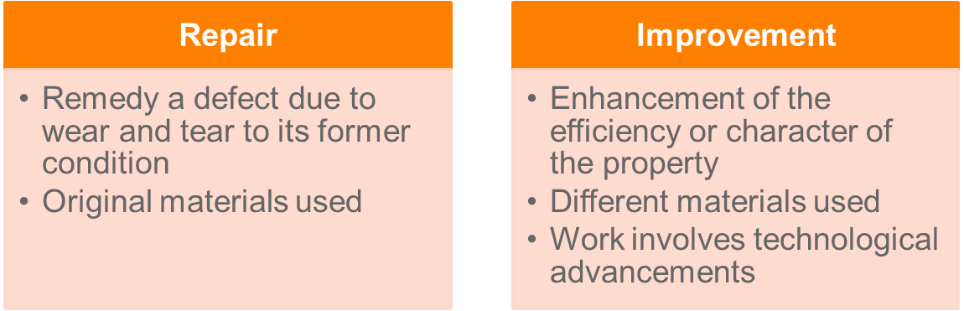

* See, *FCT v Western Suburbs Cinemas Ltd* (1952) where the repair of a ceiling with new material was not a repair, **despite old materials no longer available**.

Notional repairs

* A deduction under s 25-10 is based on actual expenditure, not a notional amount: *FCT v Western Suburbs Cinemas Ltd* (1952)*.*
  + Not able to undertake a non-deductible capital improvement and seek to deduct the amount that it would have cost to undertake a mere repair.
  + You only get deductions for the ACTUAL expenditure you incur.

**Replacements**

* Necessary to determine whether a replacement is:
  + **Part** of an asset (constituting a deductible repair); or
  + **Whole** of an asset (replacement of asset and hence capital).
* An asset will be an asset in itself when: (i) it is separately identifiable; and (ii) is capable of independent use.
* *Samuel Jones & Co (Devondale) Ltd v IRC*: Replacement of a chimney (with similar dimensions) was an inseparable part of the overall asset, being the factory.
* *FCT v Western Suburbs Cinemas Ltd:* Replacement of a roof is part of an overall asset, being the cinema
* *W Thomas & Co Pty Ltd v FCT*: Floors and walls are parts of the overall asset, being the building.

**Question:**

Digby owns a bookstore. He undertakes the following activities:

1. replastering and repainting a wall which had been damaged due to a leak;
2. recarpeting the whole shop as the old carpet had worn out due to normal wear and tear;
3. installing a new payment counter with new display signs; and
4. repainting the front of the store with a new type of glossy paint to make it more attractive to walk-in customers.

**Advise Digby of his tax consequences arising from the above information**.

*A: Repair as it is remedying a defect, there is nothing to suggest it is an improvement in the sense that it is an enhancement or that different materials than the original materials were used: W Thomas & Co Pty Ltd v FCT*

*B: Repair as there is a defect (normal wear and tear), carpet is part of the overall asset that is the building as it is fixed. If it was not fixed then would have to get depreciation deductions.*

*C: Replacement (no deduction), not remedying an asset. The payment counter is “new”.*

*D: Improvement, using different materials (better paint) to re-paint the shopfront. Not clear if the re-painting is even needed.*

## 3. S 25-35: Bad debts

* Where a taxpayer is assessed on the accruals basis, the taxpayer pays tax on the income in the year it is derived. If the debt is not paid, the taxpayer should be entitled to a deduction for the resulting bad debt which has already been taxed at the time the sale was made.
* Reasonable attempts must have been made to attempt to recover the debt
* Section 25-35 specifically provides for such a deduction. To qualify for the deduction **under s 25-35 *all* of the following conditions must be satisfied:**

**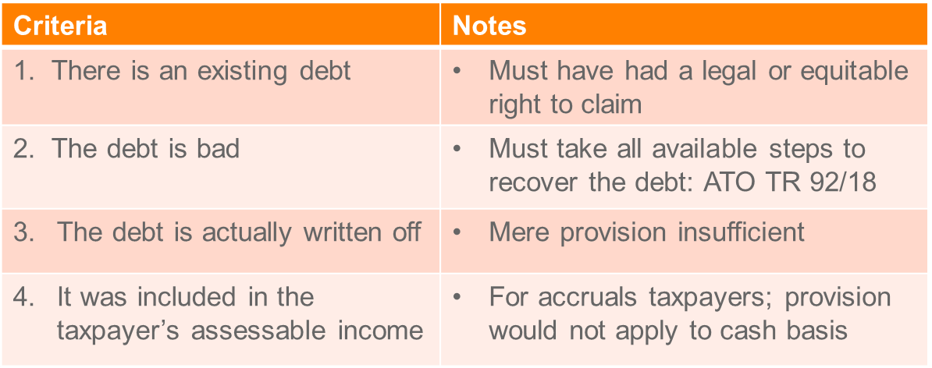**

1. There **must be an existing debt**
2. The debt **must be bad** (not merely doubtful), this means need to be considered irrecoverable
3. The debt **must have been written off as bad during the year of income** in which the deduction is claimed
4. The debt **must have been included in the taxpayer’s assessable income for the income year or earlier income year or the debt must be in respect of money lent in the ordinary course of a money lending business.** In this latter case, the bad debt is deductible whether or not the amount written off had been included in assessable income.

* Corporate taxpayers must satisfy loss recoupment tests to claim bad debts: s 25-35(5).

**Question:**

Big Shoes Pty Ltd sells shoes exclusively online. Customers are invoiced for the shoes when they are shipped and are only required to pay for the shoes once they have been received and deemed satisfactory. Big Shoes includes the invoice amount in its assessable income when the invoice is issued. As of 30 June, Big Shoes determined that it had $10,000 in unpaid invoices. Its records indicated that 70% of the invoices related to shoes sold within the last month, which was considered acceptable. However, of the remaining $3,000, $1,000 related to invoices which were more than three months overdue. In accordance with its customary practice, Big Shoes wrote off the $1,000 of outstanding invoices. Its standard practice is to issue payment reminders before writing off the debt and turning it over to a debt collector. Big Shoes also created a provision for bad debts of $2,000 at this time.

**Advise Big Shoes as to what amount (if any) it can deduct in relation to the unpaid invoices.**

*$7,000 considered collectible (acceptable). The other $3,000 may be deductible: They have attempted to collect the debt using ordinary debt collection actions (don’t have to take them to court). They also have to record the decision to write off the debt (like in the minutes of a board meeting) and it generally needs to be reflected on their ledger (books of account). The $1,000 will be deductible under s 23-35 as it has been written off, however the other $2,000 will not be as it has not been written off yet (only a provision has been made).*

## 4. S 25-55: Payments to associations (memberships and union fees)

* Payments for membership of a trade, business or professional association is deductible (s 26-55):
  + **Does not require connection with the production of income** (e.g. expenses relating to work in a different profession)
  + ^Subject to **limit of $42**
* Preferable to claim the outgoing under s 8-1 if the nexus requirement can be satisfied > e.g. membership with law institute of Victoria for lawyer.
  + If claimed this way then there is no cap of $42, the full amount can be claimed.

## 5. Gifts – Div 30

* Broadly, a “gift” or contribution of **$2 or more** made to a “deductible gift recipient” is deductible under Div 30.
  + Can be money or property “paid” or “contributed” (not including incurring a liability): *Arnold v FCT* (2017)

**“True” gift**

* No expectation of material advantage in return: see *FCT v McPhail* (1968).
* Commissioner suggests a deductible gift must be voluntary and made without the expectation of material advantage in return (eg, not receiving utility items: mugs, chocolates, pens).

**“Deductible gift recipient**”

* Is an organisation that meets the requirements for endorsement, eg, charities, hospitals.
* Lists of DGRs: ss 30-20 to 30-105.

**Limitation on deductions, include:**

* Taxpayer not entitled to a deduction under Div 30 that results in incurring or increasing a tax loss: s 25-55(1).
* Business taxpayers not entitled to a deduction for contributions or gifts to political parties: s 26-22.
* Other anti-avoidance rules apply in Div 78A ITAA36 – where the gift is not a true gift.

**General deduction and gifts:**

* It may be possible for a loss or outgoing to be deductible under s 8-1 if a **nexus between the gift and the gaining or producing of assessable income can be established**.
* For example, gifts made to current/former clients deductible if made for producing future assessable income: TD 2016/14.

**Question**

**Advise Cheryl of her tax consequences from the following transactions:**

1. Donation of $300 to the building fund of her local public primary school: *Yes*
2. Donation of $50 to her local public library (as a result she does not need to pay membership fees of $20 that year to borrow books from the library): *No getting a material advantage in return.*
3. Payment of $700 **membership fees** to the real estate agents' association. Cheryl is a professional real estate agent but she has not been working as one for the last two years following the birth of her child. However, she maintains her membership of the association as she intends to go back to work one day: *Not an expense incurred in gaining or producing an income, as she has not been producing an income, so can only deduct $42. However for the years she is working the full amount is deductible.*

## 6. S 25-100: Travel between workplaces

**Statutory position (**s 25-100**):**

* Deduction allowed for travel *directly* between two workplaces where the taxpayer is engaged in income-producing activities
  + Not deductible if a workplace is the taxpayer’s residence.

ITAA97 – s 25-100 - Travel between workplaces

When a [deduction](http://www7.austlii.edu.au/cgi-bin/viewdoc/au/legis/cth/consol_act/itaa1997240/s995.1.html#deduction) is allowed

             (1)  If you are an [individual](http://www7.austlii.edu.au/cgi-bin/viewdoc/au/legis/cth/consol_act/itaa1997240/s995.1.html#individual), you can [deduct](http://www7.austlii.edu.au/cgi-bin/viewdoc/au/legis/cth/consol_act/itaa1997240/s995.1.html#deduct) a [transport expense](http://www7.austlii.edu.au/cgi-bin/viewdoc/au/legis/cth/consol_act/itaa1997240/s995.1.html#transport_expense) to the extent that it is incurred in your [travel](http://www7.austlii.edu.au/cgi-bin/viewdoc/au/legis/cth/consol_act/itaa1997240/s995.1.html#travel_between_workplaces) [between workplaces](http://www7.austlii.edu.au/cgi-bin/viewdoc/au/legis/cth/consol_act/itaa1997240/s995.1.html#travel_between_workplaces).

[Travel between workplaces](http://www7.austlii.edu.au/cgi-bin/viewdoc/au/legis/cth/consol_act/itaa1997240/s995.1.html#travel_between_workplaces)

             (2)  Your [*travel between workplaces*](http://www7.austlii.edu.au/cgi-bin/viewdoc/au/legis/cth/consol_act/itaa1997240/s995.1.html#travel_between_workplaces)is travel directly between 2 places, to the extent that:

                     (a)  while you were at the first place, you were:

                              (i)  engaged in activities to gain or produce your [assessable income](http://www7.austlii.edu.au/cgi-bin/viewdoc/au/legis/cth/consol_act/itaa1997240/s995.1.html#assessable_income); or

                             (ii)  engaged in activities in the course of [carrying on](http://www7.austlii.edu.au/cgi-bin/viewdoc/au/legis/cth/consol_act/itaa1997240/s995.1.html#carrying_on) a [business](http://www7.austlii.edu.au/cgi-bin/viewdoc/au/legis/cth/consol_act/itaa1997240/s995.1.html#business) for the purpose of gaining or producing your [assessable income](http://www7.austlii.edu.au/cgi-bin/viewdoc/au/legis/cth/consol_act/itaa1997240/s995.1.html#assessable_income); and

                     (b)  the purpose of your travel to the second place was to:

                              (i)  engage in activities to gain or produce your [assessable income](http://www7.austlii.edu.au/cgi-bin/viewdoc/au/legis/cth/consol_act/itaa1997240/s995.1.html#assessable_income); or

                             (ii)  engage in activities in the course of [carrying on](http://www7.austlii.edu.au/cgi-bin/viewdoc/au/legis/cth/consol_act/itaa1997240/s995.1.html#carrying_on) a [business](http://www7.austlii.edu.au/cgi-bin/viewdoc/au/legis/cth/consol_act/itaa1997240/s995.1.html#business) for the purpose of gaining or producing your [assessable income](http://www7.austlii.edu.au/cgi-bin/viewdoc/au/legis/cth/consol_act/itaa1997240/s995.1.html#assessable_income);

                            and you engaged in those activities while you were at the second place.

             (3)  **Travel between 2 places is not**[***travel between workplaces***](http://www7.austlii.edu.au/cgi-bin/viewdoc/au/legis/cth/consol_act/itaa1997240/s995.1.html#travel_between_workplaces)**if one of the places you are travelling between is a place at which you reside.**

             (4)  Travel between 2 places is not [*travel between workplaces*](http://www7.austlii.edu.au/cgi-bin/viewdoc/au/legis/cth/consol_act/itaa1997240/s995.1.html#travel_between_workplaces)if, at the time of your travel to the second place:

                     (a)  the [arrangement](http://www7.austlii.edu.au/cgi-bin/viewdoc/au/legis/cth/consol_act/itaa1997240/s995.1.html#arrangement) [under](http://www7.austlii.edu.au/cgi-bin/viewdoc/au/legis/cth/consol_act/itaa1997240/s995.1.html#under) which you gained or produced [assessable income](http://www7.austlii.edu.au/cgi-bin/viewdoc/au/legis/cth/consol_act/itaa1997240/s995.1.html#assessable_income) at the first place has ceased; or

                     (b)  the [business](http://www7.austlii.edu.au/cgi-bin/viewdoc/au/legis/cth/consol_act/itaa1997240/s995.1.html#business) in respect of which you engaged in activities at the first place has ceased.

No [deduction](http://www7.austlii.edu.au/cgi-bin/viewdoc/au/legis/cth/consol_act/itaa1997240/s995.1.html#deduction) for capital [expenditure](http://www7.austlii.edu.au/cgi-bin/viewdoc/au/legis/cth/consol_act/itaa1997240/s40.548.html#expenditure)

             (5)  You cannot [deduct](http://www7.austlii.edu.au/cgi-bin/viewdoc/au/legis/cth/consol_act/itaa1997240/s995.1.html#deduct) [expenditure](http://www7.austlii.edu.au/cgi-bin/viewdoc/au/legis/cth/consol_act/itaa1997240/s40.548.html#expenditure) [under](http://www7.austlii.edu.au/cgi-bin/viewdoc/au/legis/cth/consol_act/itaa1997240/s995.1.html#under) [subsection](http://www7.austlii.edu.au/cgi-bin/viewdoc/au/legis/cth/consol_act/itaa1997240/s26.97.html#subsection) (1) to the extent that the [expenditure](http://www7.austlii.edu.au/cgi-bin/viewdoc/au/legis/cth/consol_act/itaa1997240/s40.548.html#expenditure) is capital, or of a capital nature.

* This provision was introduced in 2004 after the case of FCT *v Payne* (2001) 202 CLR 93. In *Payne* the HC found that travel between two unrelated workplaces were not deductible under 8-1.
* The provision overrides the HC decision – a deduction IS allowable where an individual incurs transport expenditure in travelling directly between two workplaces, where purpose is to derive AI.
* **E.g. Cancer Council donation**
* So not deductible under s 8-1 but is under s 25-100

## 7. Prior year tax losses – Div 36

* A tax loss will arise for the year if deductions exceed total assessable income.

For example, if a taxpayer has $70 000 of assessable income and deductions totalling $100 000, the tax loss would be $30 000. Division 36 allows this tax loss to be carried forward indefinitely to be used as a tax deduction against future taxable income. Without Div. 36 the excess tax deduction of $30 000 would be wasted.

A tax loss for an income year is calculated under s 36-10:

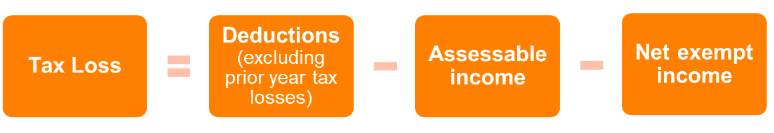

* Losses are carried forward indefinitely to future income years

In the future income year, the tax loss is offset:

1. Firstly against any exempt income (if any); and
2. The remaining against assessable income.

* If the taxpayer has losses from more than one year, the losses are deducted on a first-in-first-out basis.
* Individuals may be subject to non-commercial loss rules: Div 35 –

Example:

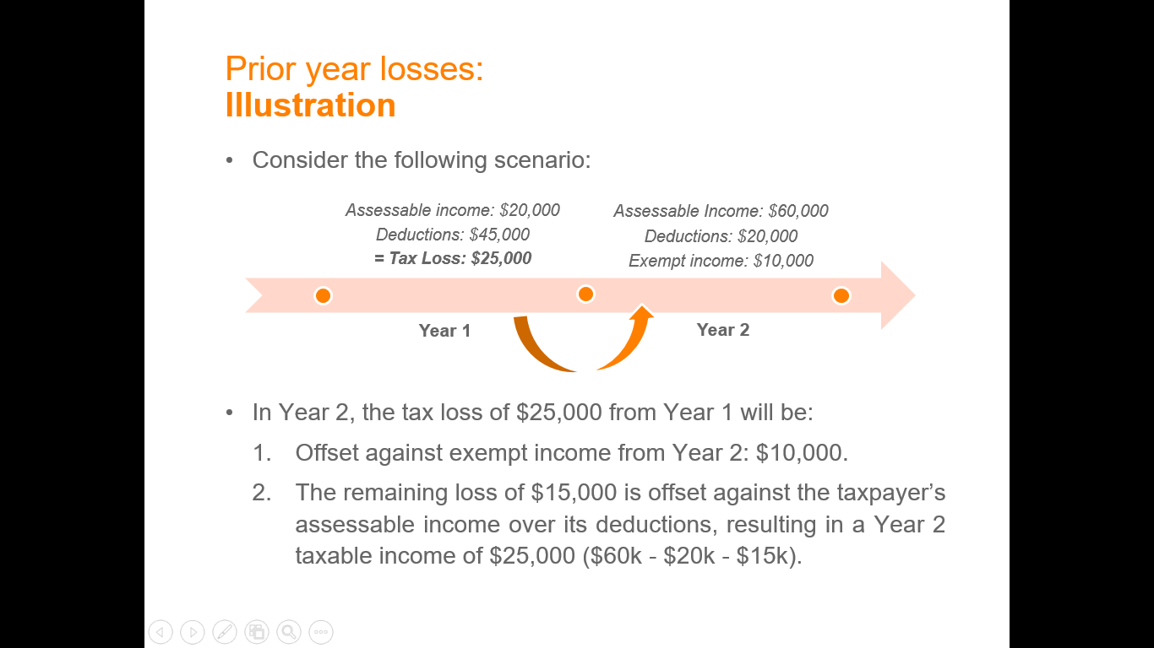

In Year 2, the tax loss of $25,000 from Year 1 will be:

1. Offset against exempt income from Year 2: $10,000.
2. The remaining loss of $15,000 is offset against the taxpayer’s assessable income over its deductions, resulting in a Year 2 taxable income of $25,000 ($60k - $20k - $15k).

Note: A **taxpayer who earns $250K + in income cannot offset tax losses between earning activities.**

General rule: Losses cannot be used against other income but can still be carried forward for use in later years when activity starts to earn income

However the above restriction can be avoided if taxable income under $250K and have **met one of the four tests** in Div 35:

1. Assessable income > $20,000; or
2. The business for at least 3 out of the last 5 years? (Profits test); or
3. The amount of real property invested in the business > $500K; or
4. Other assets > $100K

**Companies**

* Companies can choose how much of their carried-forward losses to apply against current year assessable income, *after* applying losses against exempt income: s 36-17.
* Utilisation of carried forward losses for corporate taxpayers is subject to the satisfaction of recoupment tests:
  + Continuity of ownership test: Looks at who are the owners at the time the loss occurred and who was the owner at the time income was earned (have to be the same)
  + Same business test (same as above in effect)
    - These two tests are not examinable^

## 8. S 25-25: Borrowing Expenses

* S 25-25 allows for a deduction for expenditure incurred in borrowing money where the money is used by the TP for purposes of producing assessable income.
* It is important to distinguish between the ‘cost’ of borrowing and the ‘cost’ of the money (*Ure v FCT* 81 ATC 4100).
* **For example**, expenditure on legal expenses, valuation fees, survey fees, stamp duty, prospectus advertising, printing and other costs relating to a debenture issue are costs of borrowing; while interest payable represents a cost of money. Interest is therefore not deductible under s 25-25, however it should be considered for deductibility under s 8-1.
* Borrowing expenses are not deductible under section 8-1 as capital expenses.
* Costs are **apportioned over life of the loan or 5 years**, whichever is shorter.
* **Interest is not a “borrowing expense”**
  + Deductible under section 8-1 if loan is used for an income-producing purpose (*Munro*).

**Borrowing expenses are:**

* **Loan application fees** etc. They are the cost of borrowing as opposed to interest on the loan, which is generally deductible under s 8-1.
* Also note **lease document expenses** (s 25-20) which allows for expenditure incurred by TP for preparation, registration and stamping of lease etc to be deductible.
* Expense of **discharging mortgage** (s 25-30) – section allows for a deduction for expenditure (excluding P and I) in connection with the discharge of a mortgage given as security for repayment of a loan (as long as used to gain or produce AI)

## 9. Capital expenditure allowances (depreciation) – Div 40

* Under s 8-1(2)(a) a taxpayer is denied an immediate deduction for an **outgoing of capital or of a capital nature**. Similarly, under s 25-10(3) capital expenditure is **not deductible as a repair**. Therefore, there are no deductions under the general provision for the depreciation of capital items or the loss in value of any wasting asset.
* Taxation allowance for depreciation of wasting assets
* **Depreciation based solely on effective life of the asset**
* Special rules applied to small business taxpayers
* To overcome this problem, Div 40 allows the taxpayer a deduction for the write-off of certain depreciable assets **used for income-producing purposes**. Effectively, this division introduces the notion of depreciation into the income tax system and is not the same as depreciation for accounting purposes.
* S 40-60 – Depreciation begins when first used or installed ready for use.

Section 40-25 allows the taxpayer to claim a deduction for the decline in value for the income year of depreciable assets **that are used for producing assessable income**.

**Definition of a “depreciating asset” (s 40-30(1)):**

An asset which has a limited effective life and can reasonably be expected to decline in value over the time it is used.

**What items are not allowed to be depreciated?**

S 40-30 – Depreciable asset defined as assets with limited effective life, **excludes**:

* Trading stock
* Land
* Intangibles
* Div 43 deductions (building write-off)

Common depreciable assets include computers, furniture, cars, machinery, telephones, etc.

**Depreciation rules do not apply in certain circumstances, e.g.:**

* Expenditure on capital works (ie buildings) under Div 43 (s 40-45)
* Car expenses where deduction is calculated in accordance with the “cents per kilometre” method
* Depreciating assets used or installed in residential rental premises and was ‘previously used’: s 40-27.

**Composite items**

* Necessary to determine if components making up a depreciable asset are: (i) separate depreciating assets; or (ii) one whole depreciating asset.
* Similarly, for buildings, necessary to identify if capital expenditure relates to a depreciable asset or capital works.
* Question of fact and degree: s 40-30(4). Commissioner suggests in TR 2017/D1 factors include:
  + Identifiable function
  + Use
  + Degree of integration with other components
  + Effect of attachment.

**Key elements of Div 40 are:**

1. The asset **must be a depreciable asset**
2. The depreciable asset must be used or **‘held’** ready for use for the production of assessable income during the income year
3. The depreciation deduction is **calculated using the asset’s cost and its effective life**
4. The taxpayer may **choose** between the **prime cost and diminishing value** methods of depreciation
5. The amount of the deduction may be **apportioned if the asset is used for non-income earning activities** OR is **not held for all of the income year.**

**Example**: Ben holds a depreciating asset that he uses for private purposes for 30% of his total use in the income year.  If the asset declines by $1,000 for the year, Ben would have to reduce his deduction by $300 (30% of $1,000).

**Claiming a deduction**

To claim a deduction under s 40-25 in respect of a “depreciating asset”, it is necessary to determine:

1. **‘Held’:** When the taxpayer has ‘held’ a depreciating asset;
2. **Decline in value:** A deduction is equal to the ‘decline in value’ taking into account ‘taxable purpose’.

* Non-business depreciable assets costing **less than $300** that are predominately used to gain or produce assessable income may be claimed immediately (write off): s 40-80(2).

1. **Held**

* The holder of an asset is entitled to the deduction for the decline in value of a depreciating asset: s 40-25.
  + The ‘holder’ is described in s 40-40.
  + Jointly held: deduction reflects holder’s interest: s 40-35.
* Generally it is the legal owner, but in certain circumstances it may the economic owner, e.g. in hire-purchase arrangements:

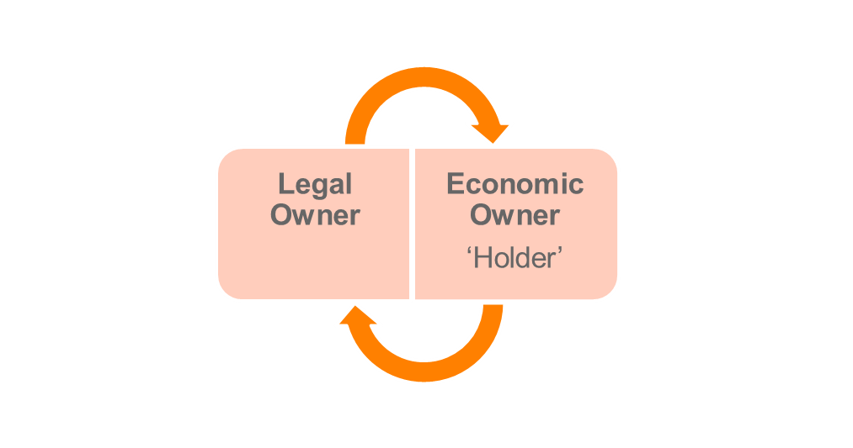

**General rule: "holder" is the legal owner:** s 40-40

**Exceptions to the general rule**

* In some cases, the legal owner of an asset will not be its **economic owner**.
* For example where there is a "hire purchase arrangement". Have a look at Item 6 of the table. *Taxation Ruling* TR 2005/20)
* Legal owner provides asset to economic owner under a HP arrangement. Economic owner bears all risk.
* Economic owner pays legal owner in instalments and has option to purchase the asset.

1. **Decline in value**

Two methods to work out the decline in value: s 40-65.

Prime cost: equivalent to “straight line method” in accounting where equal depreciation deductions each year.

Diminishing value: equivalent to “reducing-balance method” in accounting where greater deductions in the early years.

* Choice of method is made on an asset-by-asset basis:
  + A different method can be chosen for each asset.
  + Method cannot be changed once chosen: s 40-130.
  + Replacement assets do not need to follow original asset.
* Taxpayer **does not have a choice in certain circumstances**, eg:
  + Assets acquired from an associate: the same method as the method used by the associate (s 40-65(2)) – For example an asset given by a holding company to a subsidiary must use the same method originally used for that asset.
  + Assets allocated to a low value pool (s 40-65(5)).

**Diminishing value**

Formula to calculate the decline in value under the diminishing value method:

* Assets held pre-10 May 2006 (s 40-70):



* Assets held on or after 10 May 2006 (s 40-72):



**Prime cost method**

Formula to calculate the decline in value under the prime cost method (s 40-75):



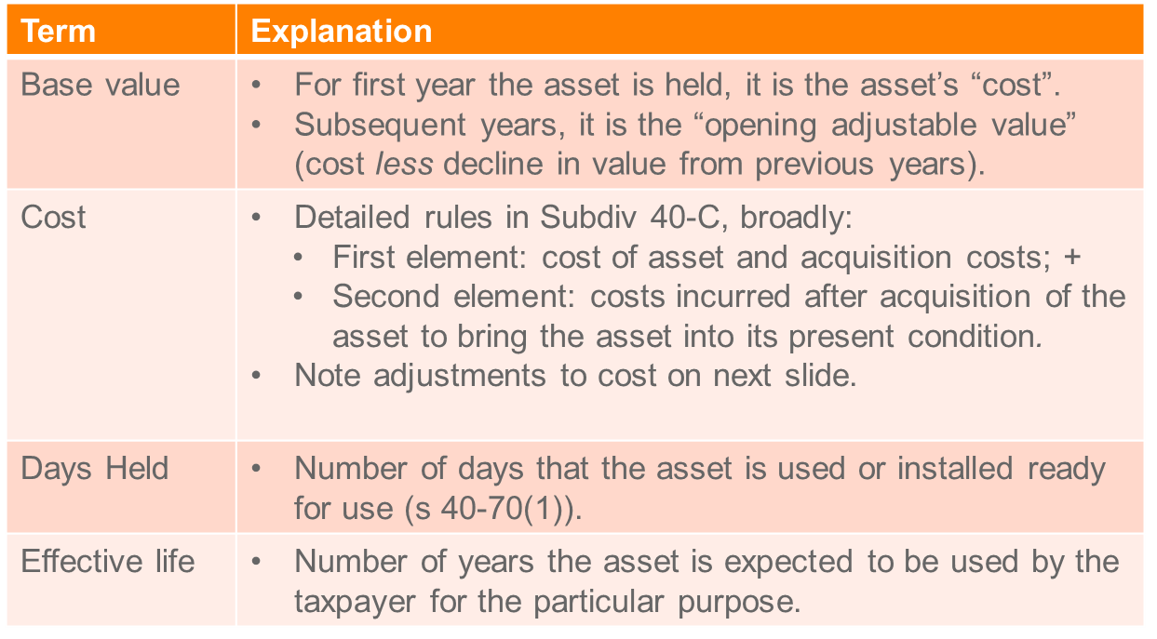

**Adjustments to the asset’s cost**

Key adjustments to the asset’s cost can include:

* Cost can include value of non-cash benefits: s 40-185
* Deductible costs under a different provision cannot be included in the cost: s 40-215
* **Exclude GST input tax credits from cost**: s 27-80
* Market value substitution rules apply to non-arm’s length transaction: s 40-180(2) – For related party
* When the **depreciating asset is a car**, the cost is limited to the car limit of $57,581 (for 2017-18): Determination TD 2017/18.

**Effective life**

* Under s 40-95, the taxpayer can choose either:
  + To use the effective life determined by the Commissioner for a depreciating asset under s 40-100 (see Ruling TR 2017/2); or
  + To **self-assess the effective life themselves**.
* No choice of effective life in certain circumstances, eg, asset acquired from an associate (parent to subsidiary), certain intangible assets
* Note:
  + A capped life may apply to a depreciating asset when the Commissioner’s determination is used.
  + Self-assessment may lead to a greater risk of audits and penalties if estimates are unrealistic.

**Taxable purpose**

Decline in value can only be claimed in relation to depreciating assets that are used for taxable purposes: s 40-25(2).

* A taxable purpose **generally exists where the asset is used in the production of assessable income**: s 40-25(7).
* Deduction reduced by the percentage of any non-taxable purpose.

**Balancing adjustments**

* Taxpayer’s taxable income adjusted where a ‘balancing adjustment’ event occurs under s 40-295:
  + Broadly, an event occurs when the taxpayer stops holding the asset, stops or never uses the asset.

Adjustment:





Elements:

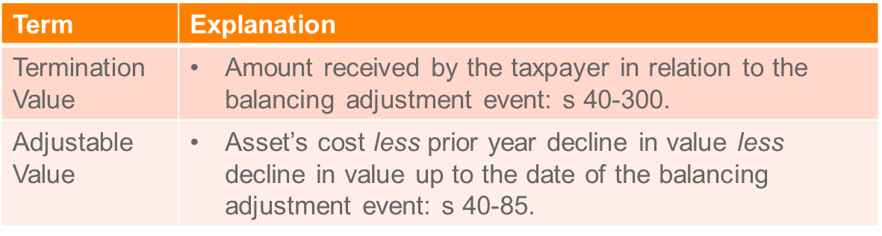

**Example**

Asset purchased on 1 July X1 for $3,000. Effective life is 3 years. Method: prime cost. Sold 30 June X2 for $2,500.

**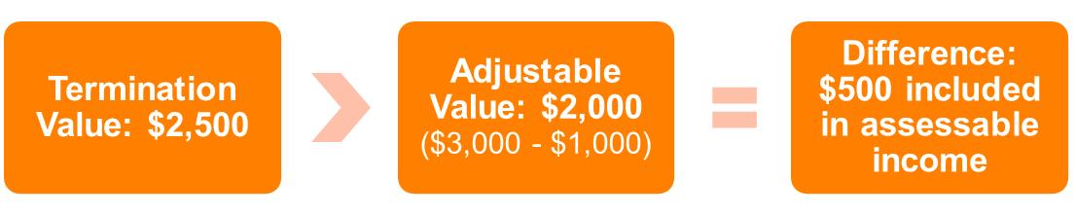**

**Asset used for non-taxable purpose**

* Balancing adjustment amount is reduced where the taxpayer used the asset for non-taxable purposes: s 40-290.

Reduction is calculated as follows:

****

Where:

* Sum of reductions = reductions in decline in value due to non-taxable purpose
* Total decline = total decline in value.

CGT implications apply to non-taxable component (CGT Event K7): see Chapter 11

**Pooling of assets**

* Taxpayers may claim deductions for the decline in value of certain assets on a group basis.
* Two pools may be utilised by a taxpayer:
  + Low value pool
  + Software development pool

Low cost assets

A depreciating asset whose cost at the end of the income year in which the taxpayer started to use it, or installed ready for use for a taxable purpose is less than $1,000.

Low-value assets

A depreciating asset held by a taxpayer that has been depreciated under the diminishing value method has an opening adjustable value of less than $1,000.

Exclusions include:

* Immediately deductible non-business income producing depreciating assets **under $300**.
* Assets deductible under small business entities rules.

Decline in value

The decline in value of low-value pool assets for each year is calculated in accordance with the s 40-440(1):

**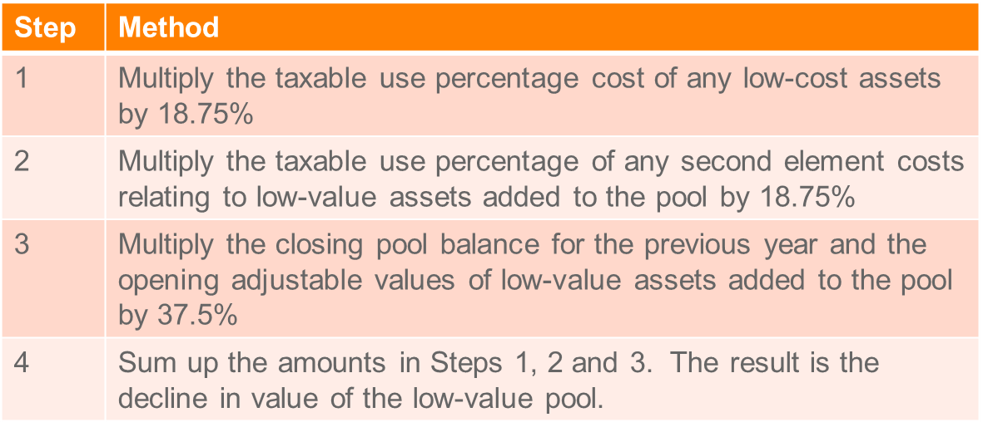**

Software development pool

Taxpayers who develop software generally required to capitalise expenditure.

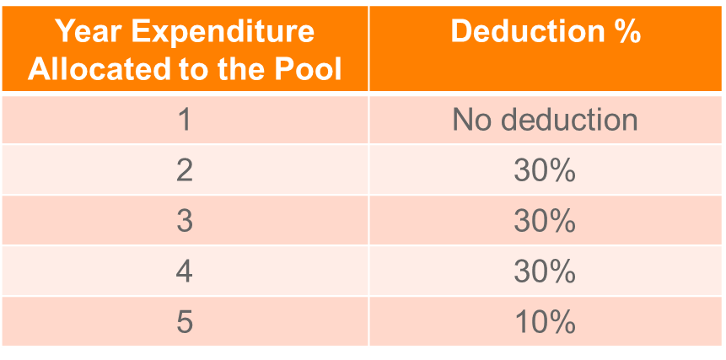

**Small business entity concessions**

* Small business entities can access simpler depreciation rules.
  + A small business entity is a sole trader, partnership, company or trust that operates business, for whole or part year, and has an aggregated turnover over less than $25m (for 2017-2018 income year).

Concessions:

1. Immediate deduction for assets < $1,000. Note: assets acquired between 12 May 2015 and 30 June 2018, the immediate deduction threshold is increased to $20,000
2. Pool all other assets into a general small business pool which are treated as a single asset subject to one rate

General small business pool

* Under s 328-190, small business entities are entitled to a deduction of:
  + 30% of the value of existing assets in the general small business pool.
  + 15% of the value of general small business pool assets acquired in the current income year.
* Opening pool balance determined under s 328-195.
* Closing pool balance determined under s 328-200.

## 10. Capital works deductions – Div 43 (Special building write off)

* Division 43 provides taxpayers with a deduction for capital expenditure on buildings used for income-producing purpose.
* Capital works include (s 43-20):
  + Buildings
  + Structural improvements
  + Environmental protection earthworks.

**Calculation of capital works deduction**

Capital works deductions are calculated using the following formula in ss 43-210; 43-215:

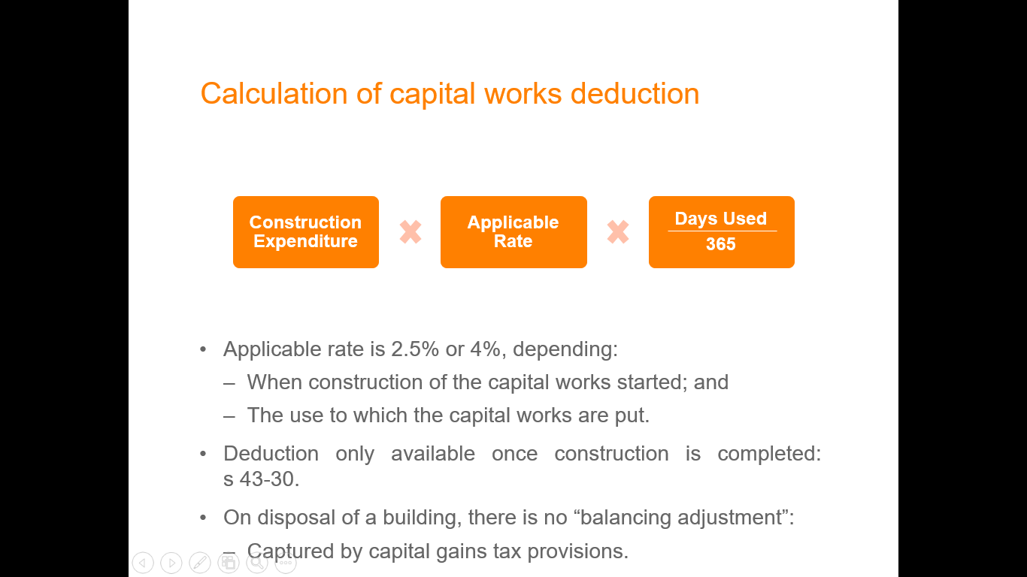

* Applicable rate is 2.5% or 4%, depending:
  + When construction of the capital works started; and
  + The use to which the capital works are put.
* Deduction only available once construction is completed: s 43-30.
* On disposal of a building, **there is no “balancing adjustment”**:
  + Captured by capital gains tax provisions

Construction expenditure

* Construction expenditure is determined on the basis of the actual cost incurred in relation to the construction of a building, structural improvement, extension, etc.

Excludes:

* + **Expenditure on acquiring land**
  + **Demolishing existing structures**
  + **Landscaping or expenditure on plant**.
* See, s 43-70 ITAA97.

## 11. Black Hole Expenses – Subdivision 40-1

* “Black hole” expenses are outgoings that are not recognised for tax purposes, for example:
  + Not deductible under s 8-1 ITAA97 (eg, preliminary costs)
  + Not recognised by capital allowances provisions
  + Not recognised under capital gains tax provisions.

**E.G.** Feasibility studies undertaken before TP committed to project,

* Expenses of setting up or closing a business, obligations incurred after business ceased that were not connected with production of assessable income.

Two categories of “black hole” expenses:

1. Project pools
2. Business- related costs

**Project pools**

* Capital expenditure associated with a project carried on for a taxable purpose and mining or transport capital expenditure are allocated to a “project pool”: s 40-830
  + Pooled expenditure must not form part of a depreciable asset or be deductible under another provision: s 40-840
  + Broadly, a deduction is spread over life of project.

**Business-related costs**

* Provides a deduction for expenditure that is capital in nature, with the key limitation:
  + Only applies to expenses that are not otherwise taken into consideration under income tax legislation: s 40-880.

Examples include:

* + Expenditure to establish a business structure (eg, legal expenses, company incorporation costs): *Softwood Pulp and Paper Ltd v FCT* (1976)
  + Expenditure to raise money for a business (eg, advertising).
  + Costs to stop carrying on a business, including liquidation and deregistration costs.
* Qualifying capital expenditure can be deducted in equal proportions over five years: s 40-880(2).
* The full capital expenditure amount can be deducted in the year incurred in realtion to a business proposed to be carried on that is a small business entity (less than $10M turnover): s 40-880 (2A)
* For expenditure relating to a proposed business, it must be reasonable to conclude that the business is proposed to be carried on within a reasonable time: s 40-880(7).
  + Demonstration of commitment: business plan, establishing business premises, undertaking research on the business, investments.

**Start-up expenses**

* Immediate deduction available to qualifying individuals and small business entities incurring expenditure that relates to a proposed business or structure: s 40-880(2A)
  + Expenditure would need to have been otherwise deductible under s 40-880 over 5 years.

## 12. No Double Deductions 8-10

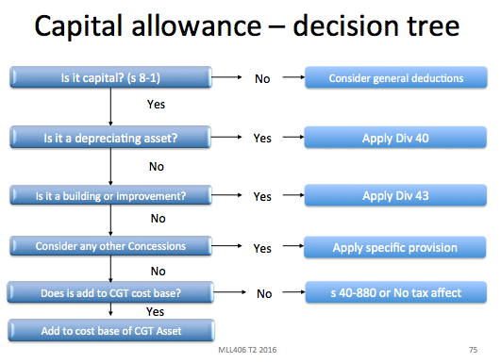

* If 2 or more provisions of this Act allow you deductions in respect of the same amount (whether for the same income yea or different income years), you can deduct only under the provision that is most appropriate.

## Other specific deduction provisions

Many other specific deduction provisions in Div 25 ITAA97, including:

* Lease document expenses: s 25-20
* Loss from profit-making undertaking or plan: s 25-40
* Loss by certain types of theft: s 25-45.

## Revision questions

**Discussion question:**

Jack and Jill jointly own and run a bed and breakfast business, J & J Bed and Breakfast. Jack and Jill also own an investment property which they purchased together. During the year, the following occurred:

1. J & J Bed and Breakfast recorded sales of $70,000 but had revenue expenses of $80,000. It is noted that the business had been operating at a loss for the last five years.
2. Purchased an air-conditioner for their investment property for $2,000 on 15 March 2016. The air-conditioner was installed on 20 March 2016 is expected to last for eight years, although the Commissioner states the effective life to be 10 years. *Used for investment activity (Falls under s 8-1 positive limb but falls under the negative limb as being capital). Can get a spread depreciation deduction under div 40. Will have to apportion depreciation for days between 20 March 16 – 30 June 16 (103/365). Can choose their own useful life if they like. Characteristics of use could be arguably different, for example a warmer climate could warrant more use. If they do not have a reasonable argument they risk being audited by the ATO and getting penalties (if there is a tax short fall) if the effective life is not appropriate.*
3. Constructed a granny flat at the rear of the investment property which is rented out on completion to Jack’s mother. Jack and Jill entered into a contract to build the unit with Bob the Builder on 1 July 2015, construction commenced on 1 September 2015 and was completed on 1 March 2016. The total costs of building the unit was $60,000 and this included demolition of an existing structure at a cost of $10,000. *Special building write-off – Capital works deduction. Demolition costs not included (s 43-70)*

*Calculation = Construction exp. X Rate X Days used/365*

*Note: Div. 43 states that a deduction cannot claimed until building is completed and ready for use.*

*Number of days ready for use in 2016 year: 1 March 16 – 30 June 16*

*$50,000 X 2.5% x 122/365 = $417.81 (half of this is deductible for Jack and half for Jill)*

# TOPIC 3.4 CHECKLIST: Deductions - TRADING STOCK

What is trading stock?

**Deductibility:** Sale of TS will be assessable income - the purchase of TS will be deductible.

**Definition S 70-10:** Anything produced, manufactured or acquired that is held for purposes of manufacture, sale or exchange in the ordinary course of a business and livestock **(***Sutton***)**

* Livestock
* Shares
* Land
* Packaging materials
* Items that create trading stock are not trading stock

**Trading stock must be on hand  
Dispositive power test:** does corp have power to dispose of stock? (not holding it for someone in particular *Farnsworth*)

**What value for trading stock?** (70-45)

**Can pick:**

* Cost
* What is stock worth?
* Cost may mean the invoice costs for item plus other expenses associated with bringing item to sale. So it is not just ‘cost price’ that cost refers to.
* Market selling price
* need to proportion for different prices sold in different markets (ex Nic and NSW)
* Replacement value
* What the stock would cost to replace on 30 June in the relevant tax year **(***Brigg Neuman***)**

**Is there an abnormal transaction?**Transactions involving TS that are not in ordinary course of business –S 70-90

* Taxpayer deemed to have disposed of item at its market value on day of disposal

**Has someone started using trading stock for personal use?**Then it is no longer trading stock and is valued at market value: s 70-90

**Has someone decided to use a personal item as trading stock?** S 70-30 Goes by original cost or its market value

**Someone bought trading stock above market value (‘not at arm’s length’)?** S 70-20eg. Paying your kid $5 for their cakes to sell in your shop instead of $2 to usual cake maker

**Are there any deductions for trading stock?**

# TOPIC 4.5: TRADING STOCK

* S 6-5 and 8-1 still exist and operate in tandem with them
* Income tax aspects of trading stock will draw on your knowledge of income, deductions and to some extent CGT.
* The rules and procedure for bringing trading stock into account for taxation purposes are deceptively simple. This area is, however, extremely complex and the treatment in this unit will of necessity be extremely superficial.
* Yes, sales of trading stock is ordinary income s 6-5 and purchases are deductible under s 8-1.
* “Anything” can be trading stock: *FCT v St Hubert’s Island Pty Ltd* (1978)
  + Necessary to determine the *purpose* for which it is *held.*
* An item can be trading stock of a taxpayer even if the taxpayer is not its legal owner.

**A taxpayer will have tax consequences arising:**

1. From the acquisition of trading stock;
2. From disposals of trading stock; and
3. At year end.

**Answering trading stock**

* Trading stock goes to the TP’s assessable income and deductions: s 70-35

1. Define the stock: s 70-10
2. **anything produced, manufactured or acquired that is held for purposes of manufacture,** sale or exchange in the ordinary course of a business; and
3. **live stock**
4. **Determine whether it is on hand**: *Farnsworth*
5. **Valuation of the stock ‘on hand’**

* Cost
* Market Selling Value; or
* Replacement value

1. **Valuation of abnormal transactions (obsolete stock/stock sold outside the course of ordinary business)**

* Reasonable value (Obsolete s 70-50)
* Market value (Outside ordinary business s 70-90)

ITTA 1997 s 70-35 - Value of trading stock in working out assessable income and deductions

1. If you carry on a business, you compare:
2. the value of all your trading stock on hand at the start of the income year; and
3. the value of all your trading stock on hand at the end of the income year.

* **Note:** You may not need to do this stocktaking if you are a small business entity: see Division 328.

1. Your assessable income includes any excess of the value at the end of the income year over the value at the start of the income year.
2. On the other hand, you can deduct any excess of the value at the start of the income year over the value at the end of the income year.

**Main things to consider:**

* defining what is trading stock under s. 70‑10
* determining when trading stock is ‘on hand’
* valuation of closing stock ‘on hand’
* Valuation of abnormal transactions.

## ‘Trading stock’ to be taken into account – Background

* **Section 6-5 provides that the gross income from carrying on a business is assessable income since such proceeds are income in the ordinary meaning of the word**. Receipts from the sale of trading stock are therefore ordinary income on the basis of the fixed and circulating capital test (i.e which is turned over and over in the course of the business which is carried on, like operating expenses and material, stock). Circulating capital is of an income nature, whereas fixed capital is not.
* **Similarly, the purchase of trading stock will normally be deductible under s 8-1.**
* Division 70 of the ITAA 97 aims to achieve a similar outcome by requiring that **closing trading stock is taken into account** (s 70-35(1)), with any **increase in the value of trading stock from the start to the end of the year being assessable income** (s 70-35(2)), and any **decrease giving rise to a deduction** (s 7-35(3**)**). This effectively means that although a deduction is claimed (s 8-1) in the year the trading stock is purchased, the real effect of the deduction is not seen until that stock is sold (see example).
* **If the closing stock is higher than opening stock the difference is included in assessable income** s 70-35(2)
* If the reverse applies the difference is an allowable deduction s 70-35(3)
* The following simple example illustrates how Div 70 defers the deduction for the purchase of trading stock to the year in which the stock is sold.
* This example starts with the commencement of a business and the purchase of one item of trading stock in the first year, with no sales.
* The sale of this one item occurs in the second year of business.
* Although a deduction is claimed in year one for the purchase of the stock, this is reversed by the increase in closing stock value, resulting in no effective deduction for the year.
* In the year when the stock is sold closing stock declines resulting in a deduction against the assessable income from the sale.

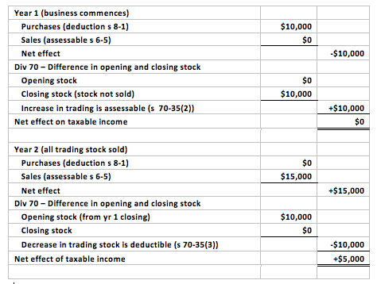

* **Trading Stock Div 70, S 70 -1**
* This Division deals with amounts you can deduct, and amounts included in your assessable income, because of these situations:
* you acquire an item of trading stock;
* you carry on a business and hold trading stock at the start or the end of the income year;
* you dispose of an item of trading stock outside the ordinary course of business, or it ceases to be trading stock in certain other circumstances.

## Trading stock defined

S 70-10: Meaning of trading stock

1. Trading stock includes:
2. **anything produced, manufactured or acquired that is held for purposes of manufacture,** sale or exchange in the ordinary course of a business; and
3. **live stock**

**Common items of trading stock**

* Land;
* Items that yield trading stock;
* Shares;
* Work in Progress (WIP);
* Intangibles (eg, shares) may constitute trading stock if held with the relevant purpose: *Patcorp Investments Ltd v FCT* (1976).
  + Share trading vs passive investing (shares usually tree, but if in the business of investing this is different)
* Consumables used by a service provider in the course of providing services may constitute trading stock:
  + Items must be separately identifiable things before and after the services are provided (e.g. Repairing business that re-fills a machine with oil is not separately identifiable), but an additional part could be trading stock.
  + Ownership of items must pass to the customer.
* Packaging materials held by a taxpayer may be trading stock where they are disposed of, and closely associated with “core goods”:Ruling TR 98/7.
  + E.g. You buy a blender, the box it comes in will also be trading stock.

Distinction between goods and services:

Goods –

* Raw materials and partly finished goods constitutes trading stock of a manufacturer: *FCT v St Hubert’s Island* (1978).
* Spare parts held for the purpose of exchange in the ordinary course of business constitutes trading stock.

Services –

* **Unbilled work in progress** of a professional services firm is generally not trading stock: *Henderson v FCT* (1970).

**Land**

Land may be trading stock following the decision in *St Hubert’s Island Pty Ltd v FCT* (1978) 13 CLR 210, 8 ATR 452; 78 ATC 4104 if it is the subject of the business of buying and selling land or where the taxpayer is a land developer.

* Normally land would go to CGT; however assessable income will take priority where the sale relates to business

**Items that yield trading stock**

It is important to make the distinction between something that yields trading stock and something that is trading stock. **The purchase of an item that yields trading stock is of a capital nature and is not trading stock. For example, the purchase of the right to mine land is the acquisition of a capital asset and the trading stock does not come into existence until it is removed from the ground**.

**Shares**

**After some disagreement it is now beyond doubt that shares can be trading stock for the purposes of s 70-35(1)** (*IMFC v FCT* (1971) 2 ATR 361; 71 ATC 4140).

### 

|  |
| --- |
| *Investment and Merchant Finance Corp Ltd v FCT* (1971) HC   * *Shares are capable of being trading stock* * This case decided that shares acquired by a dealer in shares with the intention of resale were trading stock. * Majority – ‘shares are capable of being trading stock and that shares intended for resale in the not-too-distant future were the trading stock of a company whose business it was to deal in shares. |

**Work in Progress (WIP)**

There seems to be little difficulty in concluding that the unfinished product (WIP) of a manufacturer is trading stock according to the definition in s 70-10. However, the treatment of the unfinished work of a builder or the unfinished work of a professional (e.g. unfinished work of an accountant) is generally not trading stock: *Henderson v FCT* (1970).

## Revision questions

**Discussion Question 1**

**A manufacturer who produces electric toasters has the following stock on hand at the end of the year. Which of these must be taken into account as trading stock for tax purposes?**

* 1. *Half-finished toasters – Yes: St Hubert’s Island Pty Ltd v FCT* (1978) 13 CLR 210
  2. *Stationery for use in the office - No, it is not produced or manufactured for the purpose of manufacture of toasters: S 70-10*
  3. *Metal plate which is used in making the toasters and forms part of the finished article – Yes as it is the raw materials used to produce the toasters.*
  4. *Finished toasters waiting to be delivered – no money has been received but this is part of a standard order that is supplied each month under contract – They are produced for the purpose of re-sale and they arguably do not have control over the tasters due to an existing contract (note this is not clear). If they are earmarked for a particular customer they will be regarded as no longer ‘on hand’.*
  5. *Labels and cartons used to package the finished toasters ready for sale – Yes see TR 98/7, if they are disposed of or closely associated with the product (which is the case)*
  6. *Spare parts held for the repair of the machinery used to make the toasters – Not spare parts for the toasters, but for the machines that make the toasters, so this will not be part of trading stock.*
  7. *Moulds used in the metal presses that form the metal plate into toasters – a mould can be used to form 500 toasters before it is replaced – No, again not trading stock, part of the machinery used to make the trading stock. Not part of the ‘final product’.*
  8. *Building materials to be used for extensions to the factory – these extensions will enable increased production – No, not part of the manufacturing process or the final product.*

## Year-end adjustments

* An adjustment is required to ensure the taxpayer only accounts for a deduction when there is an actual economic decline.
* Taxpayers are required under s 70-35 to **compare the “value” of trading stock on hand at the start and at the end of the year**:





**Value of trading stock at start of year**

* The value of stocks held at the beginning of the year is quite clearly the value used as the closing value for the previous year (see s 70-40). However, the valuation of closing stock is not as straightforward.

**Value of trading stock and end of year**

The closing value for each item of trading stock can be, at the option of the taxpayer (s 70-45(1)), either its:

1. ‘Cost’;
2. ‘Market selling value’; or
3. ‘Replacement value’.

**‘Cost’**

* Should be determined in accordance with accounting principles: *Phillip Morris Ltd v FCT* (1979):
  + Manufacturers, retailers and wholesalers should use the accounting **“absorption cost method”**: All the direct or indirect costs involved in manufacturing or acquiring the asset.
  + ATO: **Cost price** - this i**ncludes all costs connected with bringing the stock into existence.** The cost of finished goods, for example, must include freight, customs duties and delivery charges, as well as the purchase price. For manufactured goods and work in progress, the full cost includes the cost of labour and materials, plus an appropriate proportion of fixed and variable factory overheads, such as power, rent, rates and factory administration costs.
  + In terms of working out which item of stock has been sold – the **first-in-first-out method** should be used where it is not possible to track individual items: *Australasian Jam v FCT.*

**‘Market selling value’**

* Is the amount for which the taxpayer could sell the stock in the ordinary course of business.
* This method provides few problems. The value of stock would be determined by estimating its value in the ordinary course of business, that is, normal quantities in the normal market (*Australasian Jam Co. Pty Ltd v FCT* (1953) 88 CLR 23; 5 AITR 566; 10 ATD 217).
* Note that an item’s market selling value may however be different to its market value.
* **Exceptional assumptions such as a forced sale, are not relevant**. It is also commented that where goods are sold in more than one market it is not possible to value them by reference to one market only; they were to be valued in the proper proportion in each market.

**Replacement Value**

* Is the amount the taxpayer would have to spend to replace the stock. I.E. The price that would have to be paid to secure replacement item.
  + In *Brigg Neumann & Co. v Commissioners of Inland Revenue* (1928) 12 TC 1191 at 1203, Rowlatt J held that replacement cost meant the price the taxpayer would have to pay in order to have the item on hand on the last day of the tax year.

**Obsolete stock**

* Taxpayer may value trading stock at a value lower than the 3 methods if it is obsolete and the value used by the taxpayer is reasonable: s 70-50.

## When is trading stock ‘on hand?’

Section 70-35(1) only requires trading stock, which is ‘**on hand**’ at the start or end of the year of income to be ‘valued’. This question must be answered for tax purposes and does not always follow accounting practice.

General guidance on what constitutes “on hand”, includes:

* Taxpayer having **dispositive power**: *Farnsworth v FCT* (1949)
* Dispositive power **may not include legal ownership**: *FCT v Sutton Motors (Chullora) Wholesale Pty Ltd* (1985)
* Dispositive power **does not require physical possession of the goods**: *All States Frozen Foods v FCT* (1990).

**Dispositive (control of the stock) power test**

* Can the TP determine what happens to the stock?
* Whether **TS is ‘on hand’ is vital with respect to timing and adjustments** (TS on hand at end of year compared to beginning etc). **Stock where the TP has title and possession will generally be straight forward, but where this does not happen then difficulties can arise.**
* This is the general test, whether there is dispositive power – meaning that the TP is in a position to sell or otherwise direct the use of the terms in question.

|  |
| --- |
| *Farnsworth v FCT* (1949) HC   * Stock not ‘on hand’ if stock is delivered to a packing house where it is to be graded and sold = not assessable * **Facts:** TP was a member of a growers’ association and participated in pooled scheme where growers delivered their goods to the packing house where they were graded and sold. * Upon delivery, property passed to the pool operators. * Payments were made to members on the basis of quality and quantity of the fruit sold. * The Commissioner assessed TP on installments received and also on an estimated amount to be received based on the unsold fruit still at the packing house. * **Held:** The HC held that the amount estimated was not assessable because the stock was not on hand to the TP. * It was held by that the goods where no on hand as the taxpayer had lost its ‘dispositive power’ over the goods. * Subsequent payments would clearly be income. |

**Legitimately held for sale test**

* As discussed, where TP has physical possession of property there will usually (not always) be a power to dispose of it.
* Conversely, where TP does not have property in stock will normally not be able to dispose of it. However, an exception to this is in *FCT v Sutton Motors Case*

|  |
| --- |
| FCT v Sutton Motors (Chullora) Wholesale Pty Ltd (1985)   * **Facts:** TP was Co in a group of companies selling motor vehicles. * TP acted as wholesaler for the group (SM) * Vehicles were owned by a finance company (GMAC) but were displayed in SM’s showroom under a floor plan arrangement. * When a vehicle was sold by SM to a customer, the TP immediately invoiced SM the wholesale price and SM paid GMAC * **Issue:** Under former legislation re trading stock where needed to be ‘on hand’ to claim deduction * TP argued that parties to the agreement regarded the vehicles as TP’s trading stock. * Commissioner argued that were not trading stock on hand because were property of GMAC and stored in SM showrooms. In addition that were not COB but just shuffling paper. * **Held:** Dismissed Commissioner’s appeal and held that although not owned or paid for by TP, vehicles were held for the purpose of sale in the ordinary course of business. * That goods in the possession of, but not owned by the taxpayer may still be part of the taxpayer’s trading stock. |

**Does not require physical possession**

* In *All States Frozen Foods Pty Ltd v. F.C. of T.* (1990) 21 FCR 457 (90 ATC 4175; (1990) 20 ATR 1874), the Full Federal Court of Australia (Bowen C.J., Lockhart and Gummow JJ.) upheld the decision of Davies J. in F.C. of T. v. *All States Frozen Foods Pty Ltd* (1989) 88 ALR 575 (89 ATC 5135; (1989) 20 ATR 1454) that the goods en route (transit) from overseas suppliers were in certain circumstances trading stock on hand of the taxpayer.

## Revision question

**Discussion Question 2**

Ryan designs and makes chairs. He sells the chairs through a website. His books of account provide the following information:

|  | **1 July** | **30 June** |
| --- | --- | --- |
| Completed chairs ready for sale | $3,000 | $1,000 |
| Partly completed chairs | $1,500 | $3,000 |
| Timber | $700 | $500 |
| Springs | $1,000 | $600 |
| Total purchases of timber during the year = $3,000 | | |
| Total purchases of springs during the year = $1,000 | | |
| Total sales of chairs during the year = $20,000 | | |

**Advise Ryan of his income tax consequences arising from the above information**

* *Completed chairs: Yes*
* *Partly completed chairs: Yes: St Hubert’s Island Pty Ltd v FCT* (1978) 13 CLR 210
* *Timber and springs: The costs associated with the purchase of the timber and springs are deductible under s 8-1*

*Year-end adjustment:*

* *Total costs at year end: $5,100*
* *Total costs at year beginning: $6,200*
* *This results in a deduction of $1,100*

## Transactions involving trading stock, not in in the ordinary course of business or not ‘at arm’s length’

**Non-arm’s length acquisitions**

Under s 70-20, a deduction **equal to the market value** of the trading stock should be adopted where the:

(i) Buyer and seller did not deal at “arm’s length”; **and**

(ii) The expense is greater than the “market value”.

**Non-arm’s length disposals**

Where an adjustment to the purchaser’s deduction applies, the market value is included in assessable income of the seller: s 70-20.

**Disposals outside the ordinary course of business** (eg, disposed on sale of a business, gifts or donations provided):

* Taxpayer disposing the trading stock includes the market value in assessable income: s 70-90.
* Purchaser is deemed to acquire the trading stock for the same value: s 70-95.

S 70-90 -Assessable income on disposal of trading stock outside the ordinary course of business

1. If you dispose of an item of your trading stock outside the ordinary course of a business:
2. that you are carrying on; and
3. of which the item is an asset;

* Your assessable income includes the market value of the item on the day of the disposal.

## Special rules

* The characterisation of an item as trading stock depends on the taxpayer’s purpose in holding the asset.
* Special rules may apply when the taxpayer’s purpose changes.

Special rules include:

1. Asset of taxpayer becomes trading stock;
2. Item ceases to be trading stock but continues to be owned by TP;
3. Lost or destroyed stock
4. **Asset of taxpayer becomes trading stock**

Where an asset that is owned by the taxpayer becomes trading stock:

* + Taxpayer is deemed to have disposed the item; and
  + Re-acquired the item: s 70-30.
* The taxpayer has a choice as to whether the deemed disposal and re-acquisition is done at “cost” or at “market value”: s 70-30(3).

Other tax considerations:

* + Balancing adjustment if the asset was a depreciating asset
  + CGT event K4 if the asset was a CGT asset and disposal and re-acquisition done at “market value”.

1. **Item ceases to be trading stock**

Where a taxpayer ceases to hold an item as trading stock, but continues to own it:

* + Taxpayer is deemed to have disposed the item; and
  + Re-acquired it for “cost”: s 70-110.
* The cost on re-acquisition becomes the asset’s cost base (for a CGT asset) or cost (for a depreciable asset).
* Commissioner provides reasonable estimates of the value of goods taken from trading stock for private use for certain businesses: TD 2017/9.

1. **Lost or destroyed stock**

* Any lost or destroyed stock taken into account through the year-end adjustment as stock is not “on hand”.
* Any compensation received for lost or destroyed stock is included in the taxpayer’s assessable income under s 70-115.

## Small business entity concession

* Definition of a small business entity (SBE):
  + A sole trader, partnership, company or trust that operates business, for whole or part year, and has an aggregated turnover over **less than $10m**.
* Concession for SBE:
  + If the difference between opening and closing stock value is **less than $5,000**, the taxpayer may choose not to account for changes: s 328-285(1). < So do not have to work out an adjustment.

.

## Interaction with other income tax rules

* Where trading stock also qualifies as a CGT asset:
  + Any capital gain or loss is disregarded if, at the time of the CGT event, the CGT asset is classified as trading stock: s 118-25.
* Where trading stock also qualifies as a depreciating asset subject to the capital allowances regime:
  + Trading stock is excluded from the definition of a “depreciating asset”: s 40-30(1)(b).

# TOPIC 3 CHECKLIST – CAPITAL GAINS TAX (CGT)

* Contributes to SI
* This is a last resort tax, if the receipt can come under a provision in OI or SI, this provision is to be applied
* Applies to assets **prior to 20 September 1985**

## STEP 1: IS THERE A GAIN OR LOSS?

1. **Is it a CGT Asset?**

Section 108-5(1), defines a CGT asset in general terms**: any kind of property** (tangible/intangible) (1)(a) or a **legal or equitable right** that is not property (1)(b). Some Examples of CGT assets:

* Right to compensation is a legal right: *Hepples*
* Goodwill: (2)(b)
* Interest in a partnership: **(**2)(c), (d)
* **Note 1:** Land and buildings, company shares, units, options, debts owed to you, a right to enforce contractual obligations, foreign currency

**Sample Answer:** “the \_\_\_\_\_\_ is a CGT asset pursuant to s 108-5”

S 108-10(2): **Collectables –** exhaustive definition:

1. **Artwork, jewellery**, an **antique**, or a **coin** or **medallion**
2. A **rare folio, manuscript or book**
3. A **postage stamp** or **first day cover** that is used or kept mainly for your personal use or enjoyment.

* **Will only apply if purchase value was over $500:** s 118-10
* **Collectable sold individually** **if it is in a set will not avoid CGT consequences** (eg. TP try to sell a stamp from a set): s 108-15

**Sample Answer:** “the \_\_\_\_\_\_ is a CGT asset, particularly a collectable pursuant to s 108-10(2)(\_)”

Subdivision 108-C**: Personal use assets –** non-exhaustive

* Assets not defined under ‘collectables’ may fall under this provisions
* **No exhaustive definition**, includes cars, tv, fridge, furniture etc
* These assets are exempt from **CGT if they cost $10 000 or less (s 118-10(3))**
* However, any **capital losses realised are also disregarded** (s 108-20(1))

**Sample Answer:** “the \_\_\_\_\_\_ is a CGT asset does not satisfy the ‘collectables’ definition in s 108-10(2); thus it can be regarded as a personal use asset pursuant to subdivision 108-C”

## Is there a CGT Event?

* Sec 102-20: gain/loss only applies if there is a CGT event in s 104-5
* **The steps for selecting the applicable CGT event:**

1. Select which of the CGT events apply (ignore D1 and H2—these are left to last).
2. If **more than one event applies select the most specific**.
3. If **no previously considered CGT event applies consider if D1 applies**.
4. **If D1 does not apply consider if H2 applies**.
5. **If none of the above apply there is no CGT**

**CGT Event A1 - Disposal of an Asset:** s 104-10

* Disposal’ of a CGT asset would generally occur when ownership of an asset passes from one owner to another
* CGT Event A1 ( **s 104-10(3)**), **the timing of the event is when:**

1. **you enter into the contract for the disposal** (selling a house); or
2. **if there is no contract** – **when the change of ownership occurs**.

* **S 109-5:** Asset must be acquired (TP must be owner)

**CGT Event C1 – Loss or Destruction of a CGT Asset:** s 104-20

* **Applies to tangible assets**
* Occurs if a **CGT asset owned by a TP is lost or destroyed** **s 104-20(1)**. It can also apply where part of a CGT asset is lost or destroyed.
* **Any compensation received becomes part of the capital proceeds s 116 – 20(1)**.
* **The time of the CGT event C1 is s 104-20(2)**
* **when compensation is first received** for the loss or destruction; **OR**
* if **no compensation is received, when the loss is discovered** or the destruction occurred.

**CGT Event C2 – Cancellation, Surrender or Similar Endings:** s 104-25

* **Applies to intangible assets**
* Event C2 occurs where ownership of an **intangible CGT asset** ends as a result of the asset:

1. Being redeemed or cancelled (eg shares/ debentures)
2. Being released, discharged or satisfied (a debt)
3. Expiring (contractual rights)
4. Being abandoned, surrendered or forfeited (contractual rights)

* **Time of CGT event:** A C2 event occurs where a taxpayer enters into a contract that results in the asset ending s 104-25(2)(a) or if there is no contract, when the asset ends s 104-25(2)(b)
* Discharge of a future liability/debt by paying a lesser amount immediately did not constitute a profit; however constitutes a C2 event: ***Orica* HC**

**CGT Event F1 – Lease Grant or Renewal:** s 104-110

* CGT event F1(**s 104-110**) occurs **when a lease is granted, renewed or extended.**
* Event F1 is **aimed at taxing lease premiums (lump sum payments** to the lessor).
* **Discount NOT available in this event**

**CGT Event D1 – Creation of Contractual Rights:** s 104-35

* Event D1 applies where a person enters into a contractual agreement with another entity and they acquired rights under that agreement.
* There is **no need to have a CGT asset**.
* Event D1 deems a **capital gain to arise where payment is received for the creation of a contractual right**.
* **The time of the event,** is when you enter into the contract or create the other right **s 104-35(2)**.
* **Indexation/ discount NOT available**
* ***Hepples*:** contract with former employer to not tell others of employer’s trade secrets

**CGT Event H2 – Receipt relating to a CGT asset (last resort):** s 104-155

* Event H2 arises if an act, transaction or event **occurs/ happens in relation to a CGT asset, and as a result of the act or transaction, capital proceeds are received**. The act, transaction or event doesn’t change the assets cost base.
* **Time of CGT event**: when act, transaction or event occurs **s 104-155(2**)
* **Indexation/ discount NOT available**

## STEP 2: CALCULATING CAPITAL GAIN

* **Capital Gain** = Capital Proceeds (CP) – Cost Base (CB)

CG = CP – CB

* **Capital Loss** = CP – Reduced Cost bade (RCB)

CL = RCB – CP or CP – RCB (if you want a neg. number to remind you it’s a loss)

**Capital Proceeds:** s 116-20

S 116-20 (1) The capital proceeds are**:**

1. The **money you have received**, or **are entitled to receive**, in respect of the event happening; and
2. **The market value of any other property you have received, or are entitled to receive**, in respect of the event happening (worked out as at the time of the event).

The **amount will be reduced by any GST included in the price** (s 116-25(5**)**)

**Modifications of CP:** s 116-10

S 116-25 shows the events that the modifications are relevant to:

1. **S 116-30** **– “market value” modification**. If no money is received as if the transaction was conducted at arm’s length (**eg** Candice sold me her house for $10 because we’re friends)
2. **S 116-40** – **Apportionment modification.** Single proceed is the total of two or more events, the proceeds must be apportioned between those events (**eg.** A lump sum of $800,000 for the sale of house and a yacht will need to be apportioned to determine individual value
3. **S 116-45 – Non-receipt rule.** Capital Proceeds to be reduced by any amount that you have not received and will not receive after all reasonable attempts
4. **S 116-50 – Repaid Rule.** Reduces the capital proceeds by any non-deductible amount paid as compensation resulting from the CGT Event (**eg** sued after settlement of house for $300,00 and you need to pay $40,000 compensation, it will be reduced to $260,000)
5. **S 116-55** – **Assumption of liability rule.** Your capital proceeds are increased by the amount of any liability assumed as part of the sale (**eg** buy house for $100k plus take over ongoing mortgage ($50k) = $150k CP)
6. **S 116-60 – Misappropriation Rule.** Allows you to reduce capital proceeds by any amount misappropriated by an employee or agent (**Eg** Real estate agent takes the 10% deposit from a house sale, this 10% will be deducted)

**Cost Base:** s 110-25

* Sec 110-45: **CGT assets acquired after 13/5/97, all deductible amounts not included**
* Sec 103-30: CGT events after 19/2/2004 GST input credits not included in cost base

**Five cost base elements (**s 110-25**):**

1. **Acquisition cost**: 110-25(2)

* Modifications in s 116-25 will fall under this element

1. **Incidental costs of acquisition and the CGT event** **(3)**

* Legal fees, transfer costs, stamp duty, advertising etc. s 110-35

1. **Costs of owning the CGT Asset** **(4) (purchase after 20 Aug 1991)**

* Rates, interest, maintenance, borrowing costs etc. (see main notes)

1. **Capital expenditure relating to the asset** **(5)**

* Expenses to install, move, increase or preserve the asset (**e.g.** renovating and goodwill)

1. **Capital expenditure of establishing, preserving or defending title to the property**. **(6)**

* Cost of litigation
* **Is there a loss? Reduced Cost Base:** s 110-55 **remove element 3** **and indexation** where you thought the answer was gain and it was actually a loss

**STEP 3: CALCULATING NET CAPITAL GAIN/LOSS**

* S 102-5: Assessable amount is NET capital gain. **Net losses for the year can be carried forward indefinitely:** Div 122-126
* S 115-15 **General discount of 50% of the Capital gain assessable for CGT Events after 11:45 AM 21 Sep 1999 where:**

1. TP is individual, trust or super fund and **not a company:** s 115-10
2. TP must have **owned asset for 12 months:** s 115-25(1)
3. **Cannot be an excluded event (D1, F1, H2):** s 115-25(3)

**General CGT Exclusions**

* s 118-5 - Motor vehicles
* s 118-10 - Collectables & PU assets (see previous)
* s 118-20 - Otherwise assessable - CGT is a last resort tax
* s 118-24 - Depreciable assets - covered by Div 40 balancing adjustment
* s 118-25 - Trading stock - covered by s 6-5 and s 8-1
* s 118-37(1)(a) & (b) - Personal compensation (personal wrong, injury or illness)
* s 118-40 – private lease ends

**Main Residence Exemption:** Subdiv 118-B

S 118-110 gain fully exempt if:

1. Owned by individual
2. Dwelling is a main residence

S 118-145: You may be absent from your main residence, and earn assessable income from it, for up to six years provided that you do not have another main residence

S 118-185(1) gain partially exempt where:

1. you are an individual; and
2. the dwelling was your main residence for part of your ownership period; and
3. the interest did not pass to you as a beneficiary and you did not acquire it as a trustee of, the estate of a deceased person.

* (2) Calculating partial exemption for the main residence is as follows: CG or CL amount x Non-residence days/days in your ownership period
* Only one main residence per family (pick one where more then one)(s 118-170)
* Dependant child cannot have a different main residence to both parents (s 118-175)

**Disposals Resulting from Death:** s 128-10

* Disposals resulting from death should be disregarded: s 128-10
* Capital gains and losses are also disregarded for assets passed from the legal personal representative to a beneficiary: s 128-15

S 118-195: For full exemption of disposal resulting from death

* Interest from an estate passed to you as a beneficiary: (1)(a)
* Must be the main residence of the deceased: (1)(b)
* Beneficiary disposed of asset within two years of ownership: (1)(b)

S 118-200: Partial exemption for deceased estate where:

1. You are an individual and your ownership interest in a dwelling passed to you as a beneficiary in a deceased estate, or you owned it as the trustee of a deceased estate; and
2. Section 118-195 does not apply.

* You calculate your capital gain or capital loss using the formula: CG or CL amount x Non-main res. days/Total days (2)
* If the two years expires: Dwelling assessed at market value when sold and deceased’s cost base is applied: s 128-15

**CGT Record Keeping**

* S 121-20 – transaction details of CGT to be recorded (date, consideration, parties)
* S 121-25: Records to be retained for 5 years

# TOPIC 4: CAPITAL GAINS TAX (CGT)

* Any **assets prior to 20 September 1985 are not subject to CGT**, that is the date CGT came in

Capital Gains Tax technically comes under statutory income.

## Steps for CGT

1. Is there a capital gain or loss?
2. Amount of Capital gain/loss
3. Calculate net capital gain/loss
4. Other CGT events & records

**Step 1:** **Is there a gain or loss?**

* CGT Event (Pre requisite)
* CGT asset (Pre requisite)
* Timing of the event

**Step 2:** **Determine amount of gain/loss**

* What are capital proceeds (Div116)/modifications
* What is the cost base
* Reduced cost base
* Cost base modifications

**Step 3: Calculating the gain or loss (net)**

* CGT losses
* 50% general discount
* Exemptions and concessions
* Roll-over concessions
* Net capital gains as assessable income

**These steps can be applied to other events:**

* Event C1
* Event C2
* Event D1
* Event F1
* Event H2

**Record keeping requirements for CGT**

## Overview

* CGT is "essentially a tax upon gains from the realisation of property where the realisation is not an aspect of the carrying on of a business".
* In other words, CGT aims to tax gains made on the disposal of assets and sometimes also to tax the receipt of certain other capital amounts that do not derive from the disposal of assets.
* Relates to assets acquired after 20 September 1985 (when CGT came into effect)

## CGT Provisions

* The basic structure of s6-5 and s 8-1 is not followed by the CGT provisions.
* The CGT provisions include as assessable income a net capital gain. As such CGT is statutory income

## STEP 1: Is there a capital gain/loss?

1. Has a CGT event happened to the taxpayer?
2. Is the asset a CGT asset?
3. Does an exemption or exception apply?
4. Can there be a rollover?

***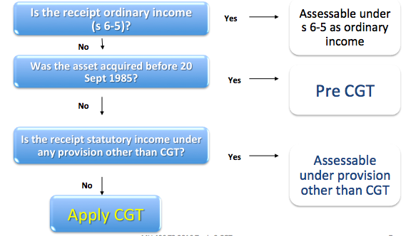***

## i. Has a CGT event happened?

* **For Capital tax provisions to apply,** s. 102-20 **requires that there is a ‘CGT event’** (a summary of these events is contained in s. 104-5).
  + A taxpayer only makes a capital gain or loss if a CGT event occurs: s 102-20.
* Sometimes, more than one CGT event will happen. Generally, the most specific to the situation is used: s 102-25(1).
* Only 52 CGT events exist. For summary of CGT events, see s 104-5.
* We look at only the main CGT events
  + A1, C1, C2, D1, F1, H2
  + Event A1 is the most general: s 104-10 (Sale and disposal of assets)
* If more than one event applicable make the decision in the following order - s 102-25:
  + Ignore D1 and H2
  + Select most appropriate of remainder
  + If no other event applies try D1
  + If not D1 - try H2
  + If not H2 - no CGT
* Look at CGT Event A1 and D1 first – look at other events later

**CGT Event A1 – Disposal (**s 104-10(1))

* Occurs when the taxpayer disposes of a CGT asset.
* Time of the CGT event:
  + When the taxpayer enters into the contract, or
  + If no contract, when ownership change occurs. See, *FCT v Sara Lee Household* (2000)*.*
* Illustration: Timing of CGT event (and hence capital gain or loss) will be in the income year ended 30 June X1

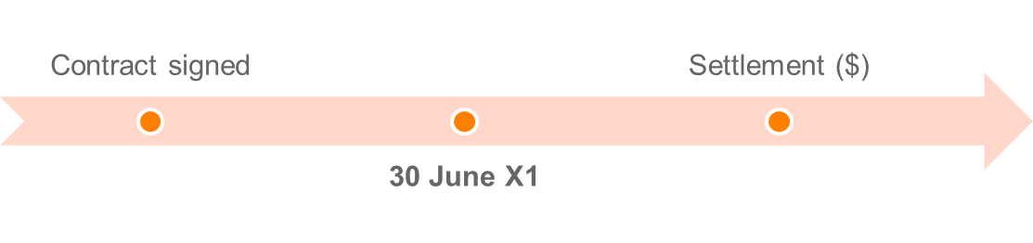

Under CGT event A1, a capital gain is made:



A capital loss is made:



* Capital Gains or losses disregarded if CGT Asset acquired before 20 September 1985 (s 104-10(5))

**CGT event D1 – Creating contractual and other rights (**s 104-35(1))

* Occurs where a taxpayer creates a contractual or other legal right in another entity, for example:
  + **Restraint of trade** where a taxpayer agrees not to operate a similar business within a particular radius.
  + Exclusive trade agreements.
* Time of the CGT event: when the taxpayer enters into the contract or creates the right.

Under CGT event D1, a capital gain is made:



A capital loss is made:



* Incidental costs include, e.g., legal costs in drawing up the contract.
* The incidental costs can also include giving property (but not a recoupment of them that is non-assessable).
* Section 104-35(5) **excludes certain situations involving the creation of rights**, e.g.:
  + TP creates the right by **borrowing money**;
  + Contractual right requires TP to do something that is a CGT Event:

S agrees to sell land to B. S creates a contractual right in the B to enforce completion of the transaction. The sale results in S disposing of the land, an example of CGT event A1. This means that CGT event D1 does not happen.

## ii. CGT ‘asset’?

1. You identify there is a CGT asset
2. There has been disposal of the asset to trigger a CGT event
3. You identify the date you had acquired the asset
4. You identify the date you disposed of the asset

* Broad definition of a CGT asset. Defined in s 108-5(1) as:
  + **Any kind or property**; or
  + **Legal or equitable right that is not property**.
* Examples include:
  + Land and buildings
  + Shares in a company / units in a unit trust
  + Collectibles costing over $500 (eg, stamp collection)
  + Personal use assets costing over $10,000 (eg, boat)
  + Contractual rights (eg, restraint of trade)
  + Business goodwill.
* Commissioner has suggested bitcoin is a CGT asset. (Taxation Determination TD 2014/26)

ITAA s 108.5 - CGT assets

             (1)  A [*CGT asset*](http://www6.austlii.edu.au/cgi-bin/viewdoc/au/legis/cth/consol_act/itaa1997240/s995.1.html#cgt_asset)is:

                     (a)  any kind of property; or

                     (b)  a legal or equitable right that is not property.

             (2)  To avoid doubt, these are [*CGT assets*](http://www6.austlii.edu.au/cgi-bin/viewdoc/au/legis/cth/consol_act/itaa1997240/s995.1.html#cgt_asset):

                     (a)  [part](http://www6.austlii.edu.au/cgi-bin/viewdoc/au/legis/cth/consol_act/itaa1997240/s995.1.html#part) of, or an [interest](http://www6.austlii.edu.au/cgi-bin/viewdoc/au/legis/cth/consol_act/itaa1997240/s974.10.html#interest) in, an asset referred to in [subsection](http://www6.austlii.edu.au/cgi-bin/viewdoc/au/legis/cth/consol_act/itaa1997240/s51.54.html#subsection) (1);

                     (b)  goodwill or an [interest](http://www6.austlii.edu.au/cgi-bin/viewdoc/au/legis/cth/consol_act/itaa1997240/s974.10.html#interest) in it;

                     (c)  an [interest](http://www6.austlii.edu.au/cgi-bin/viewdoc/au/legis/cth/consol_act/itaa1997240/s974.10.html#interest) in an asset of a [partnership](http://www6.austlii.edu.au/cgi-bin/viewdoc/au/legis/cth/consol_act/itaa1997240/s995.1.html#partnership);

                     (d)  an [interest](http://www6.austlii.edu.au/cgi-bin/viewdoc/au/legis/cth/consol_act/itaa1997240/s974.10.html#interest) in a [partnership](http://www6.austlii.edu.au/cgi-bin/viewdoc/au/legis/cth/consol_act/itaa1997240/s995.1.html#partnership) that is not covered by [paragraph](http://www6.austlii.edu.au/cgi-bin/viewdoc/au/legis/cth/consol_act/itaa1997240/s51.54.html#paragraph) (c).

Note 1:       Examples of [CGT assets](http://www6.austlii.edu.au/cgi-bin/viewdoc/au/legis/cth/consol_act/itaa1997240/s995.1.html#cgt_asset) are:

* land and buildings;
* [shares](http://www6.austlii.edu.au/cgi-bin/viewdoc/au/legis/cth/consol_act/itaa1997240/s995.1.html#share) in a [company](http://www6.austlii.edu.au/cgi-bin/viewdoc/au/legis/cth/consol_act/itaa1997240/s995.1.html#company) and units in a unit trust;
* options;
* debts owed to you;
* a right to enforce a contractual obligation;
* [foreign currency](http://www6.austlii.edu.au/cgi-bin/viewdoc/au/legis/cth/consol_act/itaa1997240/s995.1.html" \l "foreign_currency).

**‘Any kind of property’**

S 108-5(a) “Any kind of property”

|  |
| --- |
| FCT v Orica (1998) HC   * MMBW agreed to assume Orica’s obligations under debenture trust deeds to make payments to debenture holders – Orica paid MMBW $62.3m to assume the obligations and made a profit because it “defeased” an obligation to pay $98.6m at a later time. The $62.3 million represented the aggregate of the “present values” of the debentures payable in the future. * High Court said that Orica acquired a right to compel MMBW to perform the obligations under the debt defeasance agreement. * **Held** that the right was capable of assignment and therefore was property. |

**Legal and equitable rights that are not property**

* S 108-5(1)(b) of the definition of a CGT asset includes legal and equitable rights that are not property. This would include non-proprietary rights.
* For example, right to compensation for a cancelled contract for work.
* In *Hepples v FCT* (1991) 22 ATR 465 the taxpayer was paid $40,000 on his retirement for agreeing not to disclose the secrets of his employer 🡪 receipt was not a substitute for income and was a capital payment for entering the restrictive covenant on termination of employment.
* A right to sue is a CGT asset
* An asset is real or intangible property
* **Proprietary right – right relating to property**
* **Not** personal rights e.g. right to work or trade
* **Not** civil rights - available to all

**Questions**:

What are the assets, if any, under s 108-5 in the following situations?

(a) The creation of a work of art - *Yes*

(b) Sale of a business as a going concern – *Yes, goodwill, plant and equip etc., building, land and shares.*

(c) The issue of new shares to a corporate shareholder - *Yes*

(d) A negligent act that caused a school pupil to become permanently disabled – *Second limbof CGT asset, a right to sue (legal right).*

**Tangible**

Items of tangible property (have physical existence) such as land, buildings, and chattels do not provide any difficulty when considering the meaning of the term property. They are capable of possession, ownership may be transferred and the right of ownership may be defended in a court.

**Intangible**

* An idea may be a CGT asset if it is manifest either in a Trademark, a copyright or an application for patent
* Something still in your head is not property (knowledge or know-how)
* If you create a patent or other industrial property over your idea or knowledge, property exists in the patent as it is transferable and may be the subject of legal action. If you sell the patent to another person, you have given up the right to use that idea and therefore you have transferred property to a new owner.

Important to classify CGT assets into their relevant categories (special rules apply to each):

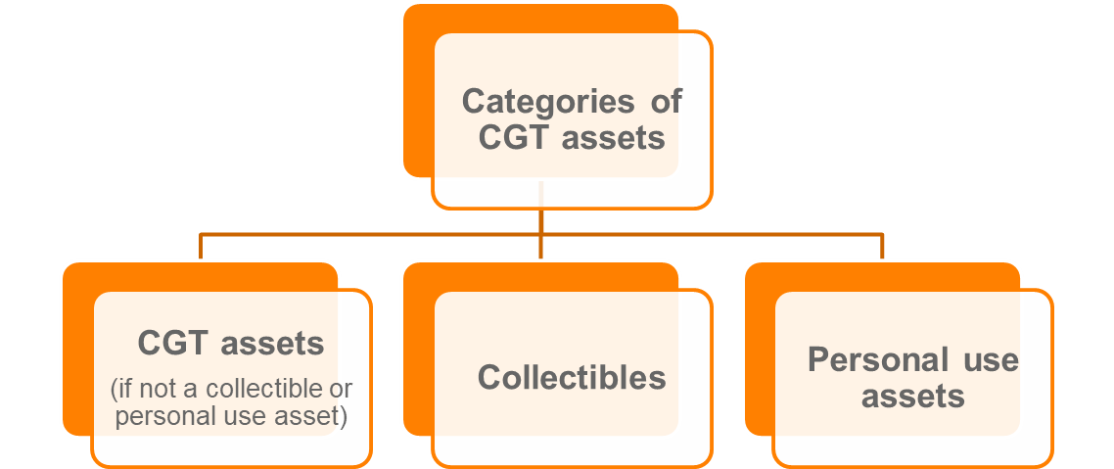

**Collectables and other personal use assets**

S 108.10(2)a *collectable* is:

1. Artwork, jewellery, an antique, or a coin or medallion
2. a rare folio, manuscript or book
3. a postage stamp or first day cover

that is used or kept mainly for your personal use or enjoyment.

* This provision is exhaustive, if the facts indicate a different collectable, it will not fall under s 108.10(2)

Special rules apply to collectibles **(**s 108-10; s 118-10**)**, as follows:

1. Capital gains or losses are disregarded when the first element of a collectible’s **cost base is less than $500**
2. Cost base of a collectible: **disregard 3rd element** (non-capital costs of ownership)
3. Quarantining rule: capital losses from collectibles can only be used to reduce capital gains from collectibles
4. Set of collectibles are treated as a single collectible

**Personal use assets**

Defined as an asset (other than a collectible) that is used or kept mainly for personal use or enjoyment, excluding land or buildings (s 108-20(2)).

Examples include:

* + Television at home
  + Mobile telephone for private use
  + A bicycle
  + A yacht owned for personal use and enjoyment.
* Does not include land or building, or if considered a collectible (s 108-20(3))

Special rules apply to personal use assets (s 108-20; s 118-10), as follows:

1. Capital gains are disregarded when the first element of a personal use asset’s **cost base is less than $10k**
2. Cost base of a personal use asset: **disregard 3rd element** (non-capital costs of ownership)
3. Capital losses from personal use assets are disregarded
4. Set of personal use asset are treated as a single personal use asset

* Note that collectables is exhaustive definition, so start there, then query whether personal use assets
* Should only be one sentence for assets: “the \_\_\_\_\_\_ is a CGT asset pursuant to s 108-5”.

**Question:**

Are the following CGT assets, collectables or personal use assets:

(a) An engagement ring which cost $5,000? – *Personal use – used or kept for personal use (less than $10K)*

(b) A second-hand car purchased for $2,000? – *Gains and losses from cars are exempt: s 118-5*

(c) Shares in BHP? – *CGT asset*

(d) Your home? – *CGT asset*

(e) A painting hung in the foyer of an accounting firm? – *Likely a collectible if it costs <$500. Is it kept for personal enjoyment? Hard to say, if it is held by the business it will be a CGT asset.*

(f) A holiday house at Byron Bay? – *CGT asset*

**Separate CGT assets**

* Common Law Rule – what is attached to land is part of the land
* Special rules that treat buildings, adjacent land and capital improvements as separate CGT assets in certain circumstances.

**Pre-CGT land and post-CGT buildings (**s 108-55(2))

Land acquired before 20 September 1985, a building or structure constructed on land is taken to be a separate CGT asset.

**Capital improvements (s 108-70)**

* A capital improvement is a separate CGT asset to the land if a balancing adjustment applies to the improvement.
* If the asset is acquired pre-CGT:
  + Cost base of the capital improvement (or related capital improvements) is > the improvement threshold; and
  + > 5% of the capital proceeds from the event.
* Improvement threshold is $147,582 (for year ended 30 June 2018) (TD 2017/16).

**Other specific rules include:**

* Post-CGT land is separate to the building or structure on the land if a depreciating asset or R&D balancing adjustment applies (s 108-55(1)).
* **Depreciating asset** that is part of a building is a separate CGT asset (s 108-60).
* Combining adjacent land onto one property title (s 108-65).

## Timing – Disposal & Acquisition

* Time of acquisition of the CGT asset is generally when the taxpayer becomes its owner (s 109-5(1)).
* When acquiring a CGT asset as a result of a CGT event, specific rules in s 109-5(2) apply first, for example:
  + Where CGT event A1 occurs, the taxpayer acquires the asset when the disposal contract is entered into or if none, when the entity stops being the assets owner.

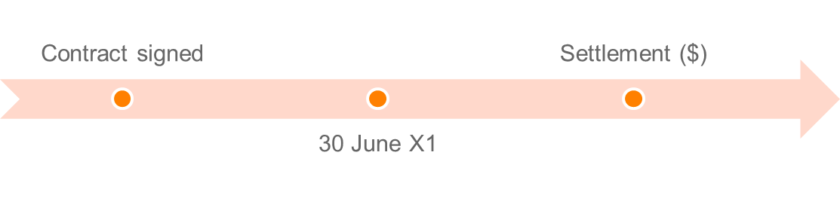

*When the contract is signed is the date in which the purchaser is taken to have acquired the asset*

* **^Mirror image of the timing rule for CGT Event A1 (disposals) in** section 104-10

**Other Specific Rules relating to when an asset is acquired:**

* Section 109-5(2) specific rules for the circumstances in which, and the time at which, you acquire a CGT asset as a result of a CGT Event happening:
  + CGT Event D1 – contractual rights (CGT Asset) created when contract is entered into or right created
* CGT Asset can be acquired without a CGT Event happening (section 109-10)
  + Eg, a CGT Asset is constructed or created and Tpr owns asset when the construction or creation is finished – Tpr taken to acquire asset when construction, or work that results in the creation, started: build a building, paint a picture, write a book - **the asset is acquired** “when the work ... started”

## iii. Exceptions and exemptions

**Disregard capital gains and losses on the following assets:**

* Cars, motorcycles and valour decorations (s 118-5)
* Collectibles < $500; Personal use assets
* Assets used to produce exempt income (s 118-12(1))
* Shares in a pooled development fund (s 118-13)
* Investments made in start-up companies (Subdiv 360-A)
* Depreciating assets (s 118-24(1))
* Trading stock (s 118-25)
* Otherwise assessable (anti-overlap provisions) - s 118-20 (1)
  + CGT is a last resort tax
* Personal compensation - s 118-37(1)(a) & (b)
  + Personal wrong, injury or illness
* Private lease ends - s 118-40
* Gambling and competitions with prizes - s 118-37(1)(c).

Expresses the exemptions as “disregarding the capital gain/loss”. The effect of this approach is that the asset and the event remain subject to the CGT provisions but the gain/loss is not included in the net capital gain and therefore has no effect on taxable income.

* See Div 118 may exempt
* The asset
* The receipt
* Avoid double taxation
* The transaction
* **Exempt Asset**
* Motor Vehicles s 118 – 5
* Collectables and Personal Use Assets s 118-10
* A collectable (acquired for < $ 500)
* A personal use asset (acquired for < $ 10,000)
* **Anti-Overlap** (cover these later)
* S 118-24 – depreciable assets (dealt with in Topic 4)
* S 118-25 – trading stock
* **Exempt or loss denying transactions**
* Personal Compensation s 118-37
* Windfall gains

### Subdiv 118-B: Main Residence Exemption

* s 118-110 **- Gain exempt if:**

1. **Owned by an individual**
2. **Dwelling is main residence**

* 118-100 – full main residence
* 118-115 - caravans etc,
* 118-120 – 2HA max of adjacent land
* 118-135 - Move into in a reasonable time
* **Absences** s 118-145
* You **may be absent from your main residence, and earn assessable income from it, for up to six years provided that you do not have another main residence.**
* You can have two times six year periods. NB can only have two periods away.
* **Eg** Living in Melbourne, but renting out old Geelong residence = okay. However, Buying Melbourne house, but live in Geelong = not okay. **Therefore, cannot claim exemption from two residents**
* **Build/renovate etc – 118-150/155**
* Vacant land included for 4 years previous to completion and moving in.
* **Accidentally destroyed – s 118-160**
* Exemption continues provided no new main residence

**Partial exemption**

* S 118-185 **Partial exemption for main residence:**

1. You get only a partial exemption for a CGT event that happens in relation to a dwelling or your ownership interest in it if:
2. you are an individual; and
3. the dwelling was your main residence for part only of your ownership period; and
4. the interest did not pass to you as a beneficiary in, and you did not acquire it as a trustee of, the estate of a deceased person.
5. You calculate your capital gain or capital loss using the formula:

**CG or CL amount x Non-residence days/days in your ownership period**

* S 118-200 **Partial exemption for deceased estate**

1. You get only a partial exemption (or no exemption) if:
2. you are an individual and your ownership interest in a dwelling passed to you as a beneficiary in a deceased estate, or you owned it as the trustee of a deceased estate; and
3. section 118-195 does not apply.
4. You calculate your capital gain or capital loss using the formula: **CG or CL amount x Non-residence days/days in your ownership period**

* Time - 118-185: Not always main residence - apportioned on days
* Partial income Use - 118-190: apportioned on deductibility of interest
* Change from main residence to income earning 118-192: market value at time first used to earn income.
* **Only one main residence per family (pick one where more then one)(**s 118-170**)**
* Your **dependent child cannot have a different main residence to both parents (**s 118-175**)**
* NB there may be partial MR exemption.. S118-185 – partial exemption when MR for only part of the ownership period. Or, S118-190: If you use part of the dwelling to produce assessable income you will pay partial CGT on your total gain

## Iii Roll-over relief

Allows taxpayer to defer or disregard a capital gain or loss by way of “roll-over”. Two categories:

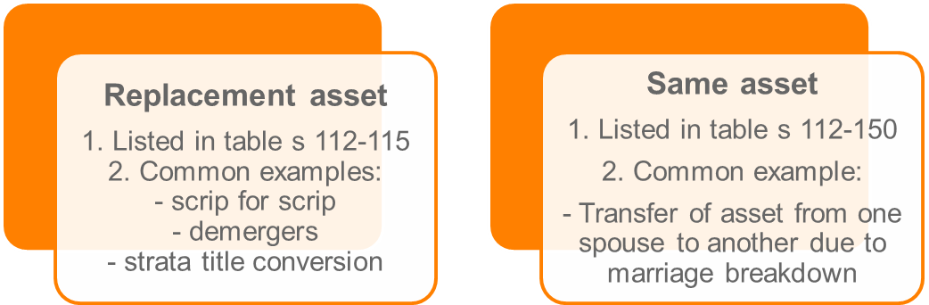

* Also when a sole trader becomes a company, sole trader owned assets transferred to company and attributable to owners share in company.
* Optional roll-over relief available from 1 July 2016 where a small business undertakes a genuine restructure but the ultimate legal ownership of the asset remains unchanged.
  + Not covered in this unit.

## STEP 2: Calculating Capital Gain

* For most CGT events, a capital gain occurs when the “capital proceeds” exceeds the “cost base” of the CGT asset.

Taxpayer makes a capital gain if:



Taxpayer makes a capital loss if:



* Taxpayer makes *neither* a capital gain nor capital loss if the capital proceeds are less than the cost base but more than the reduced cost base.

**Capital proceeds**

* Capital proceeds are the amount the taxpayer receives or is entitled to receive in relation to the CGT event: s 116-20.
* Can include property (market value)
* Ignore GST on the capital proceed received: s 116-20(5).

## Six modifications to capital proceeds:

1. Market value substitution rule
2. Apportionment rule
3. Non-receipt rule
4. Repaid rule
5. Assumption of liability rule
6. Misappropriation rule

**Example**

If land is sold for $200 000 and is to be paid for in four equal annual payments, then the full amount of the gain will be assessable in **year one** even though only one quarter of the amount has been received.

Money you receive or are entitled to receive PLUS the value of property you receive or are entitled to receive… i.e. if you sell your house for $300,000 plus acquire an apartment worth $200,000 = $500,000.

1. **“Market value” modification** - S 116-30

* Applies when the taxpayer:
  + Receives no capital proceeds;
  + Some or all capital proceeds cannot be valued; or
  + Did not deal at ‘arm’s length’ with the other entity.
* Capital proceeds are deemed to be the market value ***‘Arms-length’*:** an unrealistic value for purchase normally because of the relationship (e.g. Candice sold me her house for $10 because we’re friends).
  + **Would the reasonable person consider the sale at arm’s length?**

1. **Apportionment modification -**  S 116-40

* When a single proceed is the total of two or more events, the proceeds must be apportioned between those events.
* **E.g.** A lump sum of $800,000 for the sale of house and a yacht, these will need to be apportioned to determine the value of each
* Illustration: capital proceeds are for land and buildings; but need to be apportioned to the building (land is pre-CGT).

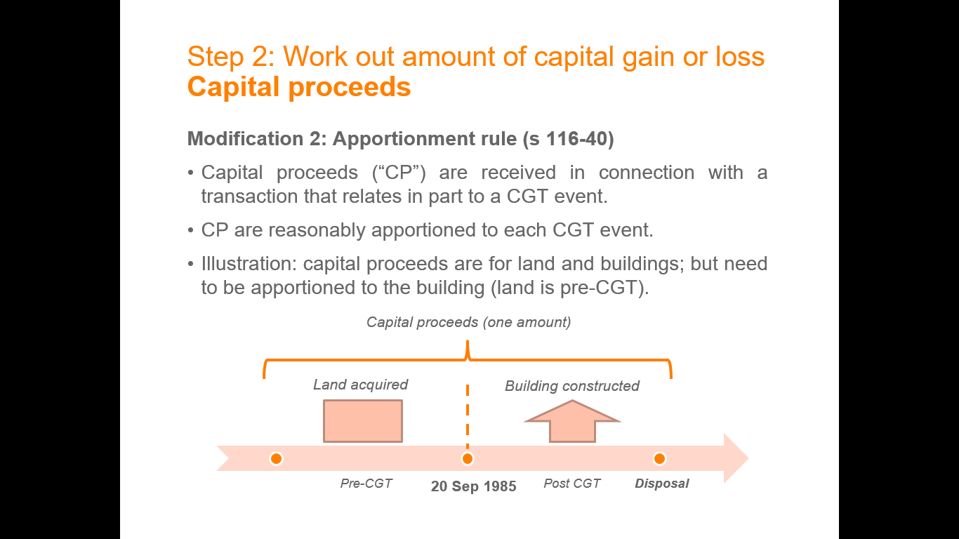

See TR 118/5^

1. **Non-receipt rule -** S 116-45

Allows the **Capital Proceeds to be reduced by any amount that you have not received and will not receive after all reasonable attempts** have been made to get it.

1. **Repaid Rule -** S 116-50

* Capital proceeds are reduced to the extent the taxpayer has to repay capital proceeds already received.
* Reduces the capital proceeds by any non-deductible amount paid as compensation resulting from the CGT Event (i.e. if sued after settlement of house for $300,000 and you need to pay $40,000 compensation, it will be reduced to $260,000 due to the compensation payment)

1. **Assumption of liability rule** - S 116-55

* Capital proceeds are increased if another entity assumes liability in connection with the CGT event. (I.e. pay you $100k plus take over mortgage for $100k).
* **E.g.** John sells apartment for $250,000 and purchaser took over $50,000 debt = capital proceeds will be $300,000

1. **Misappropriation Rule -** S 116-60

* Allows you to reduce capital proceeds by any amount misappropriated by an **employee or agent**.
* **E.g.** Real estate agent takes the 10% deposit from a house sale, this 10% will be deducted

## Cost base

* Cost base are the total costs associated with the CGT asset.
* The cost base is reduced to the extent GST input tax credits have been claimed by the taxpayer.

S 110-25 Cost Base

* **The general definition of cost base in** s.110-25 **defines cost base as consisting of five elements:**

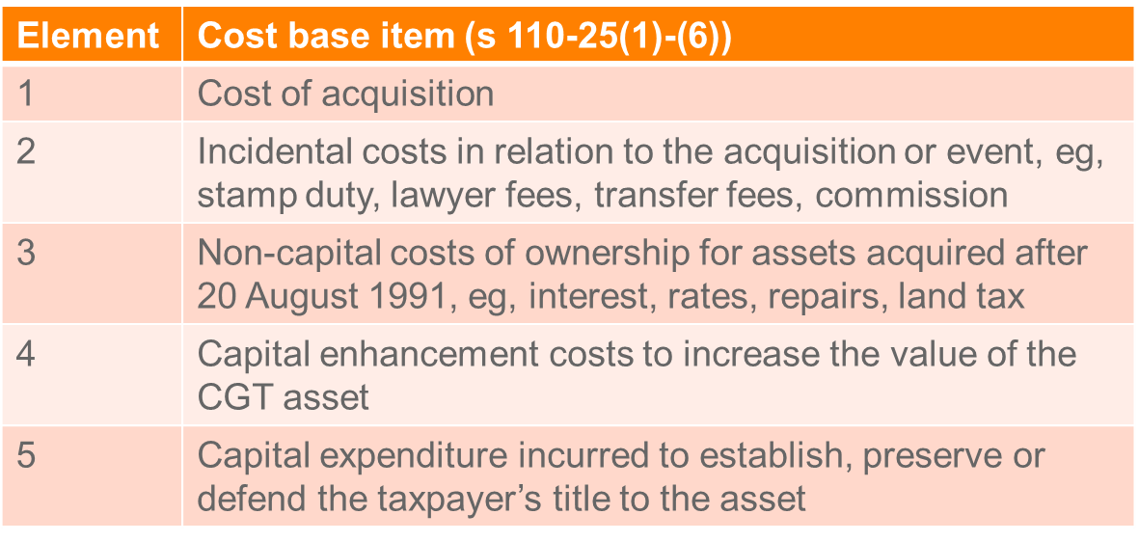

**Element 1:** **Money** **or** value of **property given for acquisition -** S 110-25(2)

Modifications that reduce in CP in s 116-25 will fall under this element (e.g. borrowing expenses deducted cannot be double dipped in the CB)

**Element 2:** **Incidental costs** **related** to **acquisition and CGT event (disposal) -** S 110-25(3)

**Incidental costs list at** s 110-35: incidental costs defined. It **must be included in one of the nine categories otherwise not allowed**

1. Remuneration for legal advisor, accountant, valuer, auctioneer (2)
2. Cost of transfer (3)
3. Stamp duties (4)
4. Marketing and advertising (5)
5. Valuations (6)
6. Search fees (7)
7. Conveyancing kit (8)
8. Borrowing expenses (9)
9. Corporate groups (10)

Deductible amounts not included

**Element 3:** **Costs of ownership** (**assets purchased after 20 Aug 1991**) - S 110-25(4)

* Includes: interest, maintenance, rates and insurance.
  + Deductible amounts not included
* Not allowed for collectibles and PUAs

**Element 4:** **Capital expenses relating to the asset -** S 110-25(5)

* Expense to increase or preserve asset’s value
* Expense to install or move the asset
* Does not include costs related to goodwill
  + **E.g.** expenses for renovating a house would fall under this element

**Element 5: Capital expenses** **relating to title -** S 110-25(6)

* Preserving the assets title
* May arise where you litigate to reinforce our title. **Eg** litigation regarding adverse possession and the costs of litigating to preserve your title

**Other factors affecting cost base**

* Sec 110-38: **excludes** penalties, bribes, **entertainment**, **illegal activities**
* Sec 110-45: **CGT assets acquired after 13/5/97, all deductible amounts not included**
* Sec 103-30: CGT events after 19/2/2004 GST input credits not included in cost base
* Generally a capital gain is the difference between the cost base of an asset and the capital proceeds from a GCT event in relation to that asset.
* The concept of cost base is crucial in the calculation of the capital gain or loss for most CGT events.
* For assets acquired after 7.30 pm on 13 May 1997 s. 110-45 **makes it clear that an expense that is deductible under another provision of the Act cannot be included in *any* of the cost base elements.**

S 110-25 - General rules about cost base

             (1)  The [*cost base*](http://classic.austlii.edu.au/au/legis/cth/consol_act/itaa1997240/s995.1.html#cost_base)of a [CGT asset](http://classic.austlii.edu.au/au/legis/cth/consol_act/itaa1997240/s995.1.html#cgt_asset) consists of 5 elements.

Note 1:       You need to keep records of each element: see Division 121.

Note 2:       The [cost base](http://classic.austlii.edu.au/au/legis/cth/consol_act/itaa1997240/s995.1.html#cost_base) is reduced by [net input tax credits](http://classic.austlii.edu.au/au/legis/cth/consol_act/itaa1997240/s995.1.html#net_input_tax_credit): see section 103-30.

Note 3:       An [amount](http://classic.austlii.edu.au/au/legis/cth/consol_act/itaa1997240/s995.1.html#amount) that [makes](http://classic.austlii.edu.au/au/legis/cth/consol_act/itaa1997240/s995.1.html#make) up all or [part](http://classic.austlii.edu.au/au/legis/cth/consol_act/itaa1997240/s995.1.html#part) of an element of the [cost base](http://classic.austlii.edu.au/au/legis/cth/consol_act/itaa1997240/s995.1.html#cost_base) of an asset may be determined [under](http://classic.austlii.edu.au/au/legis/cth/consol_act/itaa1997240/s995.1.html#under) [section 230](http://www.austlii.edu.au/au/legis/cth/num_act/itaa1997240/s230.html)-505, if the [amount](http://classic.austlii.edu.au/au/legis/cth/consol_act/itaa1997240/s995.1.html#amount) is [provided](http://classic.austlii.edu.au/au/legis/cth/consol_act/itaa1997240/s995.1.html#provide) for acquiring a thing, and you start or cease to have a Division 230 [financial arrangement](http://classic.austlii.edu.au/au/legis/cth/consol_act/itaa1997240/s995.1.html#financial_arrangement) as [consideration](http://classic.austlii.edu.au/au/legis/cth/consol_act/itaa1997240/s995.1.html#consideration) for the acquisition of the thing.

**5 elements of the**[**cost base**](http://classic.austlii.edu.au/au/legis/cth/consol_act/itaa1997240/s995.1.html#cost_base)

             (2)  The **first element** is the total of:

                     (a)  the [money](http://classic.austlii.edu.au/au/legis/cth/consol_act/itaa1997240/s995.1.html#money) you paid, or are required to pay, in respect of acquiring it; and

                     (b)  the [market value](http://classic.austlii.edu.au/au/legis/cth/consol_act/itaa1997240/s995.1.html#market_value) of any other property you gave, or are required to give, in respect of acquiring it (worked out as at the time of the acquisition).

Note 1:       There are special rules for working out when you are required to pay [money](http://classic.austlii.edu.au/au/legis/cth/consol_act/itaa1997240/s995.1.html#money) or give other property: see section 103-15.

Note 2:       This element is replaced with another [amount](http://classic.austlii.edu.au/au/legis/cth/consol_act/itaa1997240/s995.1.html#amount) in many situations: see Division 112.

             (3)  The **second element** is the [incidental costs](http://classic.austlii.edu.au/au/legis/cth/consol_act/itaa1997240/s995.1.html#incidental_costs) you incurred. These [costs](http://classic.austlii.edu.au/au/legis/cth/consol_act/itaa1997240/s995.1.html#cost) can include giving property: see section 103-5.

Note:          There is one situation to do with options in which the [incidental costs](http://classic.austlii.edu.au/au/legis/cth/consol_act/itaa1997240/s995.1.html#incidental_costs) relating to the [CGT event](http://classic.austlii.edu.au/au/legis/cth/consol_act/itaa1997240/s995.1.html#cgt_event) are modified: see section 112- [85](http://www.austlii.edu.au/au/legis/cth/num_act/itaa1997240/s85.html).

             (4)  The **third element** is the [costs](http://classic.austlii.edu.au/au/legis/cth/consol_act/itaa1997240/s995.1.html#cost) of owning the [CGT asset](http://classic.austlii.edu.au/au/legis/cth/consol_act/itaa1997240/s995.1.html#cgt_asset) you incurred (but only if you [acquired](http://classic.austlii.edu.au/au/legis/cth/consol_act/itaa1997240/s995.1.html#acquire) the asset after 20 August 1991). These [costs](http://classic.austlii.edu.au/au/legis/cth/consol_act/itaa1997240/s995.1.html#cost) include:

                     (a)  [interest](http://classic.austlii.edu.au/au/legis/cth/consol_act/itaa1997240/s974.10.html#interest) on [money](http://classic.austlii.edu.au/au/legis/cth/consol_act/itaa1997240/s995.1.html#money) you borrowed to [acquire](http://classic.austlii.edu.au/au/legis/cth/consol_act/itaa1997240/s995.1.html#acquire) the asset; and

                     (b)  [costs](http://classic.austlii.edu.au/au/legis/cth/consol_act/itaa1997240/s995.1.html#cost) of maintaining, repairing or insuring it; and

                     (c)  rates or land tax, if the asset is land; and

                     (d)  [interest](http://classic.austlii.edu.au/au/legis/cth/consol_act/itaa1997240/s974.10.html#interest) on [money](http://classic.austlii.edu.au/au/legis/cth/consol_act/itaa1997240/s995.1.html#money) you borrowed to refinance the [money](http://classic.austlii.edu.au/au/legis/cth/consol_act/itaa1997240/s995.1.html#money) you borrowed to [acquire](http://classic.austlii.edu.au/au/legis/cth/consol_act/itaa1997240/s995.1.html#acquire) the asset; and

                     (e)  [interest](http://classic.austlii.edu.au/au/legis/cth/consol_act/itaa1997240/s974.10.html#interest) on [money](http://classic.austlii.edu.au/au/legis/cth/consol_act/itaa1997240/s995.1.html#money) you borrowed to finance the capital [expenditure](http://classic.austlii.edu.au/au/legis/cth/consol_act/itaa1997240/s40.548.html#expenditure) you incurred to increase the asset's [value](http://classic.austlii.edu.au/au/legis/cth/consol_act/itaa1997240/s995.1.html#value).

                   These [costs](http://classic.austlii.edu.au/au/legis/cth/consol_act/itaa1997240/s995.1.html#cost) can include giving property: see section 103-5.

Note:          This element does not apply to [personal use assets](http://classic.austlii.edu.au/au/legis/cth/consol_act/itaa1997240/s995.1.html#personal_use_asset) or [collectables](http://classic.austlii.edu.au/au/legis/cth/consol_act/itaa1997240/s995.1.html#collectable): see sections 108-17 and 108-30.

             (5)  The **fourth element** is capital [expenditure](http://classic.austlii.edu.au/au/legis/cth/consol_act/itaa1997240/s40.548.html#expenditure) you incurred:

                     (a)  the purpose or the expected effect of which is to increase or preserve the asset's [value](http://classic.austlii.edu.au/au/legis/cth/consol_act/itaa1997240/s995.1.html#value); or

                     (b)  that relates to installing or moving the asset.

The [expenditure](http://classic.austlii.edu.au/au/legis/cth/consol_act/itaa1997240/s40.548.html#expenditure) can include giving property: see section 103-5.

Note:          There are 3 situations involving leases in which this element is modified: see section 112-80.

          (5A)  [Subsection](http://classic.austlii.edu.au/au/legis/cth/consol_act/itaa1997240/s51.54.html#subsection) (5) does not apply to capital [expenditure](http://classic.austlii.edu.au/au/legis/cth/consol_act/itaa1997240/s40.548.html#expenditure) incurred in relation to goodwill.

             (6)  The **fifth element** is capital [expenditure](http://classic.austlii.edu.au/au/legis/cth/consol_act/itaa1997240/s40.548.html#expenditure) that you incurred to establish, preserve or defend your title to the asset, or a right [over](http://classic.austlii.edu.au/au/legis/cth/consol_act/itaa1997240/s995.1.html#over) the asset. (The [expenditure](http://classic.austlii.edu.au/au/legis/cth/consol_act/itaa1997240/s40.548.html#expenditure) can include giving property: see section 103-5.)

**Cost Base Modifications**

* Just **like there are modifications to capital proceeds, there are modifications to the cost base.** **Modifications can occur from the time you acquire the asset to when the CGT event happens in relation to it.** Most modifications replace the first element (what you paid for the CGT asset) of the cost base and reduced cost base of the asset.
* **The most important of the** Div. 112 **modifications are**:
* **Replacement of actual cost with market value where consideration is nil,** cannot be determined or is not at arm’s length s.112-20;
* Apportioning costs between assets that are split into more than one asset of changed into different nature and adding together costs of merged assets s.112-25;
* A**pportioning costs when only part of an expense relation to an asset of CGT event;** s 112-30
* Including any assumed liability by taxpayer when asset was acquired – i.e. taking over a debt s 112-35

***‘Arm’s length’***

* **One of the most important aspect to appreciate here is that** s 112-20 (2) **is** not a test of whether the two parties are at arm’s length or not (e.g. a husband and wife), but it is **a test of whether the parties are dealing at arm’s length (***Elmslie & Ors v. FCT* (1993) 26 ATR 611; 93 ATC 4964)**.**
* **The test of an arm’s length transaction is whether the price agreed is similar to an open market price**. In *Granby Pty Ltd v. FCT* (1995) 30 ATR 400; 95 ATC 4240 Lee J stated, ‘What is asked is whether the parties behaved in the manner in which parties at arm’s length would be expected to behave in conducting their affairs.’ **Dealing at arm’s length can therefore be equated to a test of market value.**

S 112-20 - Market value substitution rule

             (1)  The first element of your [cost base](http://classic.austlii.edu.au/au/legis/cth/consol_act/itaa1997240/s995.1.html#cost_base) and [reduced cost base](http://classic.austlii.edu.au/au/legis/cth/consol_act/itaa1997240/s995.1.html#reduced_cost_base) of a [CGT asset](http://classic.austlii.edu.au/au/legis/cth/consol_act/itaa1997240/s995.1.html#cgt_asset) you [acquire](http://classic.austlii.edu.au/au/legis/cth/consol_act/itaa1997240/s995.1.html#acquire) from another [entity](http://classic.austlii.edu.au/au/legis/cth/consol_act/itaa1997240/s995.1.html#entity) is its [market value](http://classic.austlii.edu.au/au/legis/cth/consol_act/itaa1997240/s995.1.html#market_value) (at the time of acquisition) if:

                     (a)  you did not incur [expenditure](http://classic.austlii.edu.au/au/legis/cth/consol_act/itaa1997240/s40.548.html#expenditure) to [acquire](http://classic.austlii.edu.au/au/legis/cth/consol_act/itaa1997240/s995.1.html#acquire) it, except where your acquisition of the asset resulted from:

                              (i)  [CGT event](http://classic.austlii.edu.au/au/legis/cth/consol_act/itaa1997240/s995.1.html#cgt_event) D1 happening; or

                             (ii)  another [entity](http://classic.austlii.edu.au/au/legis/cth/consol_act/itaa1997240/s995.1.html#entity) doing something that did not constitute a [CGT event](http://classic.austlii.edu.au/au/legis/cth/consol_act/itaa1997240/s995.1.html#cgt_event) happening; or

                     (b)  some or all of the [expenditure](http://classic.austlii.edu.au/au/legis/cth/consol_act/itaa1997240/s40.548.html#expenditure) you incurred to [acquire](http://classic.austlii.edu.au/au/legis/cth/consol_act/itaa1997240/s995.1.html#acquire) it cannot be [valued](http://classic.austlii.edu.au/au/legis/cth/consol_act/itaa1997240/s995.1.html#value); or

                     (c)  you **did not deal at arm's length with the other**[**entity**](http://classic.austlii.edu.au/au/legis/cth/consol_act/itaa1997240/s995.1.html#entity) [in connection with](http://classic.austlii.edu.au/au/legis/cth/consol_act/itaa1997240/s995.1.html#in_connection_with) the acquisition.

The [expenditure](http://classic.austlii.edu.au/au/legis/cth/consol_act/itaa1997240/s40.548.html#expenditure) can include giving property: see section 103-5.

             (2)  Despite [paragraph](http://classic.austlii.edu.au/au/legis/cth/consol_act/itaa1997240/s115.10.html#paragraph) (1)(c), if:

                     (a)  you did not deal at arm's length with the other [entity](http://classic.austlii.edu.au/au/legis/cth/consol_act/itaa1997240/s995.1.html#entity); and

                     (b)  your acquisition of the [CGT asset](http://classic.austlii.edu.au/au/legis/cth/consol_act/itaa1997240/s995.1.html#cgt_asset) resulted from another [entity](http://classic.austlii.edu.au/au/legis/cth/consol_act/itaa1997240/s995.1.html#entity) doing something that did not constitute a [CGT event](http://classic.austlii.edu.au/au/legis/cth/consol_act/itaa1997240/s995.1.html#cgt_event) happening;

the [market value](http://classic.austlii.edu.au/au/legis/cth/consol_act/itaa1997240/s995.1.html#market_value) is substituted only if **what you paid to**[**acquire**](http://classic.austlii.edu.au/au/legis/cth/consol_act/itaa1997240/s995.1.html#acquire)**the**[**CGT asset**](http://classic.austlii.edu.au/au/legis/cth/consol_act/itaa1997240/s995.1.html#cgt_asset)**was more than its**[**market**](http://classic.austlii.edu.au/au/legis/cth/consol_act/itaa1997240/s995.1.html#market_value)[**value**](http://classic.austlii.edu.au/au/legis/cth/consol_act/itaa1997240/s995.1.html#market_value) (at the time of acquisition).

**‘Reduced cost base’ for capital losses** (s 110-55)

* Reduced cost base is used for the purpose of working out a capital loss.
* Largely the same as cost base, except for two notable differences:
  + 3rd element is any amount that is included in the taxpayer’s assessable income because of balancing adjustments. All other elements are the same.
  + Reduced cost base cannot be indexed.
* Capital losses are determined by comparing the capital proceeds with the *reduced cost base*. **In essence, the definition of reduced cost base in s. 110-55 is similar to the definition of cost base, but with the following important differences:**
* reduced cost base is not indexed (s. 110-55(1))
* **Element 3 of the reduced cost base does not include costs of ownership and is very limited**.
* Therefore, it is *reduced* by not allowing element 3 to be considered
* Therefore, remove element 3 where you thinkt the answer was gain and it was actually a loss
* Unlikely that this will be examinable either^

**Indexation (not examinable)**

* **NOTE: Need to know that it exists. Prior to 21 September 1999 the cost base could be indexed to reflect current inflation, thus reducing the overall gain.**
* Indexation of the cost base was introduced so that capital gains tax would not be a tax on inflation (Div 114). However, indexation is only applicable for the determination of capital gains and not capital losses (s. 114-1), and indexation is also **not available if the asset was acquired after 11.45 am 21 September 1999**.
* **For an asset purchased before 21 September 1999 that is sold after that date the taxpayer has a choice of applying indexation or the general discount of 50% (see later in this topic).** This is as much as you need to know about indexation.

## STEP 3: Calculate Net capital gain/loss for FY

Five-step process to calculate the net capital gain (ie gains and losses for all events in the income year)

1. Current year capital gains **less current year capital losses** (in the order the taxpayer chooses - Note special rule re collectibles)
2. Remaining capital gains are reduced by any unapplied net capital losses from previous years (in the order the taxpayer chooses, however applied in the order they were made) (Note collectibles)
3. Reducing any remaining **discount capital gains by the discount percentage** (50%)
4. Any remaining capital gains: Apply small business concessions (if available)
5. Any remaining capital gains - Add up: any remaining capital gains that are not discount capital gains + any remaining discount capital gains

Sec 102-5: Assessable amount is NET capital gain

* **Determine the gain/loss for separate events (Eg CGT for house and then the CGT for boat in separate calculations)**. Apply exclusions and rollover.
* There are no exempt CGT assets
* Gains/losses may be disregarded in part or in full
* Rollover is a deferral so gain/loss will effect a later tax return.
* May rollover excess CL

**Capital losses**

* A capital loss cannot be deducted from the taxpayer’s assessable income: s 102-10(2).
  + Capital losses are carried forward to a later income year   
    (s 102-15(1)).
* Capital losses only used against capital gains – special rules for collectibles and personal use assets.
  + **Net losses for the year can be carried forward indefinitely**
* **All losses must be applied before general discount and other concessions (Eg.** CG for house and CL for boat, Apply the loss from boat before applying the 50% general discount. **If formula is done after could result in a different value**)
  + Capital gain/loss adjusted for exclusions, concessions and rollovers.

**Discount method (step 3 of working out a net capital gain)**

Eligibility (see Div 115):

* CGT asset must have been held for more than 12 months.
* CGT *event* must have occurred after 11.45 am on 21 September 1999.
  + Not examined on indexation so a CGT event will occur post 21/9/99 for exam purposes
* Certain CGT events are ineligible (exempt), eg, D category events.
  + Sec 115-25(3): Only applies to certain events – Not: D1, D2, D3, E9, F1, F2, F5, H2, J2, J5, J6, or K10

Discount percentage:

* 50% for individuals (Only discount we need to know for exam purposes)
* 33.3% for superannuation funds
* 0% for companies

## Revision questions

**Discussion Question 1**

Brendan Brown is a recently retired AFL footballer that has lived in Melbourne throughout his life. In November 2013, Brendan accepted a position as an assistant coach of the new AFL team located in Sydney, the Owls.

Before Brendan and his family relocated to Sydney he disposed of the following assets:

|  |  |  |  |  |
| --- | --- | --- | --- | --- |
| **Asset** | **Purchase Date** | **Purchase Price** | **Sale Date** | **Sale Price** |
| Investment Property | 15 Sep 1998 | $200,000  (Note 1) | 31 Jan 2014  (Note 2) | $900,000  (Note 3) |
| Sail Boat | 10 Jul 2013 | $60,000 | 1 Feb 2014  (Note 4) | $81,000 |
| Caravan | 18 Nov 2009 | $15,000 | 10 April 2014 | $11,000 |
| Ford Motor Car | 15 Feb 2006 | $28,000 | 14 May 2014 | $16,000 |
| Postage Stamps Collection | 14 Dec 1994 | $14,500 | 31 Mar 2014 | $28,000 |

**Notes**

1. Stamp duty and legal costs totaling $20,000 was paid by Brendan on 15 Dec 1998.
2. The Contract of Sale was signed 31 Jan 2014 with possession to pass to the purchaser at settlement on 31 July 2014.
3. A deposit of $90,000 was received on 31 Jan 2014. The balance of $810,000 is due at settlement on 31 July 2014. At settlement Brendan will be required to pay the estate agent’s commission of $40,000 and legal expenses of $5,000.
4. The sale of the sailboat was arranged through a selling agent who charged $1,000 commission.

Brendan had a loss from the sale of a sculpture in the amount of $5,000 from the 2009/10 income year.

**Required: Advise Brendan of his net capital gain for the year ending 30 June 2014. Please show all calculations and cite relevant legislation to support your answer.**

*Ford motor car: CGT event A1 has happened to the car, but it is a personal use asset: s 118-5 exempts capital gains or losses that happen to cars (not a CGT asset).*

*Caravan: CGT event A1 has occurred. Personal use asset. Capital loss made from a personal use assets are disregarded s 118-10; s 108-20*

*Sail boat: CGT event A1 has happened to the sail boat. We are not told that there is a separate contract, so CGT event date is presumed to be when the change of ownership occurred: 1 Feb 14. Personal use asset – capital gain. Special rules of less than $10K do not apply here. CB = $60K + $1,000 (incidental cost). $81K - $61K =* ***$20k CG****. No discount as less than 12 months.*

*Postage stamps: CGT event A1 has occurred as there has been a disposal. Collectible - Not less than $500, so the quarantining rules are disregarded. S 104-10 applies so CG has to apply. What’s received is $28K (s 116-20), CB = $14,500 (s 110-25). CG = $13,500. Prior year loss: Sale of sculpture cannot be applied against any other assets, other than collectibles (the postage stamps): s \_\_ Postage stamp CG with loss offset ($13,500 - $5,000) = $8,500, discount* ***CG = $4,250.***

*Investment property: A1 CGT event has occurred. CB = E1 $200K + E2 $20K (costs of acq) + $45K (costs of sale), CG = $900K - $265K = $635K. Discounted* ***CG = $317.5K****. Taxable in 14 FY as it is the date in which the contract is signed in which the asset is taxed accordingly (2014 FY).*

*Total CG = $20k + $4,250 + $317.5 = $341,750*

**Note^ check section accuracy before exam**

**Discussion Question 2**

George is a manager at Wollongong Steel Ltd. His employment contract is for 10 years. In the third year George‘s position at the company is made redundant, and his employment terminated. George enters into a restrictive covenant with Wollongong Steel Ltd which provides that:

1. in return for a payment of $40,000 he agrees not to disclose any trade secrets of his employer to any other person; and
2. in return for a payment of $200,000 he agrees that he will not work for a competitor for a period of 18 months after his employment with the company ends.

*CGT event – D1 has happened. Created rights with Wollongong steel via contract in return for a contract: s 104-35. Time of the event is when the rights were created (signing the contract). Capital proceeds - $240K, no CB, so CG is $240K. Cannot apply CG discount, CGT discount does not apply as it has not been held for a period of time, it happens all instantly. The whole amount will go into assessable income under s 102-5 ITAA 97.*

*Change the facts: $240K is a sign on fee. The amount would then be OI. Whether it is a CG or OI does not apply as the end result is the same but s 102-5 but makes it OI.*

**Discussion Question 3**

Colette is a Chartered Accountant with her own business. Due to the retirement of a number of her clients, the business was starting to make a loss for the first time in twenty years. To cover the loss, she decided to start disposing of her assets. Her portfolio is as follows:

|  |  |  |  |  |
| --- | --- | --- | --- | --- |
| Item | Purchase Date | Purchase Price | Sale Date | Sale Price |
| Property in Thornbury | 1 May 1985 | $20,000 | 30 June 2017 | $700,000 |
| Subaru Outback Wagon (Vehicle) | 1 Oct 2012 | $40,000 | 1 May 2017 | $15,000 |
| Sculpture | 18 Sep 1985 | $11,000 | 1 May 2017 | $55,000 |

Colette sold her Thornbury property to her brother, and the transaction settled on 1 July 2017. At the time, the market value of the property was $900,000.

When she bought the property on 1 May 1985, it was a vacant block of land. A broker sourced the land for her after undertaking preliminary investigations of the surrounding areas. The broker’s fee was $900. On finding the property, the acquisition costs included legal fees of $990 and stamp duty of $10,000.

On 1 July 2013, Colette built a house on the property at a cost of $200,000 (land was valued at $400,000). The house has been rented out since completion and Colette pays bank interest of $25,000 per annum.

On 22 September 2016, Colette inspected the Thornbury property and decided to renovate it, undertaking the following:

1. Replacement of the kitchen at a cost of $50,000;
2. Replastering and repainting a wall which had been damaged due to a leak costing $20,000;

Colette also has a carry forward capital loss from the sale of shares from the 2010-2011 income year in the amount of $6,000.

***Sculpture****: CGT event A1 has happened to the collectible. Purchase date indicates this asset is a pre-CGT asset, thus exempt from capital gains tax.*

***Car****: CGT event A1 has occurred. It is a personal use asset. However CGs or CLs on motor vehicles are exempt under s 118-5.*

***Property:*** *CGT event A1. The cost of building the house on its face is deductible under s 8-1 as it has been built for an income purpose. But the expense is capital in nature, so no deduction under 8-1. The interest is deductible under s \_\_. Replacing the kitchen is arguably changing the income producing activity, but it is a capital expenditure so no deduction under 8-1. Re-plastering and re-painting the wall is a repair under s 25-10 and is deductible under 8-1. Div 43 capital write off will be allowed here for all the construction costs and improvements:*

* *Construction costs (200K) x 2.5% = $5,000 (note held for full FY), X 4 years = $20,000 worth of deductions*
* *Kitchen replacements = $50,000x 2.5% x 282/365= $966 deduction for 17FY*

*Total Div 43 deductions = $20,966.*

*Contract date = 30 June 17, so gain has to be reported in 17FY. The land however is a pre-CGT asset. But the house is a post-CGT asset: s 108-55. So the house is a separate asset from the land for CGT purposes. Calculate the CG only on the house. But the capital proceeds relate to both the house and the land, so an apportionment is needed s 116-40 (modification 4). Here the capital proceeds are $700K, but the circumstances in which the sale occurred was not at arm’s length, so the market value substitution applies ($900K) – s 116-30 (modification). The land was valued at $400K and $200K and the time of their respective purchases (expenses), indicating that the building is going to be 2/3’s of the capital proceeds. ($300K).*

***CB***

* *E1 costs: $200K.*
* *No E2 costs as the only possible expenses relate to the land purchase.*
* *S 118-25: expenses relating to the house should not go into the cost base as they were deducted throughout the year – no double dipping.*
* *E3: Kitchen expenses less all capital write offs applied ($50K - $916 - $20K = $229,034)*

*Capital proceeds = $300K – 229,034 = 70,966.*

*Less capital loss carried forward = 70,966 – 6000 = 64,966, X 50%* ***= discounted CG of $32,483.***

*Discount if held for more than 12 months: s 115-25*

**Note^ check section accuracy before exam**

**Won’t get a question quite like this on the exam.**

## 4. Other CGT Events

* CGT event A1 is the most general event but the following are also important.
* The events are outlined in s 104-5 (this is a good overview).
* **S 104-5 Events (only ones covered in unit):**
* **A1** – disposal of a CGT asset
* **C1** – loss or destruction of a CGT asset
* **C2** – cancellation, surrender and similar endings
* **D1** – creating contractual or other rights
* **F1** – granting a lease
* **H2** – receipt for event relating to CGT asset

**Steps for Answering CGT question:**

1. Is there an event? Which event is it?
2. Go to the relevant provisions for that event to see what you are required to do to calculate the Capital Gain or Loss and obtain formula (i.e CGT event A1 s104-10(4) … CG = CP – CB)
3. Work out the CP (under Div 116)(remember modifications)
4. Work out the CB (Under s110-25)(remember modifications)
5. Now go back to the original formula to work out the CG.
6. Consider general discount, exemptions or concessions

* Section 102-20 state that a capital gain/loss only occurs if a CGT event happens and s. 104-5 sets out the events that need to be considered.
* Therefore, you need an event to occur to have CGT consequences. You need to determine which event applies as this may affect how you work out capital gain or loss (and may determine the timing of it).

## CGT Events

* A taxpayer only makes a capital gain or loss if a CGT event occurs: s 102-20.
* Sometimes, more than one CGT event will happen. Generally, the most specific to the situation is used: s 102-25(1).
* 52 CGT events exist. For summary of CGT events, see s 104-5.
* We have already looked at CGT Event A1 and D1
* We look at only the main CGT events:
  + A1 – disposal of a CGT asset
  + C1 – loss or destruction of a CGT asset
  + C2 – cancellation, surrender and similar endings
  + D1 – creating contractual or other rights
  + F1 – granting a lease
  + H2 – receipt for event relating to CGT asset

## S 104-10(1): Review of CGT Event A1 – Disposal of a CGT Asset

* Event A1 is the most significant - Change in ownership of CGT asset **s104-10(1)**
* The A1 Elements
* CGT Asset
* Disposal
* Time
* Capital Gain or Capital Loss
* Exceptions
* 104-10(3) [Time of the event]
* The time of the event is:

1. when you enter into the contract for the \*disposal; or
2. if there is no contract - when the change of ownership occurs.

* 104-10(4) [Capital gain and capital loss]
* You make a capital gain if the \*capital proceeds from the disposal are more than the asset's \*cost base. You make a capital loss if those \*capital proceeds are less than the asset's \*reduced cost base.
* 104-10(5) [Capital gain or loss disregarded]

- A \*capital gain or \*capital loss you make is disregarded if:

1. you \*acquired the asset before 20 September 1985; or
2. for a lease that you granted:
3. it was granted before that day; or
4. if it has been renewed or extended - the start of the last renewal or extension occurred before that day.

## S 104-35: D1 CGT Event – Creation of Contractual Rights

* D1 - Creation of contractual rights
* Event D1 applies where a person enters into a contractual agreement with another entity which acquired the rights under that agreement.
* There is no need to have a CGT asset.
* Event D1 deems a capital gain to arise where payment is received for the creation of a contractual right.
* **The time of the event,** is when you enter into the contract or create the other right s104-35(2).
* **Discount NOT available**
* *Hepples*:contract with former employer to not tell others of employer’s trade secrets
* *s 104-35* : creation of a contractual right
* last resort - except H2
* Gain or loss – only incidental costs allowed
* Originally there were specific provisions in ITAA 1936 in relation to taxing capital amounts received when contractual rights were created. These were found to be ineffective in *Hepples v FCT:*
* In this case, the taxpayer received an amount of $40,000 in return for an agreement that he entered into. The agreement was a restrictive covenant, which followed termination of his employment. The Commissioner included this amount as income on the basis that it constituted a Capital Gain under Pt IIIA. (Remember Net Capital Gains are to be included in assessable income)
* Court said NO. Court said that s 160A was confined to proprietary assets that were recognised by law. The taxpayers right to wok and the choses in action that arose out of the restrictive covenant were not proprietary in nature and so could not fall under the s160A asset definition.
* Note that the Law changed in June 1992. The new second limb of the definition of a CGT asset now includes legal and equitable rights that are not property. S 108-5(1)(b).
* The ITAA36 provisions amended in 1992 but there were still issues with the provisions which were ‘deeming provisions’ to deem the entry into a liability to be creation and disposal of capital asset. CGT Event D1 seems to overcome these difficulties.

**Example:**

You enter into a contract with the purchaser of your business not to operate a similar business within the same town. The contract states that $20,000 was paid for this. You have created a contractual right in favour of the purchaser. The time of the event was when contract entered into. If you paid your lawyer $1500 to draw contract then your capital gain would be $18,500.

* Note that D1 does not happen where the right requires you to do something that is another CGT event.
* **For example:** You agree to sell land. You have created a contractual right in the buyer to enforce completion of the transcation. The sale results in you disposing of the land (say CGT event A1) this means that gain or loss from D1 does not happen.

## S 104-20: CGT Event C1 – Loss or Destruction of a CGT Asset

* Applies to tangible assets
* Occurs if a CGT asset that the taxpayer owns is **lost or destroyed**.
* **Time of the CGT event:** when the taxpayer first receives compensation for the loss or destruction, or if no compensation, when the loss is **discovered or the destruction occurred**: s 104-20(2)
* To the extent that the capital proceeds exceed the cost base of the asset, a capital gain will result; to the extent that the reduced cost base of the asset exceeds the capital proceeds, a capital loss will arise (subsection 104-20(3) of the ITAA 1997).

**Example 1:**

House with a cost base of $200,000 burn down. Insurance pays the taxpayer $250,000

* Capital Proceeds $ 250,000
* Cost Base: $ 200,000
* Capital Gain $ 50,000 (disregarding indexation and 50% discounting)

**Example 2:**

House with a cost base of $ 200,000 burns down. No insurance.

* Capital Proceeds $ 0
* Reduced cost base $ 200,000
* Capital loss $ 200,000
* **If this is the example applied in the exam and there is no compensation, you can note that a rollover of CL may apply**

**Example 3:**

On 12 November of the current tax year your client had an antique four-poster Louis XIV bed stolen from her house. She recently had the bed valued for insurance purposes and the market value at 31 October of the current tax year was $25,000. She purchased the bed for $3,500 on 21 July 1986. Although the furniture was in very good condition, the bed needed alterations to allow for the installation of an innerspring mattress. These alterations significantly increased the value of the bed, and cost $1,500. She paid for the alterations on 29 October 1986. On 13 November of the current tax year she lodged a claim with her insurance company seeking to recover her loss. On 16 January of the current tax year her insurance company advised her that the antique bed had not been a specified item on her insurance policy. Therefore, the maximum amount she would be paid under her household contents policy was $11,000. This amount was paid to her on 21 January of the current tax year.

* *CGT Event C1 occurs when the antique bed was stolen.*
* *The timing of the event is when the insurance proceeds were received on 21 January: s 104-20.*
* *The antique bed is a collectable: s 108-10*
* *Any gains or losses are* ***not*** *disregarded as acquisition cost > $500: s 118-110(1).*
* *The cost base of the bed = $3,500 + $1,500 = $5,000*
* *Alterations are included in element 4 of cost base: s 110-25(5).*
* *A capital gain exists as sale proceeds > cost base*
  + *Gain = $11,000 – 5,000 = $6,000*
  + *Gain is an eligible discount capital gain: Subdiv 115A*

## S 104-25: CGT Event C2 – Cancellation, Surrender or Similar Endings

* Applies to intangible assets
* Occurs if, broadly, ownership of the taxpayer’s intangible asset ends by, among other things, cancellation or expiration.
* **Time of the CGT event**: when the taxpayer enters into the contract that results in the asset ending, or if there is no contract, when the asset ends: s 104-25(2)
* To the extent that the capital proceeds exceed the cost base of the asset, a capital gain will result; to the extent that the reduced cost base of the asset exceeds the capital proceeds, a capital loss will arise (subsection 104-25(3) of the ITAA 1997).
* Event C2 occurs where ownership of an **intangible CGT asset** ends as a result of the asset:
* Being redeemed or cancelled (eg shares/ debentures)
* Being released, discharged or satisfied (a debt)
* Expiring (contractual rights)
* Being abandoned, surrendered or forfeited (contractual rights)

**Example:**

Where an intangible asset ends:

* Arthur has an agreement with the McDonalds Company to run a McDonalds outlet. It has cost Arthur $100,000 to enter into an agreement when he first entered into it.
* *At the end of 5 years, there had been an event C2 – being the right to run the McDonalds outlet ending.*
* *Reduced Cost base = $100,000 (this is the amount that it cost Arthur to enter into the agreement)*
* *Capital Proceeds = $0 (because Arthur has not received any money upon the agreement ending)*
* *Therefore Capital Loss is $100,000*

**Example 2:**

* Deakin pays Monica $50,000 to not work anywhere else for three years
* Deakin now have a contractual right for three years

*At the expiration of these three years, there will be a CL of $50,000.*

|  |
| --- |
| *FCT v Orica* (1998) 39 ATR 66   * In the FCT v Orica case, the taxpayer entered into a debt defeasance agreement with MMBW whereby in return for agreeing to pay MMBW $62.3M, MMBW would meet the taxpayers liability to pay the principle on debentures it had issued with a face value of $98.6M. * **High Court** commented that the taxpayers business was one of a chemical company and that the debt defeasance transactions were outside the scope of the business, and so the Myer Emporium doctrine did not apply to make any gains assessable income under s 25(1) (now s6-5). Nor could they constitute statutory under s 25A (profit making undertaking or scheme). Crt commented that the discharge of a future liability by a lesser amount immediately did not constitute a profit. It was merely an accounting difference. * However they held that the arrangements did fall under the CGT regime. * **Held:** that each time MMBW effected a payment there was a deemed disposal of part of the taxpayers asset under s 160 (3)(b) (predecessor of s 104-25, Event C2). Under the debt defeasance agreement the taxpayer acquired rights against MMBW and these rights constituted an asset under s 160A. |

**Example 3:**

Beta enters into a restrictive covenant with Delta. **Delta pays Beta $50,000 for entering into the restrictive covenant. The term of the restrictive covenant is 5 years. Delta’s rights under the restrictive covenant will be a CGT asset to Delta.**

**When the restrictive covenant expires, CGT event C2 will happen.** There will be no capital proceeds and MVS will not apply (because expiry of CGT asset owned and C2 event see s 116-30(3)). Capital proceeds therefore zero.

*There would be capital loss of $50,000*

**Example 4:**

B Co is a company listed on the ASX. On 12 December 2016, B Co undertook a Selective Capital Reduction by way of a share cancellation. The proposal was to cancel all shares in B Co not held by its holding company, effectively privatising the company. B Co announced it would outlay approximately $45 million to implement the proposed capital reduction of approximately 15 million shares.

*CGT Event C2 happens to the shares on the date the shares are cancelled.*

*To the extent that the capital proceeds exceed the cost base of the B Co shares, a capital gain will result; to the extent that the reduced cost base of the B Co shares exceeds the capital proceeds, a capital loss will arise (subsection 104-25(3) of the ITAA 1997).*

## S 104-110: CGT Event F1 – Lease Grant or Renewal

* CGT event F1 (s. 104-110) occurs when a lease is granted, renewed or extended.
* Event F1 is aimed at taxing lease premiums (lump sum payments to the lessor).

The time of the event is:

(a) for the grant of a lease:

(i) when the contract for the lease is entered into; or

(ii) if there is no contract--at the start of the lease; or

(b) for a renewal or extension--at the start of the renewal or extension.

* The lessor makes a capital gain if the capital proceeds from the grant, renewal or extension are more than the expenditure it incurred on the grant, renewal or extension. It makes a capital loss if those capital proceeds are less.
* **Discount NOT available in this event**

**Example:**

CGT event F1 will occur if a lessor enters into a three year lease, **and the lessee agrees to pay an upfront premium of $20 000 as well as rent of $1000 per month. In this case, the $20 000 premium will be subject to event F1, and the $1000 rent per month will constitute ordinary income**.

**Example: Receiving an amount for granting a lease**

Elisabeth operated a footwear retailing business and wished to lease some shop space in a prestigious location in the Sydney CBD. There was considerable demand for shop space in the locality and competition between prospective tenants was fierce. To secure the lease of the particular shop space she wanted, Elisabeth paid Jean Paul (the owner of the shop space) a premium of $6,000 for the grant of that particular lease.

She entered into the lease on 6 September 2016, and Jean Paul incurred stamp duty of $300 and solicitor's fees of $500 on the grant of the lease.

*Jean Paul made a capital gain of $5,200 from CGT event F1:*

* *Capital proceeds: $6,000*
* *Incidental costs (stamp duty and solicitor's fees): $800*

*For Elisabeth, this transaction results in CGT event C2 (cancellation, surrender and similar endings) when the lease expires.*

* *Capital Proceeds: $0*
* *Cost Base: $6,000*
* *Capital Loss: $6,000*

## S 104-155: CGT Event H2

* **Very last resort – consider all other events first**
* Amount received from an act or transaction in relation to an asset
* The time of the event is when the act, transaction or event occurs.
* Limited application

Example: Max owns land on which he intends to construct a manufacturing facility. A business promotion organisation pays Max $50,000 as an inducement to start construction early. No contractual rights or obligations are created by the arrangement.

The payment is made because of an event (the inducement to start construction early) in relation to Max’s land so CGT Event H2 happens.

To the extent that the capital proceeds exceed the incidental costs relating to the event, a capital gain will result; to the extent that the incidental costs exceed the capital proceeds, a capital loss will arise (subsection 104-155(3) of the ITAA 1997).

## 3. Exceptions and exemptions

## Main residence exemption

Basic exemption allows a capital gain or loss arising from a CGT event where the CGT asset is a dwelling and the:

1. Taxpayer is an individual; and
2. The dwelling was the taxpayer’s main residence throughout the whole of ownership period: s 118-110 (1).

**Acquire new home before selling old home?**

Time to move between dwellings: s 118-135.

Changing residences (s 118-40):

* If you acquire a new home before you dispose of your old one, both dwellings are treated as your main residence for up to six months if:
  + you lived in your old home and it was your main residence for a continuous period of **at least three months in the 12 months before you disposed of it**
  + you did not **use it to produce assessable income** (such as rent) in any part of that 12 months when it was not your main residence
  + the new dwelling becomes your main residence.
* So if you sell your old home within six months of acquiring the new one, both dwellings are exempt for the whole period between when you acquire the new one and dispose of the old one.

**Example –bought new home before selling old home:**

Jill and Norman bought their new home under a contract that settled in January and they moved in immediately. They sold their old home under a contract that settled in April.

* *Both the old and new homes are treated as their main residence for the period January to April, even though they didn't live in the old home during that period.*
* *As Jill and Norman sell sold their old home within six months of acquiring the new one, both dwellings are exempt for the whole period between when they acquired the new one and disposed of the old one*

**Absence:** TP can treat a residence as main residence:

* + Absence for up to six years – Where dwelling **used for income producing purposes**: s 118-145.
  + indefinitely **if it is not used to produce income**
  + No other dwelling can be treated as a main residence.
* Building, renovating or repairing, treat as MR during period unable to live in house: see s 118-150.

**Example - Absence:**

* **Dwelling stops being the main residence and is used to produce income for one period of six years**

Lisa bought a house after 20 September 1985 but stopped using it as her main residence for the 10 years immediately before she sold it. During this period, she rented it out for six years and left it vacant for four years.

Lisa chooses to treat the house as her main residence for the period after she stopped living in it, so she disregards any capital gain or loss she made on the sale of the house.

* The maximum period the house can continue to be her main residence while it is used to produce income is six years. However, while the house is vacant, the period is unlimited, which means the exemption applies for the whole 10 years. It doesn’t matter whether the period during which the house is used to produce income is a single block of six years or several shorter periods, so long as the total period it is used to produce income is no more than six years.

**Exemptions from the dwelling exemption:**

Exemption does not apply to CGT Event that happens in relation to **land, or a garage, storeroom or other structure** if the event **does not** also happen to the dwelling: s 118-165.

Different main residences **for taxpayer and his/her spouse**:

* If taxpayer and spouse nominate different residences, the main residence exemption is split between the two dwellings: ss 118-170(3) and (4).

Different main residences for **taxpayer and their child under 18**:

* Taxpayer must choose one residence for themselves and their dependant: s 118-175.

**Partial exemptions:**

* Partial exemption for a CGT event that happens where main residence was for **part of the ownership period**
  + Apportioned according to the days the dwelling was the taxpayer’s main residence (s 118-185)
* Partial exemption where dwelling was used for the **purpose of producing assessable income** (eg, a room in the dwelling used for business purposes) (s 118-190). Calculating exemption:
  + Where income is first produced **after 20/8/96**: taxpayer is deemed to have acquired the property at market value on the date it first produces income (s 118-192).

**Example – partial exemptions**

* Erin bought a house in July 2000 for $280,000. The house was her main residence until she moved into a new house on 1 August 2003. On 2 August 2003, she began renting out the old house. At that time, the market value of the old house was $450,000.
* Erin wanted the new house to be treated as her main residence from the date she moved into it.
* On 14 April 2018, Erin sold the old house for $696,000. Erin is **taken to have acquired the old house for $450,000** on 2 August 2003 and calculates her taxable capital gain to be $246,000.

*Because Erin is taken to have acquired the old house on 2 August 2003, and held it for more than 12 months, she can use the discount method to calculate her capital gain. As Erin has no capital losses she includes a capital gain of $123,000 ($246,000 × 50%) on her 2018 tax return.*

## CG effects from a death

* The Division 128 of ITAA 1997 sets out what happens when a taxpayer dies and a CGT asset devolves to a legal personal representative or a beneficiary of the estate.
* The capital gain or capital loss made by the deceased from the CGT event is disregarded: s 128-10.

**Consequences for the beneficiary**

The beneficiary will have acquired either a pre-CGT asset or a post-CGT asset. Where the beneficiary acquires a pre-CGT asset, he or she is deemed to have acquired the asset for the market value on the date of death: s 128-15(4). Where the beneficiary acquired a post-CGT asset, he or she is deemed to have acquired the asset for the deceased person' s cost base as at date of death: s 128-15(4)

* If the CGT asset was the deceased's main residence, the beneficiary is deemed to have acquired the asset for market value **at the date of death**: s 128-15(4).
* Under section 118-195 ITAA 1997, a **full exemption can apply** on sale of a dwelling inherited from a deceased individual if the property was the deceased’s main residence just before their death and was not being used to produce income at that time and:
  + The property is sold **within 2 years of the date of death** (the Commissioner can extend this period)
* **Cost base is MV** (s 128-15) if sold **after** 2 yrs

**Question:**

On 1 October 2015 Linda’s dad Bill died, leaving Linda a small beach house in Sorrento near the ocean (Sorrento House). Bill had lived in the Sorrento House since he initially purchased it for $58,000 on 21 September 1987. Bill incurred $2,000 in legal fees when he purchased the property and in 2001 spent $40,000 on a kitchen renovation.

Linda was surprised to hear that the Sorrento House had a market value of $500,000 at the date of Bill’s death, so she decided she would sell the property to make some money. Linda rented out the Sorrento House until 1 September 2017 when she then sold it for $700,000.

***Answer:***

*Div 128 – no tax on death (for Bill)*

*Disposal for Linda* ***CGT event A1*** *104-10*

*Important – was the main residence of Bill so Linda uses market value at* ***date of death for acquisition cost*** *(128-15(4) Item 3)).*

*Therefore:*

*Capital Proceeds (116-20) 700,000*

*Cost Base (110-25)*

*Element 1 market value 500,000   
Capital Gain 200,000*

*Note as was disposed of within 2 years, CG is disregarded (118-195(1) Item 1))*

* **Note:** If asset is MR just before the person died then passes to the beneficiary as a result of death, the beneficiary has a further 2 years to dispose and take advantage of MRE. Cost base is MV (128-15) if sold   
  after 2 yrs. **(you have two years to sell it to be exempt from CGT; otherwise asset is assessed by market value at the date of death for CGT.)**
* **The** s 128-15 **test also applies where the deceased person purchased the property pre CGT**
  + Must be the main residence of the deceased – where it is not the main resident you carry the deceased person’s CB for the property

## Small business CGT Concessions (Div. 152)

These concessions are available when TP disposes of an active asset and any of the following apply:

* TP has a small business with an aggregated annual turnover of **less than $2 million**
* TP has net assets of **no more than $6 million** (excluding personal use assets such as TPs home, to the extent that it has not been used to produce income).
* Satisfy **active asset test** – asset used in connection with business TP carries on.
* Concessions can apply to disposal of shares or interest in a trust = ownership interest of TP must 90% or more

Four small business concessions:

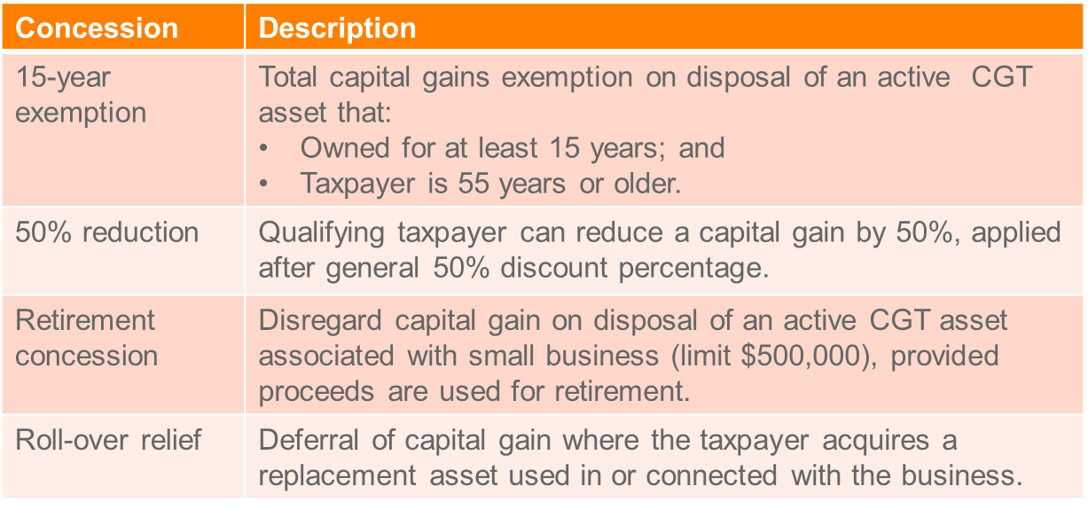

**Example re 15 Year Exemption (**subdiv 152-B**)**

Jo is 60 years old. He has owned the local newsagency which he purchased in 1986 for $50,000. Jo decides to retire as he wants to travel the world. In March 2018 Jo sells the business for $250,000, making a capital gain of $200,000.

*Assuming Jo meets the three basic conditions to qualify for the small business exemptions, he will qualify for the 15-year exemption as he is over 55 and has owned the business for more than 15 years. As this will exempt all capital gains made from the sale of the business, Jo will not need to consider any other exemptions or concessions, nor will he need to consider indexation.*

**Example re 50% Reduction (**subdiv 152-C**)**

Zara, who operates a small manufacturing business, disposes of a CGT asset. She owned the CGT asset for three years. It was used as an **active asset** of the business.

Zara qualifies for the CGT 50% discount and for the small business 50% reduction. From the CGT event she makes a capital gain of $20,000 and she sells another asset, which gives her an additional capital loss of $5,000 in the income year

*Zara calculates her net capital gain for the year as follows:*

* *$20,000 - $5,000 = $15,000*
* *$15,000- (50% X $15,000) = $7,500*
* *$7,500- (50% X $7,500) = $3,750*

*If she chose the rollover or the retirement exemption, some or all of this remaining capital gain would be disregarded.*

**Example re Retirement Exemption (**subdiv 152-D**)**

Jack acquired a farm in 2011. In December 2017, at the age of 60, he retires and transfers the farm to his son for no consideration. The market value of the farm was $1 million, so the **market value substitution rule applies (**s 116-30**)**. It deems that the capital proceeds equal the market value of the farm.

*The cost base of the farm was $600,000, so, assuming the other retirement exemption conditions are satisfied, Jack made a capital gain of $400,000.*

*Jack reduces his capital gain twice: first, by the 50% CGT general discount (div 115) to $200,000; then further, by the 50% active asset reduction (, to $100,000. Although he received no capital proceeds, and assuming the other retirement exemption conditions are satisfied, Jack may choose to apply the retirement exemption for the full amount of the remaining $100,000 capital gain.*

**Example re Rollover Relief (**subdiv 152-E**)**

Jude's small business has an original capital gain of $100,000 on the disposal of an active asset. After Jude applies the CGT general discount and 50% active asset reduction, his original capital gain is reduced to $25,000.

*If we assume the first and second elements of the cost base of the business' replacement asset* ***total $20,000,*** *this amount can be disregarded under the roll-over, leaving Jude with a final capital gain of $5,000.*

## Record Keeping

* What records - s 121-20
* all transactions effecting CGT events
* date acquisition and disposal
* each cost base element
* consideration on disposal
* parties to the transaction
* Retain records for 5 years - s 121-25

## Revision questions

**Elements to look at in a question involving the disposal of an asset:**

Mere realisation of an asset or OI?

1. Isolated transaction – forms a business in itself (Whitford’s Beach)

2. Extraordinary transaction - (Myer Emporium)

Strands of Myer

**Question 1**

Five years ago Bruce purchases 10 hectares of land for $1 million in an area that was ripe for subdivision. Legal fees and stamp duty in relation to the purchase were $50,000. At the time of purchase he intended to get planning permission from the local council to develop the land by subdivision and then resell it at a proﬁt, but instead he leased it for grazing horses. Three years ago Bruce attempted to get planning permission to subdivide his 10 hectares, but it proved very difficult, and finally in March of the current tax year the local council refused permission to subdivide. Bruce reluctantly sold the land in May for $3 million, incurring legal fees and agents commission of $75,000.

**Required:** What are the tax consequences of Bruce’s sale?

*Isolated transaction that forms a business in itself? No significant development of the land, so the Whitford’s Beach principle does not apple as there has been no activity on the land that forms a business in itself.*

*Extraordinary transaction? Has there been a commercial transaction? Yes he has bought land with the intention of making a profit. There was a profit making intention when he acquired the asset (sub divide and make a profit). He fact that h*

**Question 2**

Tom Brown is a General Manager in a large international construction firm called Buildfast. Tom's investment portfolio comprises of the following:

|  |  |  |  |
| --- | --- | --- | --- |
| **Asset** | **Acquisition Date** | **Acquisition Price** | **Notes** |
| Richmond Property | 24 June 2015 | $600,000 | * Property is a vacant warehouse. |

Tom loved working with his hands, and had a hobby as a furniture-maker. Tom set up a studio in his backyard so that he could pursue his hobby without bothering his wife.

Tom wanted to move his studio to somewhere bigger so that he could make more furniture. He decided to renovate a vacant warehouse that he owned in Richmond. He bought the property back in 2015 as a friend told him that Richmond was popular and the land would increase in value in the next 10 years. He incurred legal fees and stamp duty of $25,000 in relation to the purchase of the Richmond property. He engaged an architect to help him renovate the warehouse. The architect advised Tom to keep his studio in his backyard and turn the vacant warehouse in Richmond into 15 apartments and sell them. Tom thought this was a good idea. Tom built the apartments using a builder who charged him $1.2million to do the construction. The value of the vacant warehouse at the time the construction commenced was $1.1million. He sold the 15 apartments in January 2018 for $4.7million, incurring legal fees and agents commission of $80,000.

**Required:** Explain to **Tom Brown** how the above-mentioned transactions would or would not constitute assessable income under the Income Tax Assessment Acts. Include calculations. Use legislation and case law to support your answer.

*Significant development in the property, which resulted in a gain. Makes it an isolated transaction that forms a business in itself and OI under Whitford’s Beach.*

*Still need to look at Myer- extraordinary transaction. Doesn’t look like it is a gain that is connected to the carrying on of a business. It is a commercial transaction, intention was to make a profit, friend told him it would increase in value. The profit was not realised in the manner intended, so the first strand of Myer does not apply: Westfield.*

*So gain is OI according to Whitford’s Beach. OI = Sale proceeds – (land value at time development commenced + Development costs)*

*4.7m - (1.1m+ 1.2m & 80K) = amount assessable under s 6-5*

**Question 3**

Olivia is doctor. Olivia’s investment portfolio comprises of the following:

|  |  |  |  |
| --- | --- | --- | --- |
| **Asset** | **Acquisition Date** | **Acquisition Price** | **Notes** |
| Painting | 10 September 2000 | $60,000 | * Painting by a well-known Australian artist. |
| Farmland | 20 March 2012 | $1,500,000 | * Property is 20 ha of vacant farmland in Little River. |

When Olivia bought the Farmland (see Olivia’s investment portfolio, above), she knew that the local Council was considering allowing farmland in the Little River area to be used for housing developments. She expected that the housing developments would commence in the next five years pushing up the price of the Farmland considerably. She bought the land with the intention of holding the land and then selling it to a developer within the next five years. She incurred legal fees and stamp duty in relation to the purchase of $10,000.

By October 2016, no significant housing developments had been approved in the area by the local Council. In November 2016, Olivia decided to subdivide the land into two blocks of 10 ha each. The subdivision cost $20,000. The Council approval for the subdivision did not require her to do any work to the land apart from putting in new fences. In February 2017, she sold one block to the farmer next door who wanted to expand his plantings of lettuce and zucchini. The farmer paid her $1,300,000. The other block was near the Werribee Zoo so she decided to build a motel and restaurant which would allow visitors to the Zoo to stay overnight in the local area. The block has a market value of $800,000 at the time the construction commenced. The construction costs totalled $1,000,000. She sold the motel and the restaurant to the Werribee Zoo in August 2017 for $3,000,000. She incurred legal fees and agents commission of $60,000 in relation to the sale.

Olivia decided she needed funds to buy medical equipment, so she sold her Painting (see Olivia’s investment portfolio, above) to her brother for an amount of $120,000 on 1 May 2017. At the time of sale, the Painting was valued at $240,000.

She had capital losses of $20,000 resulting from a loss she made when selling an antique dressing table in 2014.

**Required:** Explain to **Olivia** how the above-mentioned transactions would constitute assessable income under the *Income Tax Assessment Acts*. Use legislation and case law to support your answer.

*Land sold to farmer:*

*OI or a mere realisation from selling an asset?*

* *Whitford’s Beach: Has an activity happened to the farm that would form a business in itself? – No the facts hint that there was not a sufficient amount of capital planning or effort. Only a subdivision which did not require her to do anything to the land but put in new fences.* 
  + *Reference Casimaty*
* *Myer First strand: Intention to make a profit? Yes her intention was to make a profit by holding land and then selling it to housing developers. She has abandoned her original intention, any profit realised was not in a manner with regard to her previous intention, thus a capital gain.*

*Land and building sold to Werribee Zoo:*

*OI or mere realisation of an asset?*

* *Whitford’s beach: A sufficient amount of development has happened which arguably forms a business in itself. Hence an isolated business activity and assessable as OI.*
* *Not a situation where Myer 1 would apply as she has abandoned her original intention: Westfield.*

*Sale proceeds – (Land value at time of development + Development Costs)*

*4.7M – (0.8M + 1M + Half subdivision costs (10K) + legal and agents fees of 60K) = $*

*Paintings:*

*CGT event A1*

*Time: May 17*

*Collectible:*

# Topic 5 Checklist: Who pays tax and how? Individuals, Companies, Trusts and partners

**Who is the tax payer?**

Income tax is payable by each individual and company, and by some other entities ITAA 97, s. 4-1

**Individual**

* Every person with an income **over $18,200** must supply a tax return for all taxation entities specified by the Commissioner in the Gazette ITAA 36, s. 161
* **Tax free threshold for**: part resident and minors
* **Tax offsets (reduce your tax)-**
* **Medicare levy**
* **Income tier thresholds**
* **HECs help**

**Companies and shareholders**

**Taxing company:**

* A company is a separate taxpayer
* Shareholders are assessable on company distributions
* A company’s taxable income is taxed at a flat rate (currently 30%) on every dollar of income.
* Shareholders then taxed on the company’s distributions of profits (dividends) (double taxation issue)
* Defining company s 995-1 ITAA 97

1. a body corporate
2. any other unincorporated association or body of persons; but does not include a partnership.
3. Public or private?

## Taxation of company distributions ‘dividends’

Imputation system

* Company pays tax on taxable income.
* Individual pays tax on dividends received.

**Step 1: state what a dividend is** DIV 205 ITAA 97, s 995-1(1); ITAA 36, s 6(1)

* any distribution; and
* any amount credited;
* can be deemed dividend (unfranked)- dividends made on winding up of a company
* S 44 ITAA 36**:** Dividends are considered as statutory income pursuant to s 44 ITAA 36

**Step 2:** state must be Australian resident

**Step 3:** Dividends are still AI to shareholder but rebate received for tax already paid by company on its income **(**s 67-25**)**

**Step 4:** what type of dividend

* Deemed dividend **(**s 6(1))
* Fully franked= company already paid all tax so taxpayer entitled to discount
* Dividends are still AI to shareholder but rebate received for tax already paid by company on its income (s 67-25**)**

**Step 5: state imputation system may apply**

1. Record distribution (fully franked means dividend fully taxed (30%)):
2. Gross up amount – add back company tax (eg $70 distributed, but $100 gross up amount)
3. Multiply by marginal tax rate (depends on the individual’s tax rate)
4. Subtract company tax
5. Final amount is amount assessable as dividend of s 44 ITAA 36

* The imputation system provides the members of a corporate tax entity with a tax offset known as ‘Franking Credit’ for tax paid by the entity.
* If the company tax rate of 30% is higher than the shareholder’s rate, then too much tax has been withheld and the shareholder will receive a rebate, and vice versa.

## Trusts

**Step 1: Only trustee of beneficiary are liable to tax, not both**

* Trust has no separate legal existence
* taxable income of a trust is determined in a similar manner to that of an individual **(**ITAA 36, s 95(1))
* No double taxation: If the beneficiary is taxed, the trustee is not. This effect is the result of ss 97, 98, 99, 99A, 99B
* “A trust’s tax return is initially only a statement of distribution of the trust income and is not subject to tax unless no beneficiary is presently entitled to the trust income, or one or more beneficiaries, presently entitled to trust income, are under a legal disability.”

**Step 2: is any beneficiary presently entitled to that income?**

* A beneficiary will be deemed to be presently entitled to the income of a trust estate if they have an ‘indefeasible vested interest’ in that income.
* If presently, entitled, this is a right to income whether or not actually paid over
* Beneficiaries taxed at normal individual tax rates unless under a legal disability
* Beneficiaries are taxed on the income, which they are presently entitled to.
* **If the beneficiary is taxed, the trustee is not.**
* **If beneficiary not presently entitled= trustee taxed**

**Step 3: is the beneficiary under a legal disability? (**s 98**)**

* If a legal disability exists, the trustee is taxed in place of the beneficiary at the rates of tax applicable to the beneficiary.
* **S 98, 99 and 99A** make the trustee liable to tax if, *inter alia*, the beneficiary is under a legal disability (ex. under 18), or where no beneficiary is presently entitled to the income.
* **Look at diagram**

**Step 4: if no beneficiary is presently entitled**

* S 101, trustee may exercise discretion (if power exists) to apply income to the benefit of beneficiaries, therefore making them presently entitled.
* Where trustee doesn’t have power to distribute income, or doesn’t exercise that power, and still no beneficiary is presently entitled, then the income of the trust is the taxable income of the trustee and is taxed at penalty rates s 99A.
* S 99, Commissioner has discretion to tax this income at ordinary rates if appropriate.
* Normally Commissioner applies s 99 (ordinary rates of tax) to deceased estates for the year of death and two additional tax returns.

## Partnership

**Step 1: Partners are each individually taxed**

Partnerships are not separate legal entities and are not taxed directly—only the individual partners are taxed.

**Step 2: ‘Partners’ definition**

Wider that its legal definition for tax purposes

* an association of persons carrying on business as partners;
* an association of persons in joint receipt of ordinary or statutory income, e.g. joint owners of rented property **(McDonald-** joint owners of rented property**)**

**Step 3: The ‘partnership’ not liable to tax, just individual partners**

* *s.91 -* Must furnish a return but not liable to tax
* *s.90* - Taxable income - as if it is a taxpayer.
* No deduction allowed for past year losses and personal superannuation
* Cannot carry forward tax losses
* Partnership is not taxable per se:
* Only the partners of a partnership are taxable on their individual share of the net partnership income ITAA 36, s. 92(1)
* Each partner then liable to tax on his or her share of partnership income.

**Step 4: Partnership able to distribute losses to its partners (**s. 92(2**))**

* Partner may not be an employee of their own partnership as this is contracting with yourself.
* Salary paid to a partner is not an allowable deduction against the partnership income, as there in no loss or outgoing ITAA 97, s. 8-1
* Salary or wage is only a distribution made after the calculation of taxable income.
* No deduction is allowed on interest paid on partners’ capital contributions.
* Capital gains: partners are the joint owners of the assets of the partnership.

-So, a partnership cannot be liable to CGT as it can never own assets, but the partners are liable to CGT for their share of any gain or loss realised on the disposal of partnership assets, s. 108‑5(2)(c)).

# Topic 5.1: The Taxation of Individuals

**Who pays tax: s 4-1 - individuals and companies and some other entities**

S 960-100 – Entities:

* Individuals – taxed – tax return required
* partnerships - tax return required but not taxed – partners taxed
* companies – taxed – tax return required, shareholder taxed on dividends
* trusts - tax return required trustee may or may not be taxed – beneficiaries taxed

**Lodgement of Tax Return**

* Who must submit an income tax return:
  + s 161 - Every resident individual with assessable income over $18,200 (2015/16)
  + Low income offset $445 (2017/18) means **no tax if income below $20,400**.
  + Taxpayer <18 years of age with unearned income
  + Non-residents with Australian source income
* Tax return due - 31 Oct following end of the tax year
  + Tax agents lodgment schedule may differ
* Resident Individuals -
* Progressive tax rate
  + Tax free threshold resident $18,200
  + Marginal rate 19% - 45%
* Income of minors, including distributions from trusts, are in general taxed at the top marginal rate plus Medicare levy.
  + See, Div 6AA ITAA97.

Rates for 2017-18 for resident minors:

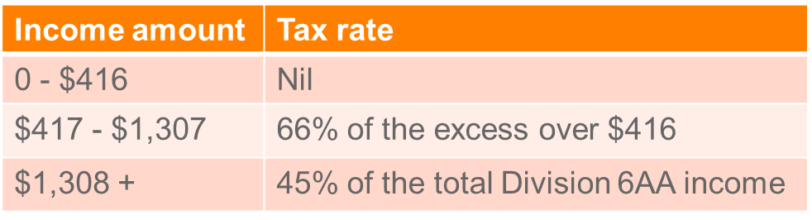

* Certain minors are exempt from Div 6AA.
  + Examples, minors in full time employment.

**Tax offsets**

* A number of concessions are given under the Act by allowing a reduction in the tax due. These concessions are known as tax offsets in the ITAA 97. Tax offsets range from the dividend imputation credits to rebates for dependants and social security beneficiaries and tax offsets for private health insurance (ITAA 97, Subdiv. 61-G).
* *Note: Rebates are not a reduction of taxable income, they are a reduction of tax due thereby making them of the same value to all taxpayers regardless of their tax rate*.
* These concessions are known as rebates or credits in the ITAA 36 but have been renamed as tax offsets in the ITAA 97.

**Other taxes and levies**

* Medicare Levy
  + 2% of taxable income
  + Exempt if below threshold (varies on number of dependents)
* Medicare - 1% Surcharge (if no private health insurance)
  + Single - > $90,000 taxable income + reportable Fringe Benefits (RFB)
  + Couple - > $180,000 taxable income + RFB
  + Rate increases to 1.25% ($105,000/$210,000) and 1.5% ($140,000/$280,000)
  + Threshold increases if more than one dependent
* HECS - HELP - Higher Education Loans Program
  + Repayment starts at $55,874 (17/18) taxable income at 4% – rate increases with taxable income – max 8% at $103,766.
  + HECS-HELP debt is indexed to CPI
  + Proposed decrease to repayment threshold to $45,881 with more repayment rates from 1 July 2019.
  + Taxpayers living overseas with an outstanding loan required to make repayments similar to if they were living in Australia.

**Tax offsets**

* Generally claimed against income tax liability. In some cases, offsets may be:
* Refundable
* Transferable to another person, or
* Carried forward to be used in future income years.

Fixed amount to reduce tax– not a tax deduction – Some from s 13-1 ITAA97:

* Childcare
* Dependents (Invalid and Carer)
* Pensioner, Low income earners
* Recipient of social security
* Private health insurance (means tested)
* Dividends imputation – imputation (franking) credit – look at later
* Foreign Income Tax paid on income
* Remote zones

# Topic 5.2: Taxation of Companies and Shareholders

* Companies are subject to income tax at a flat rate of 30% (proposed reductions to 25%; not yet enacted)
* Small business entities are subject to income tax at a flat rate of 27.5% (2017-2018). Further changes discussed in Topic 1.

### 

**Public officer**

* Every company carrying on business or deriving property income in Australia must appoint a public officer: s 252 ITAA36
  + Public officer must be a resident, a natural person aged at least 18 years
* For income tax law, the public officer is responsible for:
  + Documents served on them
  + Answerable for all obligations imposed on the company
  + The same penalties if the company defaults.

## Taxation of dividends

Taxing provisionin s 44 ITAA36 stipulates that the assessable income of a resident shareholder in a company includes:

1. Dividends paid to the shareholder by the company out of profits derived by it from any source; and
2. All non-share dividends paid to the shareholder by the company.

**Who is a shareholder?**

* Definition of ‘shareholder’ includes “member or stockholder”:   
  s 6 ITAA36.
* Entry on company’s register of members necessary to constitute membership of a company: *Patcorp Investments Ltd v FCT* (1976).

**What are dividends?**

S 6(1) ITAA 36

*“dividend”*includes:

                     (a)  any distribution made by a [company](http://classic.austlii.edu.au/au/legis/cth/consol_act/itaa1936240/s24aw.html#company) to any of its shareholders, whether in money or other [property](http://classic.austlii.edu.au/au/legis/cth/consol_act/itaa1936240/s343.html#property); and

                     (b)  any amount credited by a [company](http://classic.austlii.edu.au/au/legis/cth/consol_act/itaa1936240/s24aw.html#company) to any of its shareholders as shareholders;

But does not include:

                     (d)  moneys paid or credited by a [company](http://classic.austlii.edu.au/au/legis/cth/consol_act/itaa1936240/s24aw.html#company) to a shareholder or any other [property](http://classic.austlii.edu.au/au/legis/cth/consol_act/itaa1936240/s343.html#property) distributed by a [company](http://classic.austlii.edu.au/au/legis/cth/consol_act/itaa1936240/s24aw.html#company) to shareholders (not being moneys or other [property](http://classic.austlii.edu.au/au/legis/cth/consol_act/itaa1936240/s343.html#property) to which this [paragraph](http://classic.austlii.edu.au/au/legis/cth/consol_act/itaa1936240/s94d.html#paragraph), by reason of [subsection](http://classic.austlii.edu.au/au/legis/cth/consol_act/itaa1936240/s94d.html#subsection) (4), does not apply or moneys paid or credited, or [property](http://classic.austlii.edu.au/au/legis/cth/consol_act/itaa1936240/s343.html#property) distributed for the redemption or cancellation of a redeemable preference share), where the amount of the moneys paid or credited, or the amount of the value of the [property](http://classic.austlii.edu.au/au/legis/cth/consol_act/itaa1936240/s343.html#property), is debited against an amount standing to the credit of the **share capital account** of the [company](http://classic.austlii.edu.au/au/legis/cth/consol_act/itaa1936240/s24aw.html#company); or

**Share capital account**

* A share capital account is “an account which the company keeps of its share capital”: s 975-300.
* Tainted share capital account:
  + Occurs when a company capitalises profits and/or transfers other amounts into the share capital account: s 197-50.
  + Anti-avoidance rules apply, for example:
    - Dividends deemed to be paid out of profits, and hence assessable: s 44(1B).
    - Franking debit arises in the company’s franking account.

**Meaning of ‘paid’**

* “Paid” means credited or distributed: s 6(1).
* Dividend still paid if it is credited and irrevocable: *Brookton Co-operative Society Ltd v FCT* (1981).

**Meaning of ‘profits’**

* Income (including exempt income) will be, in general, profits and therefore taxed as dividends in the shareholder’s hands.
  + See, *FCT v Slater Holdings Pty Ltd* (1984)

**Anti-avoidance:**

* “A dividend paid out of an amount other than profits” is also deemed to be a dividend paid out of profits for income tax purposes: s 44(1A).

**Avoidance issue:**

* Schemes used by private companies to pass benefits (ie, use of profits) to shareholders while avoiding the payment of ‘dividends’ include:
  + Paying excessive salaries or fees paid to shareholders
  + Making payments and loans to shareholders.

**Excessive salaries or fees paid to shareholders (**s 109(1)**)**

* To the extent that salaries or fees for services provided by a shareholder (or associate) is excessive, that portion:
  + Is deemed to be a dividend to the shareholder; and
  + Is not deductible to the company.

## Division 7A

* Provisions that deem certain kinds of amounts paid by a private company to a shareholder (or associate) as dividends:
  + Payments (s 109C)
  + Loans (s 109D)
  + Debt forgiveness (s 109F).
* Total amount of Division 7A deemed dividends capped at the “distributable surplus” (or distributable profits) of the private company: s 109Y.
* Deemed dividends under Div 7A are taken to be paid out of profits and assessable under section 44 (s 109Z).

**Payments to shareholders (**s 109C**)**

* Payments made to shareholders (or associates) are treated as deemed dividends.
  + “Payment” is widely defined: any payment or credit to, on behalf of, or for the benefit of, the shareholder and includes the transfer of property or the provision of an asset.
* Exclusions include:
  + Payment to discharge an arm’s length debt: s 109J.
  + Payment to corporate shareholders: s 109K.

**Loans to shareholders (**s 109D**)**

* Loans made to shareholders (or associates) that are not repaid by the “lodgement date” (broadly, of the tax return for the year in which the loan is made) constitutes a deemed dividend.
* Exclusions include:
  + Loans made to a corporate shareholder: s 109K.
  + Loans meeting minimum criteria: (i) converted to written loan agreement before the lodgement date; and has (ii) commercial interest rate; and meets rules re maximum (iii) term of loan: s 109N.

**Forgiven debts to shareholders (**s 109F**)**

* Debts owed by shareholders of private companies that are forgiven constitute a deemed dividend.
* Exclusions include:
  + Debts that were owed by another company.
  + Debts forgiven due to bankruptcy of the shareholder.

## Deemed dividends for liquidator distributions

* Distributions paid by a liquidator are generally treated as deemed dividends paid out of profits to the extent it represents income derived by the company: s 47(1) ITAA36.
* Return of capital not a dividend.
* CGT event **C2** applies when shares are **redeemed or cancelled**.
  + Capital gain reduced by amounts captured as assessable income under s 47. (Application of the **anti-overlap rule** in s118-20)

## Imputation system

Issue of double taxation on company and shareholder are offset by franking credits

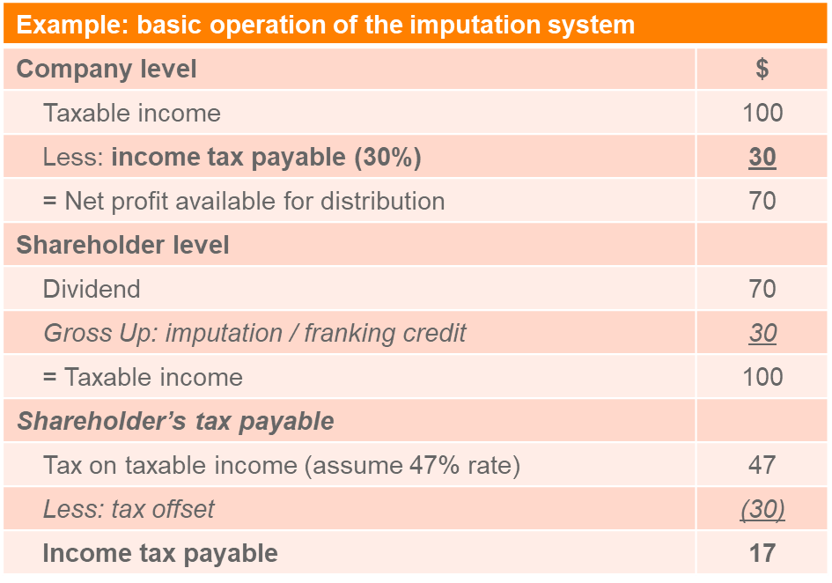

In general, if a shareholder receives a franked distribution:

1. It has to “gross up” its assessable income by the amount of the franking credit: s 207-20(1); and
2. It is entitled to claim a tax offset by the same “gross up” amount: s 207-20(2).

The maximum franking credits that can be attached to a distribution is determined by the formula in s 202-60(2):

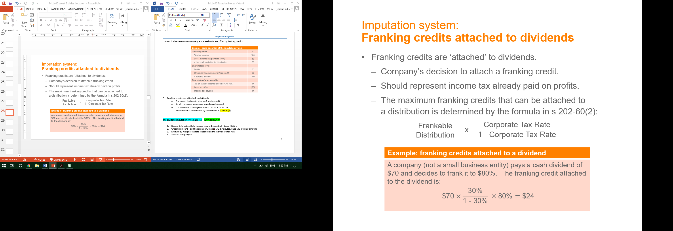

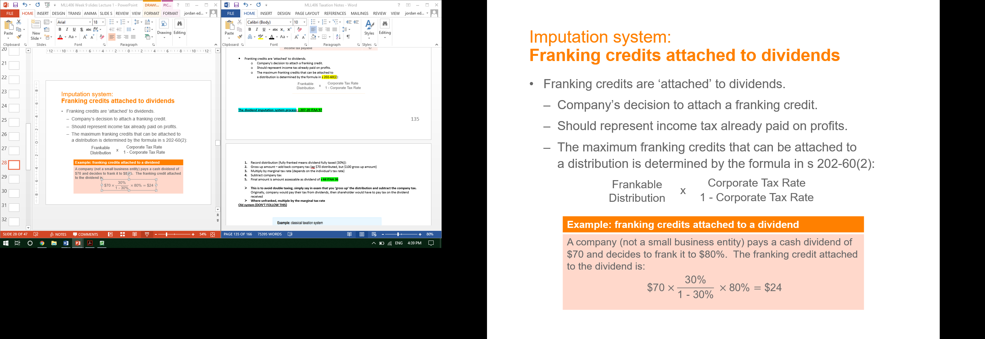

Refundable if it exceeds the resident’s tax payable

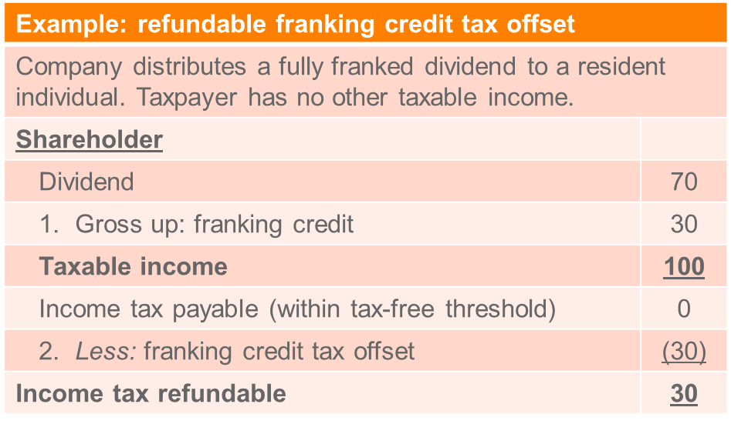

Not refundable for corporate shareholder’s

* Franking credit tax offset is generally not refundable for shareholders who are corporate tax entities
* Excess franking offsets can be converted into a **tax loss which can be carried forward to future income years**

**Question:**

A resident company pays a fully franked dividend of $700 to a resident shareholder. Advise the income tax implications of the shareholder if it is:

(a) an individual subject to the top marginal tax rate;

1. an individual with marginal tax rate of 15%;
2. How are the calculations different if the dividend are is partially franked to 60%?

**Answer:**

*Imputation system: tax implications of resident shareholders based on the assumption that the resident company paying the dividend has based the distribution on a 30% company tax rate:*

*(a) Resident individual at top marginal rate:*

* *Assessable income = $700 (s 44 ITAA36) + $300 (gross up) = $1,000*
* *Tax @ 47% = $470*
* *Tax offset = $300*
* *Net tax payable on the dividend = $170*

*(b) Resident individual with marginal tax rate of 19%:*

* *Assessable income = $700 (s 44 ITAA36) + $300 (gross up) = $1,000*
* *Tax @ 21% = $210*
* *Excess tax offset = $90, being tax offset of $300 less tax payable of $210. The excess is refundable from the ATO*

*(c) How are the above calculations different if the dividend is partially franked to 60%?*

*Resident individual at top marginal rate:*

* *Assessable income = $700 (s 44 ITAA36) + $180 ($300 x 60%) (gross up) = $880*
* *Tax @ 47% = $413.60*
* *Tax offset = $180*
* *Net tax payable on the dividend = $233.60*

*Resident individual with marginal tax rate of 19%:*

* *Assessable income = $700 (s 44 ITAA36) + $300 x 60% (gross up) = $880*
* *Tax @ 21% = $184.80*

*Additional payment of $4.80 required, being tax offset of $180 less tax payable of $184.80. No refundable excess from the ATO*

**Resident partnerships and trusts as shareholders**

* + Generally, franked distributions are traced through so that partners and trust beneficiaries receive their share of the distribution and franking credits.

**Non-resident shareholders**

* + “Gross up and offset” mechanism not available to non-resident shareholders: s 207-20.
  + Treated generally as non-assessable non-exempt income in the hands of the non-resident shareholder: s 128D ITAA36.
  + Withholding tax applies to unfranked dividends.

**Question:**

A resident company pays a dividend of $1,400 (franked to 60%) to a non-resident shareholder. Advise the Australian income tax implications of the shareholder if it is an individual living in the US.

**Answer:**

* *Non-resident individual:*
* *no gross up or tax offset*
* *dividend: non-assessable non-exempt income*
* *franked portion: exempt from withholding tax*
* *unfranked portion ($1,400 x 40%, ie $560): subject to withholding tax at 15% assuming the Australia-US treaty is applicable*

**Benchmark rule**

* Purpose: counteracts streaming arrangements
  + Ensures that one member of a corporate tax entity is not preferred over another when the entity franks distributions.
* Rule: all distributions in a “*franking period*” must be franked to the same “*benchmark franking percentage*”: s 203-25.
  + Over-franking: liable to pay over-franking tax (s 203-50(1)). (no credit in franking account).
  + Under-franking: debit in the franking account (s 203-50(1)(b)).
  + Commissioner may permit deviation from the benchmark rule in extraordinary circumstances: s 203-55.
* “Benchmark franking percentage”: franking percentage of the first frankable distribution in the franking period (s 203-30).

“Franking period”

Private company:

* One period – 1/7-30/6

Public company:

* Two franking periods: 1/7 to 31/12; 1/1 to 30/6

**Qualified person**

Use of the “gross up and tax offset” mechanism is denied if the distribution is made to a person that is not a “qualified person”.

* “Qualified person” is, among other things, a shareholder that holds the shares **at least 45 days** (90 days for preference shares).
* The qualified person test is intended to ensure only the true economic owners of shares benefit from franking credits attached to distributions made from the shares. That is the owner is the person who holds the shares and benefits from the gains as well as subject to any losses arising from holding the shares.

## Company losses

Under s 36-10 a tax loss occurs when deductions are greater than assessable income and net exempt income, the difference is a tax loss

* Carried forward revenue losses cannot be deducted unless it satisfies either the:
  + Continuity of ownership test (CoT); or
  + Same business test (SBT) (applies if COT not satisfied): s 165(10) ITAA97.
* Above tests also apply to a revenue loss in the current year: Subdiv 165-B.

# Topic 5.3: Taxation of Trusts

A trust is not a separate legal entity, but a relationship whereby a trustee (which may be a person/s or a company) holds property (trust property or corpus) for the benefit of the trust’s beneficiaries.

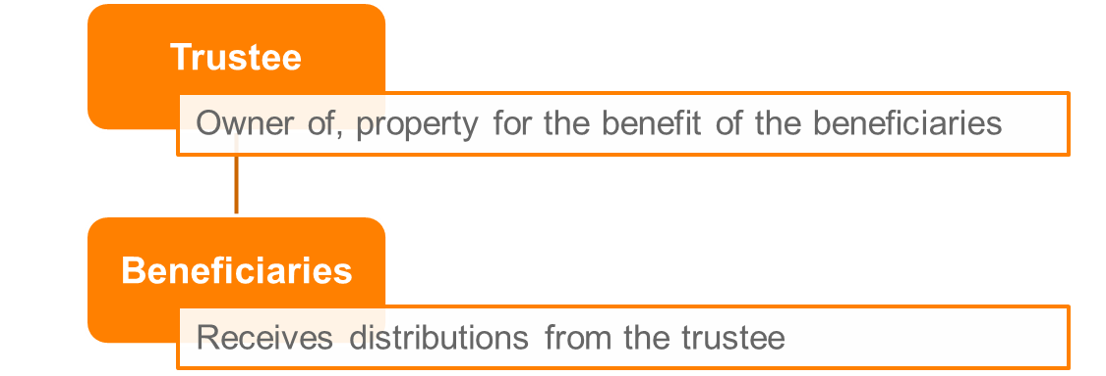

**The key elements to the trust are:**

* ***Trust deed*** – sets out (amongst other things) the powers of the trustee to control the operation of the trust, the appointment of trustees and the rights of the beneficiaries. It is not necessary that the creation of a trust be documented in a formal deed, but in all business relationships, a deed is vital to formalise the trust.
* ***Trust property*** – the property under the control of the trust deed; also termed the corpus.
* ***Trustee*** – person/s or company who at law owns the trust property and is bound to administer the trust according to the trust deed.
* ***Beneficiary*** – people, companies, partnerships or other trusts that stand to benefit from the distribution made by the trustee. A beneficiary may stand to benefit from distributions of income and/or capital.
* ***Trust obligation*** – the personal obligation of the trustee to carry out the trust obligation under the trust deed.

## Types of trusts

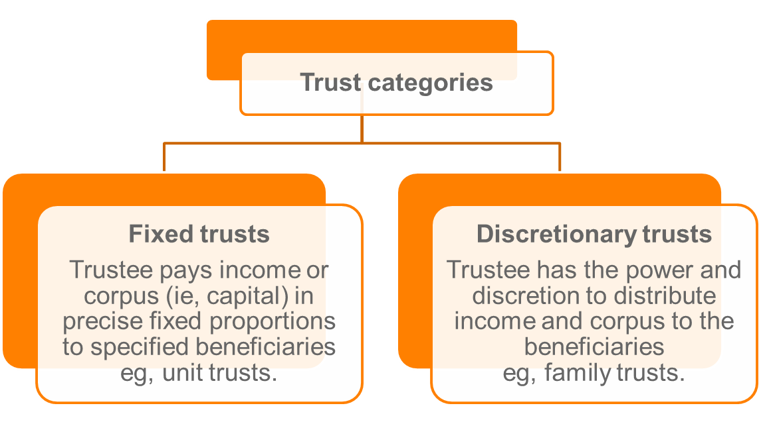

* It is also fairly common for the trustee to be a private company. The advantage of a corporate trustee is that it is perpetual and has some protection against liability through the limited liability nature of a private company. It also allows the people behind the business to maintain control of the operations of the trust through their control of the trustee company.

**Fixed trust**

Entitlements of beneficiaries to income and corpus are predetermined or fixed by the terms of the trust deed.

* Trustee has no discretion to change fixed entitlement.
* Proprietary interest in all of the trust property held by beneficiaries.
* Common fixed trusts are unit trusts: beneficiaries (known as unit holders) hold ‘units’ in the trust.

Example of fixed trust (unit trust):

* Number of units held by each beneficiary typically corresponds to the contribution made to the trust

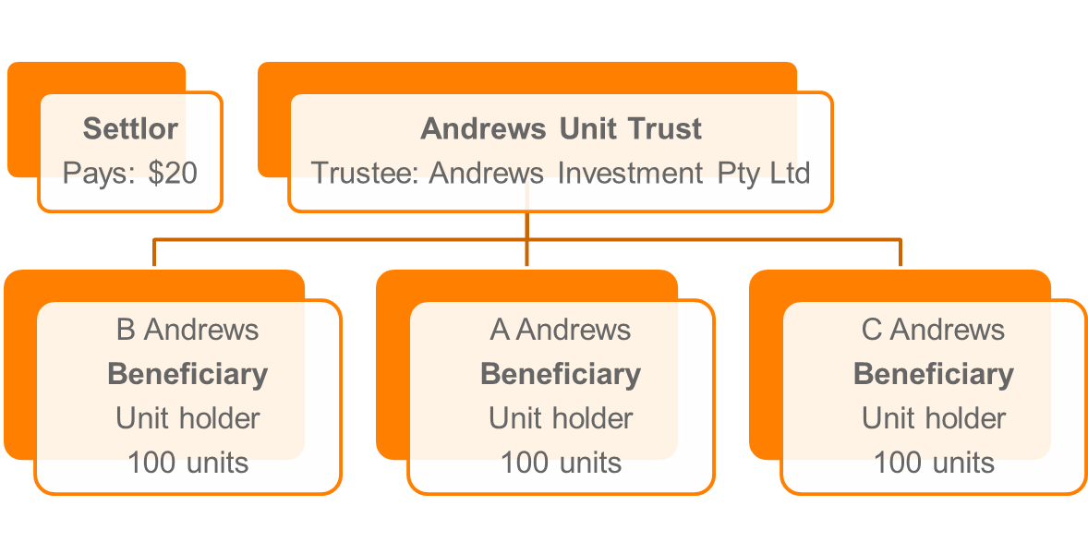

**Discretionary trusts**

Trustee has absolute discretion to allocate trust income or capital to a beneficiary.

* Beneficiaries have no entitlements until the trustee decides
* Useful for asset protection
* Typically known as family trusts.

Example of a discretionary trust (family trust):

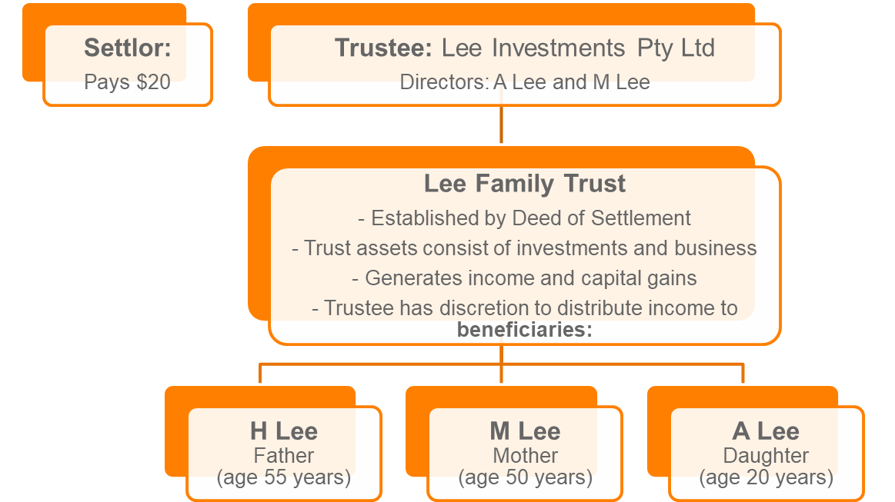

**Establishment and operation of a family trust**

A typical family trust is established and operates in the following way:

1. **Main beneficiary appoints trustee as an “appointor”**

Appointor is nominated in trust deed and has the power to remove/appoint a trustee.

1. **Establishment of trust: Settlor makes initial cash contribution (usually $20) and executes trust deed**

Settlor is usually the family accountant or solicitor.

1. **Trustee operates the trust**

Trustee is legal owner of trust property. Trust property is administered on behalf of the beneficiaries (being, current and future family members).

1. **Trustee distributes income to beneficiaries**

Advantages of a family/discretionary trust is that the trustee can split income taking into account the tax profiles of the beneficiaries.

**Testamentary trusts**

* A testamentary trust is a trust created under a will and can either be a fixed trust or discretionary trust
* Beneficiaries can be the widow or widower, and children or grandchildren.

## Taxation of trust income

The taxable income of a trust is determined in a similar manner to that of an individual (ITAA 36, s 95(1)). However, the annual tax return of a trust may or may not give rise to a tax liability for the trustee. A trust’s tax return is initially only a statement of distribution of the trust income and is not subject to tax unless no beneficiary is presently entitled to the trust income, or one or more beneficiaries, presently entitled to trust income, are under a legal disability.

When working with trusts, it is important to remember that a trust has no separate legal existence. Only the trustee or the beneficiaries are therefore liable to tax, not both.

The following flowchart summarises how a trust is taxed:

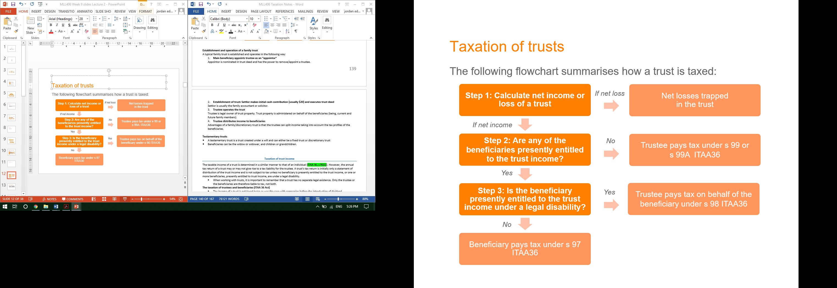

## 1. Net Income or loss of the trust?

* **Income of the trust estate** is not defined in tax law. If not defined in the trust deed, it may refer to the general concepts under trust law.
  + Typically, this *excludes* capital gains.
* **Net income of a trust** is broadly the trust’s taxable income, calculated according to tax law: s 95(1) ITAA36.
  + Thus, this *includes* capital gains.

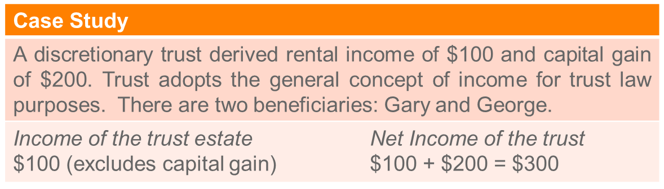

**Issue: what does “share” mean?**

The **proportionate view is adopted, not quantum view**: *Commissioner of Taxation v Bamford* (2010)

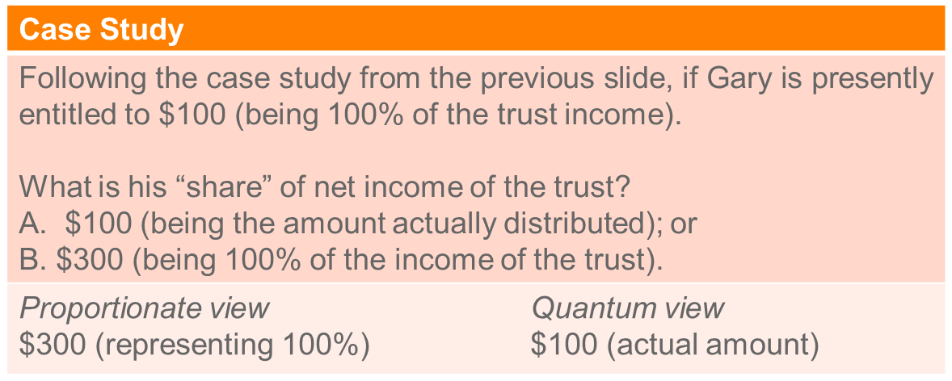

## 2. Presently entitled?

A beneficiary is presently entitled if:

* The beneficiary has an interest in the income which is both vested in interest and possession (legal right is held to income); and
* The beneficiary has a present right to remand and receive payment of the income (exercise legal right to be paid).
  + See, *Harmer v FCT* (1991).
* It is not necessary for a beneficiary to have knowledge of a distribution: *Vegners v FCT* (1991).
* A resolution by a trustee in favour of a distribution to a beneficiary constitutes deemed present entitlement: s 101.
  + Present entitlement doesn’t depend on exercise of discretion to distribute.

## 3. Legal disability?

Beneficiaries who cannot give a valid discharge to the trustee in respect of payments made to them.

Examples:

* Minors
* Undischarged bankrupts
* Intellectually impaired persons

**Scenario 1**

Beneficiary is presently entitled to the trust income and is not under a legal disability.

* Beneficiary pays tax under s 97 (taxed at their marginal rate)

**Scenario 2**

The beneficiary is presently entitled to the trust income and is under a legal disability.

* Trustee will be required to pay income tax on behalf of the beneficiary at the rate of tax that the beneficiary would have paid: s 98.

**Scenario 3**

No beneficiary is presently entitled to the trust income.

* Trustee is taxed at a penalty rate of the top marginal individual rate plus Medicare levy: s 99A.
  + Exception: if the trust resulted from a will and if the Commissioner is of the opinion that it is unreasonable to apply the penalty rate: s 99.

**Preservation of income character**

Character of an item of income is preserved when it is distributed to a beneficiary (*Charles v FCT*).

Examples:

* Dividends received by the trust can be distributed to a beneficiary and carry the imputation credit.
* Capital gains can be distributed to an individual beneficiary and the individual can claim the CGT discount

**Minor beneficiaries**

Income of minors, including distributions from trusts, are in general taxed at the top marginal rate plus Medicare levy.

* See, Div 6AA ITAA97.

Certain minors are exempt from Div 6AA. Examples, minors in full time employment.

**Non-resident beneficiaries**

If a non-resident beneficiary is presented entitled to a share of the trust income and is not under a legal disability:

Broadly, the share of the net income (excluding foreign sourced income) is taxed in the hands of the trustee at non-resident rates: ss 98(2A) and (3).

## CGT events for trusts

* Nine CGT events relating to trusts.
* In relation to taxation of distributions, CGT event E4 occurs if a unit trust (not discretionary trust) makes a payment that is not regarded as assessable income in the beneficiary’s hands.
  + Broadly, a capital gain is made if the non-assessable receipts is greater than the cost base of the units.

## Revision questions

**Discussion question**

Bruce Whelan established the “Whelan Family Trust” in 1990 with ABC Pty Ltd as the corporate trustee. Bruce and his wife May are the directors of the trustee company. The trust holds a variety of investments in property and cash. The trust was established to protect the investments as Bruce is a tax accountant and he is always concerned that he could be sued for negligence.

The trust records for this income year disclose the following:

*Receipts ($)*

80,000 Rent from investment properties

6,000 Interest from a bank account

*Payments ($)*

2,000 Accounting expenses for tax return

10,000 Repairs to investment properties

4,000 Interest on a loan for the investment property

1,000 Legal expenses incurred in defending a claim by a tenant

May does not work. Bruce is a senior tax manager and received a salary of $160,000 in this income year.

He has three children:

* a son, John, aged 21 years, a student at university who earned $12,000 for the year;
* a daughter, Kim, aged 19, also a university student who earned only $2,000 for the year; and
* a second daughter, Amy, aged 16 years, a full time high school student with no other income.

Bruce has his grandmother living with him and she had no income for the year. All family members are beneficiaries of the trust. Bruce also established a corporate beneficiary and this is available to receive trust distributions.

**Calculate the net income of the Whelan Family Trust for this income year and advise Bruce as to how he can distribute the net income in the most tax-effective way.**

***Answer***

*Net income of the trust:*

|  |  |
| --- | --- |
| *Rent* | *$80,000* |
| *bank interest income* | *6,000* |
| *accounting expenses* | *(2,000)* |
| *Repairs* | *(10,000)* |
| *loan interest* | *(4,000)* |
| *legal expenses* | *(1,000)* |
|  | *69,000* |

*Distributions to beneficiaries to minimize tax liabilities:*

*The aim is to minimize tax by taking advantage of the differential marginal tax rates of the beneficiaries.*

*There are different options, but the following is one of the possibilities under which all beneficiaries except one (May in this case) do not have to pay income tax:*

*John: $18,200 – 12,000 = $6,200*

*Kim: $18,200 – 2,000 = $16,200*

*Amy: $416 (to avoid Child Tax at 68%)*

*Grandmother: $18,200*

*May: the balance, ie $27,984 ($69,000 – 6,200 – 16,200 – 416 – 18,200)*

# Topic 5.4: Taxation of Partners and Partnerships

* Not a separate legal entity – only the partners are taxed. Partnerships are therefore not subject to double taxation and can provide a simple method of structuring a business without the concerns of double taxation.
* A partnership does not pay tax, but must lodge a tax return (irrespective of a loss or gain): s 91.
* A tax file number is provided for each partnership
* The tax return sets out, among other things, the net income or loss of the partnership and its attribution to each partner.
* S 92(1) provides that only the partners of a partnership are taxable on their individual share of the net partnership income.
* A partnership’s taxable income is mostly computed on the same basis as the taxable income of an individual, (except that deductions for partners superannuation (ITAA 36 s 82AAT) and prior years’ losses (ITAA 97, Div. 36) are not deductible in arriving at the net income or net loss of a partnership (s 90)).

**What is a partnership?**

A partnership at tax law as defined in s 995-1 ITAA97:

1. An association of persons (other than a company or a limited partnership) carrying on business as partners or in receipt of ordinary income or statutory income jointly; or
2. A limited partnership.

Note, broader definition under general law where contractual obligations regarding who is entitled to what profit (or loss) is allowed.

**Sharing of profits or losses cannot be varied by agreement**

Allocation of profits or losses is based on the partner’s ownership interests in the underlying property:

|  |
| --- |
| *FCT v McDonald* (1987)   * Husband and wife owned investment properties as joint tenants * Partnership agreement:   + Wife 75% of profits;   + Husband 25% of profits and 100% for losses * **Held**: Not a general law partnership (not carrying on a business) * Profits and losses split by ownership interest (ie, 50/50) as it was a tax law partnership, not a partnership at general law. |

**Calculating partnerships taxable income:**

**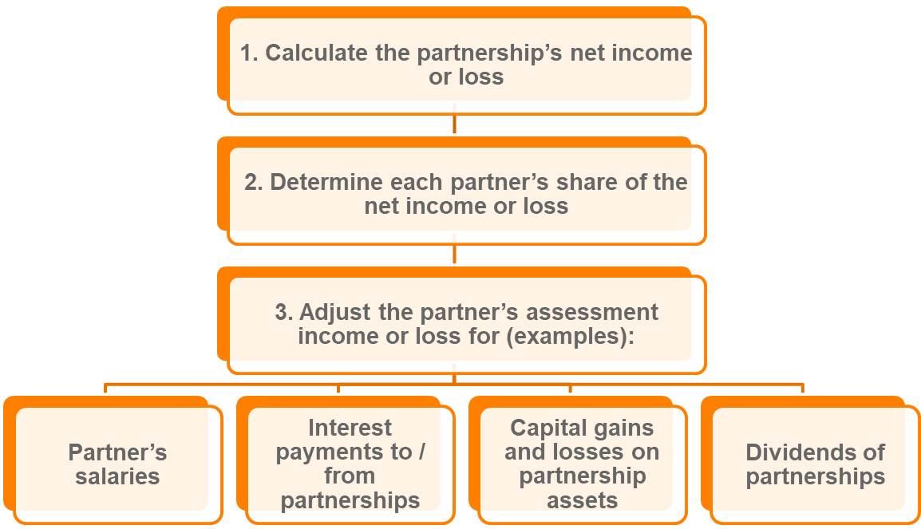**

**1. Net income or loss of a partnership**

* **“**Net income”of a partnership is broadly (s 90 ITAA36):

Net Income = Assessable income calculated as if taxpayer is a resident – Allowable deductions

* A capital gain is **not** included in the partnership’s assessable income. Partnership’s **cannot be liable to CGT** as it can never own assets, but the partners are liable to CGT for their share of any gain or loss realised on the disposal of partnership assets, s 108-5(2)(c).
* **“Net loss”** of a partnership is broadly the excess of the allowable deductions over the assessable income, calculated as if the partnership taxpayer is a resident.
  + Exempt income derived by a partnership is attributed to the partners, thus may affect amount of loss deductions available to the partners: s 92(3) ITAA36.
  + A loss is distributable to a partner, unlike in a trust

**2. Partners share of net income or loss**

* Assessable income of the partner includes the individual interest of the partner in the “net income of the partnership”.
* Deduction is allowed to the partner representing the individual’s interest in the “partnership loss”.

**3. Treatment of special partnership items**

**Partners’ salaries**

* A partner’s salary is **not regarded as an expense** as a partnership is **not a separate legal entity**, and thus not deductible.
* This principle applies even if partners are paid extra amounts over the share of partnership profits.
* Treated as an allocation of profits and losses
  + See, *Re Scott v FCT* (2002).

Example:

Andy and Ben are partners in a partnership, sharing profits and losses equally. Andy receives a salary of $40,000. In this income year, profit of the partnership after deduction of the salary is $100,000.

*As the salary is not deductible, for income tax purposes, the net income of the partnership is $140,000. Out of this amount, Andy has already received $40,000, so he has a 50% entitlement to the remainder, ie, $50,000. Therefore Andy has to include a total of $90,000 as assessable income from the partnership in his tax return. Ben includes $50,000.*

**Interest payments between a partnership and its partners**

* Interest paid to a partner on capital contributed to the partnership is **not regarded as an expense and not deductible**.
* Interest incurred by a partnership on a loan used for working capital is deductible
  + Applies even if the loan is used to repay capital contributions of partners, provided the borrowings are used to refinance funds employed in the partnership business
  + See, *FCT v Roberts and Smith* (1992) and TR 95/25.

**Dividends received by the partnership**

* A partnership includes in assessable income the amount of a dividend received plus imputation credit: s 207-35.
* On distribution as part of the “net income of the partnership”, the dividend and imputation credit **retains its same character**.
  + In a partnership of two people, dividends and imputation credits are split 50/50

**Uncontrolled partnership income**

A penalty tax rate is imposed on “uncontrolled partnership income” in the hands of the partner: s 94

* “Uncontrolled partnership income” arises when a partner of a partnership has **no real and effective control of his/her share of the net income of the partnership**
  + Penalty tax rate is generally the top marginal tax rate less the average rate of tax of the partner
  + Does not apply to a partner that is a company, trustee or minor.

## Collection of tax

* **The Pay As You Go system (PAYG)**
* This unified system of collection of taxes applies from 1 July 2000. The aim of this system is to facilitate taxpayers ability to meet their annual tax liability. This is achieved by requiring the withholding or payment of part of their income at regular intervals during the tax year to meet their tax liability including Medicare Levy and HECS/ HELP repayments.
* *The PAYG withholding system*
* The PAYG withholding system applies to payments for work and services as an employee, whether paid by the employer or another entity. It also includes payment to directors and like office holders, payments under labour hire agreements, taxable return to work payments, ETPs and other retirement payments. This system of withholding tax also applies where a contractor has not quoted a TFN or ABN.
* The timing of the remittance of the amounts withheld depends upon whether the remitter is a large, medium or small withholder.
* *The PAYG instalment system*
* This replaces the system for payments of provisional tax and company tax instalments. It applies to individuals (including partners), companies, corporate partnerships, trading trusts and so on. Instalments are only required to be made where the Commissioner has given written notice of an instalment rate. This system allows for the collection of tax over the relevant tax year. Thus partners and investors will no longer have to pay tax in advance as was the case under the provisional tax system.
* **Higher Education Contribution Scheme (HECS – HELP)**
* The taxation system also collects tax levied under other Acts. HECS-HELP is one example of this where tertiary students who are not exempt or enrolled in an exempt course are required to pay additional tax to contribute towards the cost of their education.

**Quotation of tax file number (TFN – ITAA 36, Part VA)**

* One of the greatest losses of revenue from the tax system is through cash transactions that are never declared as assessable income. To reduce the level of evasion of tax through cash transactions, a system of identification using tax file numbers was introduced in 1989. The main transactions affected by this legislation are:
* Employment Declaration Forms: Employees are required to quote their tax file number on an employment declaration form or tax must be deducted at the top marginal tax rate plus Medicare levy (ITAA 36, s 202C).
* HELP: Students who choose to utilise the government loan scheme are required to quote a tax file number.
* Account Holders and Investors: Tax will be deducted at the top marginal tax rate from interest and dividends before payment unless the investor has quoted a tax file number (s 221YHZC(1A)). Some exemptions exist for children and small accounts.
* Unemployment and Sickness Benefits: These will not be paid unless a tax file number is presented.
* **Australian Business Number (ABN)**
* From July 1 2000 the ABN system applies to complement the PAYG system as part of the Government’s planned improvement of the effectiveness and efficiency of the collection of tax. The ABN is a unique number which will identify businesses in their dealings with the ATO and is relevant for GST and PAYG. Entities who can obtain an ABN are:
* entities carrying on business in Australia
* Commonwealth and state departments which are deemed to be carrying on a business
* companies registered under Corporations Law
* certain charitable organisations will also need to register to enable tax deductibility of donations.

# TOPIC 6.1 CHECKLIST –GST

*A New Tax System (Goods and Services Tax) Act 1999*

## Step 1: define GST (s7-1):

1. GST is payable on **taxable supplies** and taxable importations.
2. Entitlements to **input tax credits** arise on creditable acquisitions and credible importations.

* GST amount is **10%** on the consumption of goods and services (tax burden falls on final consumer but paid by supplier)
* GST is levied on each supply of goods and services throughout the production or distribution chain, with a credit given to registered businesses for their GST paid.

## Step 2: For a taxable supply to exist s 9-5 states that it requires five elements:

1. **You make a supply**

* Must be actually providing something
* Does not include a supply of money unless the money is consideration for the acquisition of currency (purchase of foreign $) s 9-10
* Supply of anything really

1. **The supply is for consideration**

* Cash or property as consideration (s 9-15)
* Gifts do not have consideration
* Doesn’t include fires, taxes, rates, registration (s 81-5)

1. **The supply is made in the course of furtherance of an enterprise that you carry on**

* Any activity in form of business, trade, or regular activities involving a lease. Licence (s 9-20)

1. **The supply is connected with Australia**

* Supply must be made in Aust, be an importer or export from Aust

1. **You are registered, or required to be registered for the GST**

* Entity that is not registered will pay GST on taxable acquisitions but not charge GST on supplies and will not be eligible for any credit for GST paid on its inputs
* However, the supply is not a taxable supply if it is GST free or input taxed.
* $150,000: at present, registration turnover threshold for non for profit
* $75,000: threshold- must be registered for GST

## Step 3: is it a type of supply that doesn’t get GST taxed?

* Fresh food: s38-2
* Health: s38-7
* Education: s38-85 – profession causes not exempt
* Religious services: s38-220
* Non-commercial activities of charitable institutions
* Water and sewerage: s38-285/290
* Farming land: s38-480
* Going concern: s38-325

## Step 4: Is it an input taxed supply?

No GST charged to consumer because already charged to supplier. Defined unders 90-30(2)as those under Div 40 GST act

* Financial supplies: s 40-5
* Supplies of residential rent: s 40-35
* Supplies of residential premises: s 40-65

## Step 5: Apply input tax credits

* GST charged at each step of supply chain so GST only levied on the value added to the product at each stage of production
* **An input tax credit can be claimed for GST component of:**
* acquisitions
* importations s 7-1(2)
* **Credit allowed:** 1/11th the price of the acquisition **(**s 7-5**),** this credit reduces GST liability of the entity by reducing its net amount.
* Right to an input tax credit is available to entities that make GST taxable supplies or GST-free supplies but it is not available on input taxed supplies.

**To get credit of GST payment, entity must (**s 11-15**):**

* Acquires anything solely or partly for a creditable purpose
* thing supplied is a taxable supply
* entity provides, or is liable to provide, consideration for the supply
* the entity is registered or required to be registered.

**Calculating GST and net amount**

* GST charged at each stage of supply chain, input tax credits can be off-set ‘netting off’ against GST liabilities for same period.
  + This gives rise to ‘net amount’ (s 7-5)
  + The amount remitted to the Tax Office or if it is negative, the amount refunded to the tax payer.
  + Net amount is defined as being: GST – (minutes) input tax credits s 17-5

**Accounting for GST**

* Time: Timing of GST supplies and acquisitions important for calculating the transactions applicable to relevant tax period.
* Methods:Timing depends on which of the two permitted accounting methods are used

**Cash**:

* Attributes to a given tax period only the portion of GST referable to the actualcash payments received and made during that period: ss29-5(2) and 29-10(2).

**Accruals**

* Entities not eligible to use cash basis must account for GST using the accrual- attributes entire GST payable, or the full input tax credit, to the tax period in which the tax invoice was issued, or the payment was made, whichever is the earlier:ss29-5(1) and 29-10(1).

# TOPIC 6.1: GOODS AND SERVICES TAX

* + Value = 10/11 x Price
  + GST payable = 1/11 x Price
* The Goods and Services Tax introduced on 1 July 2000 is a **10% tax on the consumption of some goods and services**.
* That is, **the burden of tax falls on the final consumer**. However, the tax is levied on each supply of goods and services throughout the production or distribution chain, with a credit given to registered businesses for their GST paid.
* To maintain equities between locally produced and imported goods, importations are also taxed.
* For both political and social reasons some items are designated as GST free (e.g. health costs, education and some food), and others are taxed in the hands of the supplier. Those taxed in the hands of the supplier are known as input taxed because no GST is charged directly to the consumer, although prices will be increased to compensate for the supplier’s GST.

## Underlying principles

* Tax on the consumption of goods and services in Australia.
* Multi-stage tax:
  + Effectively charged on the “value added” at each stage by a business
  + Collected at each stage of the commercial / supply chain (with a credit mechanism to avoid cascading)
  + Borne by final consumer (GST is also called an “indirect tax” – burden of tax is passed on by business to consumer).
* GST is **10% on the ‘value’ of the supply or 1/11th of ‘price’**
  + Value = GST-exclusive
  + Price = GST-inclusive (ie, value + GST).

**Example:** Buying stationary for your business, being $110.00 (10% being GST), then the $10.00 of GST is taken out before deducting the purchase. As a result, $100.00 would go to deductions

* However, if the business is not registered for GST, the whole amount can be claimed as a deduction

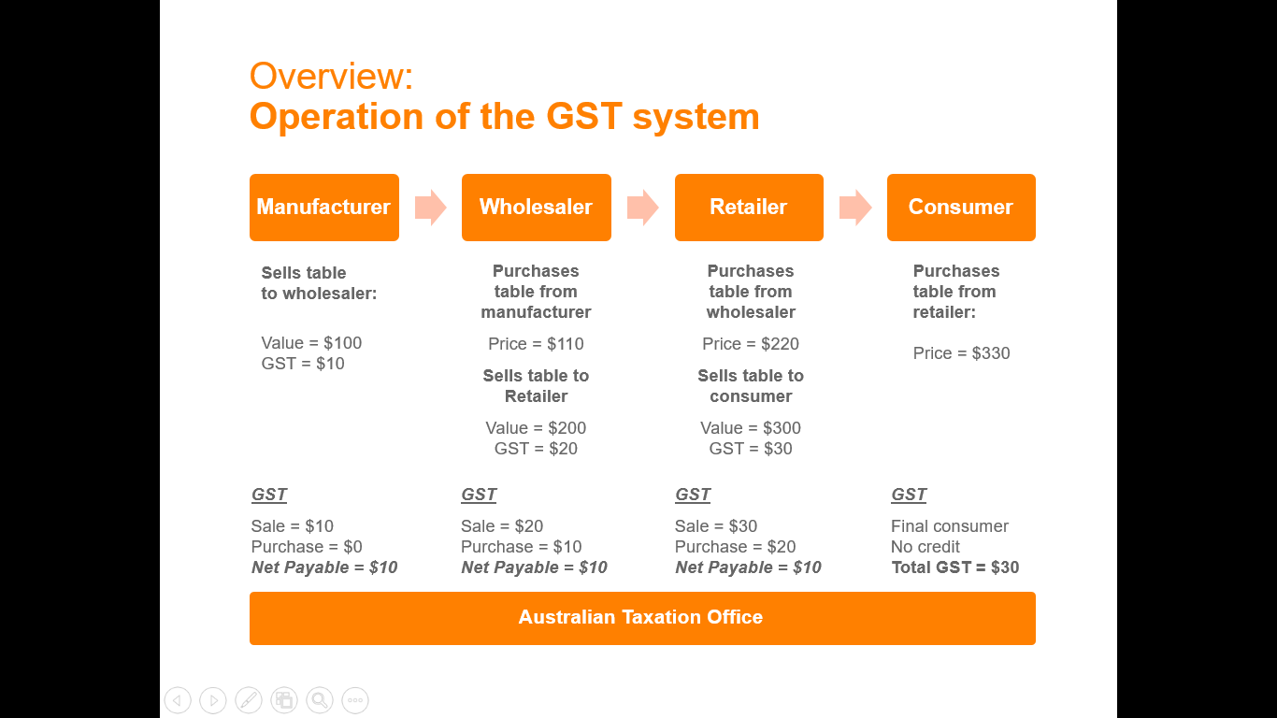

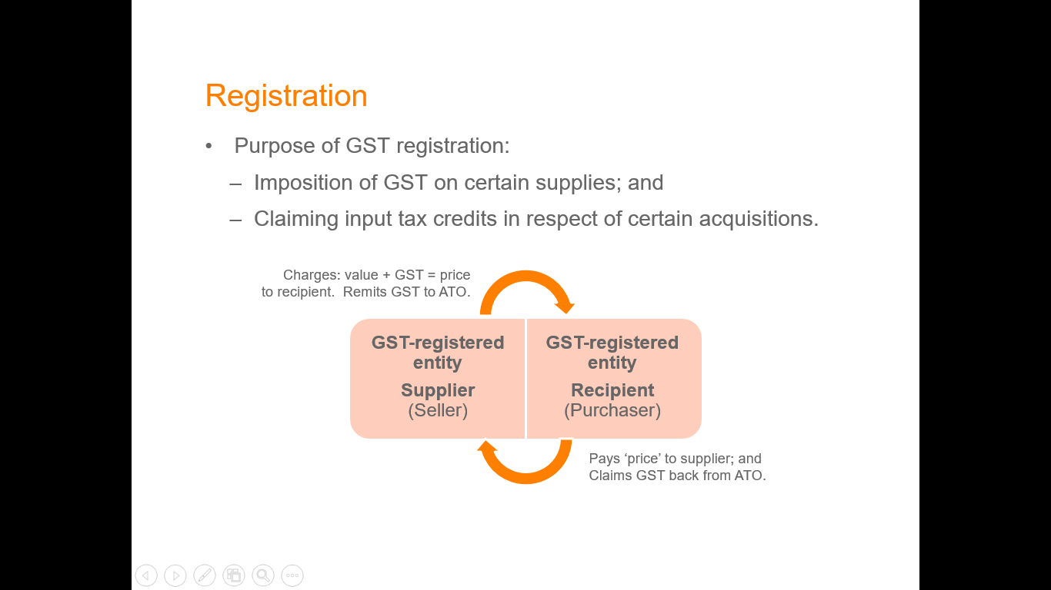

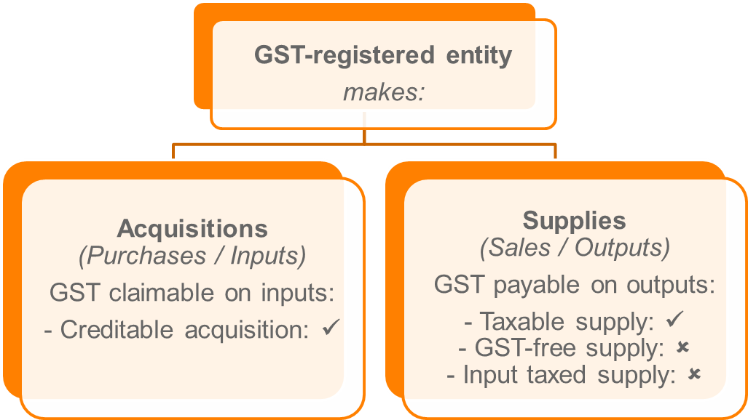

## Requirements to register for GST

An entity ***must*** register for GST when the following two requirements are satisfied (s 23-5):

1. The entity carries on an ‘enterprise’; and
2. The entity’s GST turnover is over the ‘registration turnover threshold’: $75K ($150K for non-for profits)

* If an entity meets the first test, but not the registration turnover threshold test, registration is optional (s 23-10).
  + Why would an entity do this? To claim back GST paid on inputs for business (“input tax credit”)
* If both tests are met registration is compulsory(s 23-5**).**

**Taxi Travel**

Suppliers of “taxi travel” ***must*** register for GST regardless of turnover (s 144-5)

* “Taxi travel” is “travel that involves transporting passengers, by taxi or limousine, for fares” (s 195-1)

What meets this definition?

* UberX services (*Uber BV v Commissioner of Taxation* (2017))
* “Ride-sourcing” services

**1. What is an enterprise?**

An enterprise includes an activity, or series of activities conducted:

* In the form of a business
* In the form of an adventure or concern in the nature of trade
* In the form of leasing, licencing or other grant of an interest in property on a regular or continuous basis.

Excludes certain activities, including:

* **Provision of labour as an employee**
* Private **recreational pursuits**.
  + See, s 9-20 *GST Act*.

**2. GST registration turnover threshold; > $75,000 ($150,000 for non-profits)**

* The second requirement is when the entity’s ‘annual turnover’ exceeds the ‘registration turnover threshold’ (s 23-5).
* Annual turnover is broadly the entity’s GST-exclusive sales revenue over a current and projected 12-month period   
  (Div 188).

## Taxable supplies (s 9-5 -GST Act)

S 9-5- Taxable supplies

                   You make a [***taxable supply***](http://classic.austlii.edu.au/au/legis/cth/consol_act/antsasta1999402/s195.1.html#taxable_supply)if:

                     (a)  you make the [supply](http://classic.austlii.edu.au/au/legis/cth/consol_act/antsasta1999402/s195.1.html#supply) for [consideration](http://classic.austlii.edu.au/au/legis/cth/consol_act/antsasta1999402/s195.1.html#consideration); and

                     (b)  the [supply](http://classic.austlii.edu.au/au/legis/cth/consol_act/antsasta1999402/s195.1.html#supply) is made in the course or furtherance of an [enterprise](http://classic.austlii.edu.au/au/legis/cth/consol_act/antsasta1999402/s195.1.html#enterprise) that you carry on; and

                     (c)  the [supply](http://classic.austlii.edu.au/au/legis/cth/consol_act/antsasta1999402/s195.1.html#supply) is [connected with the indirect tax zone](http://classic.austlii.edu.au/au/legis/cth/consol_act/antsasta1999402/s195.1.html#connected_with_the_indirect_tax_zone); and

                     (d)  you are [registered](http://classic.austlii.edu.au/au/legis/cth/consol_act/antsasta1999402/s195.1.html#registered), or [required to be registered](http://classic.austlii.edu.au/au/legis/cth/consol_act/antsasta1999402/s195.1.html#required_to_be_registered).

However, the [supply](http://classic.austlii.edu.au/au/legis/cth/consol_act/antsasta1999402/s195.1.html#supply) is not a [taxable supply](http://classic.austlii.edu.au/au/legis/cth/consol_act/antsasta1999402/s195.1.html#taxable_supply) to the extent that it is [GST-free](http://classic.austlii.edu.au/au/legis/cth/consol_act/antsasta1999402/s195.1.html#gst-free) or [input taxed](http://classic.austlii.edu.au/au/legis/cth/consol_act/antsasta1999402/s195.1.html#input_taxed)

An entity makes a taxable supply under s 9-5 if:

1. It makes a supply; and
2. The supply is for **consideration**; and
3. The supply is made in the course of furtherance of the entity’s enterprise; and
4. The supply is **connected with the indirect tax zone;** and
5. The entity is **registered** or required to be registered for GST; and
6. The supply is **NOT a GST-free or input taxed supply**

* GST is charged on the ‘value’ of taxable supplies (s 9-70).

**1. “Supply”**

* Defined in s 9-10 as “any form of supply whatsoever” and specifically includes (but is not limited to), eg:
  + A supply of goods
  + A supply of services
  + A provision of advice or information
  + A grant, assignment or surrender of real property
  + A creation, grant, transfer, assignment or surrender of any right
  + An entry into, or release from, an obligation to do anything, to refrain from an act or to tolerate an act or situation.
* Widely interpreted by the judiciary, see, *FCT v Reliance Carpet Co Pty Ltd* (2008)*, FCT v Qantas Airways Ltd* (2012), *FCT v MBI Properties* (2014).
* A supply of money is not a supply (unless relates, e.g., exchange of foreign currency)

**2. “Consideration”**

* “Consideration” defined in s 9-15 as any act or forbearance in connection with the supply.
  + Not limited to provision of money
  + Anything of value, eg provision of goods and services
  + Barter transactions
  + Does not have to be voluntary.

**3.** **In the course or furtherance of an enterprise**

* Meaning of “in the course or furtherance of” an enterprise is not defined in legislation.
* Judiciary suggests the interpretation take a wide approach such that any supply that is connected to the enterprise will be made “in the course or furtherance of” that enterprise
  + See, *FCT v Reliance Carpet Co Pty Ltd* (2008).

**4. Connection to the indirect tax zone**

* Section 9-25 details when a supply would be connected with the indirect tax zone.
  + ‘Indirect tax zone’ essentially refers to ‘Australia’: s 195-1.
* Examples of supplies connected to Australia include:
  + The goods are delivered or made available to the recipient in Australia;
  + The supply involves goods being removed from Australia;
  + The supply is of Australian land;
  + The supply takes place in Australia;
  + The supply is made through an enterprise carried on in Australia; or
  + The recipient of the supply is an Australian consumer.

**5. Registered?**

See above.

**6.1. GST-free supply?**

* No GST charged on the value in respect of GST-free supplies.
  + Note: GST-free supplies are excluded from the definition of taxable supplies.
* GST-free supplies are listed in Div 38, eg:
  + Food
  + Health
  + Education
  + Exports
  + Water, sewerage and drainage
  + Supplies of going concerns
  + Transport and related matters
  + Mobile global roaming services provided in Australia.

**Food**

* Food and ingredients for human consumption is GST-free, unless an exception applies (s 38-2).
* Exceptions (s 38-3):
  + Food for consumption on the premises;
  + Hot takeaway food; or
  + Food listed in Sch 1, eg, prepared food; confectionary; savoury snacks, bakery products, ice-cream food, flavoured milk.
* Broad rule of thumb:
  + Food that is only fresh, unprocessed food will be GST-free.

**Health**

* Supply of a medical service is GST-free (s 38-7).
* Medical services include:
  + Services where a Medicare benefit is payable
  + Services provided by or on behalf of a medical practitioner approved pathology provider (s 195-1).
* Other health services included, eg, dental, nursing, podiatry, acupuncture, medicine, hospital care (ss 38-10; 38-45; 38-50; Subdiv 38-B).
* **Cosmetic surgery** where no Medicare benefit is payable is ***not***GST-free (s 38-7(2)).

**6.2. Input taxed supply?**

* No GST charged on the value of input taxed supplies (ITS).
  + Note: ITS excluded from the definition of taxable supplies
* Where a supply is GST-free and input taxed, GST-free characterisation applies: s 9-30(3)
* Input taxed supplies are listed in Div 40, for example:
  + Financial supplies
  + Residential rent
  + Residential premises
  + Precious metals
  + School tuckshops and canteens
  + Fund-raising events conducted by charitable institutions
  + Inbound intangible consumer supplies.

**Financial supplies**

* Term “financial supplies” is defined by reference to the GST Regulations (s 40-5). Categories in GST Reg 40-5.09, include:

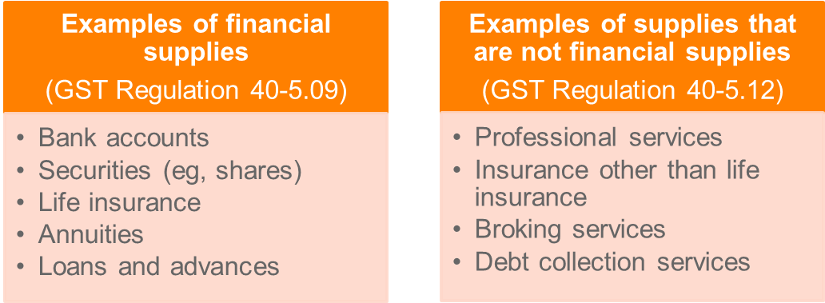

* Commissioner takes the view that the supply of **bitcoin** is not a financial supply (GSTR 2014/3)
  + Legislation introduced to treat supplies of digital currency equivalent to a supply of money.

**Residential rent**

* Broadly, the lease, hire or licence of “residential premises” is input taxed (s 40-35).
* “Residential premises” is defined as:
  + Land or a building that is occupied or intended to be occupied as a residence; or
  + **Capable** of being occupied as a residence for residential accommodation (s 195-1; also see *South Steyne Hotel Pty Ltd v FCT* (2009)).
* Broadly, the sale and **long-term lease** (lease greater than 50 years) of “residential premises” is input taxed (s 40-65), unless the premises are:
  + “Commercial residential premises”; or
  + “New residential premises” (as defined in s 40-75).
* Suppliers of “commercial residential premises” (as defined in s 195-1, eg, a hotel) on a long-term basis:
  + Possible to treat the supply as taxable supplies under concessional rules under Div 87 or input taxed.

## Credible acquisitions (s 11-5 – GST Act)

* An entity’s entitlement to “input tax credits” (ie, a refund of GST paid on acquisitions it makes) arises when the entity makes a “creditable acquisition”.

GST Act s 11-5: What is a creditable acquisition?

                   You make a [*creditable acquisition*](http://classic.austlii.edu.au/au/legis/cth/consol_act/antsasta1999402/s195.1.html#creditable_acquisition)if:

                     (a)  you acquire anything solely or partly for a [**creditable purpose**](http://classic.austlii.edu.au/au/legis/cth/consol_act/antsasta1999402/s195.1.html#creditable_purpose); and

                     (b)  the [supply](http://classic.austlii.edu.au/au/legis/cth/consol_act/antsasta1999402/s195.1.html#supply) of the [thing](http://classic.austlii.edu.au/au/legis/cth/consol_act/antsasta1999402/s195.1.html#thing) to you is a [**taxable supply**](http://classic.austlii.edu.au/au/legis/cth/consol_act/antsasta1999402/s195.1.html#taxable_supply); and

                     (c)  you provide, or are liable to provide, [**consideration**](http://classic.austlii.edu.au/au/legis/cth/consol_act/antsasta1999402/s195.1.html#consideration) for the [supply](http://classic.austlii.edu.au/au/legis/cth/consol_act/antsasta1999402/s195.1.html#supply); and

                     (d)  you are [**registered**](http://classic.austlii.edu.au/au/legis/cth/consol_act/antsasta1999402/s195.1.html#registered), or [required to be registered](http://classic.austlii.edu.au/au/legis/cth/consol_act/antsasta1999402/s195.1.html#required_to_be_registered).

Section 11-10 **defines ‘*acquisition’*** using the same terms as those used to define *supply* (s 9-10). The result of defining acquisition the same as supply means that whenever there is a supply, there will also be an acquisition.

**(a) Credible purpose**

* An acquisition has a creditable purpose to the extent that the acquisition relates to carrying on of the entity’s enterprise.
* However, the acquisition will not be for a creditable purpose to the extent that:
  1. The acquisition relates to making supplies that would be input taxed; or
  2. The acquisition of a private or domestic nature.
* An ‘acquisition’ is very broadly defined as ‘any form of acquisition whatsoever’ (s 11-10).
* Special rules relating to financial supplies (not covered).

**Acquisition *relates* to making input taxed supplies?**

* No creditable purpose exists if the acquisition relates to making input taxed supplies (see eg, *Rio Tinto Services Pty Ltd v FCT* (2015))

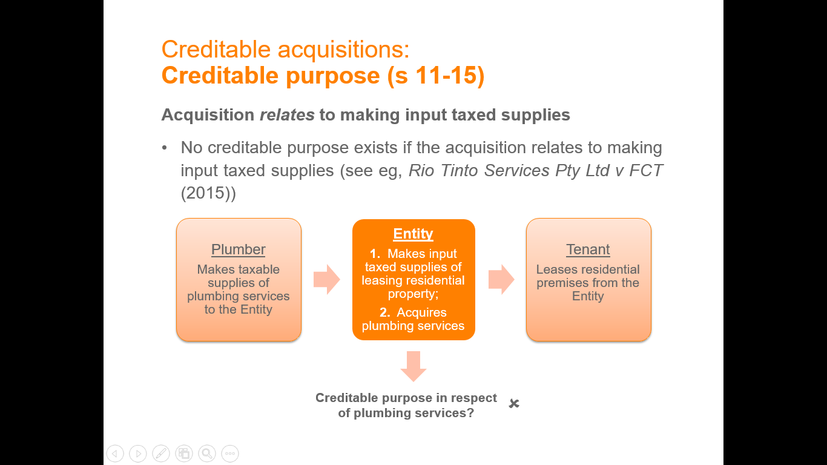

**(b) Supply to the entity was a taxable supply**

* Input tax credits are only available where GST was in fact paid on the acquisition (see above 6.1 & 6.2)

Scenario 1:

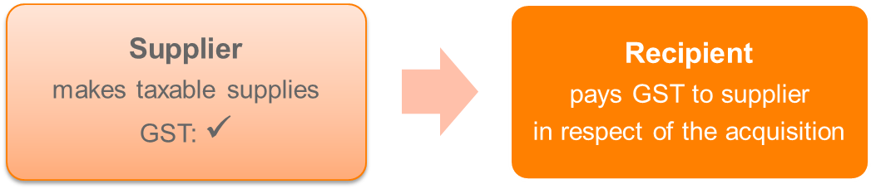

Scenario 2:

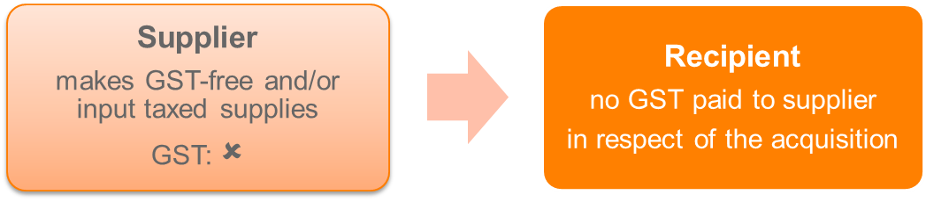

**Consequences**

* An entity that makes a creditable acquisition is entitled to input tax credits on the acquisition (s 11-20)
  + Acquisition used for a **fully creditable purpose**:



* + Acquisition used only **partly for a creditable purpose**:

**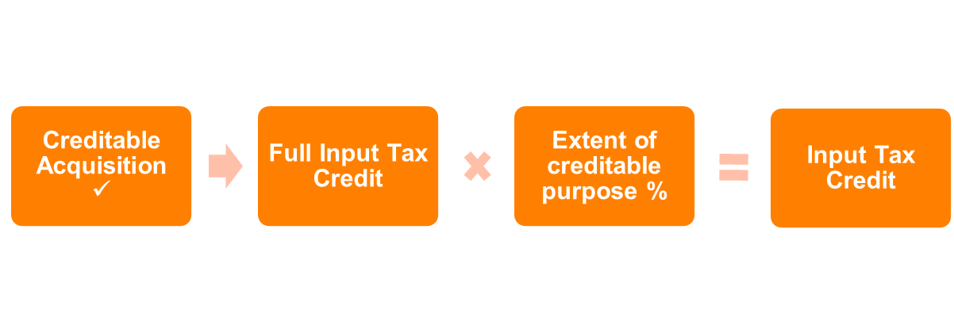**

## Special rules

**Non-deductible expenses**

* An acquisition that is a ‘*non-deductible expense*’ is deemed not to be a creditable acquisition (Div 69).
  + ‘Non-deductible expense’ is when an expense is not deductible for income tax purposes.
* Note, only certain non-deductible expenses are treated as not being creditable acquisitions, for example:
  + Penalties: s 26-5 ITAA97
  + Relative’s travel expenses: s 26-30 ITAA97
  + Family maintenance expenses: s 26-40 ITAA97
  + Entertainment expenses: Div 32 ITAA97
  + Non-compulsory uniforms: Div 34 ITAA97.

**Importation**

* Importations are different to the general rules as they:
  + Apply regardless of GST-registration
  + Only apply to importations of goods
  + Impose the liability to pay GST on the importer of goods, not the supplier of the goods.

Taxable importation:

Liability imposed on an entity that makes a ‘taxable importation’

Creditable importation

Input tax credits available to an entity that makes a ‘creditable importation’

* Special rules exist to bring the importation of intangibles into the Australian GST base in certain circumstances (Div 84).

## Administration

**Net amounts and adjustments**

* Entity reports on the GST return (BAS) the ‘net amount’ calculated as (s 17-5):



* Errors may be corrected in a later period where circumstances set out in *GST Errors Determination 2013* are satisfied.
* Net amount can be increased or decreased for adjustments.
* Adjustments arise because of changes to a supply or acquisition previously recorded, examples include:
  + Supply or acquisition is cancelled
  + Change to consideration
  + Change in extent of creditable purpose.

**Tax periods**

* Entities registered or required to be registered for GST required to complete and lodge a GST return (called a BAS) on a quarterly basis (can elect for monthly tax periods)
* Monthly tax periods mandatory for entities:
  + With an annual turnover > $20 million;
  + Carrying on an enterprise in Australia for < 3 months; or
  + With a bad compliance history.

**Timing**

* GST obligations are generally reported on a non-cash (accruals) basis
  + Cash basis may be adopted in certain circumstances, eg, the entity is a ‘small business entity’.
* Attribution rules:

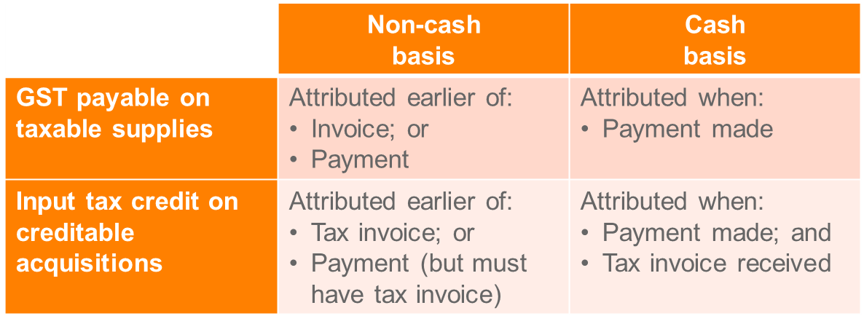

**Late claims for input tax credits**

* Generally a four-year time limit to claim input tax credits: s 93-5
  + Period commences from the day on which a taxpayer is required to lodge a GST return.

**Tax invoices**

* Tax invoices are required to claim input tax credits
  + Attribution of input tax credits cannot occur **until a valid tax invoice is held** (s 29-10(3) and (4)).
* A document will be a valid tax invoice if it contains certain information, such as:
  + Supplier’s identity and ABN
  + Recipient’s identity or ABN where consideration > $1,000
  + Details of the thing supplied, including quantity and price
  + Extent to which the supply is taxable
  + Date the document is issued.
* Tax invoices not required for **low-value transactions** **($75 excluding GST**).

**Interaction with other taxes**

Income tax

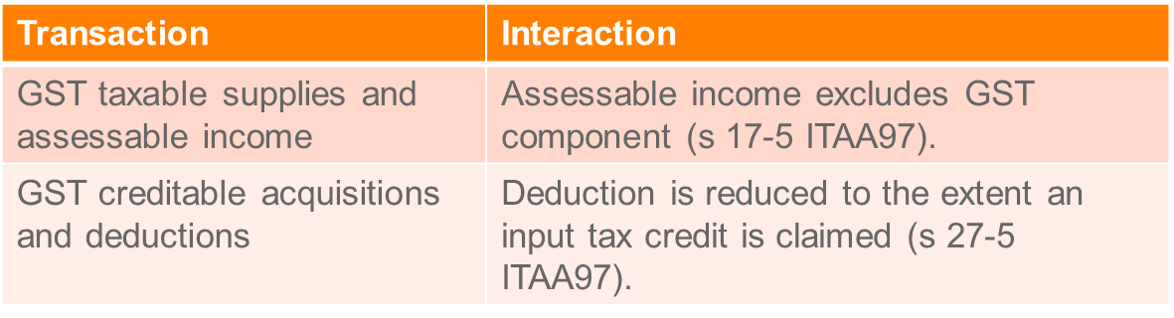

Fringe benefits tax

* Gross up factor depends on the entity’s entitlement to input tax credits:

**Summary - When you can claim a GST credit**

* You must be registered for GST to claim GST credits.
* You can claim a credit for any GST included in the price you pay for things that you use in your business.
* You can claim GST credits if the following four conditions apply:
  + You intend to use your purchase solely or partly in carrying on your business and the purchase does not relate to making input-taxed supplies
  + The purchase price included GST
  + You provide, or are liable to provide, payment for the item you purchased
  + You have a tax invoice from your supplier.

## Revision question

**MLL406 Week 10 Lecture 1 GST Discussion Question**

Thi Nguyen owns and operates a small beauty salon in the inner eastern suburbs of Melbourne. The business employs three employees and is registered for GST. The business is operated from rented premises. For the tax period 30 June 2016, the following transactions were reported in the journals of the business:

**Receipts (inclusive of GST where appropriate)**

|  |  |
| --- | --- |
|  | **$ incl GST** |
| Fees from clients | 55,000 |
| Sale of dressing table | 4,000 |
|  |  |
| ***Total GST Liability*** |  |

**Expenses (inclusive of GST where appropriate)**

|  |  |
| --- | --- |
|  | **$ incl GST** |
| Rent | 7,000 |
| Promotional sign | 1,000 |
| Repairs to laser equipment | 600 |
| Wages, incl PAYG withholding | 65,000 |
| Wax, hairdye and makeup supplies (tax invoice not rec’d) | 5,000 |
| New lounge furniture for waiting room | 2,500 |
| Repayments of business loan | 2,000 |
|  |  |

**Required:** Determine the net amount for the tax period ended 30 June 2016, assuming that a valid tax invoice has been provided unless stated otherwise.

*How to calculate GST:*

* + *Value = 10/11 x Price*
  + *GST payable = 1/11 x Price*

***GST Payable***

*Fees*

*Taxable supply under S 9-5 (GST Act)? Supply of beauty services was for consideration, it was made in the course of furtherance of the entity’s enterprise, and the supply is connected with Australia as her business is in Australia. We also know that she is registered. The supply is not a GST-free or input taxed supply also.*

*The amount received from clients of $55,000 includes $5,000 ($55,000 \* 1/11)*

*Sale of dressing table*

*Taxable supply under S 9-5 (GST Act)? Supply of table was for consideration, it was made in the course of furtherance of the entity’s enterprise, and the supply is connected with Australia as her business is in Australia. We also know that she is registered. The supply is not a GST-free or input taxed supply also.*

*The amount received from the sale of $4,000 includes $363.64 ($4,000 \* 1/11)*

*Total GST Payable = $5,363.64*

***GST Paid***

*Rent*

*Credible acquisition under s 11-5 (GST Act)?*

* *S 11 – 5 (a) - Acquisition of premises for a* ***creditable purpose*** *(S 11-10)? Was it ‘in the course of carrying on the enterprise’? Yes, and the enterprise does not involve making input tax supplies. Her business is wholly making taxable supplies so the acquisition of the premises are fully for a creditable purpose.*
* *S 11- 5 (b) -* ***Supply to the entity was a taxable supply****: The supply of the rent had GST as the lease is a commercial lease, not a residential lease.*

*The amount paid from her rent expense of $7,000 includes* ***$636.36*** *($7,000 \* 1/11)*

*Promotional sign*

*Credible acquisition under s 11-5 (GST Act)?*

* *S 11 – 5 (a) – Was the acquisition of a promotional sign was for a* ***creditable purpose*** *(S 11-10)? It was ‘in the course of carrying on the enterprise’ as it is for use in her business for promotion. We know her enterprise does not make input tax supplies.*
* *S 11- 5 (b) -* ***Supply to the entity was a taxable supply****: The supply of the sign assumedly had GST if she bought it from a business that is registered for GST.*

*The amount paid from the sign expense of $1,000 includes* ***$90.91*** *($1,000 \* 1/11)*

*Repairs to laser equipment*

*Credible acquisition under s 11-5 (GST Act)?*

* *S 11 – 5 (a) – Was the payment of repair service* ***creditable purpose*** *(S 11-10)? It was ‘in the course of carrying on the enterprise’ as laser equipment is used in her business and for promotion. We know her enterprise does not make input tax supplies.*
* *S 11- 5 (b) -* ***Supply to the entity was a taxable supply****: The supply of repair services assumedly had GST if she bought it from a business that is registered for GST.*

*The amount paid from the repair service expense of $600 includes* ***$54.55*** *($600 \* 1/11)*

*Wages*

*Credible acquisition under s 11-5 (GST Act)?*

* *S 11 – 5 (a) – Was the payment of wages for a* ***creditable purpose*** *(S 11-10)? It was ‘in the course of carrying on the enterprise’ as human labour is used in her business. We know her enterprise does not make input tax supplies.*
* *S 11- 5 (b) -* ***Supply to the entity was a taxable supply****: The payment of wages is not a taxable supply as the employees do not collect GST like ICs. No GST imbedded in the employees supply of services to Thi.*

*Hair dye, wax and make-up*

*She cannot hold an input tax credit until she has a tax invoice for the expenses:* s 29-10(3) and (4)). She has up to four financial years to attain a tax invoice and claim the credit, otherwise she cannot do so: s 93-5

*Lounge furniture for waiting room*

*Credible acquisition under s 11-5 (GST Act)?*

* *S 11 – 5 (a) – Was the acquisition of a the lounge for a* ***creditable purpose*** *(S 11-10)? It was ‘in the course of carrying on the enterprise’ as it is for use in her business for client’s waiting to for their beauty service. We know her enterprise does not make input tax supplies.*
* *S 11- 5 (b) -* ***Supply to the entity was a taxable supply****: The supply of the couch assumedly had GST if she bought it from a business that is registered for GST.*

*The amount paid from the sign expense of $2,500 includes* ***$227.27*** *($2,500 \* 1/11)*

*Repayments of business loan*

*Credible acquisition under s 11-5 (GST Act)?*

* *S 11 – 5 (a) – Was the business loan repayments for a* ***creditable purpose*** *(S 11-10)? It was ‘in the course of carrying on the enterprise’ as the funds received for the loan were assumedly used for her business. We know her enterprise does not make input tax supplies.*
* *S 11- 5 (b) -* ***Supply to the entity was a taxable supply****: No GST charged on financial supply so no input tax credit can be claimed, see s 9-30 (3) and GST reg. 40-5.09*

*Total Input tax credits = $1,009.09*

*Net amount (s 17-5) = $5,363.64 – $1009.09 =* ***$4354.55 Payable to the ATO****.*

# TOPIC 6.2 CHECKLIST –FBT

* Legislation: Fringe Benefits Tax Assessment Act 1986 “FBTAA”
* FBT is paid quarterly, the quarters end on 30 June, 30 September, 31 December and 31 March, with payment due by the 28th day of the next month.
  + Where the employer’s FBT liability in the previous year was less than $3000, the employer only pays FBT on an annual basis. The balance of FBT is payable on lodgement of the annual return by 28 April.
* An **employer is liable for tax on the total of the grossed-up taxable value of fringe benefits** provided to employees or associates of employees. The fringe benefit is non-assessable to the employee **(**s 23L ITAA 36**).**
* FBT applies to **non-cash remuneration benefits** paid or given by employer and received or benefited an employee after June 30 1986

## Step 1: Determine whether a benefit has been provided to an employee or associate

A fringe benefit exists where there is (s 136 (1)):

1. A benefit;
2. Provided during the year of tax;
3. By an employer, association or third party arranger (e.g. all employees of Deakin get 10% off Coles, Coles would be the arranger);
4. To an employee or associate;
5. In respect of employment of the employee

**For exam state:** **“**Section 136(1) states that for a fringe benefit to exists there must be a benefit provided during the year, and provided to (insert name of person on facts), as an employee, where the benefit was provided to (them), by (name of employer), and provided in respect of (their) employment.”

* Also note: an **allowance** constitutes salary and wages, whereas a **reimbursement** does not.
* Benefits provided by an employer to an **employee’s friend** will be a fringe benefit as defined under s 136 (1) as the friend is an associate of the employee: *ATO ID 2010/97*

## Step 2: Determine the category of fringe benefit

**Examinable categories of FBs:**

* Car fringe benefits – car provided for private use: s 7 (1)
* Debt waiver fringe benefits – employee owes an amount to an employer and is released from their obligation to pay: s 14
* Loan fringe benefits – Providing an employee with a loan: s 16
* Expense payment fringe benefits – Paying an in-house or external expense incurred by employee: s 20
* Meal entertainment fringe benefits – s 37AC
* Property fringe benefits – Providing an employee with property (s 40): Can be in house or external, intangible or tangible
* Residual fringe benefits – catch all category: s 45

**Excluded fringe benefits:**

Remember that the definition of ‘fringe benefit’ in s 136(1) specifically excludes from FBT:

* A benefit provided in the form of **salary or wages**, including cash allowances
* Provision of **shares** or rights pursuant to an **employee share acquisition scheme**
* **Superannuation** benefits
* Payments made in consequence of **termination of employment**
* Capital consideration for injury or a legally enforceable contract in restraint of trade
* A payment deemed to be a **dividend** under income tax law
* A payment to an associated person that is **not an allowable deduction** by the operation of s 26-35 of the ITAA (payments to related entities)
* A benefit **which is exempt.**

Exempt benefits in Div 13 include:

* Minor benefits
* Work-related items
* Membership fees and subscriptions
* Single-trip taxi travel

## Step 3: Apply any reductions in taxable value

After determining the type of fringe benefit state: “the employer’s taxable amount of the FB is reduced because:

* + It is an **in-house** fringe benefit
  + There is a **recipient’s contribution**
  + The **otherwise deductible rule** applies

**In house fringe benefit**

The taxable value of all in-house fringe benefits (namely, expense, property or residual) for each particular employee is reduced by $1,000:

* Where the taxable value of in-house fringe benefits is   
  < $1,000, the taxable value is reduced to nil.
* Reduction relates to the particular employee and cannot be done on an aggregate basis.

**Recipient’s contribution**

* The “taxable value” of certain fringe benefits (eg, expense payment) is reduced by the amount the recipient’s contributes.
  + Does not apply to car, debt waiver and loan fringe benefits.

**Otherwise deductible**

* Taxable value is reduced to the extent the amount would have been deductible to the employee, had the employee incurred the expense directly.
  + Prevents double taxation.

## Step 4: State the type of fringe benefit

Type 1 or type 2?

**Type 1:** Where the employer is entitled to GST input tax credits

**Type 2:** Any fringe benefit which is not a Type 1 fringe benefit

The difference between a Type 1 fringe benefit and Type 2 fringe benefit is whether the amount is entitled to a GST credit. Type 1 fringe benefits are a GST taxable supply with an entitlement to a GST credit whereas with Type 2 fringe benefits, the provider of the benefit is unable to claim a GST credit. A GST credit is an amount of GST that can be claimed back.

**For exam**: “Assuming the FB is a GST taxable supply with an entitlement to a GST credit, it will be a type one FB and grossed up by 2%.

## Step 5: Calculate the TV of the benefits and the FBT liability

SS 5B (1a) and 66: FBT payable = (Type 1 benefits + Type 2) x FBT rate (47%)

**State:** “The employer will pay tax on the grossed value of the fringe benefit at the FBT rate (47% for year ending 31/3/18)”

# Topic 6.2: Fringe Benefits Tax (FBT)

* The fringe benefits tax regime is essentially a tax on a wide range of benefits (that are not wages or salary) provided by an employer to an employee.
* Unlike income tax, FBT is levied on the employer, not the employee, upon the provision of fringe benefits
* FBT year is from 1 April to 31 March, being the “year of tax”
  + Rate of tax is the top marginal rate of 45% plus 2% Medicare levy.
* Overcomes inadequacies in the income tax regime:
  1. Taxes non-cash benefits that are not convertible to cash;
  2. Taxes benefits provided to an employee’s associate (e.g. spouse)

FBT provisions are contained in the:

* *Fringe Benefits Tax Assessment Act 1986* (Cth) (“FBTAA”).
* *Fringe Benefits Tax Act 1986* (Cth).
* In order not to overload the usual tax year-end, the FBT year is from **1 April to 31 March**.
* FBT is generally **payable quarterly**. The quarters end on 30 June, 30 September, 31 December and 31 March, with payment due by the 28th day of the next month.
* Where the employer’s FBT liability in the previous year was less than $3000, the employer only pays FBT on an annual basis. The balance of FBT is payable on lodgement of the annual return by 28 April.

ITAA 97 s 15-2: Allowances and other things provided in respect of employment or services

             (1)  Your [assessable income](http://www8.austlii.edu.au/cgi-bin/viewdoc/au/legis/cth/consol_act/itaa1997240/s995.1.html#assessable_income) includes the [value](http://www8.austlii.edu.au/cgi-bin/viewdoc/au/legis/cth/consol_act/itaa1997240/s995.1.html#value) to you of all allowances, gratuities, compensation, benefits, bonuses and premiums [provided](http://www8.austlii.edu.au/cgi-bin/viewdoc/au/legis/cth/consol_act/itaa1997240/s995.1.html#provide) to you in respect of, or for or in relation directly or [indirectly](http://www8.austlii.edu.au/cgi-bin/viewdoc/au/legis/cth/consol_act/itaa1997240/s995.1.html#indirectly) to, any employment of or services rendered by you (including any service as a [member](http://www8.austlii.edu.au/cgi-bin/viewdoc/au/legis/cth/consol_act/itaa1997240/s995.1.html#member) of the Defence Force).

             (2)  This is so whether the things were [provided](http://www8.austlii.edu.au/cgi-bin/viewdoc/au/legis/cth/consol_act/itaa1997240/s995.1.html#provide) in [money](http://www8.austlii.edu.au/cgi-bin/viewdoc/au/legis/cth/consol_act/itaa1997240/s995.1.html#money) or in any other form.

             (3)  However, the [value](http://www8.austlii.edu.au/cgi-bin/viewdoc/au/legis/cth/consol_act/itaa1997240/s995.1.html#value) of the following are not included in your [assessable income](http://www8.austlii.edu.au/cgi-bin/viewdoc/au/legis/cth/consol_act/itaa1997240/s995.1.html#assessable_income)[under](http://www8.austlii.edu.au/cgi-bin/viewdoc/au/legis/cth/consol_act/itaa1997240/s995.1.html#under) this section:

                     (a)  a [superannuation lump sum](http://www8.austlii.edu.au/cgi-bin/viewdoc/au/legis/cth/consol_act/itaa1997240/s995.1.html#superannuation_lump_sum) or an [employment termination payment](http://www8.austlii.edu.au/cgi-bin/viewdoc/au/legis/cth/consol_act/itaa1997240/s995.1.html#employment_termination_payment);

                     (b)  an [unused annual leave payment](http://www8.austlii.edu.au/cgi-bin/viewdoc/au/legis/cth/consol_act/itaa1997240/s995.1.html#unused_annual_leave_payment) or an [unused long service leave](http://www8.austlii.edu.au/cgi-bin/viewdoc/au/legis/cth/consol_act/itaa1997240/s995.1.html#unused_long_service_leave_payment) [payment](http://www8.austlii.edu.au/cgi-bin/viewdoc/au/legis/cth/consol_act/itaa1997240/s995.1.html#unused_long_service_leave_payment);

                     (c)  a [dividend](http://www8.austlii.edu.au/cgi-bin/viewdoc/au/legis/cth/consol_act/itaa1997240/s995.1.html#dividend) or [non-share dividend](http://www8.austlii.edu.au/cgi-bin/viewdoc/au/legis/cth/consol_act/itaa1997240/s995.1.html#non-share_dividend);

                     (d)  an [amount](http://www8.austlii.edu.au/cgi-bin/viewdoc/au/legis/cth/consol_act/itaa1997240/s995.1.html#amount) that is assessable as [ordinary income](http://www8.austlii.edu.au/cgi-bin/viewdoc/au/legis/cth/consol_act/itaa1997240/s995.1.html#ordinary_income) [under](http://www8.austlii.edu.au/cgi-bin/viewdoc/au/legis/cth/consol_act/itaa1997240/s995.1.html#under) section 6-5;

                     (e)  [ESS interests](http://www8.austlii.edu.au/cgi-bin/viewdoc/au/legis/cth/consol_act/itaa1997240/s995.1.html#ess_interest) to which Subdivision 83A-B or 83A-C (about [employee share schemes](http://www8.austlii.edu.au/cgi-bin/viewdoc/au/legis/cth/consol_act/itaa1997240/s995.1.html#employee_share_scheme)) applies.

Note: [Section 23L](http://www8.austlii.edu.au/cgi-bin/viewdoc/au/legis/cth/consol_act/itaa1936240/s23l.html) of the [*Income Tax Assessment Act 1936*](http://www8.austlii.edu.au/cgi-bin/viewdoc/au/legis/cth/consol_act/itaa1936240/)[provides](http://www8.austlii.edu.au/cgi-bin/viewdoc/au/legis/cth/consol_act/itaa1997240/s995.1.html#provide) that [fringe benefits](http://www8.austlii.edu.au/cgi-bin/viewdoc/au/legis/cth/consol_act/itaa1997240/s995.1.html#fringe_benefit) are [non-assessable non-exempt income](http://www8.austlii.edu.au/cgi-bin/viewdoc/au/legis/cth/consol_act/itaa1997240/s995.1.html#non-assessable_non-exempt_income).

* An **employer is liable for tax on the total of the grossed-up taxable value of fringe benefits** provided to employees or associates of employees. The fringe benefit is not assessable to the employee **(**s 23L ITAA 36**).**

**Three steps are taken in determining FBT:**

1. Determine whether a **benefit has been provided to an employee or associate in respect of employment**.
2. If **yes to 1, determine the type of fringe benefit**.
3. **Calculate the taxable value of the benefit/s** and the FBT liability. **Students will NOT be required to do calculations** of taxable values and FBT liabilities.

## Step 1: Determine whether a benefit has been provided to an employee or associate

The first of the requirements for determining liability for FBT is to be found in the definition of fringe benefit (FBTAA s 136(1)):

A fringe benefit exists where there is:

1. A benefit;
2. Provided during the year of tax;
3. By an employer, association or third party arranger (e.g. all employees of Deakin get 10% off Coles, Coles would be the arranger);
4. To an employee or associate;
5. In respect of employment of the employee

Specific exclusions apply, e.g. salary.

**1. Benefit?**

* The term “benefit” includes any right, privilege, service or facility provided under an arrangement in relation to the performance of work (s 136(1)):
  + Very wide definition that will likely capture most benefits, including non-monetary benefits
  + Exclusions apply.
* Thirteen specific categories of fringe benefits, including a “residual benefit” category which is a “catch-all” category.

**2. Provided during the tax year?**

* Under s 136(1), the term “provide” means:
  + In relation to a benefit: includes “allow, confer, give, grant or perform”; and
  + In relation to property: disposal of a beneficial interest in or legal ownership of the property.
* “Provided” also includes where provision of the benefit is prohibited but the prohibition is not consistently enforced:   
  s 148(3):
  + For example, an employer “turns a blind eye” to employee’s private use of an employer-provided motor vehicle.

**3. Employer, associate or third party arranger?**

A benefit needs to be provided by either an employer, a third party arranger (under an arrangement with the employer), or an associate of the employer (related party).

Definition of:

An “**employer**” under s 136(1) includes:

* Future employer;
* Current employer; and
* Former employer

An “**associate**” under s 136(1), and in turn s 318 ITAA36 which broadly includes related parties.

A **third party** may provide the benefit under an arrangement with the employer, but the employer must “participate in or facilitate the provision or receipt of benefit”.

An “employee” is someone who receives salary and wages and includes:

* Future employee;
* Current employee; and
* Former employee

An “associate”:

* Takes on the meaning per s 318 ITAA36; and
* Is deemed to be an “associate” of the employee where the benefit is provided to the person due to an arrangement between the employer and employee: s 148(2).
* Likely includes: relatives, partners, trustees and beneficiaries, and related companies

*ATO ID 2010/97*

Will benefits provided by an employer to its **employee's friend** be fringe benefits as defined insubsection 136(1)of the Fringe Benefits Tax Assessment Act 1986 (FBTAA)? **Yes**. The benefits provided by the employer to its employee's friend are fringe benefits as defined in section 136(1) of the FBTAA as all of the requirements of the definition are satisfied including that the friend is an associate of the employee.

**4. In respect of employment?**

* There must be a causal link (ie nexus) with employment
  + “In respect of”: to qualify as a fringe benefit, the benefit must be provided “by reason of, by virtue of, or for or in relation directly or indirectly to, that employment”: s 136.
* Nexus requirement subject to judicial consideration:
  + “Sufficient and material relationship”: *J & G Knowles & Associates Pty Ltd v FCT* (2000).
  + Loan to company directors and shareholders not “in respect of employment”: *Starrim Pty Ltd v FCT* (2000).
  + Repayments of loans not fringe benefits: *Slade Bloodstock Pty Ltd v FCT* (2007).

**Exclusions?**

The definition of a “fringe benefit” specifically excludes certain items, dealt with under the income tax regime, from being a fringe benefit, including (s 136 (1)):

1. Salary or wages;
2. Super contributions;
3. Payments from super funds;
4. Benefits under an employee schare scheme; and
5. Employee termination payments (ETPs).

**Allowance v reimbursement**

* Common issue is whether a payment to an employee constitutes an allowance or reimbursement:

Allowance

* Constitutes “salary and wages” and hence excluded from being a fringe benefit
* Assessed in the employee’s hand under the income tax system
* Generally, an allowance is a predetermined amount to cover an estimated expense

Reimbursement

* Does not constitute “salary and wages”
* “Reimburse” defined as “any act having the effect or result, direct or indirect, or a reimbursement”: s 136(1)
* Generally, a reimbursement is a payment made in respect of actual expenditure: *Roads and Traffic Authority of New South Wales v FCT* (1993)

## Step 2: Determine the category of fringe benefit

Once it has been ascertained that there is a fringe benefit, the next step is to determine what type of fringe benefit there is.

Examinable categories of FBs:

* Car fringe benefits
* Debt waiver fringe benefits
* Loan fringe benefits
* Expense payment fringe benefits
* Meal entertainment fringe benefits
* Property fringe benefits
* Residual fringe benefits

## Car fringe benefit

A car fringe benefit arises where an employer provides a car for an employee’s **private use**: s 7(1).

* “Private use” means any use of a car that is not exclusively in the course of producing assessable income: s 136.
* Actual use is irrelevant; a fringe benefit arises when the car is *available for use*, eg, car is garaged at employee’s home.

Other instances where a car fringe benefit may arise:

* Employee (or associate) has *custody and control* of a car that is not used for work purposes: s 7(3).
* Employer prohibits private use of car and the prohibition is not strictly enforced: see TD 94/16.

Exempt car fringe benefits include:

* Certain cars (e.g., taxi) provided for work purposes only and private use is minor, infrequent and irregular: s 8(2)
* Unregistered cars: s 8(3)
* Any fringe benefits that arise in relation to the provision of a car fringe benefit are treated as exempt benefits: s 53.

**Two methods exist to calculate the taxable value of a car fringe benefit:**

* Statutory formula method applies automatically unless the employer elects to use the cost basis: s 10(1).
* An employer can choose either method for each car that gives rise to a fringe benefit.
* Cost basis requires log book records and odometer records to be maintained: ss 10A and 10B.

**Statutory formula method**: s 9

Taxable value for FBT years starting 1 April 2011:

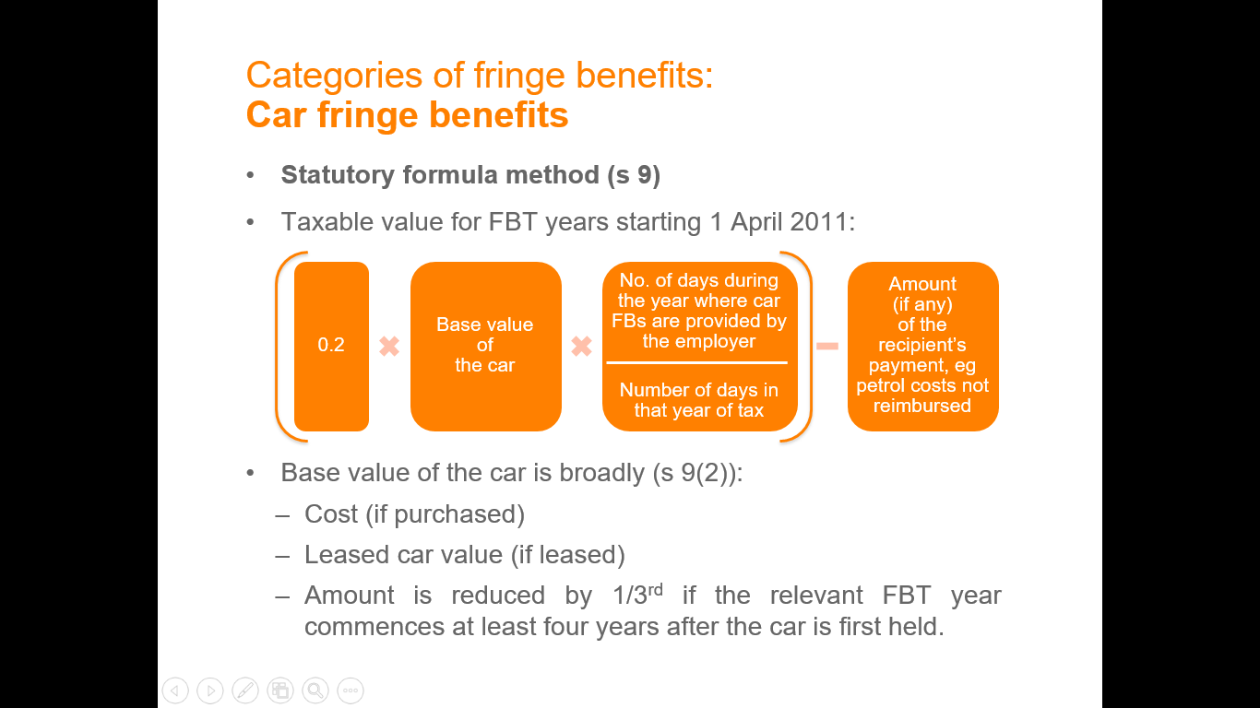

Base value of the car is broadly (s 9(2)):

* Cost (if purchased)
* Leased car value (if leased)
* Amount is reduced by 1/3rd if the relevant FBT year commences at least four years after the car is first held

**Cost basis**: s 10

Taxable value is determined as follows:

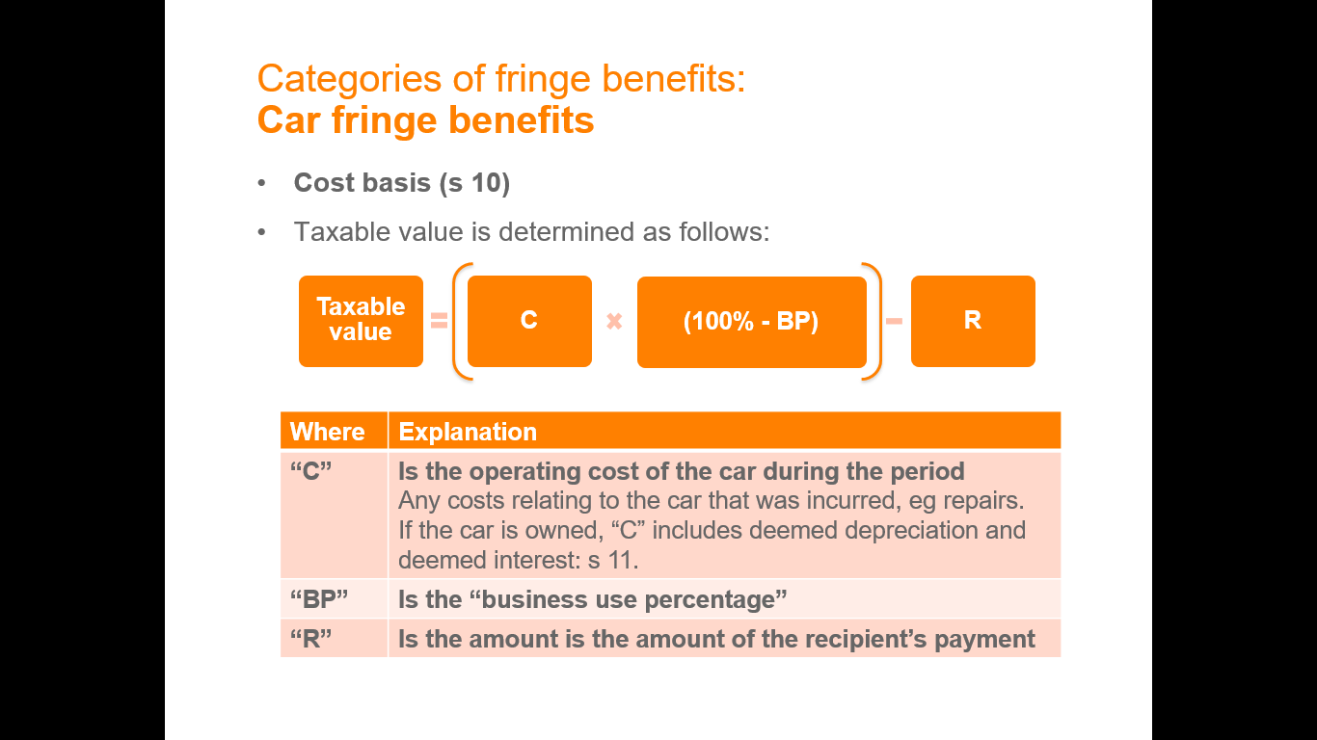

## Debt waiver fringe benefit

A debt waiver benefit arises under s 14 where:

1. An employee (or associate) owes an amount to an employer; and
2. The employee (or associate) is released from his or her obligation to repay some or all of that debt

Debt must be waived due to the employment relationship and not for some other reason, e.g., irrecoverable debt.

Taxable value (s 15)

Taxable value = amount of the loan that no longer needs to be repaid

## Loan fringe benefit

* A loan fringe benefit arises each year when an employer provides an employee (or associate) with a loan: s 16.
  + Benefit is essentially the interest “saved” by the employee from a loan with a low interest rate.
* Example of an exempt loan benefit (s 17):
  + Where the loan is provided by a person who provides loans to the general public in the ordinary course of business.

Taxable value is calculated under (s 18):

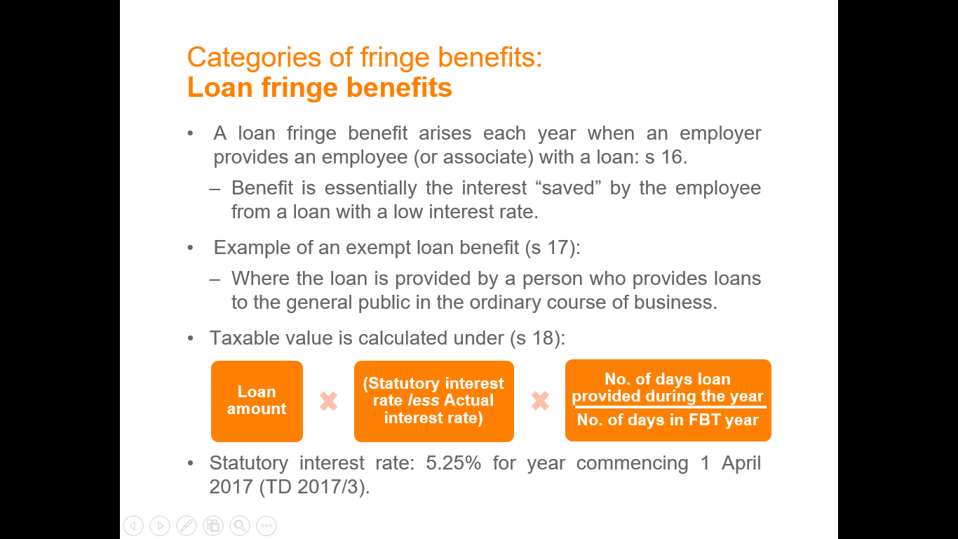

* Statutory interest rate: 5.25% for year commencing 1 April 2017 (TD 2017/3).
  + A loan from an employer to an employee will be a taxable fringe benefit if the loan is at a rate of interest lower than the specified benchmark rate. The taxable value will be the difference between the interest rate charged and the statutory interest rate for the year.

## Expense payments fringe benefit

An expense payment fringe benefit arises under s 20 where:

1. An employer pays an expense incurred by the employee (eg a telephone bill); or
2. An employer reimburses an employee for expenditure incurred by the employee.

Exempt benefits include:

* “No private use declaration”: s 20A
* Certain accommodation expense payment fringe benefit where the employee is required to live away from their usual residence: s 21.

Taxable value depends on whether the expense payment fringe benefit is an:

1. **In-house expense payment fringe benefit**

* Expense relates to goods / services provided by the employer in the ordinary course of business.
* Taxable value: as if it were a property or residual fringe benefit: s 22A.

1. **External expense payment fringe benefit**

* Applies if it is not an in-house expense payment fringe benefit, eg, paying a phone bill issued by a third party.
* Taxable value: the amount of the expense or reimbursement incurred by the employer: s 23.

## Meal entertainment fringe benefit

S 37AC: A meal entertainment fringe benefit arises where an employer provides its employees with:

1. Entertainment by way of food or drink (this will be a question of fact: see Ruling TR 97/17)
2. Accommodation or travel in connection with entertainment by way of food or drink
3. A reimbursement of expenses incurred by an employee in relation to the above

Arises regardless of whether the meal entertainment relates to business purposes.

## Property fringe benefit

A property fringe benefit arises where an employer provides an employee (or associate) with property: s 40.

* Defined to mean tangible and intangible property: s 136.

Exempt benefits:

* Where property is consumed on a working day and on the employer’s business premises by the employee: s 41.

Taxable value of an in-house property fringe benefit depends on whether the property is:

1. **In-house (**s 42**)**

* Taxable value broadly depends on whether the property is manufactured or acquired, and who the property is ordinarily sold to, eg, to retailers or the public.

1. **External (**s 43**)**

* Taxable value is the cost to the employer, or expenditure incurred by the employer to provide the property.

Note, taxable value is reduced by the recipient’s contribution.

## Residual fringe benefits

* Catch-all category to capture any benefits that do not fall into any of the other categories of fringe benefits: s 45.
* Specific exemptions detailed in s 47, e.g., bathroom facilities.

Taxable value depends on:

1. **In-house (**s 48**)**

* Taxable value is broadly, 75% of the lowest price at which an identical benefit is sold to the public; or 75% of the amount to reasonably acquire the property.

1. **External (**ss 50 and 51**)**

* Taxable value is the cost to the employer, or expenditure incurred by the employer in providing the benefit.

## Exempt fringe benefits

Remember that the definition of ‘fringe benefit’ in s 136(1) specifically excludes from FBT:

* + A benefit provided in the form of **salary or wages**, including cash allowances
  + Provision of **shares** or rights pursuant to an **employee share acquisition scheme**
  + **Superannuation** benefits
  + Payments made in consequence of **termination of employment**
  + Capital consideration for injury or a legally enforceable contract in restraint of trade
  + A payment deemed to be a **dividend** under income tax law
  + A payment to an associated person that is **not an allowable deduction** by the operation of s 26-35 of the ITAA (payments to related entities)
  + A benefit which is exempt.

**Exempt fringe benefits**

There are a number of benefits that are exempt from FBT. No FBT liability arises in relation to an exempt fringe benefit.

Exempt benefits in Div 13 include:

* Minor benefits
* Work-related items
* Membership fees and subscriptions
* Single-trip taxi travel

**Minor benefits**

* Broadly, a benefit will be a minor benefit where (s 136(1)):

Notional taxable value < $300

* $300 limit applies to each benefit and is not cumulative.
* Frequency and regularity of the minor benefit (and similar or connected benefits) taken into consideration.
  + Must be concluded that it would be unreasonable to treat the minor benefit as a fringe benefit: s 58P(f).
* Exemption does not apply to:
  + In-house benefits subject to a $1,000 reduction in TV.
  + Meal entertainment benefits under the 50:50 method.

**Work-related items**

Certain work-related items are exempt fringe benefits when used *primarily in the employee’s employment*, subject to a limit of one item of each type per employee each year (s 58X):

* A portable electronic device;
* An item of computer software;
* An item of protective clothing;
* A brief case;
* A tool of trade

Limit of one portable electronic device **does not apply** if the employer is a “small business entity” (being an entity with an aggregated turnover < $10m).

**Membership fees and subscriptions**

The following benefits are exempt benefits whether paid for directly the employer or by way of a reimbursement (s 58Y):

1. Subscription to a trade or professional journal
2. Entitlement to use a corporate credit card
3. Entitlement to use an airport lounge

**Single-trip taxi travel**

The provision of single-trip taxi journeys beginning or ending at the employee’s place of work is an exempt benefit (s 58Z).

## Step 3: Apply any reductions in taxable value

It is necessary to determine whether the taxable value of a fringe benefit can be reduced because:

1. It is an in-house fringe benefit
2. There is a recipient’s contribution
3. The otherwise deductible rule applies

**In house fringe benefit**

The taxable value of all in-house fringe benefits (namely, expense, property or residual) for each particular employee is reduced by $1,000:

* Where the taxable value of in-house fringe benefits is   
  < $1,000, the taxable value is reduced to nil.
* Reduction relates to the particular employee and cannot be done on an aggregate basis.

**Recipient’s contribution**

* The “taxable value” of certain fringe benefits (eg, expense payment) is reduced by the amount the recipient’s contributes.
  + Does not apply to car, debt waiver and loan fringe benefits.

For example:

* An employer provides an external expense payment fringe benefit of $1,000.
* If the employee contributes 50% to the fringe benefit, the taxable value will be reduced to $500.

**Otherwise deductible rule**

* The taxable value of certain fringe benefits can be reduced by the “otherwise deductible rule”:

Otherwise deductible rule:

* Taxable value is reduced to the extent the amount would have been deductible to the employee, had the employee incurred the expense directly.
* The **otherwise deductible rule** was introduced to avoid the possibility of double taxation, and therefore it allows the taxable value of a fringe benefit to be reduced. **This reduction is allowed if the fringe benefit provided to the employee *would have been an allowable deduction if the employee had incurred the expense****.*

Note:

* Only applies in relation to the employee (**not** associates)
* Expense must give rise to a **one-time-only deduction** (e.g., capital allowance deduction would not qualify)
* Where a benefit is provided to an employee and their associate jointly, it is applied on a proportionate basis.

**For example:**

An employee of a large drug company incurs considerable travel expenditure in relation to her job. If the employee incurs this expense she will be entitled to a general deduction under s 8-1. However, **if the employer reimburses these travel expenses to the employee, the employee will lose her deduction and the employer can reduce the taxable value of the fringe benefit by the amount of the deduction lost**.

## Step 4: Type of fringe benefit

Type 1 or type 2?

**Type 1:** Where the employer is entitled to GST input tax credits

**Type 2:** Any fringe benefit which is not a Type 1 fringe benefit

* Taxable value of a fringe benefit is “grossed up” by the Type 1 or Type 2 classification.
* The key purpose of “grossing up” is to add the FBT payable and GST saved on the fringe benefit back into the tax base.

## Step 5: Calculate the taxable value of the benefits and calculate the FBT liability

* **Students are NOT required to perform numerical calculations of taxable values and FBT liabilities. However, students should realise that each type of fringe benefit has its own set of calculations for ascertaining the taxable values of that benefit, e.g. the way of calculating the taxable value of a car fringe benefit is different from calculating the taxable value of a loan fringe benefit.**
* **Students should also realise that the taxable value of a benefit can be reduced by:** 
  + the recipient’s contributions
  + the otherwise deductible rule
  + concessional ‘reduction amounts’.
* **Use this sentence: ‘***The employer will pay tax on the grossed up value of the fringe benefit at the FBT rate. The fringe benefit is non-assessable or non-exempt to the employee: s 23L ITAA 36’.*

**Calculations:**

**Fringe benefits taxable amount**

The next step is to calculate the “fringe benefits taxable amount” as prescribed by s 5B.

**Type 1 fringe benefits taxable amount:**

Based on the FBT rate of 47% (for year ending 31 March 2018) and GST rate of 10%:



**Type 2 fringe benefits taxable amount:**

Based on the FBT rate of 47%:



**Fringe benefits tax liability**

Based on ss 5B(1A) and 66, the employer’s fringe benefits tax liability is:

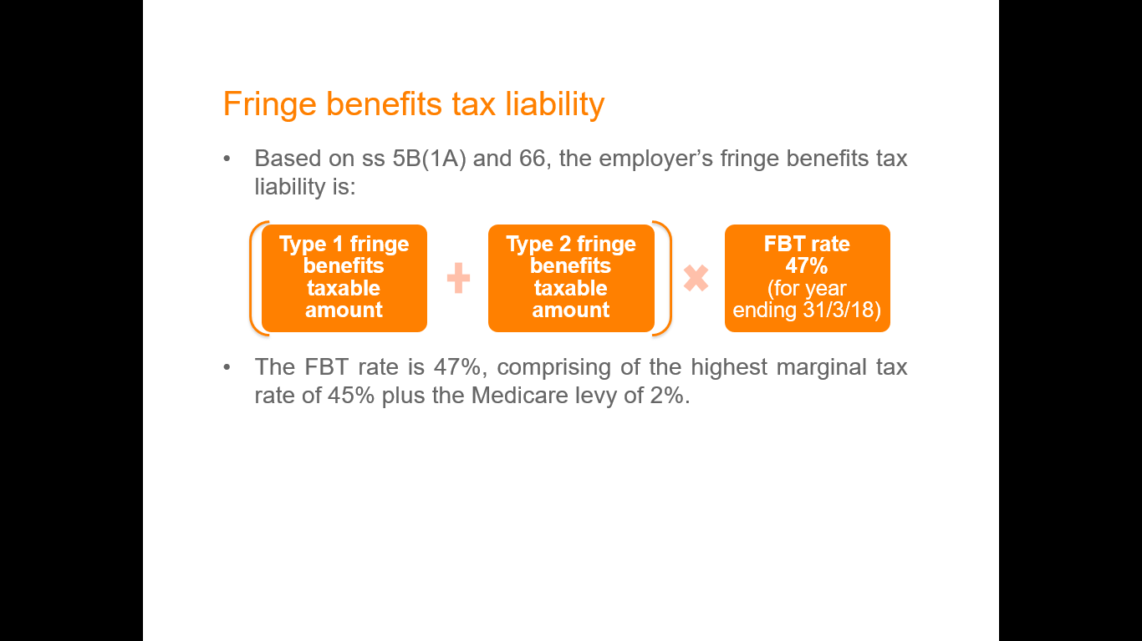

The FBT rate is 47%, comprising of the highest marginal tax rate of 45% plus the Medicare levy of 2%.

## Interaction with other taxes

**Income tax**

**Employer**

* Costs of providing the fringe benefit are generally deductible as an ordinary business expense: s 8-1 ITAA97;
* Costs of FBT liability is also generally deductible: s 8-1 ITAA97.
* Certain expenses are not deductible under income tax, however it becomes deductible if incurred in the provision of a fringe benefit.
  + Deduction might be available if the taxable value of the benefit is reduced (eg, otherwise deductible rule).
  + Examples: meal entertainment (ss 32-5 and 32-30 ITAA97), higher education contribution payments (s 26-20(2) ITAA97).

**Employee**

* Fringe benefits constitute non-assessable non-exempt income of the employee: s 23L ITAA36.
* Payment Summary reporting is required when the taxable value of fringe benefits provided exceeds $2,000 (exceptions apply).

**GST**

**Employer**

Acquisitions of fringe benefits for employees may constitute a creditable acquisition for GST purposes.

## Revision questions

**Question 1**

Katie Smith is employed as a trainee accountant for a large retail firm, Boss Ltd. During the 2017 Fringe Benefits Tax (FBT) year, Boss Ltd provided Katie with the following items as part of a salary package:

* Salary: $75,000 per annum.
* Study expenses: all of which were reimbursed as long as they were related to Katie’s work and she had passed all subjects. $2,400 was reimbursed for fees and $500 for textbooks and stationery for her postgraduate business studies course;
* Superannuation: in addition to the compulsory superannuation levy, Boss Ltd contributed an additional $5,000 to Katie’s superannuation fund;
* Laptop computer: provided to Katie to allow her to mainly work from home and for study purposes;
* Professional membership: Boss Ltd paid her CPA annual membership fee of $550;
* Mobile phone: costing $300 and provided to Katie and used by Katie mainly for work; and
* Ford Falcon company car: the car was purchased for $45,000 (incl GST) on 1 April 2011. During the FBT year, the car travelled 25,000km of which 5,000km was work related. The licence, insurance and service costs totalled $1,200. Katie paid for petrol in the amount of $1,270.

**Required:** Advise Boss Ltd of their FBT liability for the benefits provided to Katie for the year ending 31 March 2018.

Show all calculations and cite relevant legislation to support your answer.

***Salary & Super:*** *No FBT liability for salary and super, as it is excluded from the definition of a fringe benefit under s 136 (1) of the FBTAA.*

***Study expenses:*** *Meets the definition of a fringe benefit under s 136 (1). It is an expense reimbursement under s 20. It is an external fringe benefit because the benefits have been provided by the university, not Boss Ltd: s 23. The taxable value is hence the amount of the reimbursement = $2,900. Can the employer use the otherwise deductible rule to reduce all or part of these expenses? Her study is related to business and she is working as an accountant so these study related expenses will be deductible as it will likely increase her knowledge and possibly lead to a promotion: Finn. Hence the expense would be deductible for her under s 8-1 and will be otherwise deductible under \_\_\_\_ hence the taxable value will be 0.*

***Laptop:*** *Same as above regarding step 1.Portable electronic device - It is exempt as a work related item under s 58X, as it is used for work. If it is used for study purposes also this falls within the exemption also.*

***Professional membership****: External expense payment for membership fees (ss 20 & 23) and the taxable value = $550. However not liable for this amount under FT as the full amount is reduced as memberships and subscriptions: s 58Y are exempt. Also otherwise deductible as she could deduct it in full.*

***Mobile phone:*** *Portable electronic device: s 58X – exempt as it is mainly used for work. Not sure as needs to meet the <$10M rule. If not exempt under this category it could be exempt as property under s 40. They did not provide the phone in the course of their business so it is an external property FB: s 43. TV = $300. It could arguably be deductible for the full price as the phone is used for work calls, being used for an income producing purpose, hence fully deductible for her under s 8-1, hence the TV is reduced to NIL.*

***Car:*** *FB within the meaning of s 136(1). It is a car FB under s 7 assuming it is available for private use. TV: two methods, cost method or statutory method: s 9. Need to use stat method as no info on dep etc.*

*TV = 0.2 \* 30,000 (365/365) – 1270 = 4370*

*Note: No otherwise deductible rule for cars.*

*Grossing up TV:*

*Type 1: Type 2:*

*Income tax & GST Income tax & no GST*

*The car is type 1 and needs to be grossed up: $4470 \* 2.0802= $9090.47*

*FBT liability= 9090.47 \* 47% = $4272.52*

*NOTE: Check section accuracy.*

**Question 2**

On 1 July 2017 Tom Marks, a computer consultant, received a $75,000 low-interest loan from his employer, Eastpac Ltd at a 2.8% rate of interest. He used $30,000 to buy a car, which, on the basis of his log books, is used 50% for business. The remaining $45,000 was used for an extension to his house.

He also received an entertainment allowance of $1,000 per quarter, and Eastpac paid his professional subscriptions of $800.

Tom was provided with a bottle of wine at Christmas. The cost of the bottle of wine was less than $300.

**Required:** Advise Eastpac of their liability for FBT for the period ended 31 March 2018.

***Loan FB****: s 16. S 18 – TV = 75K \* (5.25% - 2.8%)\* 274/365= $1379.38*

*ODR: Half of the loan amount that is used to buy the car ($15,000). 15,000/75,000 = 20%, so 80% of the loan becomes the FB amount, which is: 1379.38 \* 0.8 = $1,103.5*

*Gross up TV: Type 2 (loans have no GST)*

*1,103.5 \* 1.8868 = 2052.09*

*FBL = 2052.09 \* 0.47 =* ***$978.58***

***Entertainment allowance:*** *Allowance, treated as the same way as salary: Rose and Tolls case <check. Assessbale under s 6-5, not as a FB for Eastpac.*

***Professional subscriptions****: Same as Katy above in Q1.*

***Wine:*** *FB within the meaning of s 136 (1). Exempt as a* ***minor benefit*** *under s 58P. The commissioner has created a ruling (TR2012/7 Example 1) that provided it is under $300 and is only for one year, this is exempt under s 58P.*

**Question 3**

On 1 November 2017 Lisa Morris commenced employment as finance manager with Custom Finance Ltd. Morris was provided with a new car costing the company $34,000. The car was fully maintained by the company, except that Morris was required to contribute $1,000 a year towards the cost of petrol. At 31 March 2018 the odometer on the vehicle showed that it had travelled 13,000 km.

Morris was also provided with a $100,000 loan at 2% interest. Morris used $60,000 of this loan to repay the mortgage on her house and the other $40,000 to purchase shares. All the companies in which she acquired shares paid a dividend during the year.

Would the position change if the loan was provided to both Lisa and her partner Roger, and the house and shares were owned jointly by them?

On 1 February 2018 Custom Finance waived the interest owing for the month of February due to Lisa exceeding her finance targets for December 2017. Custom Finance also paid Morris’s $585 annual membership to the Australian Society of CPAs and a $2,750 return airfare to England to enable her to visit her mother.

**Required:**

Advise Custom Finance as to the amount of FBT it is required to pay on each of the benefits provided to Morris for the period ended 31 March 2018.

Car: See above

***Loan:*** *FB under s 136 (1), loan under s 16. TV (s 18) = 10000 \* (5.25% -2%) \* 152/365 = 1353.42*

*ODR: What is the loan used for? 40% of loan used for an income producing purpose, could deduct 40% of the interest.*

*= 1353.42 \* 0.6 = 812.03*

*Gross up Type 2:*

*812.03 \*1.8868 = 1,532.18*

*FBTL: 15,32.18 \*0.47 = 720.12*

*The shares held jointly to by Rodger would change the ODR to make it 20% of the loan used for an income producing purpose for Lisa. So it would become 1353.42 \* 0.8 = <Same calc but with 80% instead of 60%.*

***Debt waiver****: Fb within the meaning of s 136 (1), debt waiver FB (s 14). TV is the amount of the debt waived: 2000/12 =*

*$166. Cannot apply the otherwise deductible rule (s \_\_\_).*

*Type 2*

*166 \* 1.8868*

*FBTL = \_\_\_\*0.47 =*

*Airfare = <Do this part before exam*

# TOPIC 7 CHECKLIST – TAXATION ADMINSTRATION & AVOIDANCE

**Self-assessment matters:**

* Commissioner making assessment
* Amending assessment
* Commissioner power to obtain information
* Tax audits
* Rulings
* Substantiation of expenses
* Retention of records
* Commissioners info gathering power
* Disputes in tax office
* Tax admin act
* Interest and penalties

## Tax avoidance

**Note:** Specific tax avoidance situations below

**Step 1:** State Part IVA ITAA 36 applies to tax avoidance schemes.

**Step 2: Must be a scheme** (s 177A(1))

* In exam, clearly identify the scheme (as narrowly as possible)
* **Covers:** virtually every type of arrangement, including any agreement, understanding, promise, undertaking or unilateral action entered into by the taxpayer, whether legal or not.

“Scheme” is defined in s 177A ITAA36 as:

1. any agreement, arrangement, understanding, promise or undertaking, whether express or implied and whether or not enforceable, or whether intended to be enforceable, by legal proceedings; or
2. any scheme, plan, proposal, action, course of action or course of conduct.

* **Discuss** *Hart***:** example of scheme defined narrowly

**Step 3: Identify tax benefit**

The tax benefit must arise “in connection with the scheme”: s 177D(a).

Definition of a tax benefit is in s 177C ITAA36:

* Includes an amount not being included in *assessable income* of the taxpayer, where in the absence of the scheme it would reasonably be expected to have been included.
* Includes an amount that is an allowable deduction to the taxpayer, where in the absence of the scheme it would reasonably be expected to have not been deductible.
* Similar definitions exist for: a capital loss; a foreign income tax offset; a discount capital gain; and an amount subject to withholding tax.
* Determining if a tax benefit is in existence requires a **comparison of what the taxpayer actually did, compared with what the taxpayer “would have” or “might reasonably be expected to have” done**
  + The conduct that would have occurred but for the scheme is sometimes referred to as the “counterfactual” or “alternate postulate”.
  + ‘Reasonable expectation’ requires more than a possibility, it involves a sufficiently reliable prediction.
    - See, *FCT v Peabody* (1994).

**Step 4: There must be a sole or dominant purpose of obtaining a tax benefit** (s 177D)

* Objective test for what the “Dominant” purpose is: means “the ruling, prevailing or most influential purpose”.
  + See, *FCT v Spotless Services Ltd* (1996)

**Test:** whether a **reasonable man, after considering** s 177D (b) **would conclude that the person entered into the scheme with the dominant purpose of enabling the taxpayer to obtain a tax benefit** in connection with the scheme?

Determination of the sole or dominant purpose is based on objectively **applying the eight factors** in s 177D:

1. The **manner** in which the scheme was entered into or carried out.
2. The **form** and substance of the scheme.
3. The timing at which the scheme was entered into and the length of the period during which the scheme was carried out.
4. The result that would have been achieved by the scheme.
5. The change in the financial position of the relevant taxpayer.
6. The change in the financial position of any person connected to the taxpayer.
7. Any other consequence for the relevant taxpayer and any person connected to the taxpayer.
8. The nature of connection between the taxpayer and the person connected to the taxpayer.

**If yes: benefit cancelled and may be amended:**

* Where all three elements are satisfied, the Commissioner is empowered to cancel the tax benefit: s 177F.
  + For example, denying the deduction otherwise sought.
* Commissioner can amend an assessment and apply penalties where there is a tax shortfall due to the scheme: s 177G

**Step 5: Exception:**Where a tax benefit is expressly allowed under the ITAA36/97 then this will not fall foul of the Part IVA provisions. If it is allowed for under the legislation, then it won’t be a tax benefit that has been obtained. The above penalties apply.

**Step 6: if classifies as tax evasion:** this is a crime and will be punished

# TOPIC 7 – TAXATION ADMINISTRATION & AVOIDANCE

## Annual returns

* Every person must, if required by the Commissioner, lodge an annual return in the “approved form”: s 161 ITAA36
  + Annual notice published which specifies the due date for lodgement - usually 31 October.
* The Commissioner has power under ss 161 and 163 to request:
  + A taxpayer to lodge a return, further or fuller return; or
  + Provide information about a person’s financial affairs.
* Risk assessment measures used to prevent fraud, for example, unusually large refunds may be investigated.
* If the taxpayer disagrees with the Commissioner’s assessment the taxpayer may object wholly or in part.
* ATO uses computerised data-matching services to check the accuracy of information in tax returns.
* ATO prefills information, however onus is on taxpayer to ensure prefilled information is correct.

## Self-Assessment

* **Introduction:** The assessment process usually begins with the taxpayer lodging a taxation return.
* **Obligation to lodge returns:** Each year the Commissioner publishes a notice in the Government Gazette that specifies the manner and time by which categories of persons must lodge their taxation returns.
* Tax office makes no alteration to return
* entered into computer
* Basic checking and additions
* Onus of proof is on taxpayer
* Penalties apply if incorrect
* More ATO staff in audit activities

## Commissioner making an assessment

* **Ordinary assessments:** Under s 166 the Commissioner is required to make an assessment upon the lodging of a return.

**Default assessments**

The Commissioner has power under s 167 to issue a default assessment where taxpayer has not lodged a return or Commissioner is not satisfied with the return.

## Amending Assessment

* **Self-amendment:** As part of the self-assessment system, taxpayers can request the Commissioner to amend their return: s 169A(1). Hence, s 169A(1) facilitates a form of self-amendment.
* **Commissioner’s general power of amendment:** Section 170 permits the Commissioner to amend an earlier assessment where there has been an avoidance of tax.

## Commissioner power to obtain information

* S 263-264
* C’er may request:
* Full and free access to any information required
* Removal not permitted
* Must cooperate
* attend to give evidence
* produce documents
* Not limited to information on self
* *Citibank Ltd v FCT*
* ATO have no access to legal privileged documents
* request for time to seek legal advice

## Tax Audits

* s.170 gives Commissioner power to amend an assessment
* 2011/12 ATO audit stats
* 1.4 mil returns assessed for risk with 400,000 taxpayers contacted – eg $330 mil in interest not declared
* 16,000 businesses contacted on compliance
* $151 mil collected in tax as a result
* 10% of businesses audited, 135,000 individuals required to confirm deductions.

## Substantiation of expenses

* Certain deductions are not allowed unless specific documentation is retained by the taxpayer. These concern employment related expenses, car expenses, extended overseas travel and domestic travel.

**Retention of Records**

* All records needed to determine taxable income
* In writing and in English
* Electronic form accepted if accessible
* Normally retained for 5 years
* Substantiation 5 years
* CGT 5 years after CGT event

## Commissioner’s Information Gathering Powers

* An important part of the administration of the taxation system is the conduct of audits. Audits may take the form of a simple questionnaire, a small business audit, a complex audit of large corporations, a special audit of criminal proceeds, a desk audit or an audit as to whether amounts have been remitted, a source deduction audit

## Disputes with the Tax Office

* Section 175A of the 1936 Act allows a taxpayer who is dissatisfied with an assessment to object against that assessment.
* Sections 14ZZK(a) and 14ZZO(a) empower a Federal Court or AAT hearing an application for review to permit the taxpayer to amend the grounds of the objection.
* Previously (pre-March 1992), the objection had to be lodged within 60 days of the assessment. The time limits for objecting against an assessment are now tied to the limited amendment periods specified in s 170(1) during which period the Commissioner may amend an assessment. Generally 2 or 4 years unless avoidance
* Taxation Administration Act - Part IVC
* Onus of proof on the taxpayer
* Tax must still be paid - Penalty tax
* ATO decision within 60 days
* Within 60 days - AAT OR Federal Court
* Limited to grounds stated in original objection

## Interest and penalties

* **General interest charge:** The general interest charge (GIC) is a uniform interest charge applied to unpaid tax liabilities. GIC is worked out daily on a compounding basis. The GIC rate is updated quarterly.
  + Interest charge is deductible: s 25-5.
* **Shortfall interest charge:** A shortfall interest charge (SIC) is levied where there is a tax shortfall because:
  + The ATO has relied on the taxpayer’s information when making an assessment; and
  + The tax liability was less than what it should have been.

**Penalties:** Failure to meet a tax obligation may result in a penalty being applied. Penalties are calculated according to a statutory formula or in multiples of a 'penalty unit'.

**Administrative penalties**

Return prepared by tax practitioner

* A taxpayer is not liable to pay administrative penalties where they or their agent took reasonable care in making the statement: s 284-75(5)
  + - A higher standard of care is used where a professional prepares the return, compared to if they were a self-preparer: *Re Necovski and FCT* (2009).
* “Safe harbour” - not liable to pay a penalty if:
  + A taxpayer gave a registered tax agent or BAS agent all relevant information; and
  + The agent made the statement without recklessness or intentional disregard of a taxaiton law: s 284-75(6).

**Failure to lodge on time penalty:** The failure to lodge (FTL) on time penalty is an administrative penalty that may be applied if your client is required to lodge a return, notice, statement or other approved form with us by a particular day and does not do so. Safe harbour provisions protect your client from the FTL penalty in some circumstances where they provided all relevant tax information to you.

* Commissioner has a discretion to **remit** the penalty, reduce it or increase it based on the taxpayer’s behaviour: s 298-20.

## Collection of tax from third parties

ATO can collect money owed to a taxpayer by a third party.

* If a third party owes money to a TP, ATO can issue a “garnishee” notice
* Commissioner’s policy in relation to these notices is set out in PS LA 2011/18.

## General anti-tax avoidance

* **Part IVA** governs tax avoidance schemes entered into, or furthered, after 27 May 1981.
* Part IVA, comprising sections 177A to 177G inclusive, was introduced in 1981 replacing section 260 as the general anti-avoidance provision of the *Income Tax Assessment Act 1936* (the Act) with respect to schemes entered into or carried out after 27 May 1981.

**For Part IVA to apply there must be**:

1. A ‘**scheme**’ as defined in ss. 177A(1) and (3).
2. The scheme must provide the ‘**relevant taxpayer**’ with a ‘**tax benefit**’ as defined in s 177C ; and
3. The person must have entered into the scheme for the **sole or dominant purpose** of enabling the relevant taxpayer to obtain a tax benefit (s 177D) (**difficult to satisfy**).

* For Part IVA to apply there must be a ‘**scheme**’ as defined in ss. 177A(1) and (3). The scheme must provide the ‘**relevant taxpayer**’ with a ‘**tax benefit**’ as defined in s. 177C and the person must have entered into the scheme for the **sole or dominant purpose** of enabling the relevant taxpayer to obtain a tax benefit (s. 177D).

**Tax Planning**

* Tax planning is important in many circumstances. This is especially so when a taxpayer is establishing or acquiring a new business or asset, in situations of divorce, when international transactions occur, at times of death or birth or retirement. Tax advisers need to be very careful when advising their clients because of the complexities and ongoing changes in taxation laws. There are potential benefits as well as risks associated with many tax-planning arrangements.
* Minimise Assessable Income
* Maximise deductions
* Use of Tax Offsets
* Averaging
* Use of withholding tax provisions
* International tax
* Anti Avoidance provisions

**Step 1:** S 177A**: ‘Scheme’**

***"Scheme"***means:

1. **any agreement, arrangement, understanding, promise or undertaking**, whether express or implied and whether or not enforceable, or intended to be enforceable, by legal proceedings; and
2. any scheme, **plan, proposal, action, course of action or course of conduct.**

* **Note:** As scheme is so broad, the event is likely to be a scheme. Appropriate to articulate the scheme as narrowly as you can: *Hart*

**Relevant taxpayer**

An important observation of the **High Court decision in***Peabody* is that the application of the tax benefit test in section 177C is concerned with **correctly identifying the taxpayer who obtained the benefit and the year of income in which the benefit was obtained.** Thus it is necessary to consider the issue of alternative assessments where it is not clear in which year the tax benefit may lie or to which taxpayer the benefit accrues to avoid time limit problems.

**Step 2:** S 177C: Tax benefits

1. Subject to this section, a reference in this Part to the obtaining by a [taxpayer](http://www.austlii.edu.au/au/legis/cth/consol_act/itaa1936240/s177a.html) of a tax benefit in connection with a [scheme](http://www.austlii.edu.au/au/legis/cth/consol_act/itaa1936240/s343.html) shall be read as a reference to:
2. an amount not being included in the [assessable income](http://www.austlii.edu.au/au/legis/cth/consol_act/itaa1936240/s6.html) of the [taxpayer](http://www.austlii.edu.au/au/legis/cth/consol_act/itaa1936240/s177a.html) of a year of income where that amount would have been included, or might reasonably be expected to have been included, in the [assessable income](http://www.austlii.edu.au/au/legis/cth/consol_act/itaa1936240/s6.html) of the [taxpayer](http://www.austlii.edu.au/au/legis/cth/consol_act/itaa1936240/s177a.html) of that [year of income](http://www.austlii.edu.au/au/legis/cth/consol_act/itaa1936240/s6.html) if the [scheme](http://www.austlii.edu.au/au/legis/cth/consol_act/itaa1936240/s343.html) had not been entered into or carried out; or
3. a deduction being allowable to the [taxpayer](http://www.austlii.edu.au/au/legis/cth/consol_act/itaa1936240/s177a.html) in relation to a [year of income](http://www.austlii.edu.au/au/legis/cth/consol_act/itaa1936240/s6.html) where the whole or a part of that deduction would not have been allowable, or might reasonably be expected not to have been allowable, to the [taxpayer](http://www.austlii.edu.au/au/legis/cth/consol_act/itaa1936240/s177a.html) in relation to that [year of income](http://www.austlii.edu.au/au/legis/cth/consol_act/itaa1936240/s6.html) if the [scheme](http://www.austlii.edu.au/au/legis/cth/consol_act/itaa1936240/s343.html) had not been **entered into or carried out**; **or** s 177CB

* *Spotless*addresses that there may be a range of benefits from a scheme, particularly those addressed in s 177CB.
* Increased deductions for the interest accrued on the investment property was the benefit in *Hart*

S 177CB: The bases for identifying tax benefits

1. This section applies to deciding, under section 177C, whether any of the following (*tax effects*) would have occurred, or might reasonably be expected to have occurred, if a scheme had not been entered into or carried out:
2. an amount being included in the assessable income of the [taxpayer](http://www.austlii.edu.au/au/legis/cth/consol_act/itaa1936240/s177a.html);
3. the whole or a part of a deduction not being allowable to the [taxpayer](http://www.austlii.edu.au/au/legis/cth/consol_act/itaa1936240/s177a.html);
4. the whole or a part of a [capital](http://www.austlii.edu.au/au/legis/cth/consol_act/itaa1936240/s177a.html) [loss](http://www.austlii.edu.au/au/legis/cth/consol_act/itaa1936240/s177a.html) not being incurred by the [taxpayer](http://www.austlii.edu.au/au/legis/cth/consol_act/itaa1936240/s177a.html);

(ca) the whole or a part of a [loss](http://www.austlii.edu.au/au/legis/cth/consol_act/itaa1936240/s6.html) [carry back tax offset](http://www.austlii.edu.au/au/legis/cth/consol_act/itaa1936240/s6.html) not being allowable to the [taxpayer](http://www.austlii.edu.au/au/legis/cth/consol_act/itaa1936240/s177a.html);

1. the whole or a part of a [foreign](http://www.austlii.edu.au/au/legis/cth/consol_act/itaa1936240/s177a.html) income tax offset not being allowable to the [taxpayer](http://www.austlii.edu.au/au/legis/cth/consol_act/itaa1936240/s177a.html);
2. the [taxpayer](http://www.austlii.edu.au/au/legis/cth/consol_act/itaa1936240/s177a.html) being liable to pay [withholding tax](http://www.austlii.edu.au/au/legis/cth/consol_act/itaa1936240/s6.html) on an amount.

**Step 3:** S 177D: ‘Sole dominant purpose’

Have regard to certain matters

1. For the purpose of subsection (1), have regard to the following matters:
2. the manner in which the scheme was entered into or carried out;
3. the form and substance of the scheme;
4. the time at which the [scheme](http://www.austlii.edu.au/au/legis/cth/consol_act/itaa1936240/s343.html) was entered into and the length of the period during which the [scheme](http://www.austlii.edu.au/au/legis/cth/consol_act/itaa1936240/s343.html) was carried out;
5. the result in relation to the operation of this Act that, but for this Part, would be achieved by the [scheme](http://www.austlii.edu.au/au/legis/cth/consol_act/itaa1936240/s343.html);
6. any change in the financial position of the relevant [taxpayer](http://www.austlii.edu.au/au/legis/cth/consol_act/itaa1936240/s177a.html) that has resulted, will result, or may reasonably be expected to result, from the [scheme](http://www.austlii.edu.au/au/legis/cth/consol_act/itaa1936240/s343.html)…..

* Following *Hart’s* case the **test is clearly now an objective one**. **Gummow and Hayne JJ found that when identifying a scheme:**

[t]he central question then becomes, would it be concluded, having regard to the eight matters listed in s.177D(b), that a person who entered into or carried out the wider scheme, the narrower scheme, or any part of either scheme, **did so for the dominant purpose of enabling the respondents to obtain a tax benefit in connection with the scheme?**

* **If there is another reason apart from receiving a tax benefit (s 177C/CB), then this step will fail and there will be not Pt IVA claim**

|  |
| --- |
| *Commissioner of Taxation v Hart* (2004) 206 ALR 207   * Narrow approach to scheme – must identify the transaction/conduct that gives rise to the avoidance * **Facts (brief):** The taxpayers were involved in a loan arrangement in which an amount of money would be borrowed in order to refinance an existing property and to purchase a further property. * The terms of the loan agreement included an option to split the loan into separate loan accounts which could then be applied to the different properties. The loan agreement also included an option allowing monthly repayments to be attributed to one or both of the loan accounts. * The Harts executed their option to split the Loan into two loan accounts and apportion monthly repayments. * The principal on the Residential Property Account was paid off at an increased rate, but no payments were made in respect of the Investment Property Account. * The interest on the Investment Property Account compounded and the Harts effectively claimed the compound interest accruing on the Investment Property Account as a deduction * The Commissioner determined that the compound interest was not deductible under either section 51(1) of the ITAA36 or section 8-1 of the ITAA97. * In the alternative, the Commissioner determined that the general anti-avoidance provisions of the ITAA36 applied (Part IVA) to cancel the tax benefit. * The High Court considered the application of Part IVA to the split loan. * **Held: The five judges hearing the appeal held for the Commissioner, in three separate judgments**.   **Important things to take from the case:**   * The Commissioner may focus on a small aspect of a complex transaction which the Commissioner considers is tax driven, even if the overall transaction is done for legitimate commercial purposes. The High Court appears to permit the Commissioner to consider that a very small part of a transaction can fit within the definition of 'scheme' in the Act * The case does little to assist taxpayers and advisers to confidently divide the line between acceptable commercial structuring, in the most tax effective way, and a structure that offends Part IVA. * As a result, the case reinforces the need to consider carefully the application of Part IVA in the structuring of complex commercial transactions. * The case focuses on the way the taxpayers entered into the particular transaction -they did it in a such way that the High Court ruled their dominant purpose was to obtain higher income tax deductions than would have been the case had they entered into the transaction in the alternative way considered by the Court. * Justice Gummow and Hayne's analysis confirms that Part IVA could apply where a taxpayer was unaware of the tax benefits involved in a transaction. Objective and not subjective. * Decision is likely to be used by the Commissioner in his increasing focus on Part IVA tax disputes. |

## Specific anti-avoidance provisions

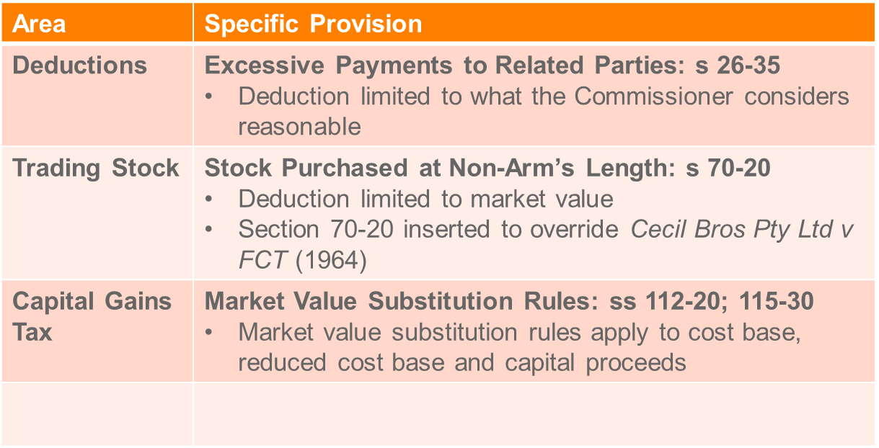

## Objections, review and appeals

* Time limit for lodging an objection:
  + General rule: same as the time limit the Commissioner has to amend an assessment: s 14ZW(1).
* Objection period for amended assessments is the later of:
  + The objection period for the original assessment; and
  + 60 days after the notice of amended assessment is served on the taxpayer: s 14ZW(1BA).
* Taxpayer can request extra time to lodge an objection.
* Objection must be in the approved form in writing, stating fully and in detail the taxpayer’s grounds of objection: s 14ZU.

**Onus of proof**

* The onus (burden) of proof when challenging an assessment or default assessment rests with the taxpayer.
* Taxpayer has to prove that the assessment is excessive: ss 14ZZK(b) and 14ZZO(b) TAA:
  + Proving that the Commissioner is wrong is insufficient; the taxpayer needs to establish on the balance of probabilities what amendments are necessary: *FCT v Dalco* (1990).

**Commissioner’s decision on tax objections**

An objection lodged within the time limit may be allowed fully, partially or disallowed: s 14ZY

* Commissioner makes an decision and serves written notice
* No prescribed time limit to make a decision.

**Application for appeal or review**

* If a taxpayer is satisfied with the Commissioner’s objection decision, the taxpayer may either (s 14ZZ):

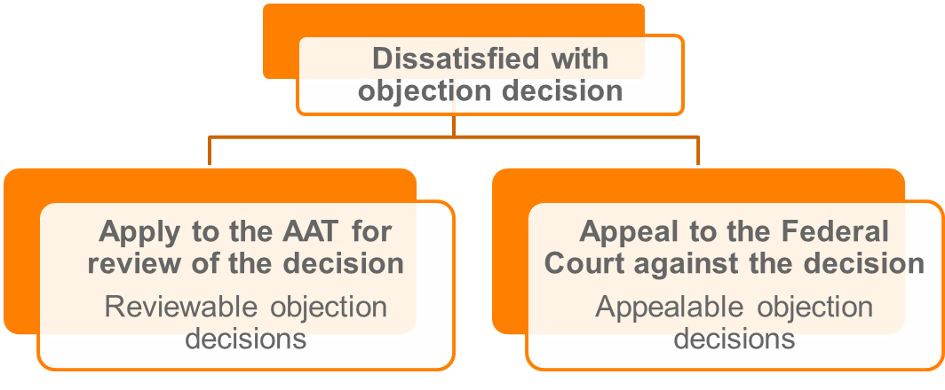

* 60 days to lodge application. Extensions possible in the AAT.
* Some objection decisions are both appealable and reviewable:
  + Taxpayer can choose between AAT or the Federal Court.

Factors to consider when choosing the AAT or Federal Court:

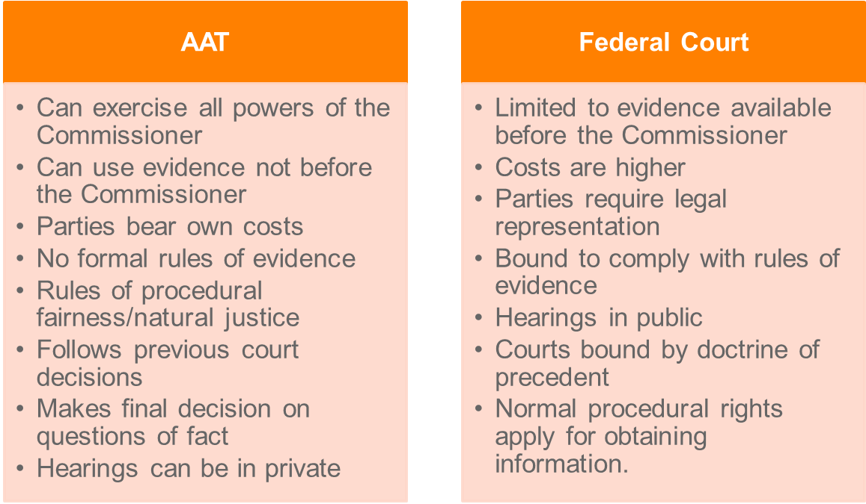

* If AAT, the Commissioner or taxpayer has 28 days from the AAT’s decision to appeal to the Federal Court:
  + - Appeal grounds must be on a question of law (not fact).

**Small Taxation Claims Tribunal**

* Part of the AAT: Pt 111AA AAT Act
* Tribunal has jurisdiction when the amount of tax is less than $5,000.

## Commissioner’s access powers

The Commissioner of Taxation has greater powers than the police, for example:

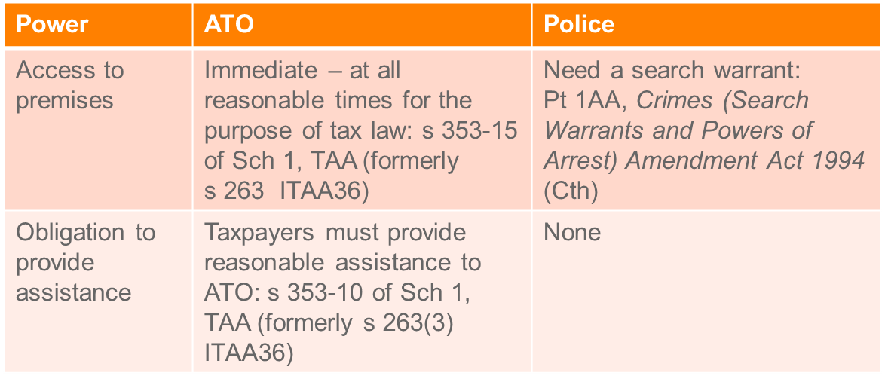

# Written Assignment Question

Note: First part of this question was Q1 for the 2016 exam

**Written assignment: Question**

CC Micro Chips Pty Ltd (CC) has been performing poorly over the last few years. Sales of CC Micro Chips are down and the company is looking at sustaining a loss of $4M in the 2017/18 financial year.

In order to address these concerns, CC’s board of directors appoints a new sales manager (Gillian), to manage the existing sales staff with the aim of lifting sales by 20%.

Gillian’s employment contract with CC is as follows:

1. Annual remuneration of $200,000 with an additional lump sum payment of $40,000 if sales increase by 20% in the first year.

2. A lump sum payment of $100,000 for agreeing to leave her current employment and work for CC for at least 3 years. If Gillian leaves CC at any time before the expiration of the three years, Gillian is required to reimburse this lump sum payment back to the company on a *pro rata* basis.

3. A superannuation contribution of 15% of Gillian’s total annual remuneration to her nominated superannuation fund. This is higher than the statutory requirement of 9.5%.

In addition to employing Gillian, CC also embarked on a promotion campaign with the aim of increasing sales. As part of this campaign CC provided, free of charge, computer hardware to the local children’s hospital which would have normally sold for $300,000. They also spent $50,000 on news and social media channels to advertise this generous gift.

Shortly after commencing work with CC, Gillian unexpectedly received a case of expensive wine from one of CC’s customers. She suspected this was to encourage her to continue the very generous discount that they had received in the past from the previous sales manager. As Gillian does not drink wine she gave it to a friend.

To take up the new position Gillian had to move home so she decided to sell her investment property which she originally purchased on 27 October 2004 for $500,000, incurring lawyer’s fees of $5,000 for the purchase. On 27 October 2008, Gillian added a new extension to her investment property at a cost of $100,000. The contract of sale was signed on 27 October 2017, for a sale price of $1,500,000 and settlement occurred on 21 January 2018.

A friend told Gillian that she should buy bit coin (digital currency) as they were going to rapidly increase in price, so she purchased $16,000 worth (1 bit coin) on 8 December 2017 and was amazed to see them rapidly rise to $19,000. However, she did not check the price for a couple of months until she saw on-line that the price has crashed to $8,000. Afraid they would continue to fall in price Gillian sold her 1 bit coin for $7,500 4 February 2018.

Gillian is also a keen follower of the share market and she spends at least one hour per day setting her automatic sell and buy prices for her extensive portfolio valued at about $600,000. She also pays an annual subscription to a market reporting service and keeps comprehensive records of movements in her share portfolio and the share market in general. During the 2017/18 tax year Gillian reported profits on sales of $60,000 and dividends of $30,000 with imputation credits of $10,000.

***Required*: For CC consider the effect on taxable income of the following. Support your answers with case and legislative authority. Calculations are not required.**

**a) The deductibility for CC of each separate element of Gillian’s employment package and any tax impact if all or part of Gillian’s bonus is repaid. (5 marks)**

**1. *$200,000 Salary and the $40,000 lump sum***

The $200,000 salary is deductible as a general deduction under s 8 – 1 (1) (b) of the *Income Tax Assessment Act 1997* (“*ITAA 97”*).It is arguably ‘necessarily incurred’ in carrying on a business, as the company needs employees like Gillian to help manage sales to keep the business running. [[1]](#footnote-1) Wages are recurring and lasting as CC has a legal requirement to pay wages in accordance with Gillian’s employment contract.

The potential lump sum payment of $40,000 meets the positive limb of s 8-1 in the same manner as the payment of salary, in regards to the first limb being satisfied.[[2]](#footnote-2) However an issue arises as to whether it is captured by the first negative limb in s 8-1 of the *ITAA* 97 through being regarded as an outgoing of capital.[[3]](#footnote-3) The ‘process-structure’ test from *Sun Newspaper Ltd v FCT* requires three matters to be considered in assessing an outgoing as revenue or capital: The character of the advantage sought, the manner in which it is to be used, relied upon or enjoyed and the means adopted to obtain it. [[4]](#footnote-4)

The ‘character of the advantage sought’ relates to its ‘lasting qualities’. [[5]](#footnote-5) Here the advantage is not arguably ‘lasting’, as the benefit for CC will have been already enjoyed for the financial year (“FY”), hinting at being more akin to revenue. The manner in which it is used is as an incentive and is only for Gillian’s first year of employment at this point, it is also arguably hard to increase sales by 20% recurringly, though not impossible. The means adopted to obtain the potential increase in sales is a once-off payment, pointing more towards capital.Weighing up these matters I would be more inclined to say the payment is structure based and a capital outlay.

It should be noted that as the lump sum payment has not occurred yet, it cannot be deducted. The payment can be spread after it is paid (if it is paid) in equal proportions over 5 years as a deduction if the capital expenditure is regarded as ‘business related’ and incurred ‘in relation to a business proposed to be carried on’.[[6]](#footnote-6) Arguably incentivising employees to increase sales is business related and although they are making a loss, the facts indicate an intention to carry on trading.

It will be deductible in the financial year it is paid (likely the next year).

***2. $100,000 sign-on and the potential tax implications of reimbursement***

The lump sum payment of $100,000 should be treated the same as explained above for the $40,000 payment, however it will certainly be captured by the same negative limb as a capital outgoing. It is a once off payment lasting for three years that does not relate to a revenue producing activity.[[7]](#footnote-7) CC can similarly spread out the payment in equal proportions over 5 years as discussed above as arguably employee retention is ‘business related’.[[8]](#footnote-8)

If the payment has to be reimbursed by Gillian (or a proportion of it reimbursed) for leaving her employment with CC before the three year term, this amount will come into CC’s taxable income as a recoupment.[[9]](#footnote-9) This is in effect a reversing entry for the prior deduction of the payment by CC when it was paid.

Technically a D1 Capital Gains Tax (“CGT”) event has occurred (CC has obtained rights under the agreement to be reimbursed). As the facts do not hint at any incidental costs ordinarily a capital loss of $100,000 would be incurred once the three years have lapsed. [[10]](#footnote-10) However as section 40-880 of the *ITAA 97* applies the loss is instead spread out over 5 years as a deduction.[[11]](#footnote-11)

***3. Superannuation contribution of 15%***

The fact that CC is choosing to pay more than the guaranteed 9.5% employer super contribution (15%) does not matter. The case of *FCT v Snowden & Wilson Pty Ltd* [[12]](#footnote-12) outlines that the outgoing need not be “necessary” – in terms of the contributions being more than the required percentage, as the operator is in the best position to determine what is best for the business.

The case of *Constable v FCT* [[13]](#footnote-13)is authority for saying that superannuation contributions are amounts that would have been given as income for an employee. As a result it will be deductible in the same way as her salary, as it is regular and recurring in the same regard as explained for Gillian’s salary. This is also reflected in an ATO fact sheet.[[14]](#footnote-14)

**b) The deductibility for CC of its gift to the children’s hospital and its promotional activities. (5 marks)**

*Division 30 of the ITAA 97* allows a deduction for gifts over $2 to certain deductible recipients.[[15]](#footnote-15) These can include property which here for CC is its computer hardware (trading stock). An issue arises as to whether this is a ‘true gift’.[[16]](#footnote-16) That is a ‘present made without return of any kind’.[[17]](#footnote-17) As the facts indicate that CC did this with “the aim of increasing sales” the gift may not be deductible under this specific division as CC is getting a form of return - increased profile in the eye of customers, i.e. goodwill. Goodwill is also arguably not a ‘material advantage’ as it is an intangible asset, so this gift might be deductible under this division, however the expenditure on marketing and promoting the gift certainly is not.

An easier way to consider the deductibility of both the gift and the promotional activities is under the general deduction provision if a nexus between the gift and the gaining or producing of assessable income can be established.[[18]](#footnote-18) The gift can be seen by customers (and potential customers) as CC being socially responsible and community minded. This is arguably related to the gaining or producing of assessable income as a customer may be incentivised to trade with a socially responsible businesses. However this might be a once-off gift, if so it will likely be capital in nature and not deductible.[[19]](#footnote-19) More facts are needed in relation to the recurrence of gifts given (if any).

Assuming hardware is trading stock for CC and meets the definition under the *ITAA 97*.[[20]](#footnote-20) Disposals of trading stock ‘outside the ordinary course of business’ are treated as a sales receipt for the market value of the trading stock on the day of disposal.[[21]](#footnote-21) Meaning a year-end closing adjustment needs to be made to include the trading stock donated in assessable income.

***Required*: For Gillian consider the effect on her taxable income of the following. Support your answers with case and legislative authority. Calculations are not required.**

1. **a) Each element of her salary package. (5 marks)**

**1. *$200,000 Salary and the $40,000 lump sum***

Her salary is ordinary income under section 6-5 (1) of the *ITAA 97* as she has made a gain that is cash,[[22]](#footnote-22) that is a real gain.[[23]](#footnote-23) It is in turn regular and periodic which is a characteristic of ordinary income.[[24]](#footnote-24)

Although the lump sum payment of $40,000 does not have the characteristic of being regular or periodic (assuming she does not get the same lump sum next financial year), it satisfies the prerequisites of ordinary income as it will be cash,[[25]](#footnote-25) and a real gain.[[26]](#footnote-26)

There is a clear nexus between receiving this lump sum (if received) and the likely work performed.[[27]](#footnote-27) Hence it will be assessable in the financial year.

***2. $100,000 sign-on and the potential tax implications of reimbursement***

The lump sum of $100,000 is similar to the $40,000 in nature and should be treated in the same way as explained above for the $40,000 lump sum. Although an issue arises as to whether this payment is a capital receipt. The relevant test is are they giving up a capital right?[[28]](#footnote-28) The payment is not restricting anything, but rather incentivising her to do something. That is giving up working with old employer (compensation) and taking up the new job with CC. In this situation such a payment would not likely be found to be capital, but rather a ‘payment for future services’, hence an ‘incident of’ her ‘employment’ with CC.[[29]](#footnote-29)

If Gillian has to repay this amount or any portion thereof, she would be able to claim a deduction in equal proportion to the amount repaid. As the repayment is arguably incurred in gaining that income, as it is directly taking away that income (or part of).[[30]](#footnote-30) It is an incident of receiving that income as the income received needs to be reimbursed.[[31]](#footnote-31)

***3. Superannuation contribution of 15%***

Constable v FCT[[32]](#footnote-32) is authority for the non-assessability of employer superannuation contributions as income. Gillian has not technically received this when looked at logically, and she cannot access this money until the fund is in pension mode or otherwise dealt with.

1. **b) The receipt of the wine. (5 marks)**

It should be noted that the fact that Gillian has given away the wine to a friend does not stop it being potentially captured as assessable income in it of itself.[[33]](#footnote-33) She will be deemed to have still derived it (if it is assessable) as she has ‘dealt with it’ by giving it to a friend.[[34]](#footnote-34)

The gift of wine is convertible as cash. She could arguably sell it and convert it to cash or give it to a third party (which she has done). However to her, it was not ‘expected’.[[35]](#footnote-35) Hence section 15-2 of the *ITAA 97* might apply by default bringing the wine into statutory income.[[36]](#footnote-36) What is crucial here is a nexus in respect of employment.[[37]](#footnote-37) On the one hand it could be said that she would not have received this wine if it weren’t for her employment. However on the other hand, in which I agree, she has not received something arising out of services rendered in employment (for example a bonus for increasing sales), rather it was for her predecessor’s discounts given, so it will not fall into assessable income.

1. **c) The sale of her investment property and bit coin. (5 marks)**

***Investment property***

The disposal of her investment property will likely attract capital gains tax. She is not carrying on a business of selling investment properties as she had to sell the property due to new employment. Here an A1 capital gains tax (“CGT”) event has occurred.[[38]](#footnote-38) The land and building are the CGT asset.[[39]](#footnote-39) The cost of acquiring the land and the building initially and the improvements (the extension) are expenses that are on their face deductible under the positive limb of s 8-1,[[40]](#footnote-40) as it has been improved and acquired for an income producing purpose. However the expense is capital in nature, so no straight write-off arises.[[41]](#footnote-41) A capital allowance deduction would have been allowed each year (see calculation below) for the extension costs under division 43.[[42]](#footnote-42) If these amounts have not been deducted the full amount of $100,000 will be added to the cost base instead. However for purposes of this example they have been presumed to have been deducted each financial year since 27 October 2008 and are taken out of the cost base.

The contract date is the year in which the gain has to be reported (2018 financial year).[[43]](#footnote-43) The capital gain, less any current year losses,[[44]](#footnote-44) is eligible for discount.[[45]](#footnote-45) The calculation of the capital gain should be as follows:

Capital proceeds = $1,500,000

Cost base:

Element 1 costs: $500,000.

Element 2 costs: $5,000.

Improvements: $100,000.

Less division 43 deductions already claimed:

2009 FY = $100,000 X 2.5 x 247/365 = $1,691.78

2010 FY = $100,000 X 2.5 = $2,500

2011 FY = $100,000 X 2.5 = $2,500

2012 FY = $100,000 X 2.5 = $2,500

2013 FY = $100,000 X 2.5 = $2,500

2014 FY = $100,000 X 2.5 = $2,500

2015 FY = $100,000 X 2.5 = $2,500

2016 FY = $100,000 X 2.5 = $2,500

2017 FY = $100,000 X 2.5 = $2,500

2018 FY = $100,000 X 2.5 X 119/365 = $815.07

Total = ($22,506.82)

Total Cost Base = $582,493.18

Capital gain = $1,500,000 - $582,493.18 = $917,506.82

Less capital losses incurred in FY = $7,500 - $16,000 = ($8,500)

Discounted capital gain = $909,006.82 X 50% = $454,503.41

***Bitcoin***

Bitcoin is a form of crypto currency. The Australian Taxation Office has ruled that cryptocurrency gains (or losses) are to be treated akin to shares and are hence A1 ‘CGT assets’.[[46]](#footnote-46) So Gillian’s bitcoin disposal will be an A1 CGT event.[[47]](#footnote-47)

1. **d) Her share portfolio activities. (5 marks)**

The tax consequences of Gillian’s gains from her share portfolio will depend on whether the activity is a hobby or a business. She may likely be found to be carrying on a business as a high degree of investing and re-investing in shares to maintain a high degree of gains are evident from the facts.[[48]](#footnote-48) There is enough indicia overall as there is a clear profit making intent, [[49]](#footnote-49) she spends an hour a day adjusting auto price sell and buy settings, subscribes to a market reporting service and keeps comprehensive records. [[50]](#footnote-50) The issue is whether this is a mere realisation of capital assets sold or was Gillian in the business of financial investing on shares in ordinary concepts,[[51]](#footnote-51) see section 25A (1) of the *ITAA 36.[[52]](#footnote-52)*As a result her gains from sales of $60,000, which is the difference between the closing stock (the shares) and the opening stock is included in assessable income,[[53]](#footnote-53) and her dividends of $30,000 will be assessable income as ordinary income.[[54]](#footnote-54) Less franking credits of $10,000.[[55]](#footnote-55) Similarly the annual subscription fee is deductible.[[56]](#footnote-56)

# Trimester 2: 2017 Examination

**MLL406 – Taxation Law**

**Trimester 2: 2017**

**Final examination**

**Instructions for Candidates:**

**Examination time: 2 hours**

**Reading time: 15 minutes**

**Candidates should attempt all questions. Total Marks 60.**

**For all questions please note that:**

* This exam accounts for 60% of the marks for this unit.
* All written answers should be presented as complete sentences.
* ITAA 1997 should be applied where the ITAA 1936 legislation has been rewritten regardless of when the transaction took place.
* Where appropriate, support your answer with legislative and case authority.
* All transactions are for the tax year 2017/2018 unless otherwise stated.
* GST should be disregarded unless specifically mentioned.
* Calculations are not required but can be undertaken.
* If you need further information, state precisely what it is and why it is required.

**Materials permitted:** Students may take into this examination any materials (including a dictionary and calculator that does not allow access to data outside the exam venue) provided it does not interfere with the comfort of other students.

**Materials NOT permitted:** Personal computers of any description, including electronic tablets or smart phones.

**QUESTION ONE (total 22 marks) Required: Discuss separately the CGT consequences for:**

1. **A. Susan in relation to the Kew Apartment (10 marks);**
2. **B. Both Jane and Greg in relation to the Lorne House (6 marks); and**
3. **C. Both Jane and Harold in relation to the Accounting Agreement (6 marks).**

Jane and her daughter Susan wanted to expand and grow their property portfolio. They decided to restructure their current finances to free up some money for a new development – the transactions they undertook are detailed below.

1. **A. Kew Apartment**

Susan owned a small apartment in Kew (‘**Kew Apartment’**) that she purchased from her mother Jane on 3 August 1999. Settlement occurred on 3 October 1999. Market value at the time of purchase was $400,000 however Jane felt bad about asking her daughter to pay too much money for the house so she sold the Kew Apartment to Susan at the reduced price of $150,000. Susan incurred stamp duty of $30,000 and solicitor’s fees of $10,000 on purchase of the Kew Apartment.

Susan immediately rented out the Kew Apartment and over the years, she incurred the following costs in relation to the property:

* Legal fees for a dispute over the boundary between Susan and her neighbour’s property - $20,000.
* Fixing a broken glass window which was damaged in a recent storm - $5,000

Susan sold the Kew Apartment on 21 July 2017 for $800,000 and the purchaser also gave her a new gold Rolex watch valued at $50,000.

***A – Susan***

*There has been a CGT A1 event in the 2018 FY: s 104-10 ITAA 97. Susan’s apartment is a CGT asset for purposes of s 108-5 (1) (a) of the ITAA 97. The calculation of the capital gain must be done in accordance with s 100-45:*

*Capital gain (-loss) = capital proceeds – cost base*

*Capital proceeds*

*Includes $800,000 received and the property received valued at $50,000 (the watch): s 116-20*

*Cost base*

*Element 1 Costs: $150,000 being the purchase price: s 110-25 (2)*

*Element 2 Costs: Incidental costs (s 110-25 (3)) including:*

* *Stamp duty of $30,000*
* *Solicitor’s fees of $10,000*

*Element 3 Costs: Costs of ownership including the maintenance expense of $5,000: s 110-25 (4), assuming this cost was not deducted in the year incurred under s 25-10.*

*Elements 5 Costs: Capital expenses relating to title: s 110-25 (6). The $20,000 in legal fees regarding a dispute about the property’s boundary falls under this element.*

*Net capital gain*

*= 850,000 – (150,000 + 30,000 + 10,000 + 5,000 + 20,000)*

*= $635,000*

*Less 50% discount (eligible as held for more than 12 months): s 115-25 (1)*

*Discounted CG = $317,500*

**B. Lorne House**

On 1 October 2015 Jane’s dad Greg died, leaving Jane a small beach house in Lorne by the ocean (**Lorne House**). Greg had lived in the Lorne House since he initially purchased it for $58,000 on 21 September 1987. Greg incurred $2,000 in legal fees when he purchased the property and in 2001 spent $40,000 on a kitchen renovation.

Jane was surprised to hear that the Lorne House had a market value of $500,000 at the date of Greg’s death, so she decided she would sell the property to make some money. Jane rented out the Lorne House until 1 September 2017 when she then sold it for $700,000.

*Jane*

*There has been a CGT A1 event in the 2018 FY: s 104-10 ITAA 97. Jane has acquired a post CGT asset under s 108-5 (1) of the ITAA 97.*

*Under s 118-195 of the ITAA 97 a full exemption from paying capital gains tax can apply on the sale of a dwelling inherited from a deceased, if that dwelling was the deceased’s main residence and it is sold within two years of the date of the deceased’s death, which is the case on the facts. Hence Jane is exempt from paying capital gains tax on the disposal of the property.*

*Greg*

*Any capital gain (-loss) made by Greg (or his estate therein) is disregarded as he has died: s 128-10 ITAA 97.*

**C. Accounting Agreement**

On 1 March 2016 Jane decided that she would need to downsize her accountancy business to save more money for her impending property developments. She decided that the best way to do this would be to make redundant one of her employees called Harold. She was nervous that Harold knew a lot of trade secrets about her business so she entered into an agreement with Harold to protect her trade. The agreement provided that Harold could not work as an accountant for 3 years within 100km of Jane’s business and she paid Harold $100,000 for entering into the agreement. MLL406 – Taxation, Final Examination 2017, Trimester page 3 of 4

*Jane*

*A CGT D1 event has occurred as contractual rights have been created: s 104-35 (1) ITAA 97. Under s 108-5 (1) of the ITAA 97 Jane has acquired an asset in her legal and/or equitable right to sue Harold if he breaches the contract. The time of the CGT is the date in which the contract was entered into (2016 FY). Jane has a capital loss of $100,000.*

*Harold*

*For Harold the $100,000 received is not a payment for services or a payment requiring him to do something, rather it is a restrictive covenant that ‘operates outside the employment period’ with Jane, hence the receipt should be treated as capital: FCT v Woite and Higgs v Oliver. In the reverse from Jane, a CGT D1 event has occurred, and in turn the payment received is a CGT asset: ss 104-35 (1) & 108-5 (1). Harold will pay capital gains tax on the $100,000 as a result.*

**QUESTION TWO (total 24 marks)**

**Discuss the consequences for CC in relation to the following transactions:**

**A. Payment of $1,500,000 to Qantax Airlines (7 marks);**

**B. Payment of both the $3,000 or $50,000 for the Broken Chip Machine (7 marks);**

**C. Receipt of $100,000 from the arrangement with Snack Pty Ltd (4 marks); and**

**D. Payment of $50,000 for the feasibility study (6 marks).**

Master Chips Pty Ltd (‘**MC**’) manufacture salted chips for distribution to supermarkets across Australia. CC are worried that their business may have to close if they do not take action to increase business profits. This year they have reported that their sales are down as a result of some unexpected expenses.

MC recorded the following transactions:

**A. Qantax Airlines**

CC spent $1,500,000 paying Qantax Airlines so that the company could be the preferred chip provider on all domestic flights. The agreement with Qantax provided that they would only sell CC brand of chips for the next 3 years in exchange for the $1,500,000 payment. CC anticipated that they would again make this payment in 3 years, and they also considered they may pay other airlines on similar terms if this arrangement was successful. By the end of the year, CC had entered into 3-year arrangements with two separate airlines: Qantax and Gurana.

*The issue is whether the payment to Qantas is deductible for CC under s 8-1 of the ITAA 97.*

*The payment meets the positive limb of s 8-1 as the payment was ‘incurred in gaining or producing assessable income’, as it was paid to secure a monopoly with Qantas in regards to suppling flights with chips exclusively. See Amalgamated Zinc v FCT. It is an incident of business and relevant to CC’s business.*

*The expense will not be deductible under s 8-1 if it is held to be capital in nature: s 8-1 (2) (a). To determine whether an expense is revenue or capital in nature the business entity test, as set out by Dixon J in Sun Newspapers v FCT, should be applied to the facts. Here we are concerned with whether the outgoing is structure (capital) or process (revenue) related based on the character of the advantage sought, the manner in which it is to be used or relied upon and the means to obtain it. Here we have a recurring lump sum outgoing, being a periodical payment for a monopoly. The facts emphasize that it is likely to be a recurring payment, hence this outgoing should be regarded as revenue in nature and therefore deductible under s 8-1 of the ITAA 97: BP Australia.*

**B. Broken Chip Machine**

CC had a major technical fault in one of their chip manufacturing machines. They had used the same machine for the past 5 years, and part of the motor had broken. CC was advised that a replacement part would cost $3,000 but that they were hard to source as the machine was quite old.

Another option for CC was that they could replace the whole manufacturing machine with a newer and better one. The new machine would cost $50,000 but would have an effective life of 10 years.

*$3,000 replacement part*

*Under s 25-10 of the ITAA 97 a specific deduction is allowed for expenses incurred for repairs made to machinery used to produce assessable income. Here replacing a part of a machine is a valid repair and not regarded as replacing the machine in its entirety as it is merely restoring the machine to the condition it was in, and not changing its character: see W Thomas & Co Pty Ltd v FCT.*

*$50,000 for a new a machine*

*The replacement of the entirety of a damaged asset is capital and not deductible as a specific deduction pursuant to s 25-10 (3), see also FCT v Western Suburbs Cinema. It would in tunr be struck out as a general deduction under s 8-1 (2) (a) as buying a new machine is capital in nature.*

*However if this option is opted for, deductions will be allowed for depreciation of the asset over its useful life under DIv 40 of the ITAA 97. CC can choose to claim depreciation based off the prime cost or the diminishing value method over the 10 years (useful life of the asset) from the date of purchase.*

**C. Agreement with Snack Pty Ltd**

In a further attempt to raise revenue, CC entered into an agreement with another chip manufacturing company, Snack Pty Ltd. Pursuant to that agreement, CC would receive a lump sum of $100,000 and in return they would assign their right to receive royalties from their salt and vinegar chips, to Snack Pty Ltd.

*The sale of rights to receive royalties is not the normal proceeds of business for CC, so the issue is whether the lump sum received for selling these rights is assessable as capital (mere realisation of an asset) or ordinary income (“OI”) under the Myer Emporium case as an extraordinary or isolated transaction.*

*The second strand of Myer is satisfied here as CC is exchanging an income stream for a lump sum, hence it is assessable as OI, see Henry Jones (IXL). Note the first strand is likely satisfied as well, however only one strand need be satisfied.*

**D. Feasibility Study**

In an attempt to reduce costs, CC commissions a company to undertake a feasibility study to investigate other factory sites for production of their chips. This company charged CC $50,000 for the feasibility study that recommended that a new subsidiary production company be formed, and a new factory site obtained, to manufacture chips at a reduced price.

*The expense is not deductible under s 8-1 as it is a feasibility study and there is not (yet) a sufficient temporal nexus with an earning activity: Softwood and Pulp and Paper Ltd v FCT.*

*As the feasibility study is a business related cost not recognised as deductible under any other section of the ITAA 97, it is deductible as a qualifying black hole expense under s 40-880 (2), claimable in equal portions over a period of five years.*

**QUESTION THREEE (total 14 marks)**

**Required: Discuss the tax implications for the following transactions:**

**A. The distributions from the Clive Family Trust to Mary and Lida (5 marks); and**

**B. The possible application of Part IVA ITAA 36, to the arrangements (house swap) between Lida and her friend Steph (9 marks).**

**A. Clive Family Trust**

Clive was trustee of the Clive Family Trust which was a discretionary trust established to help support his wife and two younger daughters.

*Assuming the trust has net income and the beneficiaries are entitled to the trust’s income, they will pay tax on any distributed income according to their marginal tax rates pursuant to s 97 ITAA 36.*

**B. Lida and Steph house swap**

Lida had been best friends with Steph since high school. A few years ago they decided to house-swap to reduce the amount of tax they may have to pay. As both Lida and Steph had approximately $300,000 left on their mortgage, they decided to move into and rent each other’s houses, so they could then make a deduction for part of the interest payments on the mortgage.

Lida was particularly eager to go ahead with this plan, as Steph’s house was much closer to the physiotherapy centre that she had to take her daughter Mary to 3 times a week.

The house swap was successful and both Lida and Steph moved into each other’s houses.

*Part IVA of the ITAA 36 applies to tax avoidance schemes. Here there is arguably a tax avoidance scheme as Lida and Steph have an understanding in which they live in each other’s houses to obtain a tax benefit: S 177A (1). See also Hart.*

*The tax benefit, being the deduction for interest payments on their respective mortgages (s 177CB) was obtained because of the house swap (s 177C), as they would not be able to receive the benefit without swapping houses: See Spotless case. An objective test, as applied in cases such as Hart and Peabody inquires as to whether a reasonable person would conclude that the dominant purpose of the scheme was enabling a tax benefit? In the factual situation at hand, it is clear that the main purpose of the house swap was to obtain the tax deduction. As a result the commissioner has the power to cancel or amend the whole or part of the tax benefit resulting from their house swap under s 177F of the ITAA 36.*

*Note: If there was another reason, apart from receiving the tax benefit, that the scheme was entered into, the objective test would fail.*

***^See below for better Part IVA answer***

# 2016 T2 Exam – Q2

**QUESTION 2 - Marks 30**

Big Mining Co (BMC) operates 15 open cut iron ore mines across Australia. It employs 4,000 workers to mine iron ore, deliver the iron to ports and sell the iron into the lucrative Chinese market. In an attempt to reduce the cost of transporting ore to the port, BMC commissions Le Ng to prepare a feasibility study into building a new, privately-owned railway. Le Ng charged $400,000 for the feasibility study which recommended that a new company (RailCo) be formed to build the railway at a cost of $100 million. BMC would hold 40% of the shares in RailCo, which will serve BMC for 50 years. BMC will pay RailCo $17 million per year for the use of the railway.

The new company, RailCo, is formed to build the railway. In a remarkable, super-human engineering feat, the railway line is built and completed by 1 January 2016. The total cost is $100 million, which RailCo obtains by borrowing money from BMC and from banks at an interest rate of 5%. RailCo’s total interest expense this year is $500,000 and, under the terms of the arrangement with BMC, it receives $17 million in fees for the year from BMC for use of the railway. This arrangement is used, in part, to transfer profits from BMC to RailCo because BMC has heard rumours that the government intends to introduce a new super-profits tax for mining companies increasing its tax from 30% to 50%.

BMC took a number of steps to oppose the tax, including:

* Spending $2m on an advertising campaign, which depicted the Prime Minister, Treasurer and Mining Minister as ‘the three stooges’ and calling for Australians to protest.
* Paying a senior government official, a secret payment of $100,000 to sabotage some economic modelling on the Mining Tax.

During the current tax year BMC had a major technical fault with the electronic controls for its conveyor system which would cost $1 million to repair. The conveyor consisted of a 1km long belt and pulley system, structural supports, motors to drive the conveyor and the electronic control system that managed the load on the conveyor. The conveyor system was already old so an alternative would be to dismantle the whole system replacing the belt and pulley system which would enable a more up-to-date electronic control system to be installed. The structural supports and motors were still fine. This alternative has a total cost of $1.5 million and would extend the life of the conveyor by 10 years.

***Required*: Discuss the tax implications for BMC for the following transactions. Support your answers with case and legislative authority. Calculations are not required.**

**a) The feasibility study (marks 6).**

*The expense is not deductible under s 8-1 as it is a feasibility study and there is not (yet) a sufficient temporal nexus with an earning activity yet: Softwood and Pulp and Paper Ltd v FCT.*

*As the feasibility study is a business related cost not recognised as deductible under any other section of the ITAA 97, it is deductible as a qualifying black hole expense under s 40-880 (2), claimable in equal portions over a period of five years.*

**b) Expenses relating to the campaign against the tax change (marks 8).**

*$2M on advertising campaign*

*The issue is whether the advertising expense is deductible for CC under s 8-1 of the ITAA 97.*

*The payment meets the positive limb of s 8-1 (1) as the payment was ‘incurred in gaining or producing assessable income’. An expense to reduce future expenses arguably establishes a nexus as it improves the business overall: see W Nevill and Co Ltd v FCT* (1937) and Magna Alloys & Research Pty Ltd v FCT (1980) 11 ATR 276.

*The expense will not be deductible under s 8-1 if it is held to be capital in nature: s 8-1 (2) (a). To determine whether an expense is revenue or capital in nature the business entity test, as set out by Dixon J in Sun Newspapers v FCT, should be applied to the facts. Here we are concerned with whether the outgoing is structure (capital) or process (revenue) related based on the character of the advantage sought, the manner in which it is to be used or relied upon and the means to obtain it. Here we have a once-off payment that is a lump sum for an advertisement encouraging voters to protest regarding burdensome taxes on BMC. As a result this expense would likely fail the test as it is not a recurring payment.*

*However it would likely be captured as a black hole expense and deductible under s 40-880 as it is a business related cost that is capital in nature.*

*Paying a senior government official*

*Political gifts and/or donations are not deductible under s 26-22. The secret payment made to a senior government official will be treated as such.*

**c) The possible application of ITAA 36, Part IVA to the arrangements with RailCo (marks 8).**

*Part IVA of the ITAA 36 applies to tax avoidance schemes. Here there is arguably a tax avoidance scheme under s 177A of the ITAA 36 as BMC is transferring profits from its subsidiary to itself in the form of charging it an expense in order to receive a tax benefit.*

*The expense between related entities (s 177CB) was obtained because of the tax benefit (s 177C), as they would not be able to receive the benefit without BMC charging this expense on its subsidiary: See FCT v Spotless Services Ltd* (1996*). In determining if a tax benefit exists a comparison of what the taxpayer actually did, compared with what the taxpayer “would have” or “might reasonably be expected to have” done should be made: FCT v Peabody* (1994).

*The facts indicate here that the expense is for the transfer of profit to avoid a new tax. Tax avoidance needs to be the dominant purpose of the scheme in order for it to be deemable as a tax avoidance scheme. However this expense is for the use of the railway. A $17M expense may likely be an excessive cost, and deemed an excessive payment under s 26-35. So arguably the excess is for tax avoidance. As a result the commissioner has the power to cancel or amend the whole or part of the tax benefit resulting from this scheme under s 177F of the ITAA 36.*

*Note: If there was another reason, apart from receiving the tax benefit, that the scheme was entered into, the objective test would fail.*

**d) The alternative of repairing or restructuring the conveyor system (marks 8).**

*See ‘17 exam for similar discussion.*

1. *Income Tax Assessment Act 1997* (Cth) s 8-1 (1) (b). [↑](#footnote-ref-1)
2. Ibid s 8-1 (1) (a). [↑](#footnote-ref-2)
3. Ibid s 8-1 (2) (a). [↑](#footnote-ref-3)
4. *Sun Newspapers Ltd v FCT* (1939) 61 CLR 337. [↑](#footnote-ref-4)
5. Ibid. [↑](#footnote-ref-5)
6. *Income Tax Assessment Act 1997* (Cth) s 40-880 (2) (c). [↑](#footnote-ref-6)
7. *Magna Alloys & Research Pty Ltd v FCT* (1980) ALR 213. [↑](#footnote-ref-7)
8. *Income Tax Assessment Act 1997* (Cth) s 40-880 (2) (c). [↑](#footnote-ref-8)
9. Ibid s 20-20 (2). [↑](#footnote-ref-9)
10. Ibid s 104-35 (1). [↑](#footnote-ref-10)
11. Ibid s 118-20 (1). [↑](#footnote-ref-11)
12. (1958) 99 CLR 431. [↑](#footnote-ref-12)
13. (1952) 86 CLR 402. [↑](#footnote-ref-13)
14. ATO Fact Sheet QC 21716 ‘Reportable employer super contributions – for employers’ 27 July 2016. [↑](#footnote-ref-14)
15. *Income Tax Assessment Act 1997* (Cth) Div 30. [↑](#footnote-ref-15)
16. *FCT v McPhail* (1968) 117 CLR 111 [5]. [↑](#footnote-ref-16)
17. *Rennell v. Inland Revenue Commissioners* (1964) AC 173, 193. [↑](#footnote-ref-17)
18. *Income Tax Assessment Act 1997* (Cth) 8-1 (1) (a). [↑](#footnote-ref-18)
19. Ibid s 8-1 (2) (a). [↑](#footnote-ref-19)
20. Ibid s 70-10 (a). [↑](#footnote-ref-20)
21. Ibid s 70-90 (1). [↑](#footnote-ref-21)
22. *FCT v Cooke and Sherden* (1980) 29 ALR 202. [↑](#footnote-ref-22)
23. *Hochstrasser v Mayes* [1960] AC 37. [↑](#footnote-ref-23)
24. *FCT v Harris* (1980) 10 ATR 869. [↑](#footnote-ref-24)
25. *FCT v Cooke and Sherden* (1980) 29 ALR 202 [↑](#footnote-ref-25)
26. *Hochstrasser v Mayes* [1960] AC 37. [↑](#footnote-ref-26)
27. *Eisner v Macomber* (1920) 252 US 189. [↑](#footnote-ref-27)
28. *Hepples v FCT* (1991) 22 ATR 465. [↑](#footnote-ref-28)
29. *Pickford v FCT* (1998) 40 ATR 1078. [↑](#footnote-ref-29)
30. *Income Tax Assessment Act 1997* (Cth) s 8-1 (1) (a). [↑](#footnote-ref-30)
31. *Amalgamated Zinc (de Bavay’s) Ltd v FCT* (1935) 54 CLR 295. [↑](#footnote-ref-31)
32. (1952) 86 CLR 402. [↑](#footnote-ref-32)
33. *Federal Coke Pty Ltd v FCT* (1977) 7 ATR 515. [↑](#footnote-ref-33)
34. *Income Tax Assessment Act 1997* (Cth) s 6-5 (4). [↑](#footnote-ref-34)
35. *FCT v Scott* (1966) 117 CLR 514. [↑](#footnote-ref-35)
36. *Income Tax Assessment Act 1997* (Cth) s 15-2. [↑](#footnote-ref-36)
37. *Smith v FCT* 164 CLR 513. [↑](#footnote-ref-37)
38. *Income Tax Assessment Act 1997* (Cth) s 104-10 (1). [↑](#footnote-ref-38)
39. Ibid s 108-5 (1) [↑](#footnote-ref-39)
40. Ibid s 8-1 (1) (a). [↑](#footnote-ref-40)
41. Ibid s 8-1 (2) (a). [↑](#footnote-ref-41)
42. Ibid div 43. [↑](#footnote-ref-42)
43. Ibid s 104-10 (3) (a). [↑](#footnote-ref-43)
44. Ibid s 102-5 (1) [↑](#footnote-ref-44)
45. Ibid div 115. [↑](#footnote-ref-45)
46. Australian Taxation Office, *Income tax: is**bitcoin a 'CGT asset' for the purposes of subsection 108-5(1) of the*Income Tax Assessment Act 1997*?* TR 2014/26, 17 December 2014. [↑](#footnote-ref-46)
47. *Income Tax Assessment Act 1997* (Cth) s 104-10 (1). [↑](#footnote-ref-47)
48. *London Australia Investment Co Ltd v FCT* (1977) 138 CLR 106. [↑](#footnote-ref-48)
49. *Stone v FCT* (2002) 196 ALR 221. [↑](#footnote-ref-49)
50. *Ferguson v FCT* (1979) 37 FLR 310. [↑](#footnote-ref-50)
51. *FCT v Whitfords Beach Pty Ltd* (1982) 150 CLR 355. [↑](#footnote-ref-51)
52. *Income Tax Assessment Act 1936* (Cth) s 25A (1). [↑](#footnote-ref-52)
53. *Income Tax Assessment Act 1997* (Cth) s 70-35 (2). [↑](#footnote-ref-53)
54. *Income Tax Assessment Act 1936* (Cth) s 44. [↑](#footnote-ref-54)
55. *Income Tax Assessment Act 1997* (Cth) s 4-10 (3). [↑](#footnote-ref-55)
56. *Income Tax Assessment Act 1997* (Cth) s 8-1 (1) (a). [↑](#footnote-ref-56)